Difference Between Quality Assurance (QA) and Quality Control (QC)
Aspect | Quality Assurance (QA) | Quality Control (QC)
Definition | A process-oriented approach to prevent defects | A product-oriented approach to detect defects
Focus | Improves and monitors software development processes | Verifies the actual product meets requirements
Goal | Prevent defects by improving process | Identify and fix defects in the finished product
When performed | During the entire development lifecycle | After development, during or after testing phase
Activity Type | Proactive | Reactive
Examples | - Process audits  - Code standards  - Training | - Manual testing  - Automation testing  - Inspections
Responsibility | Done by QA team or process specialists | Done by testers or QC team
Tools Used | Process monitoring, review tools, checklists | Test management tools, bug tracking systems

- QA = "Are we building the product right?" → Focus on the process
- QC = "Did we build the right product?" → Focus on the result

• Software Quality Assurance - It is the process of ensuring that the software meets the set standards of quality.
• Software Testing - It is the process of identifying and verifying that software applications or programs will meet the user's requirements.
Both processes are essential for delivering a high-quality product

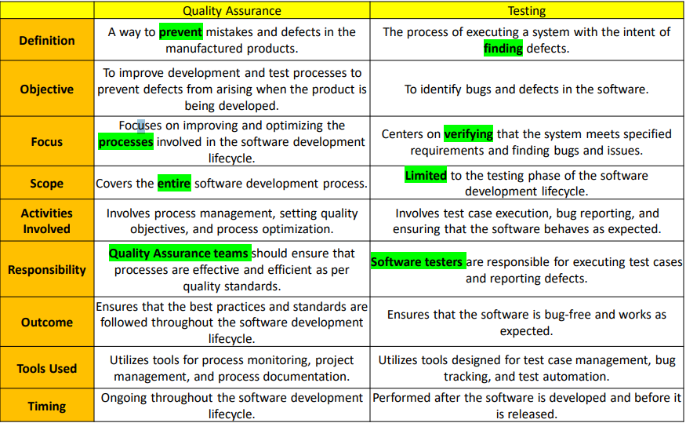

https://simplerqms.com/ce-marking-for-medical-devices/
What is the CE Mark in the Healthcare Domain?
The CE mark (short for Conformité Européenne, meaning "European Conformity") is a certification mark that indicates a medical device or healthcare product meets the safety, health, and environmental protection standards of the European Union (EU).

🏥 In the Healthcare/Medical Domain:
The CE mark is mandatory for:
- Medical devices (e.g., pacemakers, syringes, blood pressure monitors)
- In-vitro diagnostic devices (e.g., COVID-19 test kits)
- Active implantable devices (e.g., insulin pumps)

🧾 What Does the CE Mark Mean?
If a medical product has a CE mark, it means:
- The product is safe to use for its intended purpose.
- It complies with EU Medical Device Regulations (MDR 2017/745 or IVDR 2017/746).
- It can be legally sold and distributed in all EU and EEA countries.
Who Grants the CE Mark?
- For low-risk devices, the manufacturer can self-declare compliance.
- For higher-risk devices, a third-party organization called a Notified Body must review and approve the product.

🛠️ Example:
If a company develops a digital thermometer to be sold in Europe:
- They must test it for accuracy, safety, and performance.
- Create a technical file documenting the product design, use, and risk assessment.
- If required, get approval from a Notified Body.
- Once approved, they can place the CE mark on the product and packaging.

⚠️ Important Notes:
- The CE mark is not a quality mark, but a regulatory compliance mark.
- It’s not accepted in the US — the US equivalent is FDA approval.

What is Equivalence Partitioning in Software Testing?
Equivalence Partitioning (also called Equivalence Class Partitioning) is a Black Box testing technique used to reduce the number of test cases while still testing the software effectively.
It divides input data into groups (partitions) that are expected to behave similarly. You test just one value from each group because the system will handle all values in that group the same way.

🧠 Simple Idea:
"If one input in a group works, all others will too. If one fails, all might fail."

🛠️ Example: Age Input Field (Acceptable range: 18–60)
You can divide the inputs into three partitions:
- Valid input: 18 to 60 → (e.g., test with 30)
- Invalid input (too low): Below 18 → (e.g., test with 15)
- Invalid input (too high): Above 60 → (e.g., test with 65)
Even though users can enter hundreds of values, you only test one from each partition.

🎯 Why Use Equivalence Partitioning?
- Reduces test effort without missing coverage.
- Helps in identifying invalid input cases early.
- Ensures you're not doing redundant testing.

📌 Summary:
- Divide input into valid and invalid groups.
- Choose one representative from each group to test.
- It’s efficient, especially when the input range is large.

Let me know if you want a diagram or practice problems for Equivalence Partitioning!
You said:
what is boundary value analysis in software testing? with example
ChatGPT said:
✅ What is Boundary Value Analysis (BVA) in Software Testing?
Boundary Value Analysis is a Black Box testing technique that focuses on testing the values at the edges (boundaries) of input ranges.
It’s based on the idea that defects are more likely to occur at the “boundaries” of input domains than in the middle.

🔍 Why Test Boundaries?
Many bugs happen at the minimum and maximum limits of input fields because that's where developers often make mistakes (e.g., using < instead of ≤).

🛠️ Example: Age Input Field (Acceptable Range: 18 to 60)
You test the boundaries and just outside them:
Test Type | Test Value | Expected Outcome
Just below lower | 17 | Invalid
Lower boundary | 18 | Valid
Just above lower | 19 | Valid
Just below upper | 59 | Valid
Upper boundary | 60 | Valid
Just above upper | 61 | Invalid
✅ This helps catch errors developers might make like missing “equal to” conditions.

🎯 Key Rule in BVA:
For a range [min, max], test:
min - 1, min, min + 1, max - 1, max, max + 1

📌 Summary:
- Tests input edges where bugs are more likely.
- Works best with numeric ranges or input limits.
- Often used with equivalence partitioning.

Let me know if you'd like a visual chart or combined BVA + Equivalence Partition example!
You said:
Difference between Boundary value analysis and equivalence partition ?
ChatGPT said:
✅ Difference Between Boundary Value Analysis (BVA) and Equivalence Partitioning (EP)
Aspect | Equivalence Partitioning (EP) | Boundary Value Analysis (BVA)
Definition | Divides input data into groups (partitions) that should behave similarly | Focuses on testing values at the edges (boundaries) of input ranges
Goal | Reduce test cases by picking one value per valid/invalid group | Catch errors that often occur at the minimum and maximum values
Test Values Chosen | Any representative value from each group | Boundary values and just inside/outside those limits
Test Focus | Tests each partition once | Tests extreme values (like limits and edges)
Example Range (18–60) | Valid: 30  Invalid: 15, 65 | 17 (just below), 18 (boundary), 19, 59, 60 (boundary), 61
Number of Test Cases | Usually fewer (1 per partition) | Slightly more (around 6 per boundary range)
Used When | You want broad coverage with minimal tests | You want to check edge case behaviors
Test Type | Black Box Testing | Black Box Testing

🎯 In Simple Words:
- EP checks “one from each group” (middle values).
- BVA checks “just around the limits” (edge values).

🧠 Tip:
Use both together for strong test coverage:
→ Use EP to define the groups,
→ Use BVA to test the edges of those groups.
Let me know if you'd like a side-by-side visual example!
You said:
please explain with example
ChatGPT said:
Absolutely! Here's a clear explanation of the difference between Boundary Value Analysis (BVA) and Equivalence Partitioning (EP) with a simple, real-world example.

🎯 Scenario: Age Input Field
A form accepts age between 18 and 60, inclusive.

✅ 1. Equivalence Partitioning (EP)
We divide all possible inputs into logical groups (partitions):
Partition Type | Input Range | Test Example
Valid | 18 to 60 | 30
Invalid (too low) | Less than 18 | 10
Invalid (too high) | Greater than 60 | 70
You pick just one test value from each group.
- Why? Because all values in a group are expected to behave the same.

✅ 2. Boundary Value Analysis (BVA)
You test exact boundary limits and just outside them:
Test Case Description | Test Value | Expected Result
Just below minimum boundary | 17 | Invalid
Minimum boundary | 18 | Valid
Just above minimum | 19 | Valid
Just below maximum | 59 | Valid
Maximum boundary | 60 | Valid
Just above maximum | 61 | Invalid
You’re checking if the system correctly handles the "edges" of the allowed range.

🧩 Summary:
Feature | EP | BVA
Focus | Logical groups | Boundary values
Test coverage | Representative values from each group | Minimum, maximum, and just inside/outside
Example valid test | 30 | 18, 19, 59, 60
Example invalid test | 10, 70 | 17, 61

💡 Best Practice
Use both EP and BVA together for stronger testing:
- EP gives broad functional coverage.
- BVA finds edge-case bugs.

Three different types to build software.
BDD (tool) : karate, cucumber BDD tool
Behavior driven development.
Use the methods and call the methods and frame the testcase by calling the particular sequence of method.
BDD (Behavior-Driven Development) is a software development approach that focuses on how the software should behave from the user's perspective.
It encourages collaboration between developers, testers, and business stakeholders by writing test scenarios in natural language that everyone can understand.
Describe behavior of the system in simple language before coding begins.
These behavior descriptions later become automated tests.

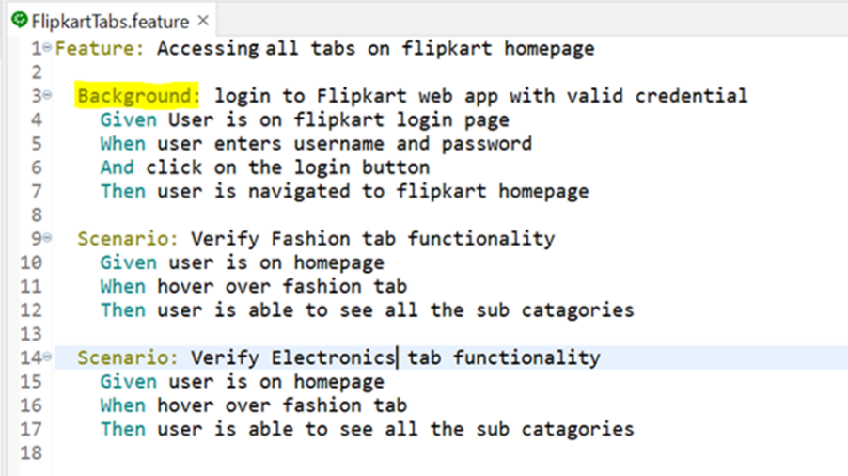
BDD Format: Gherkin Syntax (Given–When–Then)
A BDD scenario is usually written in this format:
Given [some starting context]
When [an action is taken]
Then [an expected outcome happens]
Ex:
Feature: Login functionality
Scenario: Successful login with valid credentials
- [Given] the user is on the login page
- [When] the user enters a valid username and password
- [And] clicks the login button
- [Then] the user should be redirected to the dashboard
This scenario can then be automated using tools like:
- Cucumber (Java, Ruby)
- SpecFlow (.NET)
- Behave (Python)
Why Use BDD?
- Ensures clear understanding between business, dev, and QA.
- Improves test coverage and alignment with user requirements.
- Encourages test-first development (similar to TDD, but more readable).

FDD: (Process)
Feature driven development.
- New software, get new requirement n understand, that req is defined as objectives n features
- Each features developed independently. (FDD)
- One after the other features gets developed independently, isolated development.
- Drawback :
MVP : minimal viable product, atleast minimum one feature should be stable without any issue.
- If two product development together , than MVP is violated.
- If we follow agile, in 1 sprint will deliver small chunks of code with MVP.
- if two features develop independently , and if we are not meeting MVP criteria ex: 1 feature completes on time and one feature gets delayed. So as feature and team we are not meeting MVP.
- AVW – parallelly features develops so we are not meeting MVP, we are delivering with minor known issues.
“We develop a application feature by feature, and deliver an MVP product as early as possible.” – important.
TDD: (most important concept)
Test driven development.
Objective is to ensure 100% feature/product quality delivery, whatever we are launching it is should be correct\accuracy without any issues
Whereever the accuracy is needed more, there we use this approach (ex: Finance domain.)
Before development, we are start designing test case. Manual testcase -> unit testcase.
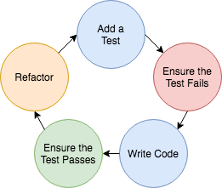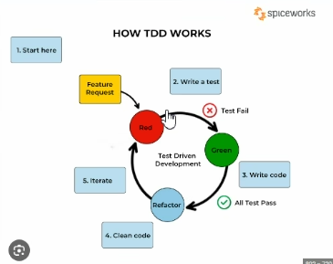
Testers write the testcase, provide the testcase to developer to write the code to implement the feature, developer write the code to pass the minimal testcase.

V Model:
You’ll want to use a V-model in situations wherein the requirements and understanding of the software’s functionality are well-defined from the beginning. In cases where the project scope is clear, and the development team has a solid understanding of the requirements, the V-model can be an effective tool for delivering high-quality software.
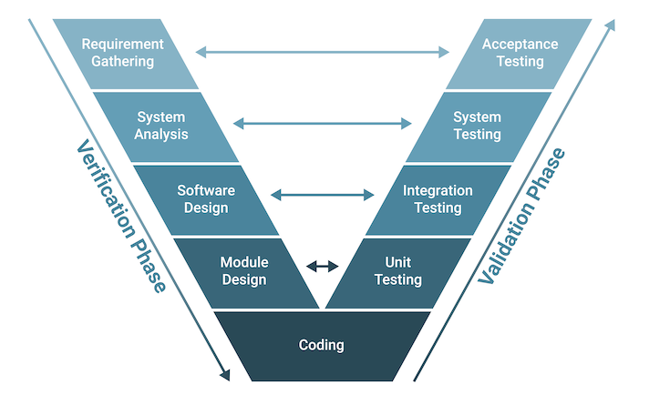

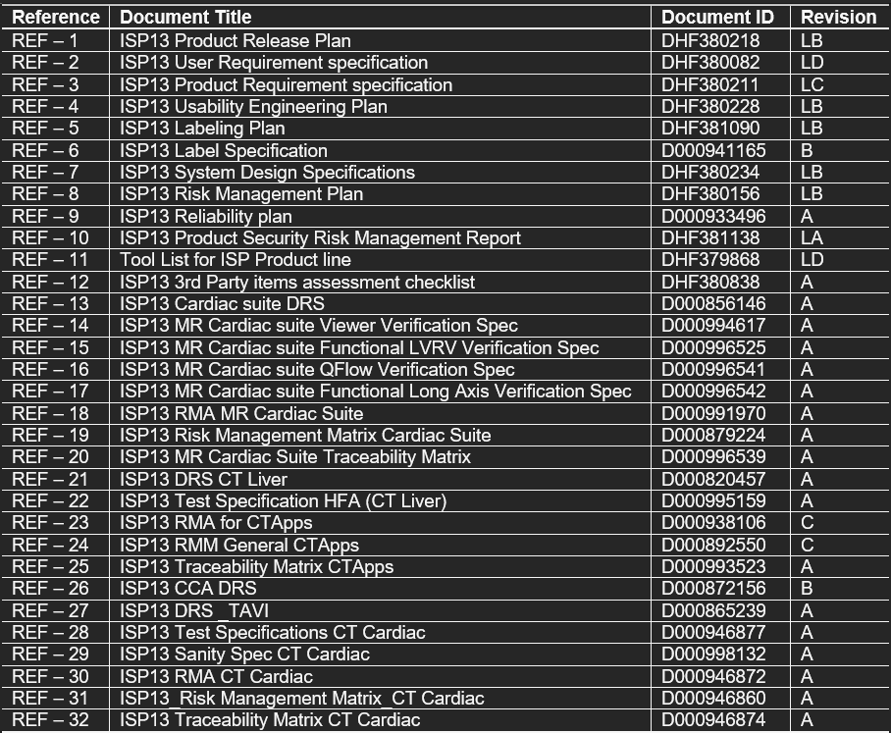
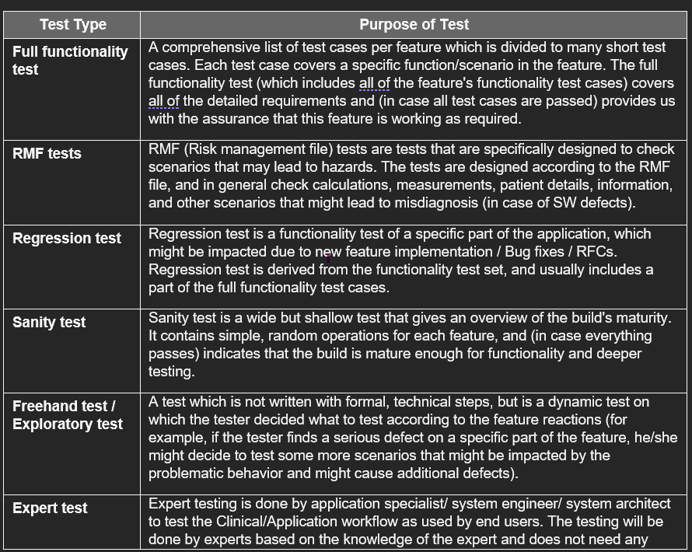

Verification Plan criteria:

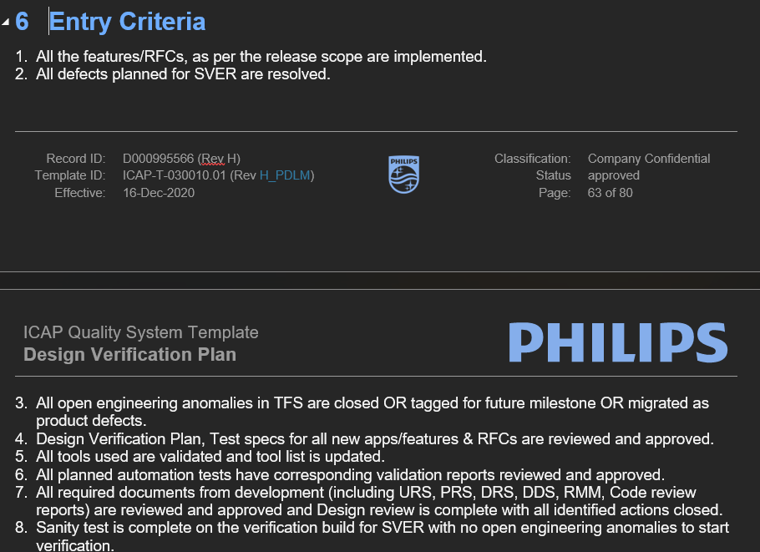

Accelerated lifetime Testing (ALT)
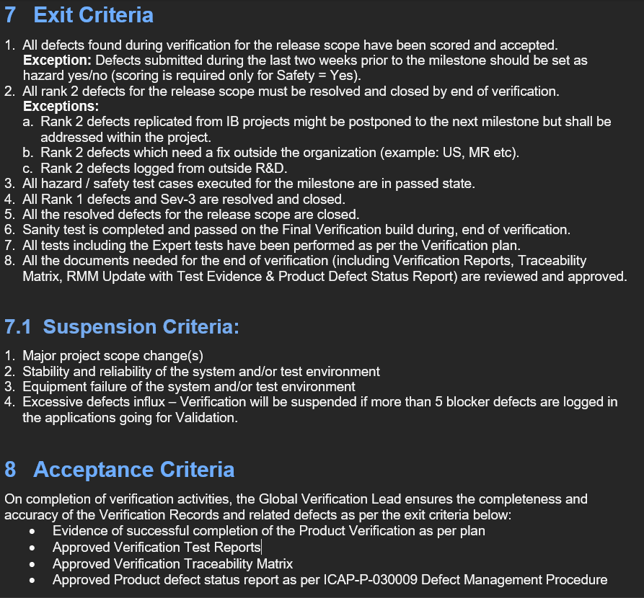

When to Use of V-Model?
- Traceability of Requirements: The V-Model proves beneficial in situations when it's imperative to create precise traceability between the requirements and their related test cases.
- Complex Projects: The V-Model offers a methodical way to manage testing activities and reduce risks related to integration and interface problems for projects with a high level of complexity and interdependencies among system components.
- Waterfall-Like Projects: Since the V-Model offers an approachable structure for organizing, carrying out, and monitoring testing activities at every level of development, it is appropriate for projects that use a sequential approach to development, much like the waterfall model.
- Safety-Critical Systems: These systems are used in the aerospace, automotive, and healthcare industries. They place a strong emphasis on rigid verification and validation procedures, which help to guarantee that essential system requirements are fulfilled and that possible risks are found and eliminated early in the development process.

