

**User Guide**

Vayu Kisore

Jordan Kodner

Xiao Li

Jose Varela

**Table of Contents**

1. Introduction

1.1 Purpose

1.2 Getting Started

2. Interface

2.1 Getting Around

2.2 Login

2.2.1 New User

2.3 Main Menu

2.4 View Students

2.4.1 View Student's Info

2.5 View Activities

2.5.1 View Students for Activity

2.5.1.1 View Student Info

2.5.1.2 Leave Comment

2.6 Syncing

3.

4.

5. Credits

**1. Introduction**

1.1 Purpose

1.2 Getting Started

**2. Interface**

2.1 Getting Around

Simply follow prompts, and press 'yes' or 'continue' buttons to move forward through the app. At any time, you can go back by pressing your phone's back button.

2.2 Login Screen

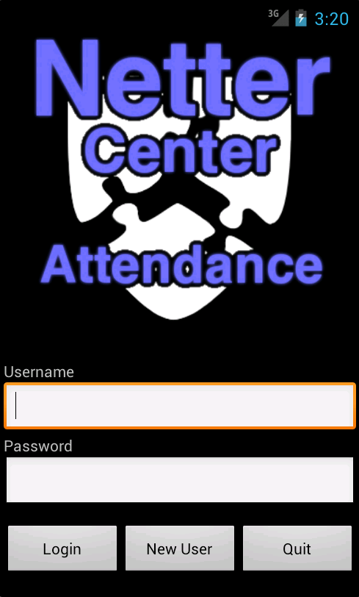

When you start the program, it will bring you to the login screen. Here, enter your username and password. Press "Login" to continue into the app, or "Quit" to leave. If you do not have an account, select the "New User" button on the bottom of the screen.

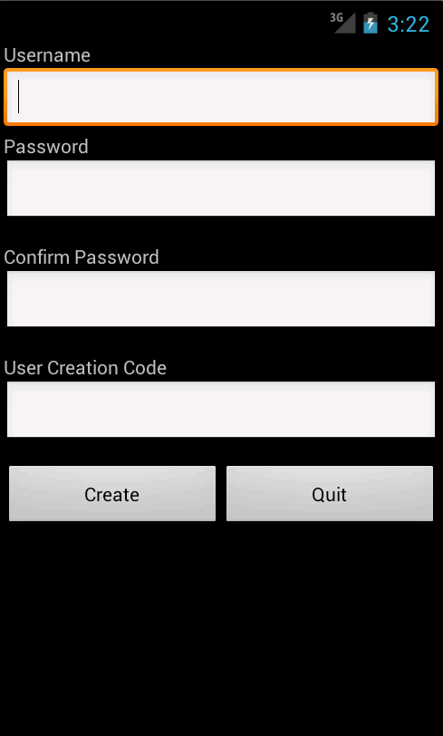2.2.1 New User

Enter a new username and password. In the User Creation Code box, enter the code that the Netter Center has provided for you. This is for security purposes.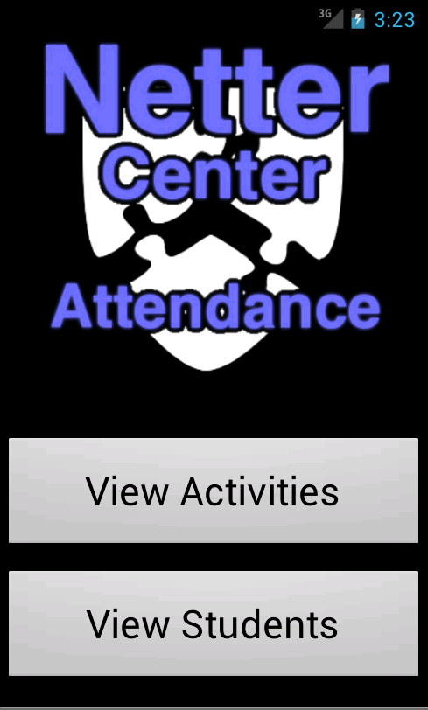

2.3 Main Menu

After you log in, the first screen you are brought to is the Main Menu. Here, you have two options. Either view the list of all students, of view the list of all activities.

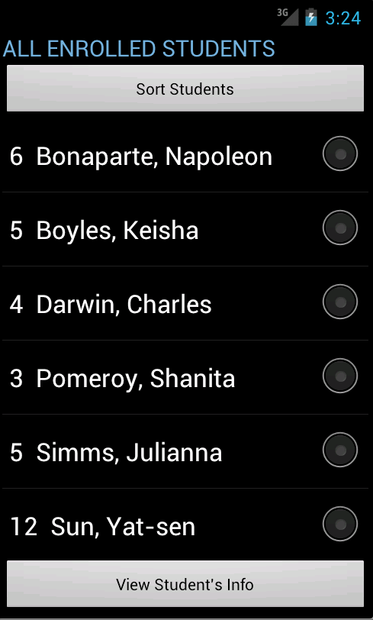2.4 View Students

Selecting "View Students" from the Main Menu brings you to a list of all students. At the top of the screen is a button that gives you the option of sorting students alphabetically or by grade level. Simply click on the students' names to select them. Once a student is selected, Press the View Student's Info button to view and edit information on that student.

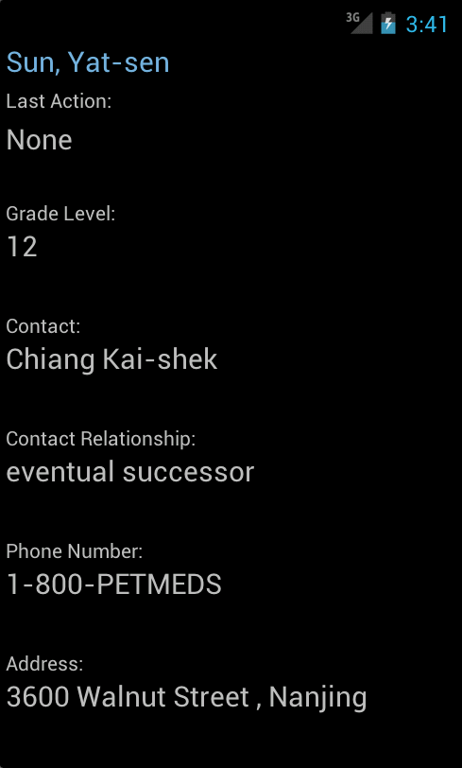2.4.1 View Student's Info

Here you can view and edit information for a student. The window displays the student's name, the last activity performed on the student, grade level, and various contact information. You cannot edit the student's name, but you can edit the other information. Click save to save your edits, or back to cancel. Either way, you will be brought back to the View Students list.

2.5 View Activities

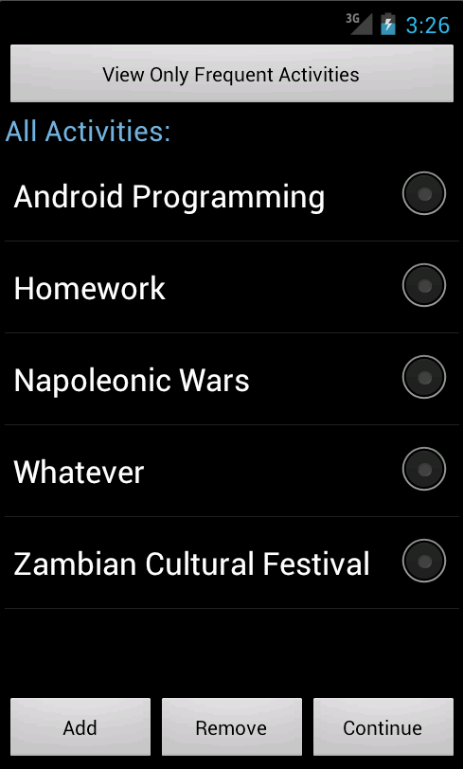

Selecting "View Activities" from the Main Menu brings you to a list of all activities. At the top of the screen is a button that gives you the option of viewing all activities, or just ones that you have added to your frequent list.

To add an activity that already exists to your frequent list, select it, press the add button, then select "Add to Frequent List."

To remove an activity from your frequent list, select it, press Remove, then press "Remove from Frequent List".

You can also create a new activity. Press Add, then "Add New Activity." When prompted, provide a name then select Create.

If you want to permanently remove an activity, select it, press Remove, then "Completely Remove Activity." Use this option judiciously.

Press Continue to view that activity's students.

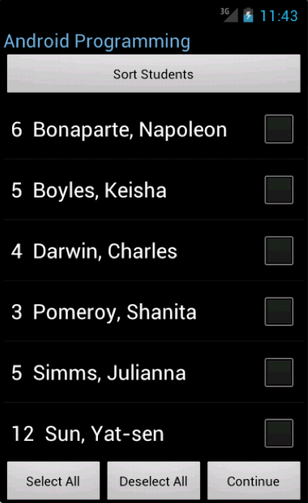 2.5.1 View Students for Activity

This works like 2.4 View Students, except you have more options. You can sort by grade level or alphabetically, or view only checked-in, checked-out, or absent students only. In case you want to perform operation on multiple students at once, you have the option to select multiple students. To make this faster, use the Select All and Deselect All button on the bottom of the screen.

Press Continue to view options.To Check students In and Out, select however many students, then press Check-In Students or Check-Out Students after Continue. It will ask you to confirm.

2.5.1.1 View Student Info

You can View Student Info as before. Please refer to 2.4.1 for more information.

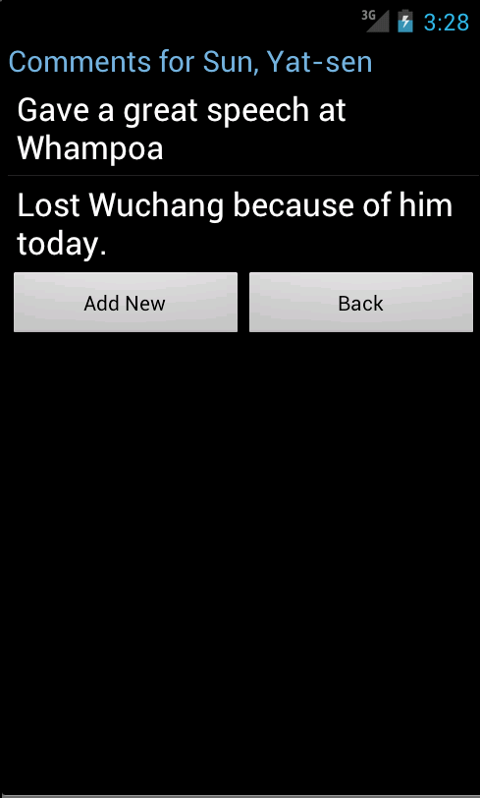2.5.1.2 Leave Comment

If you want to leave a comment, press View Comment after Continue. Here, you will see a list of past comments for a student. Press Add New to add a new comment.

Enter your comment and press submit to post it.

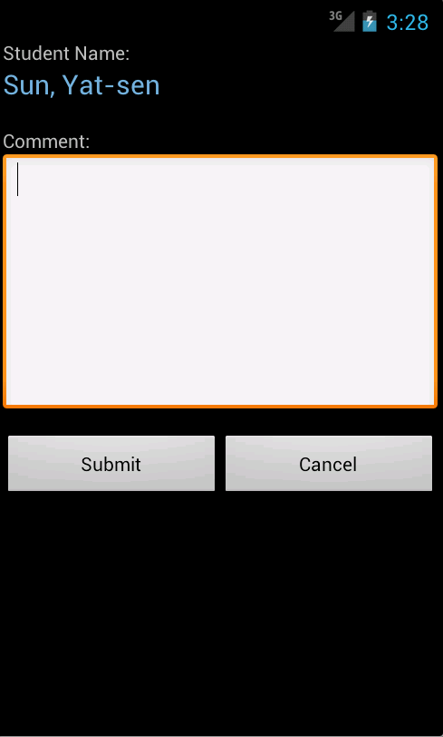 Dfeefeadf



**Technical Documentation**

Vayu Kisore

Jordan Kodner

Xiao Li

Jose Varela

Windows and corresponding Java Classes

Screenshots for all activities are provided in the User Guide.

Please refer to the User Guide’s table of contents.

Login Window: AttendanceAppActivity Test: AttendanceAppActivityTest

Handles Login

User Creation: UserCreationActivity Test:

Input new user information

Main Menu: Main Menu Activity Test:

Directs user to activity and student lists

Full Student List: FullStudentListActivity Test:

Extends StudentListActivity.

Accessible from Main Menu.

Displays list of students

Student Info: StudentDataActivity Test:

View information for a given student

Activity List: ActivityListActivity Test: ActivityListTest

Displays list of programme activities

View Comments: StudentCommentActivity Test:

View comments for a student

Leave Comment: CommentFormActivity Test:

Leave a comment

Student List: StudentSelectionActivity Test: StudentSelectionTest

View students, perform operations on them

*All Activity classes extend SyncableActivty. SyncableActivity has methods which handle syncing to the database and ui features for user interaction with syncing. This class is tested with:

Database

Schema:

Classes and Tests Classes:

External Protocol