**DATA DEFINITION LANGUAGE CHECKPOINT:**

**Instructions**

1. **Understand the Entities and Relationships**  
     
   Review the details of the system:  
   * **Employee**: Tracks employee information such as number, name, position, salary, and the department they belong to.
   * **Department**: Tracks department details, including its number, label, and manager's name.
   * **Project**: Tracks project information like number, title, start date, end date, and the department it is assigned to.
   * **Employee Roles in Projects:** Tracks the participation of employees in projects, including their roles.

**Answer:**

**Entities:**

1. Employee,
2. Department,
3. Project

**Relationships:**

* **one -to-one:**
  + *An employee can only work in one department.*
  + *A project is specific to one department.*
* **One-to-many:**
  + *A department can have multiple employees.*
  + *A department can have multiple projects.*

1. **Create SQL Tables**  
     
   Write SQL scripts to define the following tables:  
   * Department table SQL script

CREATE TABLE Department(

Department_Num_S INT,

Department_Label VARCHAR (255),

Department_Manger_Name VARCHAR (255)

);

* + 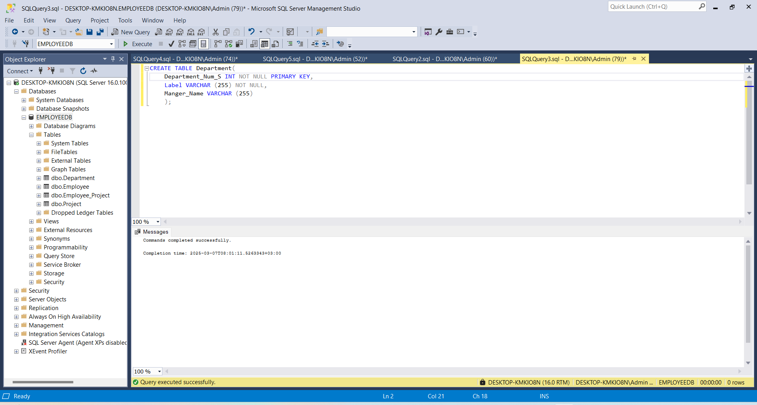
  + Employee table SQL script

CREATE TABLE Employee (

Employee_Num_E INT,

Employee_Name_E VARCHAR(255),

Position VARCHAR (255),

Salary DECIMAL (10,2),

Department_Num_S INT

);

* + Project table SQL script

CREATE TABLE Project(

Project_Num_P INT,

Project_Title VARCHAR(255,

Start_Date DATE,

End_Date DATE,

Department_Num_S INT

);

* + Employee_Project table SQL script

CREATE TABLE Employee_Project(

Employee_Num_E INT,

Project_Num_P INT,

Role VARCHAR (255)

);

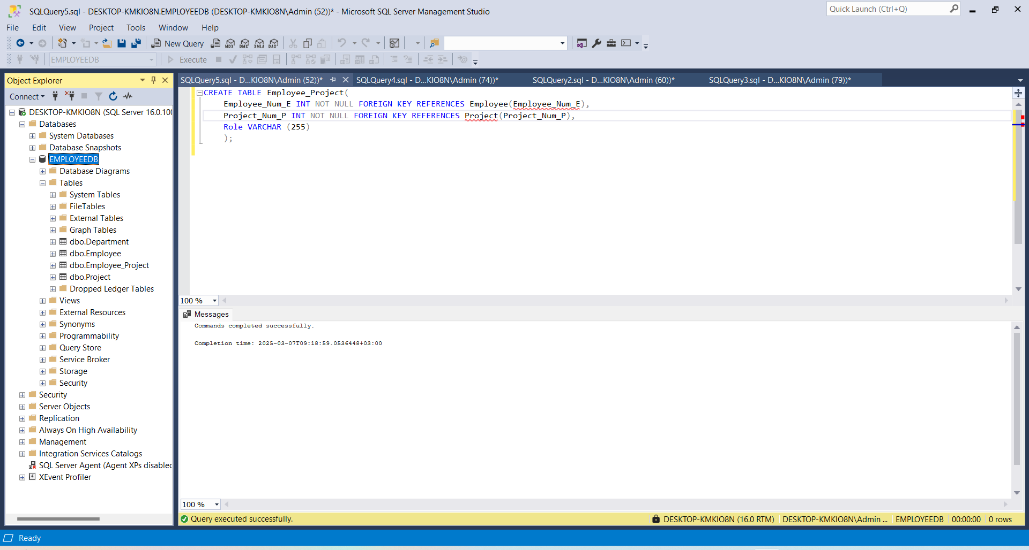

1. **Include Primary and Foreign Keys**  
   * Ensure each table has a primary key to uniquely identify each record.
   * Define foreign keys to establish relationships between tables, ensuring referential integrity.

**Employee Table:**

CREATE TABLE Employee(

Employee_Num_E INT PRIMARY KEY,

Employee_Name_E VARCHAR(255),

Position VARCHAR (255),

Salary DECIMAL (10,2),

Department_Num_S INT FOREIGN KEY REFERENCES Department(Department_Num_S)

);

Or after creating table type the following command:

ALTER TABLE Employee

ADD FOREIGN KEY Department_Num_S INT REFERENCES Department(Department_Num_S);

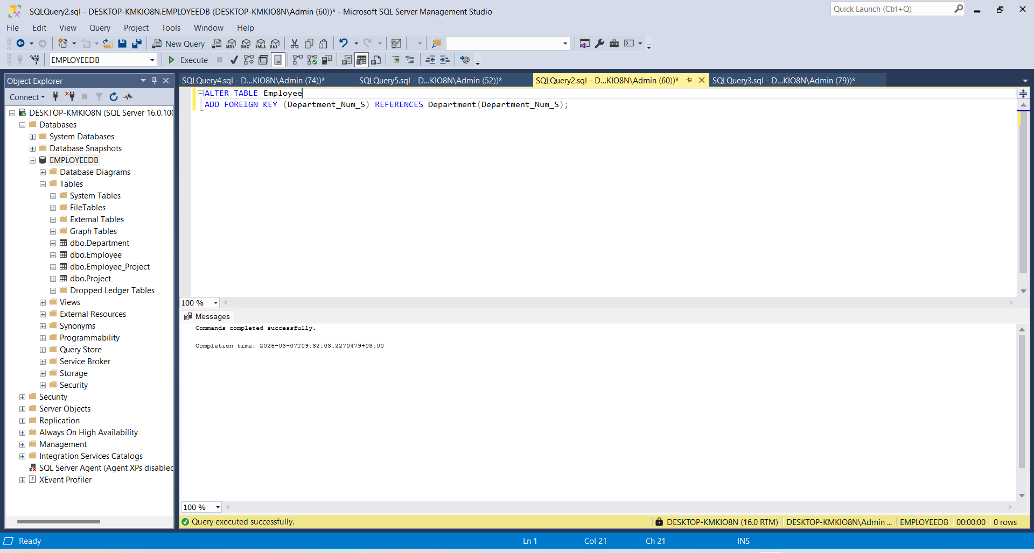

**Department Table:**

CREATE TABLE Department(

Department_Num_S INT PRIMARY KEY,

Department_Label VARCHAR (255),

Department_Manger_Name VARCHAR (255)

);

**Project Table:**

CREATE TABLE Project(

Project_Num_P INT PRIMARY KEY,

Project_Title VARCHAR(255,

Start_Date DATE,

End_Date DATE,

Department_Num_S INT FOREIGN KEY REFERENCES Department(Department_Num_S)

);

Or after creating table type the following command:

ALTER TABLE Project

ADD FOREIGN KEY (Department_Num_S) REFERENCES Department(Department_Num_S);

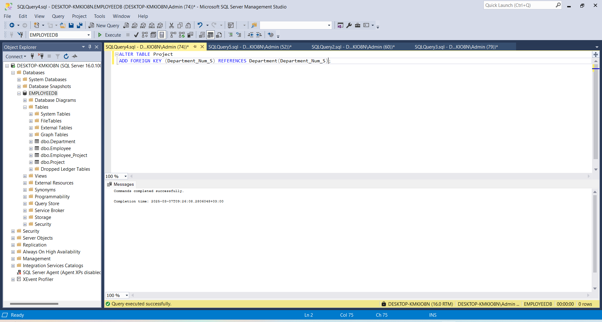

**Employee_Project Table:**

CREATE TABLE Employee_Project(

Employee_Num_E INT FOREIGN KEY REFERENCES Employee(Employee_Num_E),

Project_Num_P INT FOREIGN KEY REFERENCES Project(Project_Num_P),

Role VARCHAR (255)

);



1. **Implement Constraints**  
   * Define data types and constraints for all attributes based on the schema:

**Employee Table:**

* Num_E (Primary Key): INT
* Name: VARCHAR(255)
* Position: VARCHAR(255)
* Salary: DECIMAL(10, 2)
* Department_Num_S (Foreign Key): INT

CREATE TABLE Employee(

Employee_Num_E INT NOT NULL PRIMARY KEY,

Employee_Name_E VARCHAR(255) NOT NULL,

Position VARCHAR (255),

Salary DECIMAL (10,2),

Department_Num_S INT FOREIGN KEY REFERENCES Department(Department_Num_S)

);

**Department Table:**

* Num_S (Primary Key): INT
* Label: VARCHAR(255)
* Manager_Name: VARCHAR(255)

CREATE TABLE Department(

Department_Num_S INT NOT NULL PRIMARY KEY,

Department_Label VARCHAR (255) NOT NULL,

Department_Manger_Name VARCHAR (255)

);

**Project Table:**

* Num_P (Primary Key): INT
* Title: VARCHAR(255)
* Start_Date: DATE
* End_Date: DATE
* Department_Num_S (Foreign Key): INT

CREATE TABLE Project(

Project_Num_P INT NOT NULL PRIMARY KEY,

Project_Title VARCHAR(255) NOT NULL,

Start_Date DATE,

End_Date DATE,

Department_Num_S INT FOREIGN KEY REFERENCES Department(Department_Num_S)

);

**Employee_Project Table:**

* Employee_Num_E (Foreign Key): INT
* Project_Num_P (Foreign Key): INT
* Role: VARCHAR(255)

CREATE TABLE Employee_Project(

Employee_Num_E INT NOT NULL FOREIGN KEY REFERENCES Employee(Employee_Num_E),

Project_Num_P INT NOT NULL FOREIGN KEY REFERENCES Project(Project_Num_P),

Role VARCHAR (255)

);