Xilinx Vivado Synthesis Tutorial for Nexys-A7
This tutorial guides you step-by-step on how to synthesize the design (a simple 2-input and gate) onto the Nexys-A7 board shown below.
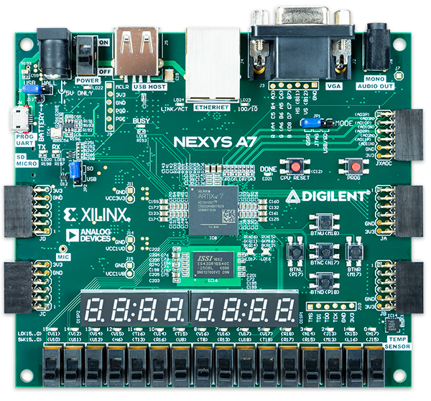

Questions for you:

Do you have the
Vivado project of 2-input AND gate
with and2gate.v file?

NO

Start your work by following the Xilinx Vivado Simulation Tutorial document

Yes

Find and open the folder “and2gate” in the computer.
Double-click on (Vivado Project File)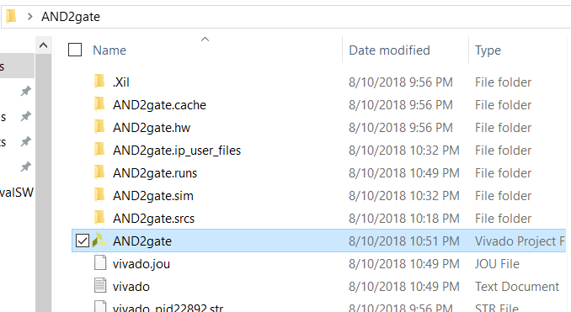
OR you can Start Xilinx Vivado 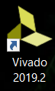 and then choose open the project (instead of creating a new project). Then locate where your project is and click on

Do you still have
The Vivado project of
and2gate OPEN?

NO

Yes

Continue next page

Using the Nexys-A7 board to implement the digital circuit for this class,
- the inputs of your digital circuit/system will likely be implemented using
switches 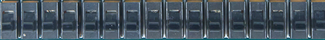 or push buttons 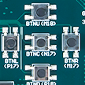
- the outputs of your circuit/system will likely be implemented using
Light Emitting Diodes (LEDs) or
seven-segment displays
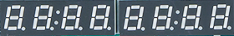

Note: We will use other pins or peripherals on the board – will be discussed later in the semester.
Since the above devices are already connected to the FPGA chip 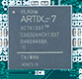 on the board (already designed and decided by the company – see “nexys-a7-reference_manual.pdf” or “nexys-a7-schematic.pdf” on D2L or documents on https://reference.digilentinc.com/reference/programmable-logic/nexys-a7/start ), we will use them by assigning the pins to the inputs and outputs of our digital circuit.

Procedure:

Before we synthesize our design, we need to map inputs and outputs of our designed module (in this tutorial, and2gate) to the pins of the FPGA chip on the board using Xilinx® Design Constraints (XDC) file. For this and2gate circuit, we will use two of the switches on the Nexys-A7 board for the inputs A and B and one of the LEDs as the output F.
We will use switches SW2 and SW3 on the board for the inputs A and B of the and2gate module and one LED (LD0) to the output F.
SW2

SW3
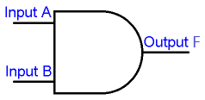

LD0

One thing you should see is that, on the board, the pin number is displayed in ( ) next to the name of that component. For example, at switch SW2, the board shows (M13) above SW2. We will use SW2 for input A of the and2gate. Therefore, The M13 is the pin number that will be assigned/ mapped to our input A. Now your turn,
Pin number
Input B (SW3) _________
Output F(LD0) ________

At this point, we are ready to assign the pin number to the inputs and outputs of our digital circuit/module.

Step 1) Creating .xdc file

  - Click “Add Sources” and then choose “Add or create constraints”. Click Next.
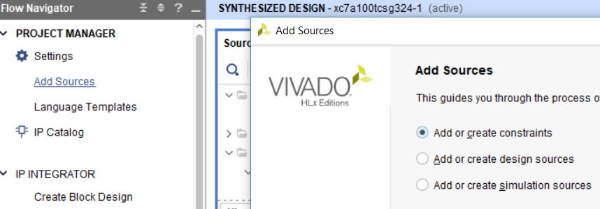

On the next window (Add or Create Constraints), click Create File. In File name box, enter the desired file name. For this tutorial, and2gate is used. Then click OK and Finish.
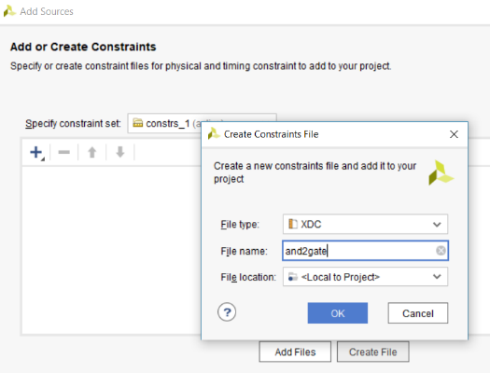

Note: the and2gate.xdc is created under Constraints in Project Manager window. Double-click on it to open it.
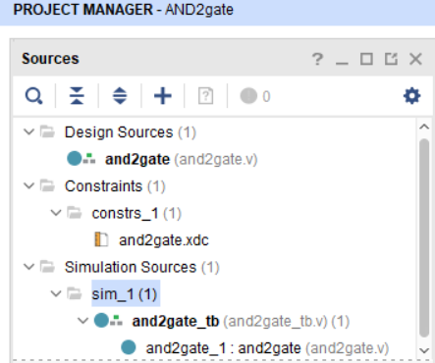

1.2 Map/Assign pins to the inputs (A, B) and output (F) of your and2gate module. Below is what we will use

SW2(M13)
SW3(R15)

F (H17)
Write the following statements into the and2gate.xdc file and save it (Ctrl+S) or click
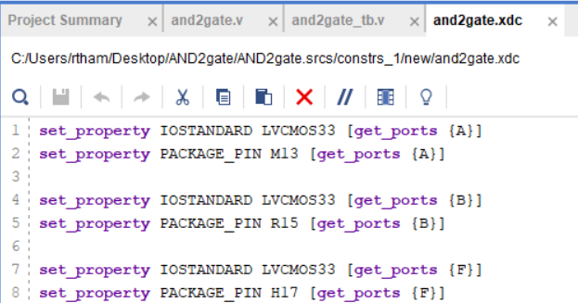

Note: each input or output pin always has the two statements below. A is one of the inputs in our and2gate module. M13 is the pin assignment for SW2 used for the input A on the FPGA board.

set_property IOSTANDARD LVCMOS33 [get_ports {A}]
set_property PACKAGE_PIN M13 [get_ports {A}]

Step 2) Synthesize the design
Click on Run Synthesis under Synthesis task of the Flow Navigator pane.
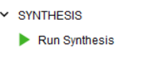
To show that it is still working on synthesizing, you will see the green circle keep circling

When it synthesizes successfully, the Synthesis Completed dialog box with 3 options will be displayed as shown below. If it does not show or you see an error, go back to make sure that there is no error when you write the statements to assign the pins.
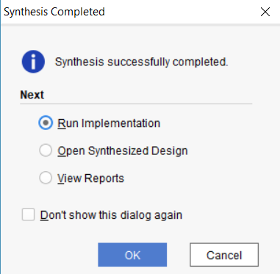
Step 3) Implementation
Choose Run Implementation (from the options above) and click OK.
or Click on Run Implementation under Implementation task of the Flow Navigator pane.
Again, the green circle keeps circling (on the top right corner of the page) while Vivado is executing the process. Clicking on Design Runs tab (at the bottom section of the project), it shows that implementation is running.
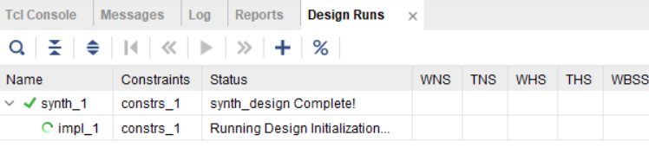
This step usually takes a while (depending on your design size, i.e. it takes longer as your design gets larger or more complicated). When it completes, the “Implementation Completed” dialog box with 3 options will be displayed.
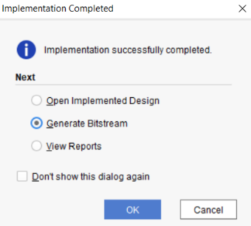

If the dialog box does not show, go back and
make sure you follow the previous step(s) correctly.
Additionally, you may want to look at the statements
under “Messages” tab to make sure that there is no
error or all critical warnings are removed.

Step 4) Program (Generate Bitstream)
Choose Generate Bitstream and click OK.
Again, the Design Runs window will show the progress of this process. When it finishes, the Bitstream Generation Completed dialog box (below) will be displayed, choose Open Hardware Manager and click Ok.
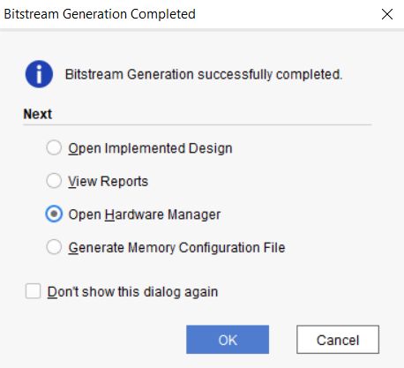
It is time to power on the board!

Step 5) Using and programing to the Nexys-A7 board

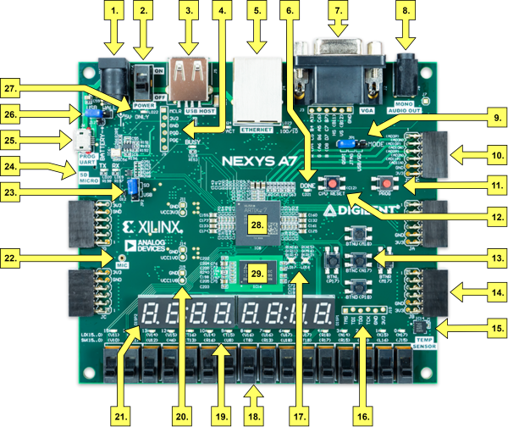

We will power the board using the USB cable (the same one that you will use to program the bitstream (containing your designed circuit (and2gate in this case)) that you just generated.
Note: as the designed circuit uses more components (peripherals) that requires more power, the power adapter can be used.

5.1 Connect the USB cable to the computer (or your laptop) where it contains your Vivado project. The other side of the cable connects to 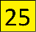 in the picture above.
5.2 Turn on the power switch 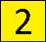. If the board is working, you should see red LED (POWER)
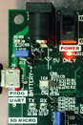
lit up and seven-segments lit up in sequence, ….
The board has memory chip that is pre-programmed with the code that is automatically loaded into the FPGA chip when the board is just turned on.

5.3 Connect to target to program the target (board)
You should see Hardware Manager window, and see currently no hardware target is open. Click on Open target and Auto Connect.
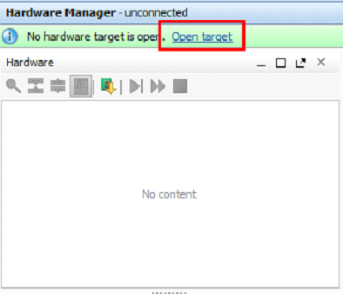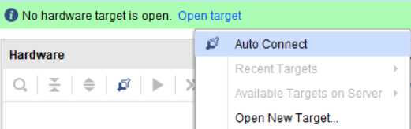
If your USB cable connects correctly and driver is installed correctly, you will see your connected hardware.
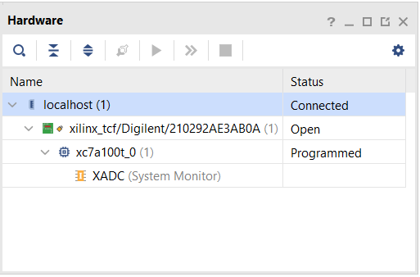
It’s time to program device. Press Program Device and xc7a100t_0 (your device)

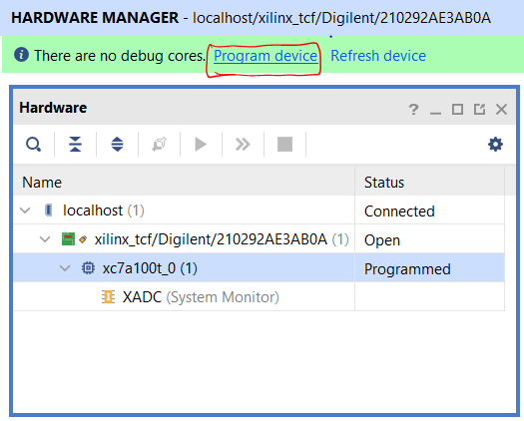

Click Program on the Program Device window.

This will open the following window to select the bitstream (.bit) file to program the FPGA with.

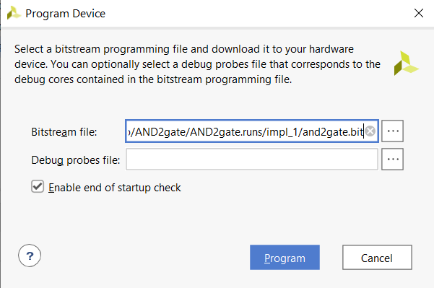
The appropriate bitstream path should already remain filled in the ‘Bitstream file’ field. If it’s not present, the generated bitstream can be found in “AND2gate/AND2gate.runs/impl_1/” folder named as “and2gate.bit” file. Upon selecting this file, click on Program. This will program the FPGA with the designed module.

How do you know your circuit is working on the board?
If the programming step is successful, you should see that your designed circuit (and2gate) is working on the board. Since it is a 2-input AND gate, when we turn on both switches (i.e. move them to the up position) -> make both inputs A and B to 1, we should see that LED LD0 is lit (output F = 1).
Congratulations! You have successfully synthesized and implemented your 2-input AND gate onto the Nexys-A7 board.

What if it is not working?

- If the circuit is not working (even though you change the inputs (switch positions)), it might be that the programming step was unsuccessful, see the messages in Messages tab (on the bottom part of the Vivado project).
One thing to try is to first turn off the switch, wait for about 30 seconds, turn it on and do the program step again.

- If the functionality of the circuit is wrong (i.e. output should be 1 given the input configuration but it does not, etc.), a few suggestions for you to check.
- Check and make sure that you use the correct inputs (switches) and outputs (LEDS, 7-segement, …) – the one that you assign in the .xdc file. If this is correct, then

- Your Verilog code can be wrong. I do not mean the syntax error. I am talking about the way you write the code. The code does not create the circuit with the correct functionality that you want. This can be checked by looking at the output(s) in the simulation waveform. This is the reason why we do the simulation after writing the Verilog code.
If this is where you (or your team) find yourself, modify the Verilog code, perform the simulation to check that it gives the output(s) that you want, and then synthesize and implement onto the board.
If this step shows the output waveform according to your design (truth table, state diagram, …) but it is not the output that the lab assignment states, then

- Your design (truth table, logic equation(s), state diagram, …) is wrong.
If this is where you (or your team) find yourself, start by redesign it, modify the Verilog code, perform the simulation, and then synthesize and implement onto the board.

