Grand Challenge: Scavenger Hunt

General Constraints
Issues to consider for the grand Challenge problem and the hardware and software required to implement it:

Early Success:
What can the students accomplish with the hardware (almost) right out-of-the-box?
Relevance:
Who cares about this problem? Is it useful?
Depth:
Can individual teams get deep in to one area, like navigation or manipulation, and still complete the challenge?
Breadth:
Can individual teams go broad to try and cover all topics in the course and still complete the challenge?
Tinkerers:
Can students get to the nuts-and-bolts level to modify servo loops, build new hardware, etc?
Nut Cases:
How crazy can the craziest students be before become hardware limited?

Rus: Climbing Robots
term 1 build climbing robot
term 2: add grippers to robot and do cooperative assembly

Rus: Cleanup task---like your scavenger task but with RFIDs in the objects

Rus: Laundry folding

Food and Drink Service – Prof. Seth Teller
Customer orders food at counter, takes numbered sign (with embedded sensor network node) to his/her table. As food items become available, robot delivers them to correct table, navigating with help of network node(s). When last item has been delivered, robot collects sign.
Advantages: many manipulation options, from simple to hard.
Disadvantages: tough nav problem, may need infrastructure.

Stocking warehouse/supermarket shelves – Prof. Seth Teller
Human manager places one node per product type in desired shelf region, and opens shipping crates in staging area. Robot stocker transports crates to correct shelf area, and places individual products on correct shelf regions. Stocker must do limited sensing to place products correctly. Optional robot shopper moves product from shelf into cart.
Advantages: uses mobility, grasping, sensing, sensor nodes.
Disadvantages: grasping and sensing problems could be too hard.

Reconfiguring rolling chairs and tables in seminar room – Prof. Seth Teller
Every table and chair has 1+ sensor nodes with ID info. Robots commanded to place furniture into specified configuration:
- Tables up front and chairs in rows;
- Tables centered and chairs arrayed concentrically;
- Tables stowed to side, and chairs facing middle; etc.

Advantages: could motivate multi-robot cooperation.
Manipulation strategies could be push (easy) or pull (harder).
Disadvantages: weight, power requirements. Cooperation might be too hard.

Transport and fetch objects for lending and borrowing – Prof. Seth Teller
Sharing model: people would like to lend things to each other, but often hesitate to do so for fear they won't get them back. So, have lender (lazily) attach sensor node to each lent object, before giving it to borrower. Lender can then command robot to fetch the object at any time. Robot locates object within sensor network, navigates to it, grasps it (perhaps with human assistance) and returns.
Other twists: Lender can command robot to bring the lent object to borrower. Borrow can dispatch robot to request an object from Lender (but must wait for Lender to appear,
and for Lender to attach sensor node to object).
Advantages: over time, most useful things get nodes attached.
Disadvantages: grasping hard to do fully autonomously, but this may be ok, since lending/returning has social component anyway.

Scavenger Hunt – James McLurkin

Summary
The goal for this grand challenge is for each group of students to build a robot capable of finding objects of interest scattered throughout the environment. Advanced students can look for objects that are more difficult to sense, or chose to manipulate, collect, and return objects to a central location. The platform should be selected so that students can modify it with extra sensors and capabilities to meet their particular design specifications. The Stata Center’s Student Street is an ideal location for the final challenge testing (competition?), offering plenty of room for setup and testing in a complex, but uncluttered environment. The popularity of the Stata Center would increase the visibility and popularity of the class.

Difficulty
It is important for the students to be able to have some success. Some of the key concepts of robotics are:

- Mobility
- Navigation
- Sensing/perception
- Manipulation

The goal is to create a multi-dimensional problem space from which to select lab problems and the grand challenge. This will allow us to select a progression of problems from simple to difficult.
Sensing/perception is a necessary prerequisite for manipulation, so these can be put on the same axis. Mobility will be wheels on flat ground in all cases, or else students will be spending a lot of time on mechanical design. That gives us a two dimensional space to pose lab problems and the Grand Challenge.

Problem space:
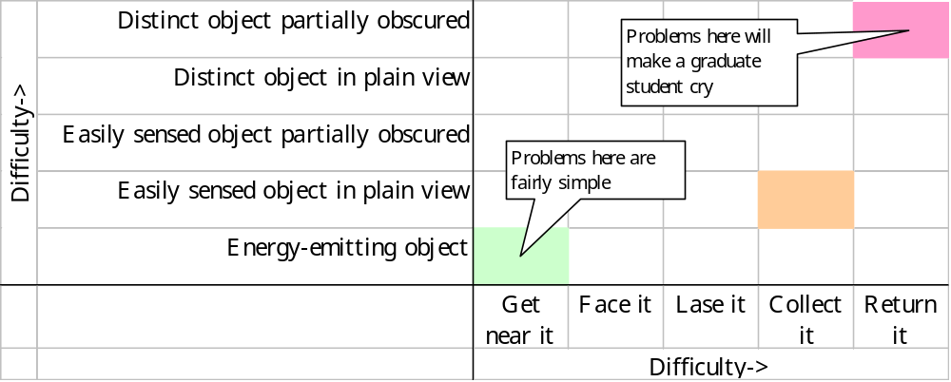

An example of an easily sensed object would be a bright green ball. A distinct object is one that does not occur in the normal environment, but it not designed to be sensed. The ultimate goal of the grand challenge would be for each team to collect as many objects as possible, and return them to a central location.

