* Powershell is object oriented
* Scripting language based on .NET
* Works with with Azure, AWS etc
* DSC – management configuration, enforce settings on systems – feature

E.g. in action:

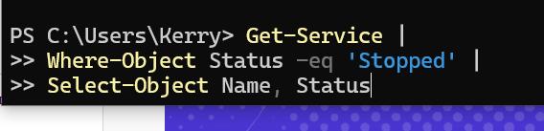

Using a variable. Write results to a variable, then output from variable to a file

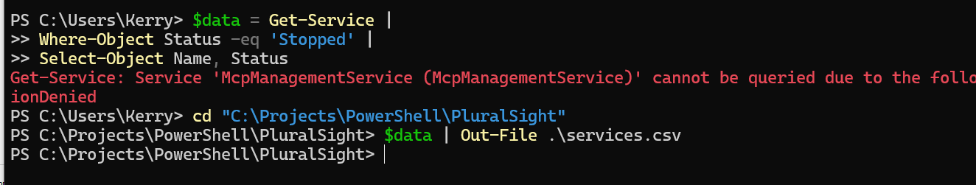

To create a comma separated value use ‘export-csv’



To import data to a variable:



Version:

