Project – ExtractAgileData

Project Structure (Refer Figure 1) –

ExtractAgileData

|________ExtractAgileData.jar

|________config.properties

|________ExtractAgileObjects.bat

|________ExportAttachments.bat

|________log

|__________ExtractAgileData.log

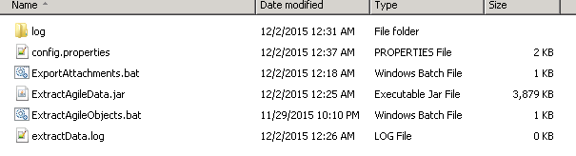

Figure 1

Execution Steps –

1. Modify config.properties (Refer Figure 2) files for any changes as required –
2. **Run batch file - ExtractAgileObjects.bat first**
3. This run will execute the Agile search as configured in config.properties file. **(AGL_SEARCH_FOLDER=Personal Searches, AGL_SEARCH_NAME=ExtractSearchTest)**
4. Each search result item will be copied to Item master index list
5. Then for each search result Item it will execute SQL queries to get all –
6. Dependent BOM items till last level & copy them to Master Item index list
   1. For each item in item master index list get all dependent MPN and add them to MPN index list
   2. For each item in item master index list get all dependent manufacturers and add them to MFR index list
   3. For each item in item master index list get all dependent Changes and add them to Change index list
7. Output of the above step will be (Refer Figure 3) –
   1. One Items index file (.idx) for each item sub class
   2. One Class index files (.idx) for each changes sub class
   3. One MFR.idx file for all manufacturers
   4. One MPN.idx file for all manufacturer parts
8. Once Index lists are ready call SDK code to get Agile objects details in text files.
9. Output of the above step will create below data files (Refer Figure 4) –
   1. Separate Item details text file for each item sub class
   2. Single AML.txt file for all AML for all items
   3. Single BOM.txt for all BOM items for all items
   4. Separate Change details text file for each changes sub class
   5. MPN.txt file for all manufacturer part details
   6. MFR.txt file for all manufacturer details
10. Path of above index and data file is configured in config.properties file.
11. Once above job completes **– run ExportAttachments.bat** batch file
12. The job will re-create the index files
    1. For each entry in index files it will query Agile and get its attachments
    2. Copy the attachment to directories, created as per agile object name and revision. (Base path is configured in config.properties file)

Current Project Location –

D:\CorientExtractPrograms\Project\ExtractAgileData_VG

Current path for generated files –

D:\ExtractAgileData

Path for attachments –

D:\ExtractAgileData\DataFiles\<timestamp>\Attachments

Figure 2

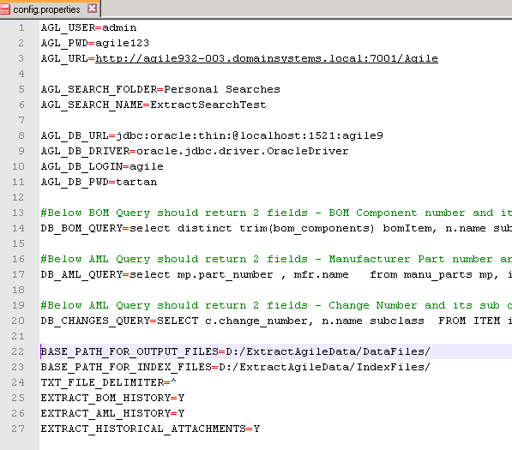

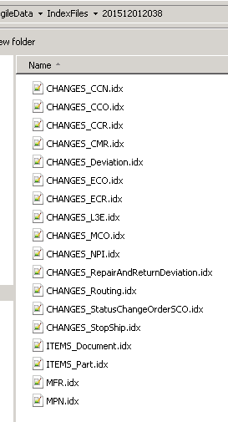

Figure 3

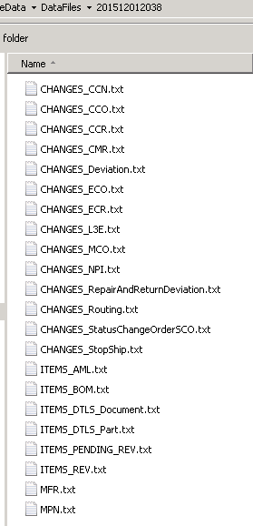

Figure 4