***CO1 PROGRAMS***

**PROGRAM1**

IDE stands for Integrated Development Environment. It’s a coding tool which allows you to write, test, and debug your code in an easier way, as they typically offer code completion or code insight by highlighting, resource management, debugging tools,… And even though the IDE is a strictly defined concept, it’s starting to be redefined as other tools such as notebooks start gaining more and more features that traditionally belong to IDEs.

Comparison between IDLE and Thonny

Thonny is built for education and you can download the latest version from the Thonny website. The download options are at the top right. Thonny looks quite different to IDLE - it has different panels for the editor, the shell and the variables watcher plus (show view) lots of other options as well. It has a powerful debugger built in and other tools which let you manage packages and plugins.

The IDLE editor comes built-in with Python and is the one that many tutorials use by default. It's a fine, basic, editor that also has a Python shell built in for interactive programming.When you start Idle up, you get the shell window. This allows you to execute python commands and see the results immediately without having to create a program. This can be useful for trying things out.

**PROGRAM2**

s=int(input("enter start year"))

e=int(input("enter end year:"))

if(s<e):

print("leap years are:",end="")

for i in range(s,e):

if i%4==0 and i%100!=0:

print(i,end=" ")

OUTPUT

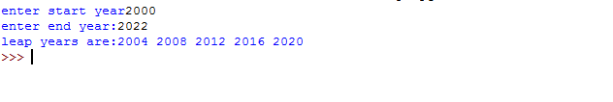

**PROGRAM3.1**

list1=[-10,20,35,-67,70]

re=[num for num in list1 if num>=0]

print(re)

OUTPUT

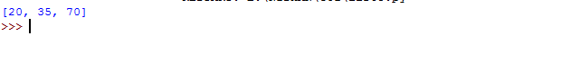

**PROGRAM3.2**

n=int(input("enter limit:"))

squarelist=[i**2 for i in range(1,n+1)]

print("square of N numbers:",squarelist)

OUTPUT**PROGRAM3.3**

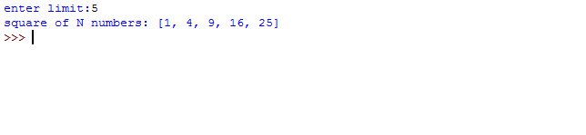

word=str(input("enter the word:"))

print("the original string is:"+word)

print("the vowels are :",end="")

for i in word:

if i in 'aeiouAEIOU':

print([i],end="")

OUTPUT

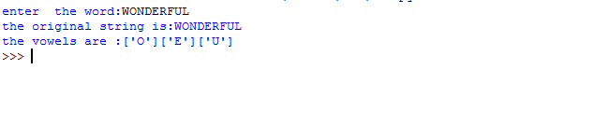

**PROGRAM3.4**

w=input("enter a word:")

print("ordinal values corresponding to each element is")

for i in w:

print(i,end=":")

print(ord(i),end=" ")

OUTPUT

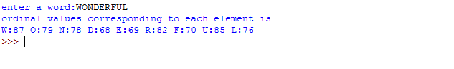

**PROGRAM4**

str1=input("enter a string")

wordlist=str1.split()

count=[]

for w in wordlist:

count.append(wordlist.count(w))

print("count of occurence:"+str(list(zip(wordlist,count))))

OUTPUT

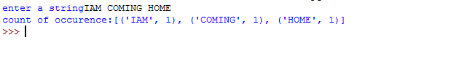

**PROGRAM5**

n=[]

s=int(input("enter a limit"))

print("enter {s} values")

for i in range (0,s):

n.append(int(input()))

print("\nthe list is after asssigning:\n")

for i in range(0,len(n)):

if n[i]>=100:

print("over")

else:

print(n[i])

OUTPUT

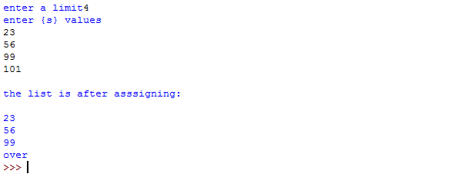

**PROGRAM6**

a_list=("a","b","a")

occ=a_list.count("a")

print("count of occurnces of a :",occ)

OUTPUT

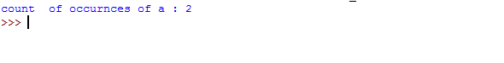

**PROGRAM7**

lst=[1,3,5,7,9,11,34]

lst1=[5,13,45,7,20,65,1]

s=int(0)

c=int(0)

if(len(lst)==len(lst1)):

print("lists are of same length")

else:

print("lists have diff length")

for i in range(0,len(lst) and len(lst1)):

s=s+lst[i]

c=c+lst1[i]

if(s==c):

print("equal sum")

else:

print("not same sum")

print("elements that matched are:")

l=[]

for i in range(0,len(lst)):

for j in range(0,len(lst1)):

if lst[i]==lst1[j]:

l.append(lst[i] and lst1[j])

else:

continue

print(l)

OUTPUT

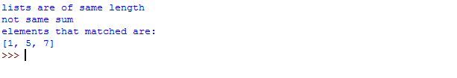

**PROGRAM8**

str1=input("enter a string:")

char=str1[0]

str1=str1.replace(char,'$')

str1=char+str1[1:]

print(str1)

OUTPUT



**PROGRAM9**

str=input("enter a string")

new_str=str[-1:]+str[1:-1]+str[:1]

print("new string:",new_str)

OUTPUT

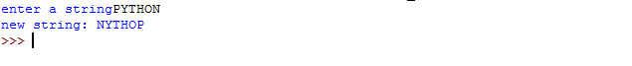

**PROGRAM10**

pi=3.14

r=float(input("input the radius of circle:"))

result=3.14*r**2

print("the area of circLe with radius is:",result)

OUTPUT

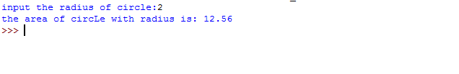

**PROGRAM11**

x=int(input("enter 1st number"))

y=int(input("enter 2nd number:"))

z=int(input("enter 3rd number"))

if(x>y) and (x>z):

largest=x

elif(y>x) and (y>z):

largest=y

else:

largest=z

print("largest no is",largest)

OUTPUT

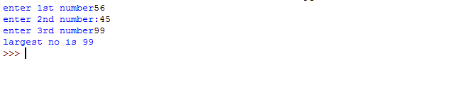

**PROGRAM12**

file=input("enter filename:")

f=file.split(".")

print("extension of file is:"+f[-1])

OUTPUT

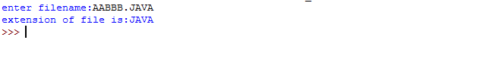

**PROGRAM13**

a=[]

for i in range(3):

b=input("enter the color")

a.append(b)

print(a)

print(a[0])

print(a[2])

OUTPUT

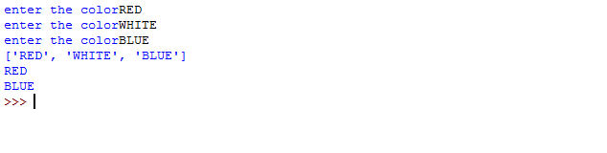

**PROGRAM14**

n=int(input("enter a number:"))

x=int("%s"%n)

y=int("%s%s"%(n,n))

z=int("%s%s%s"%(n,n,n))

print("n+nn+nnn:",x+y+z)

OUTPUT

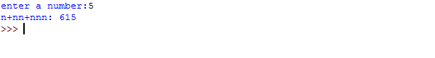

**PROGRAM15**

color_list_1=set(["white","pink","red","blue"])

color_list_2=set(["red","green","pink"])

print(color_list_1.difference(color_list_2))

OUTPUT



**PROGRAM16**

a="python"

b="java"

p1=a[0]

p2=b[0]

c=b[0]+a[1:len(a)]+" "+a[0]+b[1:len(b)]

print(a[1:len(a)])

print(c)

OUTPUT



**PROGRAM17**

import operator

d={1:2,3:4,4:3,2:1,0:0}

print('original dictionary:',d)

sorted_d=sorted(d.items(),key=operator.itemgetter(1))

print('dictionary in acending order by value',sorted_d)

sorted_d=dict(sorted(d.items(),key=operator.itemgetter(1),reverse=True))

print('dictionary in descending order by value:',sorted_d)

OUTPUT

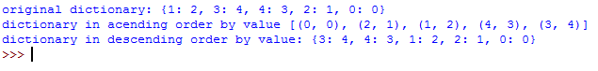

**PROGRAM18**

d1={'a':100,'b':200}

d2={'x':300,'y':200}

print("dictionary1=:",d1)

print("dictionary2=:",d2)

d=d1.copy()

d.update(d2)

print("merged dictionary:",d)

OUTPUT

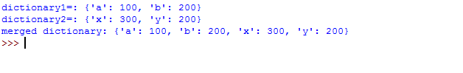

**PROGRAM19**

x=int(input("enter 1st no"))

y=int(input("enter 2nd no"))

i=1

while(i<=x and i<=y):

if(x%i==0 and y%i==0):

gcd=i

i=i+1

print("gcd:",gcd)

OUTPUT

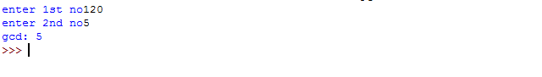

**PROGRAM20**

num=[7,8,120,25,44,20,27]

print("original list:",num)

num=[x for x in num if x%2!=0]

print("list after remooving even nos",num)

OUTPUT

