Speech

How is speech produced in a human body?

🗣️ Human Speech Production
Human speech is a highly sophisticated process involving three main mechanisms:
1. Respiration (Power Source): Air is expelled from the lungs (the power source) up the trachea.
2. Phonation (Sound Source): The air passes through the larynx (voice box), which contains the vocal folds (often called vocal cords). When you want to make a voiced sound, muscles bring the vocal folds close together. The air pressure from the lungs forces them apart, and their elastic recoil brings them back, causing them to vibrate rapidly (the voice source). This vibration creates the fundamental sound (voice).
3. Articulation (Filter/Shaper): This sound is then shaped and modified by the articulators in the vocal tract, which includes the pharynx, oral cavity, and nasal cavity. Coordinated movements of the tongue, lips, teeth, and soft palate (velum) shape the sound into recognizable vowels and consonants, which form words and speech.

🔊 Sound Production in Other Creatures
Animals have evolved diverse and often specialized mechanisms for producing sound:

• Vocal Sounds (Vertebrates):
• Mammals: Most mammals, like humans, use a larynx with vocal folds to produce sound by modulating airflow from the lungs. However, some marine mammals like dolphins use phonic lips in their nasal cavities, and whales pass air between large internal cavities.
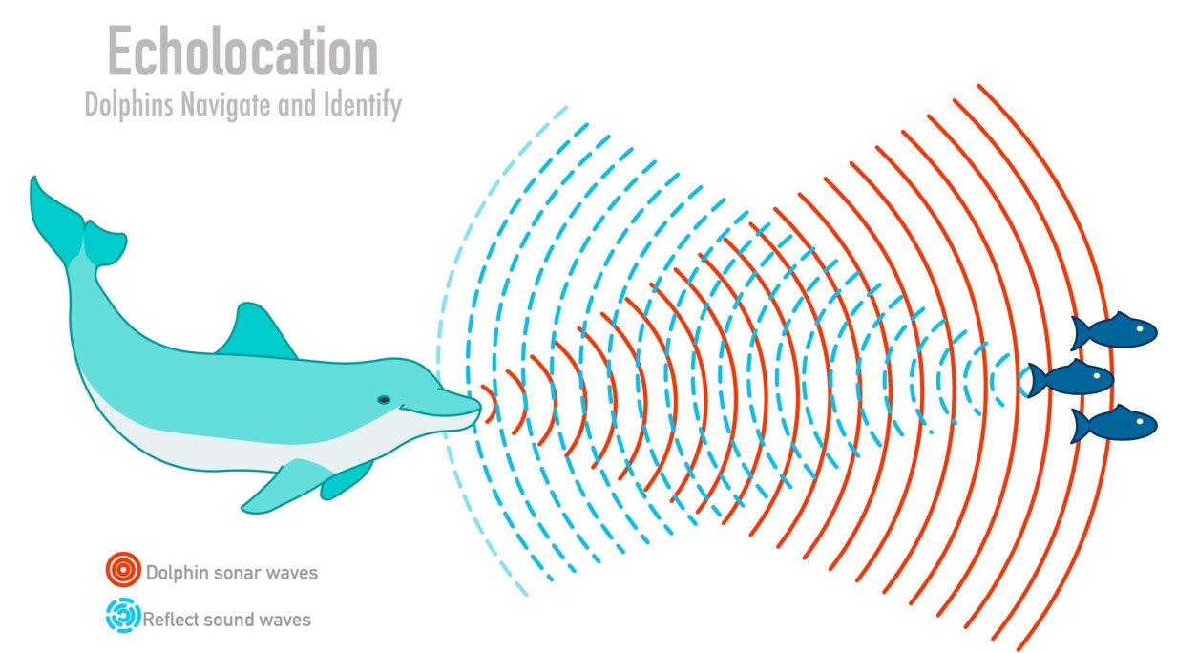
• Birds: Birds use a specialized organ called the syrinx, located at the junction of the trachea and bronchi. Some birds have two syrinxes, allowing them to produce two different sounds simultaneously, which contributes to their complex songs.
• Frogs: Frogs use vocal cords in their windpipe and often have resonating sacs (vocal sacs) to amplify their species-specific calls.
• Fish: Many fish produce sounds by vibrating their swim bladder using specialized "sonic muscles" (called drumming), or by rubbing bones or teeth together (stridulation).

Mechanical Sounds (Invertebrates and Vertebrates):
• Insects: Many insects use stridulation, rubbing together rasplike structures (e.g., on their wings or legs, as with crickets and grasshoppers). Cicadas use specialized membranous organs called timbal organs at the base of their abdomen to produce exceptionally loud sounds.
• Reptiles: Snakes and some other reptiles produce sounds, typically hissing, by expelling air. The rattlesnake uses a modified tail tip (rattle) to create mechanical sound.

Sound Reception and Perception
Sound reception in humans and many other vertebrates involves the ear, which funnels sound waves to an internal membrane (tympanic membrane/eardrum), whose vibrations are amplified by small bones and finally reach the cochlea in the inner ear. The cochlea contains hair cells that detect the frequency (pitch) of the vibrations and send the signals to the brain for processing (perception).

Differences in reception and perception among creatures include:
• Hearing Range: Different animals are sensitive to different frequencies. Humans typically hear between 20 Hz and 20,000 Hz.
• Dogs can hear much higher frequencies (up to 44,000 Hz), which is why they respond to high-pitched dog whistles.
• Elephants can hear very low-frequency sounds (infrasound, below 20 Hz), allowing them to communicate over long distances, sometimes sensing the vibrations through their legs.
• Aural Structures: While many mammals share a similar inner ear structure, other animals have unique arrangements:
• Dolphins lack outer ears but use specialized structures in their jawbone to transmit sound vibrations to the inner ear, allowing them to perceive underwater sounds.
• Invertebrates have various mechanoreceptors that function as ears, which may not structurally resemble the vertebrate ear.
• Perceptual Abilities: Humans have relative pitch, meaning we perceive the interval between notes, whereas some birds have absolute pitch, meaning they hear exact frequencies. Animals also use their sound perception for purposes other than communication, such as echolocation (bats, dolphins) for navigation and hunting.
You may find this video interesting, as it explains the physics of how the vocal folds create sound: Larynx and Vocal Folds: How Speech and Voice are Produced.
https://www.youtube.com/watch%3Fv%3Ds5R8v08y2gY
The production and perception of sound, especially complex communication like human speech, involves a fascinating convergence of anatomy and neuroscience.

Detailed Human Speech Production
Human speech production is a three-stage, precisely coordinated motor activity that transforms thought into audible sound waves.

1. Respiration (The Power Source)
Speech begins with a controlled exhale. The lungs provide the pulmonic egressive airstream (air flowing outwards from the lungs). Unlike normal breathing, speech requires a longer, more sustained exhalation controlled by the muscles of the chest, abdomen, and diaphragm to maintain steady air pressure below the vocal folds.

2. Phonation (The Sound Source)
The air travels up the trachea (windpipe) to the larynx (voice box).
• Vocal Folds: The larynx houses the vocal folds (vocal cords). For voiced sounds (like all vowels, /b/, /d/, /g/, /z/), specific muscles bring the folds together, closing the space between them called the glottis.
• The Bernoulli Effect: The air pressure from the lungs builds up below the folds. Once the pressure overcomes the muscular resistance, it forces the folds apart, releasing a puff of air. The rapid velocity of the air rushing through the narrow glottis then creates a drop in pressure (the Bernoulli effect), which, along with the natural elasticity of the tissue, sucks the folds back together.
• Vibration: This cycle of opening and closing repeats rapidly, creating the fundamental tone or voice. The frequency of this vibration is the fundamental frequency (F0), which the listener perceives as pitch. Adjusting the tension and length of the vocal folds changes the F0.

3. Articulation and Resonance (The Filter/Shaper)
The "buzzy" sound created by the vocal folds is then amplified and shaped by the vocal tract, which acts as a complex filter or resonator.
• Resonating Cavities: The vocal tract consists of the pharynx (throat), oral cavity (mouth), and nasal cavity (nose). The size and shape of these cavities modify the acoustic energy. Specific resonances (amplified frequencies) are called formants. The relationship between the first three formants (F1,F2,F3) determines the perceived vowel quality.
• Articulators: The sound is shaped into distinct phonemes (speech sounds) by the movable articulators:
• Tongue: The primary articulator, moving vertically (high/low) and horizontally (front/back) to form vowels and creating constrictions for most consonants.
• Lips: Used to round the mouth for vowels (e.g., /u/ as in boot) and form consonants (e.g., /p/, /b/).
• Soft Palate (Velum): This muscular flap controls the opening to the nasal cavity. When raised, it seals off the nasal cavity for oral sounds. When lowered, air flows into the nasal cavity for nasal sounds (e.g., /m/, /n/).
• The Brain's Role: All of this is executed by the brain, with Broca's area classically associated with speech production and Wernicke's area with comprehension. The cerebellum ensures the fine, smooth, and rhythmic sequencing of articulatory movements.
________________________________________

🔊 Sound Production in Other Creatures
Animal sound production is highly varied, often utilizing organs homologous to the human larynx but with significant functional differences, or employing entirely different, non-vocal mechanisms.
Creature Group Sound-Producing Mechanism Key Characteristics
Birds Syrinx: Located at the junction of the trachea and bronchi: Some species have two independent sides, allowing for two-voice phenomena (producing two different notes simultaneously), which contributes to complex birdsong.
Marine Mammals (Dolphins, Toothed Whales) Phonic Lips (Dorsal Bursae): Sound is produced by passing air through structures called phonic lips in the nasal passages, not the larynx. This allows for clicks used in echolocation and whistles for communication without losing precious air.
Baleen Whales (Humpback, Blue) Larynx (Modified) While they have a larynx, it lacks vocal cords. They likely use specialized laryngeal structures and a large air sac to recirculate air and create low-frequency sounds (infrasound), which travel thousands of kilometers underwater.
Insects (Crickets, Grasshoppers) Stridulation Rubbing two specialized body parts together, like a file and a scraper (e.g., on legs or wings), to create a rapid series of clicks that form a chirp or call.
Insects (Cicadas) Timbal Organ Specialized ribbed membranes on the abdomen are rapidly buckled inwards and outwards by muscle action, creating one of the loudest sounds in the insect world.
Fish Swim Bladder/Stridulation Drumming sounds are made by vibrating the swim bladder using special "sonic muscles." Stridulation involves grinding teeth or bones together (e.g., pharyngeal teeth).

Sound Reception and Perception
All terrestrial vertebrates, including humans, share the basic design of the ear (outer, middle, inner), where sound waves are physically converted into neurological signals. However, the range of hearing and the way sound is processed for survival and communication differ significantly.
Human Reception and Perception
• Mechanism: Sound waves are collected by the pinna (outer ear), travel down the ear canal to vibrate the tympanic membrane (eardrum). Three tiny bones in the middle ear amplify this vibration and transmit it to the fluid-filled cochlea in the inner ear. Hair cells along the basilar membrane within the cochlea move in response to specific frequencies, sending electrical signals via the auditory nerve to the brain.
• Frequency Range: Typically 20 Hz to 20,000 Hz.
• Perception: Humans have highly refined systems for perceiving pitch, loudness, and the complex acoustic patterns that constitute language. We are particularly sensitive to the frequencies important for speech (around 2,000 Hz to 5,000 Hz).

Non-Human Creature Reception and Perception
Animals have adapted their auditory systems for their specific ecological niches, leading to wider frequency ranges and specialized processing:
Feature | Creature Example | Comparison to Humans | Specialized Perception Role
Ultrasonic Hearing | Bats, Dolphins, Moths, Cats/Dogs | Bats hear up to ∼120,000 Hz (120 kHz); Cats up to ∼60 kHz. Humans hear up to 20 kHz. | Echolocation (Bats, Dolphins) for navigation and hunting; Predator/Prey detection (Cats/Dogs).
Infrasonic Hearing | Elephants, Baleen Whales | Elephants hear below 20 Hz (infrasound). | Long-distance communication that travels through air and ground for kilometers; detecting severe weather.
Ear Structure | Insects (e.g., Katydids) | Their "ears" (tympanal organs) are often located on the legs (forelegs). | Highly directional hearing to locate mates or prey amidst environmental noise.
Directional Hearing | Dogs, Owls | Dogs and cats have highly mobile pinnae (ears) that can swivel 180 degrees. Owls have asymmetrically placed ear openings. | Sound Localization—pinpointing the source of a sound with extreme accuracy.
Perception of Pitch | Birds | Some birds, unlike most humans, exhibit absolute pitch—recognizing the exact frequency of a note regardless of the context. | Crucial for identifying species and individual calls in crowded acoustic environments.

In summary, while the basic physical principle of converting sound waves to nerve impulses is conserved, the range of frequencies detected and the subsequent neural processing of that information are drastically specialized across the animal kingdom.

Panineeya Shiksha's Speech Production vs. Modern Phonology
The Pāṇinīya Śikṣā (a foundational treatise on Vedic phonetics, one of the six Vedāngas), offers an exceptionally detailed and systematic model of speech production that anticipates many concepts of modern phonetics and phonology, particularly articulatory phonetics.
Its process moves from the conceptual to the physical, a level of detail modern science only began to approach centuries later.

1. The Process of Utterance (Conceptual to Physical)
The Śikṣā describes the speech process in a sequence that starts deep within the mind and soul, showing a comprehensive understanding that speech is more than just anatomy.
Pāṇinīya Śikṣā Concept | Modern Phonology/Neuroscience Concept | Analysis and Overlap
Ātmā Buddhyā Sametyārthān (The Soul/Self, having united with the Intellect, comprehends the idea) | Conceptualization and Linguistic Planning | The initial, abstract stage where the intent and meaning of the utterance are formulated. Modern models recognize this as the Message Level in speech planning.
Mano Yuṅkte Vivakṣayā (The Soul engages the Mind with the desire to speak/vocalize) | Pre-Motor Planning and Activation | The transition from abstract thought to a desire for verbal output. This is the stage where the mind/brain activates the motor systems necessary for articulation.
Manaḥ Kāyāgnim Āhanti (The Mind strikes the Body Fire (energy)) | Metabolic and Respiratory Initiation | This is a psycho-physical link. "Body Fire" or Kāyāgni (vital heat/energy) can be seen as the metabolic energy required to activate the chest and respiratory muscles for phonation.
Sa Prerayati Mārutam (That [energy] impels the Māruta (internal air/breath)) | Airstream Mechanism (Respiration) | The energy acts on the Prāṇa Vāyu (life breath). It corresponds precisely to the action of the diaphragm and respiratory muscles, creating the pulmonic egressive airstream (exhaled air) that is the power source for speech.
Mārutaś Carati Uras Sthale (The air moves upwards, passing through the Chest, Throat, Head, etc.) | Phonation and Articulation | The air moves from the power source (lungs/chest) through the sound source (larynx/throat) and is shaped by the articulators in the oral cavity. This matches the modern Source-Filter Theory.

2. Articulatory Phonetics: The Classification System
The most impressive correspondence between the Śikṣā and modern phonology lies in its system for classifying sounds, which forms the basis for the modern Place and Manner of Articulation system.

Place of Articulation (Uccaˉraṇa Sthaˉna)
The Śikṣā meticulously defines the points of contact in the vocal tract. These match up almost perfectly with modern phonetic categories:
Pāṇinīya Śikṣā Sthāna | Modern Terminology | Example Sanskrit Phonemes
Kaṇṭha (Throat) | Velar/Glottal (Pharynx, Larynx) | a, k, kh, g, gh, h
Tālu (Palate) | Palatal | i, c, ch, j, jh, y, ś
Mūrdhan (Cerebral/Head) | Retroflex | ṭ, ṭh, ḍ, ḍh, r, ṣ (The modern term retroflex perfectly describes the tongue-curling involved).
Danta (Teeth) | Dental | t, th, d, dh, l, s
Oṣṭha (Lips) | Labial | u, p, ph, b, bh, m
Nāsikā (Nose) | Nasal | All nasal sounds (ṅ, ñ, ṇ, n, m)

Manner of Articulation (Prayatna)
The Śikṣā also classifies sounds based on the articulatory effort, or Prayatna, which is equivalent to the modern Manner of Articulation and the concept of Distinctive Features.
• Vowels: Classified by duration as Hrasva (short, 1 mātrā), Dīrgha (long, 2 mātrās), and Pluta (extra-long, 3 mātrās). This is a precise measurement of quantity or vowel length, a crucial phonetic and phonological feature.
• Consonants: Classified by the degree of closure, which aligns with modern manner features:
• Spriṣṭam (Complete Contact): Corresponds to Stops/Plosives (sparśa), where there is complete closure.
• Īṣat-spriṣṭam (Slightly Touched): Corresponds to Approximants/Semi-vowels (y, r, l, v).
• Vivṛtam (Open): Corresponds to Vowels and Fricatives/Sibilants (ś, ṣ, s).
• Mahāprāṇa (More Breath/Air) vs. Alpaprāṇa (Less Breath/Air): This is a direct parallel to the modern phonetic distinction of Aspiration.
Conclusion
The Pāṇinīya Śikṣā is remarkable because it integrates neuro-cognitive processes (Mind, Intellect, Intent) with articulatory anatomy and acoustic features (duration, tone, aspiration). Modern phonology views the field through three lenses: Articulatory (how sound is produced), Acoustic (the sound wave properties), and Auditory (how sound is perceived).
The Śikṣā encompasses the Articulatory system with unparalleled detail and clarity, while its analysis of Sandhi (euphonic combination) anticipates modern Phonological Rules and Prosodic Phonology by systematically describing sound changes at word boundaries due to adjacent sounds.
Its framework demonstrates a scientific precision that places ancient Indian linguistics as a clear precursor to structural linguistics and modern phonetic science.

