Shraddha Saburi Samidha
4547 Nob Hill Dr, Arlington, TN 38002 USA
Shraddha Saburi Samidha is a nonprofit organization started in 2005 by a group of University of Memphis students. We received approval as a non-profit organization under section 501(c)(3) in 2014. Our aim is to provide guidance and support individuals to better understand and lead a happy contented life. We plan to achieve this objective by providing a place for spiritual worship (sadhana), organising classes in ayurveda and yoga, with special emphasis on diet and exercise, intended to provide an environment for extensive spiritual development of the community.

New Project - Nandini Go Seva - Bhu Seva
The Vedas, Ancient Scriptures of the Oriental India, describe the cow as our mother (Go- mata). The scripture Bhagavata Puraana among others Lord Krishna has popularised the importance of Go Seva, especially in the teen age. Why? Because, the benefits from the cow are similar to those of the mothers in the family.
Cow is beneficial to our existence with its support for the community, till the last breath. Traditional Indian Cow gives the milk that nurtures and nourishes us from infancy to old age. When the cow is happy, satisfied, and well taken care of, she produces far more milk than her calf requires. We can use this milk for our dietary needs with its A2 form of beta-casein.
- Foods such as milk, milk products, sugar, rice, wheat, fruits, and vegetables are the foods that best aid health and increase life’s duration and quality.
- The ox plows the fields from which grains, fruits, and vegetables are produced. Therefore the cow and ox together provide human beings with the complete foods to satisfy all our nutritional needs.
Aa Gavo Agman Uta Bhadram Akran -
The Cattle have arrived and benefited the entire community - Mantras of Rigveda & Yajurveda emphatically proclaim to highlight their vitality for sustainable living.) In return for all the service the cow and ox provide, the Vedas prescribe three duties for human beings toward the cow:

• Serving the cow (go-seva)
• Worshiping the cow (go-puja) • Protecting the cow (go-raksha)
View the Diagram depicting the cow as the embodiment of many deities.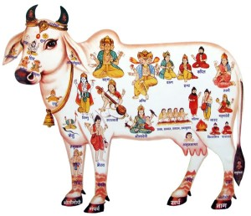 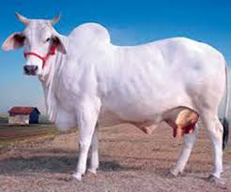
How can we protect cows today?
In the United States alone more than forty million cows will be slaughtered this year to satisfy the demands of meat-eaters. And all over the globe many millions more will be slaughtered for the same reason. Yet this should not discourage us from our goal of cow protection. Even today, when the effects of Kali Yuga (the Age of Ignorance) are so strong, intelligent people can take part in the auspicious act of cow protection in three ways:

1. Never eat cow flesh (never eat meat!) and thereby never support cow killing. Please also tell others about the sinfulness of cow slaughter.
2. Follow the path of Sri Krishna. The cattle need our love, affection, and reverence. Extend the attention as Cow is so dear to Lord Krishna.
3. Help organic farm projects where active cow protection is practiced, by adopting a cow in the Nandini Project of SSS (Shraddha Sahuri Samidha), which provides facility of 100 traditional Indian breeds.

What can you do?
- Popularize Organic Products such as Milk, Yoghurt, Ghee, Pancha Gavya and Farm Produce.
- Support the Organic Farming (Bhu Seva), Nutrition (Anna Danam), Cattle Feeding (Go Poshana), Vedic Rituals (for the Welfare of the Community) and Puja & Meditation (for personal welfare).
- Cow Sponsorship:$6,000 Cow Maintenance per year $1,200
- Your participation, suggestion and support are most welcome.
Contact: Shruti/ Purushottam email: Phone:
Donations are exempt from tax under 501C in USA.

