Forms of Shiva - Ashta Murty & Bhava - Sharva
An article by Dr. Vamshi Krishna Ghanapathi, based on the discourse of
Pujya Sri Ganapathy Sachchidananda Swamiji
at Avadhoota Datta Peetham, Mysore on 23rd February 2017

Om Namasshivaaya. Lord Shiva has many synonyms. Ashta Murty is one among them. Interestingly, the same name finds its place in Lalitaa Sahasra Naama. (Ashtamurtir Ajaa Jaitree). What is the significance of this name?
Ashta = Eight. Murty = Form. An entity which has eight forms is called Ashta Murty. And this compound word is called Bahu Vreehi Samaasa by the grammarians. Interesting part of this linguistic peculiarity called BahuVreehi is that - neither of the words in the compound word is important. In this current case study it implies that
neither Ashta - the number eight
nor Murty - the form are important.

Then what is important?
The divinity entity, who has all the eight forms is far more important. This linguistic mechanism teaches us more.
- The number is unimportant, as the Divinity can increase or decrease the manifestations to suit the creation cycles.
- The manifestations will become redundant in the end of the Kalpa, when delusion decimates the entire Universe. At that stage, no Murty is apparently available, execept for the Amurty (Formless).

Lord Shiva is traditionally associated with destruction. He is called as the Laya Kaaraka, causal force for delusion. Whereas, Brahma is described as the creator. (Vishnu happens to the charge-de-affairs for the sustenance of the creation.) At large, this dispensation seems to be palatable with many Puraana Stories.
However, the philosophical pursuit will not stop us from questioning this limitations of roles. If we need any basis for this pursuit, which negates the limitation of roles, such as:
  - Shiva destructs,
  - Vishnu Protects and
  - Brahma creates or resurrects
Vedic verses provide ample fodder for such thought churning.

As any Governance requires all the three branches for its effective functioning, the factor of GOD provides for all the three. G= Generation, O= Operation, D=Destruction.
In the modern society, the three branches include
- Legislation = Rule making
- Executive = Implementation of the Rules
- Judiciary = Dispute redressal
The list can expand or shring, by dissecting the functions into multifold departments or by clubbing the functions into one. Hence, the number of functions is only relative to the perspective, but not absolute.
Bhava - Sharva
In the verses of Athava Veda - Shounaka Samhitaa 11th Canto (Kaanda), we have an interesting reference of a Duo - Bhava & Sharva. Here, the concept of Unity in diversity is amply narrated.
भवारुद्रौ सयुजा सँविदाना वुभा- वुग्रौ चरतो वीर्याय। ताभ्यान्नमो यतमस्या न्दिशी3(इ)तः।। 14।।
 नमस्तेस्त्वायते नमो अस्तु परायते। नमस्ते रुद्र तिष्ठत आसीनायोत ते नमः।। 15।।
Here, the commentary of Vidyaaranya is illuminating.
Sharvam Pashupatim Chogram Rudram BhavamathEshwaram. Mahaadevam Cha Bheemam Cha.
While the Puraanas list the eight facets or forms of Shiva, why do you shrink the list to mere two? This question is effectively answered, when you look at the prism of existence.
1) Existent and 2) Non- Existent.
- The force of the God, responsible for the existence is Bhava. (Bhaavayati)
- Other force of withdrawal, responsible for Non- Existence is Sharva (Shrunaati).
To explain the concept better, the next hymn cited above addresses the divinity in singular number, while continuing the praise in dual number in the advent of other hymns of the same paragraph (sukta).
He is the same God, who appears or disappears. He is the same one who maintains his typical position, wherever he intends and the same one who maintains eternity at all times.
Example
Just take the example of Sri Swamiji, who operates this huge Ashrama with a number of departments and hundreds of persons. When we look at each department: each department and personnel seem to be indispensible. But, let us remember that they all are functional due to the pleasure of the Master. Once the pleasure is withdrawn, the functions and the personnel will become redundant. Though the pleasure might appear is whimsical at first sight, it is not difficult to fathom that is very responsible, after scrutiny.
On the macro scale of Cosmos, (in the case of God), it is even more gigantic responsibility, as the Future of the Universe is at stake.
Hence, we can safely conclude that the number of functions is related to the state of requirements. In Yajurveda, the list is given as under:
1) Bhava 2) Sharva 3) Eeshaana 4) Pashu Pati 5) Rudra 6) Ugra 7) Bheema 8) Mahadeva
In the Puraana Reference cited above the list slightly varies in its appearance
1) Sharva 2) Pashupatim 3) Ugra 4) Rudra 5) Bhava 6) Eshwara 7) Mahaadeva 8) Bheema
In reality, a novice grammarian can notice that the words convey the same meaning and the difference is not even superficial. Order is also not important, as the Puraana Shloka is set to a metre (Chhandas), which requires the order to alter.

From a philosophical perspective, Dakshina Murty Stotra narrates the forms of Shiva, as Eight.
भूरम्भांस्यनलोनिलोम्बरमहर्नाथो हिमांशुः पुमान् - इत्याभाति चराचरात्मकमिदं यस्यैव मूर्त्यष्टकम्।
नान्यत्किञ्चन विद्यते विमृशतां यस्मात्परस्माद्विभोः - तस्मै श्रीगुरुमूर्तये नम इदं श्रीदक्षिणामूर्तये।।
Five Elements (Earth, Water, Energy/ Fire, Air and Ether) along with their manifestations 6) Sun 7) Moon and 8) Humans/ Creatures. Here, the essence is = Whatever is seen by the human eye is the manifestation of the God.
In this scrutiny of the Ashta Murty, it is inevitable to conclude that the God, as we fondly call as Shiva (the benefactor) employs his forces and factors as deemed necessary for the being, well-being of the universe. Here force means Shakti. He can multiply the forms of that force or prune the number, at his discretion.
- In the terminology of Energy, Content and Container cannot be viewed separately.
- Ultimately, the Shakti is an inseparable part of the God. That is also the essence of understanding the phenomenon of Girija - Shankara Kalyanam (Celestial Marriage Ceremony) conducted on the occasion of Maha Shivaratri.
- If the God, manifests his energy as Being - He is Bhava.
- If the God, amalgamates his energy with Self - He is Sharva.

Our Obeisance to both the forms of Bhava and Sharva.
BhavaaRudrou Mrudayatam - Atharva Mrudayatam.
(We pray to the duo for our well-being).
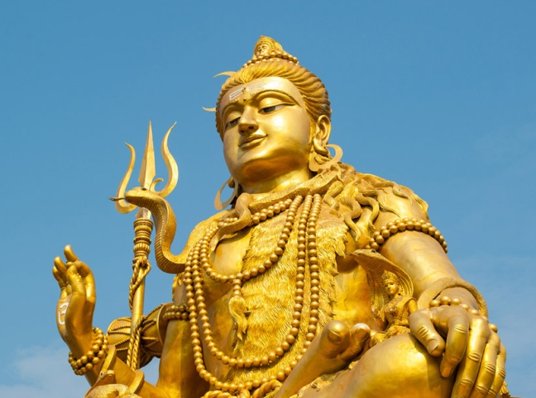
Om Namasshivaaya.

