Ksheerabdhi Dwaadashi
Ksheerabdhi Dwaadashi or Manthana Dwadashi is an important event. It is said that Deva Ganas had offered Goddess Lakshmi, who emerged from Ksheera Sagara (Milky Way) after deep churning to Sri Maha Vishnu. (On a day earlier, Vishnu had woken up from Yoga Nidra on Utthaana Ekaadashi or Prabodhini Ekadashi, to resume the protective duties.)
Since Goddess Lakshmi has emerged from Ksheerabdhi (Milky Way) on this day to join Maha Vishnu as the consort, this day is called as Ksheerabdhi Dwaadashi.
Today, Tulasi Puja and Kartika Damodara Puja is also performed. According to the story of Bhavishya Puraana, (Krishna and Narada conversation) the Puja procedures are well laid out. Lakshmi is worshipped as Tulasi Plant (Basil or Holy Basil/Scientific Ocimum tenuiflorum ) and Narayana is worshipped as Amalaka (Dhaatree) Vruksha (Indian Goose Berry or Phyllanthus emblica). It is also stipulated that three balls of fine ground powder (Semolina Flour) should be offered on this occasion. First one is placed near Tulasi Plant, Second one to a Purohita (Priest Expert) and the third ball should be placed in Ulukhala (Mortar and Pestles of Sugar Cane) and pounded by mixing condensed milk by Young Family Ladies, to be consumed by the worshippers.
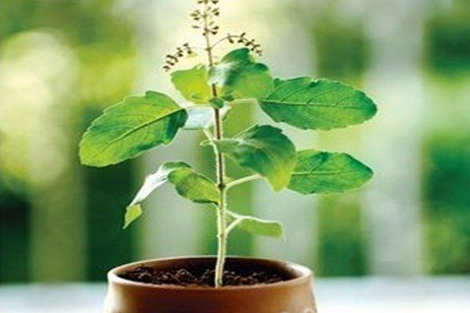 |  | 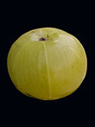 | 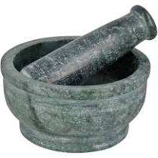
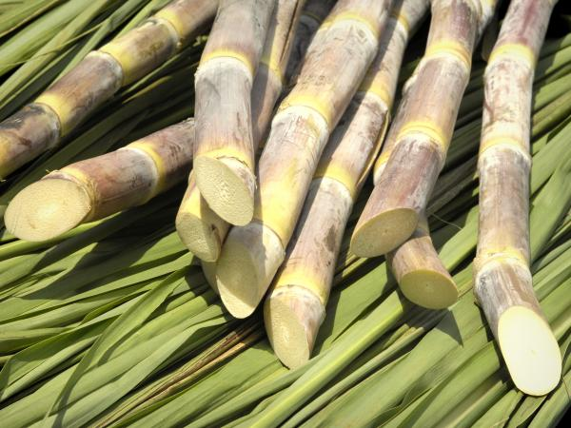 | 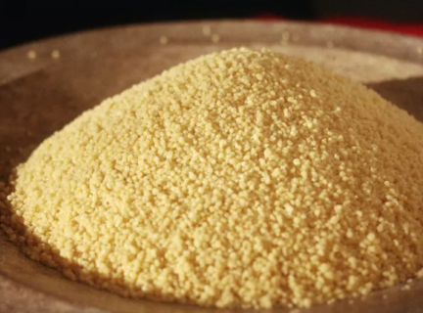 |  | 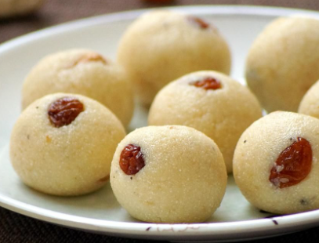

Legends and Stories apart, what does the combination suggest? Amalaka and Tulasi provide the best protection to the body in the winter. And the condensed milk with natural sweetener will give nourishment to us, apart from the spiritual benefits. Get ready for the Puja and Prasadam of course.
-------
You can find the Puja Procedures along with the source Texts here.
https://vachas.in/manage-vacha/?vacha_pk=97&lang=En
----
Story and Puja Procedure in Telugu
https://vachas.in/manage-vacha/?vacha_pk=96&lang=En

