Shraddha Saburi Samidha
4547 Nob Hill Dr, Arlington, TN 38002

Shraddha Saburi Samidha is a nonprofit organization started in 2005 by a group of University of Memphis students. We received approval as a non-profit organization under section 501(c)(3) in 2014. Our aim is to provide guidance and support individuals to better understand and lead a happy contented life. We plan to achieve this objective by providing a place for spiritual worship(sadhana), organising classes in ayurveda and yoga, with special emphasis on diet and exercise. These spiritual workshops are intended to provide an environment for extensive spiritual development of the community. We are religious non-profitable organization under section 501C3, with Tax ID: 47-2455521.

New Project - Nandini Go Seva - Bhu Seva
The Vedas, Ancient Scriptures of the Oriental India, describe the cow as our mother (Go- mata). The scripture Bhagavata Puraana among others Lord Krishna has popularised the importance of Go Seva, especially in the teen age.
Why? Because, the benefits from the cow are similar to those of the mothers in the family.
Cow is beneficial to our existence with its support for the community, till the last breath. Cow gives the milk that nurtures and nourishes us from infancy to old age. When the cow is happy, satisfied, and well taken care of, she produces far more milk than her calf requires. We can use this milk for our dietary needs.
- Foods such as milk, milk products, sugar, rice, wheat, fruits, and vegetables are the foods that best aid health and increase life’s duration and quality.
- The ox plows the fields from which grains, fruits, and vegetables are produced. Therefore the cow and ox together provide human beings with the complete foods to satisfy all our nutritional needs.
Aa Gavo Agman Uta Bhadram Akran
(The Cattle have arrived and benefited the entire community - Mantras of Rigveda & Yajurveda emphatically proclaim to highlight their vitality for sustainable living.)
In return for all the service the cow and ox provide, the Vedas prescribe three duties for human beings toward the cow:
1. Serving the cow (go-seva)
2. Worshiping the cow (go-puja)
3. Protecting the cow (go-rakshya)
Serving the cow: We should serve the cow with the same attitude that the Supreme Personality of Godhead, Lord Sri Krishna, serves the cows in Vrindavana. The Srimad- Bhagavatam describes in detail how Lord Krishna takes the cows and calves every morning to graze on the pastures of Govardhana Hill. There are hundreds of thoUSA nds of cows at the palace of Nanda Maharaja (Lord Krishna’s father), and each cow has her own name. Whenever Lord Krishna plays His flute and calls the cows by name, the cows, intelligent and affectionate, come running toward Him.
The Vedic literature enjoins us to satisfy the needs of the cows daily (with food, shelter, and so on) before we satisfy our own needs. This is how Aryans—civilized persons—should serve the cows.
Worshiping the cows: The Vedic scripture states that all the demigods and demigoddesses reside in the body of a cow. This explains why the body of a cow is divine and holy. If we worship Mother Cow, we attain the same material benefits we’d get by worshiping the demigods and demi-goddesses individually. The Garuda Purana says that anyone who has even once worshiped Mother Cow will be saved after death from the great suffering of hell (Naraka). Lord Krishna started the tradition of worshipping Mother Cow at least once a year on Govardhana Puja day.
Protecting the cows: If we accept the cow as our mother, she deserves our veneration and love. And we should protect her from all dangers. In Vedic times it was the duty of everyone, especially kings, to protect the cows at all cost.
In the Vedic literature we find the revealing story of Emperor Dilip (an ancestor of Lord Rama in the Sun Dynasty) and his commitment to cow protection. For the protection of the cow, Emperor Dilipa even offered his life to a Lion, so that the cow could live. With his commitment towards the sacred duty, the lion and cow transformed themselves into a divine man and woman. The lion was Dharma, righteousness personified, and the cow was Mother Earth personified. They had been testing the emperor’s commitment to cow protection.

A diagram depicting the cow as the embodiment of many deities.
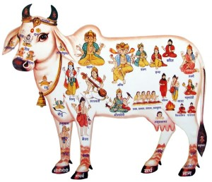
How can we protect cows today?
In the United States alone more than forty million cows will be slaughtered this year to satisfy the demands of meat-eaters. And all over the globe many millions more will be slaughtered for the same reason. Yet this should not discourage us from our goal of cow protection. Even today, when the effects of Kali Yuga (the Age of Ignorance) are so strong, intelligent people can take part in the auspicious act of cow protection in two ways:
1. Never eat cow flesh (never eat meat!) and thereby never support cow killing. Please also tell others about the sinfulness of cow slaughter.
2. The three basic duties of human beings toward the cow—service, worship, and protection—should and can be practiced today. The cattle need our love, affection, and reverence because, after all, she is our mother and she is so dear to the Supreme Personality of Godhead, Lord Krishna.
Help organic farm projects where active cow protection is practiced, by adopting a cow.
- Nandini Projects of SSS (Shraddha Sahuri Samidha), provides facility of 100 traditional Indian breeds.
- Gita Nagari farm in Port Royal, Pennsylvania, provides the upkeep of about 150 cows.

Before concluding his incarnation, Krishna spoke to Uddhava about cow. "Whatever things I could do, whatever demons I could kill, was just because I served cows and I got this power by simply worshiping and serving a cow. He attributed credit of his deeds to cows."
His love for cows is also seen from his most popular two names “Gopaala- the protector of the cows and Govinda “one who rears and develops the cows and Oxen”. In the 11th (11.11.43) Canto of Bhagvata Puraana, Krishna stated that offering cow grass and other suitable grains is equivalent to his worship.
Bhagawad Geeta tells us about the importance of "Sattva guna”, which brings us peace and happiness. Drinking cow milk blesses us with Divine consciousness and Divine energy and fills our body with transcendental qualities (Sattvikata).
According to Skanda Purana, “One can demolish all his sinful acts by simply offering services to the cows”.
As an animal, cow is very lovable, simple and gentle, what we can do to serve her is we can buy grain for her, feed her every time we get an opportunity and we can donate the cow to an institution where they are treated with utmost care.

Cow and Organic Farming & Food Security
From time immemorial, India has been an agrarian country with cow as the backbone. When fertilizers and tractors were unknown, cow was the only source sustaining the entire agriculture. Agriculture would not have been possible without cows.
Food security is most important for every country. Every country must reduce its dependence on external sources for its basic need- food. An important part of food security is that all the inputs should be locally available and cheap. A cow ensures this.
Bull power ensures ploughing and transportation. Absolutely no dependence on any external source. Consider a scenario where due to a natural calamity or international strife, oil cannot be imported for one month. There will be absolute chaos in all spheres. While we can survive the impact on other sectors, can we afford a failure in agriculture? We cannot afford to miss an agricultural season. The entire agricultural operations will come to a standstill and the food prices will soar leading to civil strife.
During the last several decades, especially the advent of green revolution, the use of chemical fertilizers, pesticides and tractors have dealt a severe blow to the importance of cows in agriculture. While productivity levels improved in the short term with their use, their long term negative impact on health and environment has totally been ignored.
In fact most of the diseases of today are being traced to the food we consume and fertilizers and pesticides are the major culprits. The cost of production has also gone up substantially due to the increase in the cost of farm inputs leading to higher food prices. The indiscriminate use of pesticides has also broken the food chain and hence contributed to most of the current problems faced in agriculture today.
Research has also proved that these high productivity levels cannot be sustained over a long term as the soil quality deteriorates due to rampant use of fertilizers and pesticides. Once the fossil fuels ( petrol and diesel ) get exhausted or become very expensive, most of the mechanized farm equipment will not be of any use .
In short, these modern farming techniques have only contributed to
a. Increased vulnerability and dependence on external sources
b. degradation of environment and soil quality
c. increase in diseases and
d. increase in profits of fertilizer and pesticide companies.
e. Billions of Dollars are spent as fertilizer subsidy bill.
In contrast, cow is the base of economic sustainable agriculture with only positive impact on environment. With only a pair of bulls and a cow, using natural farming techniques, upto ten acres of land can be cultivated for healthy organic produce. Using Dung and Urine of the traditional breeds, (Gomaya and Gomutra), organic pest repellants can be prepared.
These techniques have been perfected and have been in vogue for several centuries. The cost of inputs is very low leading to lower food prices. For some, going back to traditional farming methods may appear to be a retrograde step and impractical. Consider the following:
• Fossil fuels are definitely running out. Definitely they will get expensive. Even today, if diesel or the tractor or the harvester is not available, work stops. There is no fall back option. A lot of small farmers are losing money because of delays in getting the equipments.
• Tractors do not give cow dung and urine- major agri inputs. Emissions from the machines harm the ecology and impact the plants too, which we consume.
• Organic farming enriches the soil.
• Organic farming produces healthy and wholesome food.
• Organic farming is as productive, if not more, as the chemicals based farming.
• Organic farming reduces the input cost.
• Organic farming reduces diseases and medical costs.
• Organic farming improves quality of life.
• Traditional farming using the cow is the only option for small and marginal farmers who constitute a majority of the farmers in India.
• Organic farming will improve the economic well being of the farmers and stop farmer suicides.
• Once the development in sectors like roads and other infrastructure projects (which use most of the unskilled farm labour) slow down, the farm labour will not have any other source of employment. In the mean time they will also lose their farming skills and knowledge.

Tradition and History
India has been a land of surpluses in food grains and cow based agriculture has never failed us. It is time that we realize the contribution of cows and go back to our time tested traditional farming techniques for a sustainable future. Traditional cow based organic farming is the solution for the future. However difficult it may appear, we must pursue this for the sake of our good future and food security. It is better we act now before we are forced to act.
It is important that we save the Indian cow for the sake of good health, food and energy security. The by-products of cows have been used as alternate fuel in our villages and towns for many generations.

Pancha Gavya (Cow and Medicines)
Panchagavya means five sustainable products a cow yields: namely curd, milk, ghee, Urine and Dung. Pancha Gavya is used in all many religious rituals. These are prescribed to purify the body and mind, which in-turn helps us to tread a path of righteousness. The scientific value of this has been well established.
Pancha Gavya from Indian breed cows, with its have medicinal and curative properties has been the basis for Panchagavya system of Ayurvedic medicines. Though the importance of to Allopathy in health care has limited use of Panchagavya as medicine, there has been a revival of interest in this system as allopathic medicines have many several and severe side effects. Whereas Panchagavya medicines are said to be highly effective and have no side effects.
Cow based medicines are available for several of current day diseases including cancer treatment. Some of these have received patents in USA .
- USA Patent No 7297659 (20/Nov/2007) Plant Growth Promoting Bio Control Composition
- USA Patent No 610659 (25/June/2002) Enhancing Antimicrobial Effect Of Antibiotics
- USA Patent No 20040198769 (07/Oct/2007) Protecting/Repairing DNA from Oxidative Damages
- USA Patent No 6896907 (24/May/2005) Cow Urine Distillate as a Bio Enhancer Of Anti- Infective, Anti- Cancer Agents And Nutrients
Panchagavyam is prescribed to cleanse the body system from all many faults.
Yat twak- asthi gatam Paapam Dehee tishthati maamake.
Praashanaat Panchagavyasya Dahatyagniriva Indhanam ..
Other medicines -Several other medicines and cosmetics based on cow products are also available. Some of them are Ghee based medicines - Go Gritham- for curing epilepsy, dementia, Schizophrenia, cancer, leprosy, migraine etc
Gomutra based medicines - Sarvaroga nivarani- Cure for many types of diseases- cancer, blood pressure, diabetes, mouth ulcer, asthma etc. (Details are available in the book- Panchagavya Ayurvedic Treatment by Govigyan Anusandhana Kendra- Nagpur.)
It is also essential that more research is carried out in the traditional Panchagavya medicines so that we can all lead healthy lives.

Our Mission
Our mission is to protect, preserve, and improve India's indigenous cattle population, which are called gou, desi Cows and Bulls. Focusing on this mission will not only improve the life of cows, but will also preserve nature by conserving the quality of soil, water, and air, and improve human life by providing higher quality milk and milk products than that of cross-bred exotic (European breed) cows.
Crossbreeding indigenous Indian cows with imported bulls to increase milk production started in the 1960s, which has caused the obliteration of the indigenous Indian cattle, which includes precious breeds developed over a millennium. Our goal is to bring more awareness of the benefit of rearing pure bred indigenous Indian cows in congenial environment.
A farm is set up on the traditions of Veda, near Arlington - Tennesse to benefit the local community, as well as serve as the Proof of Concept.
Protection and preservation of the gou, desi, or Brahman breed is a focus area in this farm. Creating sanctuaries for the rehabilitation of old or barren cattle is also a significant component in the protection of the breed. Such cattle are often abandoned even though they can still provide valuable products for farming and for human use.
These cattle can be rehabilitated in a natural environment through preservation and expansion of pasture land to ensure adequate grazing areas.

Protecting cattle from exploitation by greedy dairy and beef farmers is another component in the protection of the breed.

Educating people and cultivating their compassion will help stop the cycle of abuse against cows.

Preventing cross-breeding is an important component in this project, to maintain purity.

As the shift from being self-sufficient to industrial dairy production begins to dominate, nations will have to import a large percentage of its milk demand and become reliant on importing exotic semen and cattle feed for the exotic crossbreeds reared.
- The procedure of insemination and impregnation practiced in the farms, is also against natural principle of privilege and choices bestowed to every species.
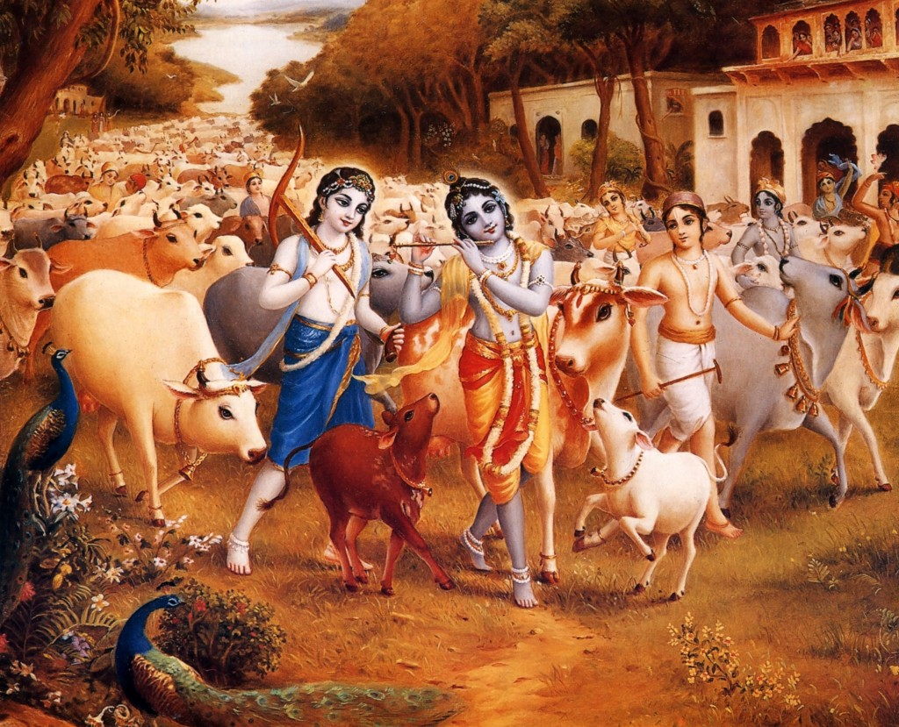

Superiority of the Milk Quality

Throughout the world people are starting to recognize that the A2 protein trait in the milk of India's indigenous cattle is of distinctly superior quality to the A1 protein trait in Western breeds and cross-breeds.

There is an increased worldwide demand for ghee and milk products from A2 cows globally, resulting in an increased demand for Indian Cattle. Sustainable breeding and maintenance practices, as well as increased milk production are a part of improving the breed.

Cow-Based Natural Farming

Adoption of cow-based natural farming is the future of farmers. Through adoption of natural farming methods, farmers can immediately improve their own life style and the community in the longer term.

Our goal is to help develop natural farming as a long-term, sustainable alternative to current farming methods without reducing food production. This will be accomplished by creating a model farm, to demonstrate the efficiency of the natural farming methods as the future. Model farms will make better use of cow dung and cow urine, including:

• Vermi compost and natural compost

• Natural crop protection (cow urine and neem leaves)

• Panchagavya (made from milk, yogurt, ghee, cow urine, and cow dung) for treating various diseases as an alternative medicine as prescribed in Ayurveda.

• Consumable items such as soap, toothpaste, tooth powder, shampoo, mosquito repellant, incense sticks, and more.

• Generating electricity using bio gas made from cow dung.

Model farms are the first step in helping us achieve all aspects of our mission.

How can you join? Start with these Simple Things:

Take a Sankalpa (firm decision) to Worship Gomaathaa and engage in Go Sevaa in whatever way possible.

Speak to others about Gosevaa and spread the awareness .

Become a volunteer Gosevak and encourage others to become one by offering some food to Cow(s) every day.

Offer plantains ( bananas)or even kitchen waste to cows.

Visit a Goshaala at least once a month/ year.

Offer donations to Goshalaas. The amount is not important. The thought is important. Every cent counts.

Use products of Goshalas for religious activities. You will get the full benefit of conducting the religious activity only if you use pure cow products .

At the time of celebrations and functions of the community or family, offer whatever you can for cow protection.

Conduct Go Puja before conducting religious activities like Homa etc.

Avoid leather products.
- Adopt the maintenance of a Cow for a day/ week/ month/ year.
- Donate a Cow to a Go Shaala.

Go Sevaa is a Great blessing. Don’t miss any opportunity to do GoSevaa.

