Pavamaana Mantras - Excellent method of cleansing the mind and body
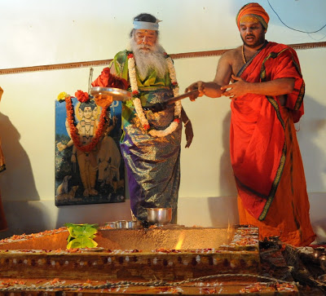
Pavamana Homa
Wealth or poverty does not matter to a man of contentment.
मनसि च परितृप्ते कोर्थवान् को दरिद्रः।
The mankind is ever engaged in countless activities, as it is entangled in the web of successive desires in the infinite ocean of the worldliness, which is difficult to cross. One who is shackled in the astonishing bondage of desire always runs after pleasures. However one who is liberated of desire attains equipoise of intellect and stays still like a lame man.
पावमान्यः पुनन्तु माम्।।
To a worldly man, entangled in the ocean of worldliness, several types of Punya (merit) and Papa (sin), whether known or unknown to him accrue for his various deeds. How so ever much Punya one accumulates, it is certain that one must experience the evil effects of one’s sins. Hence the merciful sages have stipulated some rituals and repentance, in order to uplift humanity. Many of such rituals are difficult to commoner. Hence Sri Ganapati Sachchidananda Swamiji, widely believed as an incarnation of Lord Dattatreya, himself an ocean of mercy, has been conducting Pavamana Homa for the benefit of innumerable devotees.
The famous and auspicious Pavamana Mantras in the ninth Mandala of Rigveda, are 610 in number. The Mantras are well known as Pavamana Pancha Suktas. The following is the summary of the effect of these Mantras.

पावमान्यः पुनन्तु माम्।
“May the Pavamana Mantras relieve me of the grave sins such as
- the fierce sin due to my physical and mental acts, and deeds
- disobedience, negligence, harm committed to parents;
- theft
- killing cow or woman;
- sin accrued during sales or purchases;
- sin caused by several births (even causing or being born as illegitimate child);
- sins due to one’s own unrighteousness such as marital or extra marital connections;
- Eating food that is supposedly not to be eaten,
- receipt of things that are supposedly not to be received;
- eating impure food and food that is not sanctified;
- killing or harma a pious person;
- consuming intoxicants;
- grabbing others’ property or illegal possession;
- infanticide;
- wrongful occupation of others properties;
- adultery or unfaithful to spouse;
- giving up traditional recital of stipulated texts
- discontinuity or non - conduct of rituals and righteous acts, ordained to be done etc.
- May these Mantras purify my body by removing all these sins committed by me during last year with my senses of action (karmendriya), senses of perception (Jnanendriya) and my mind (Manas). May untimely death to me be prevented.”
पठतां शृण्वताञ्चैव ददाति परमां गतिम्।।
Apart from this ” Those who recite these mantras and those who listen to them shall have fine progress spiritually equally.” Thus assert the mantras. Thus it is also obvious that these mantras benefit even the listener.

