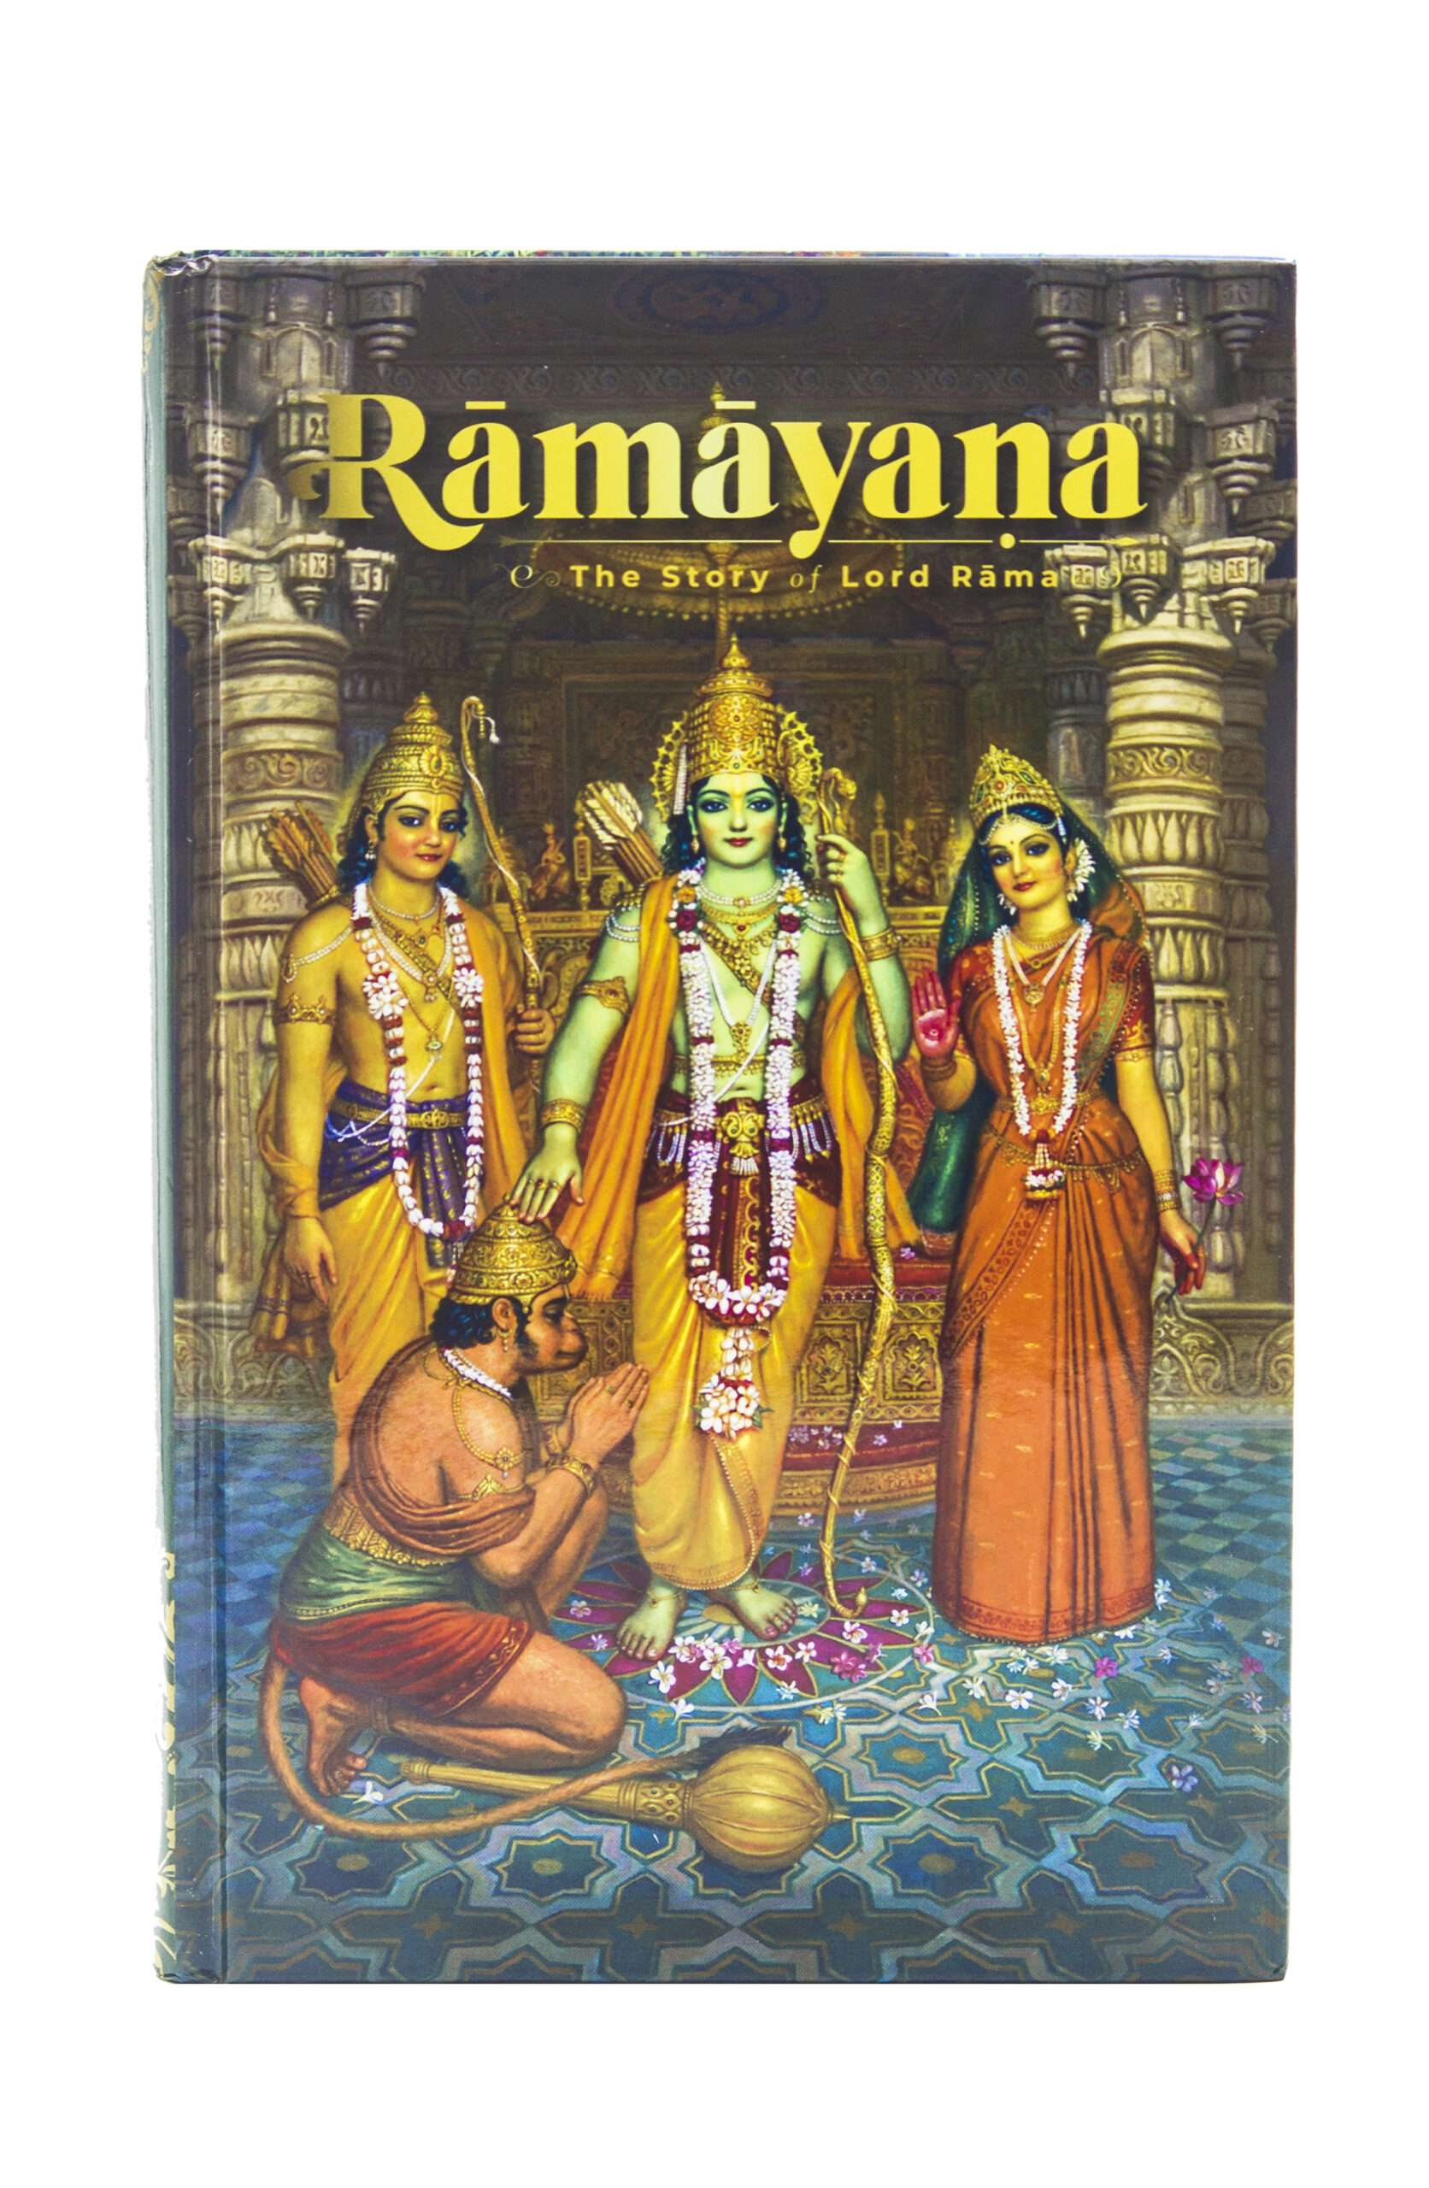
रामायणम्
Sankshepa Ramayanam Series
Foreword
The significance of Sri Ramayana cannot be described in words. The impact of Sri Rama’s character has captivated the Indian psyche. The magnanimity of his virtues, perseverance to adhere to the principles of Dharma in the face of intense adversity; catapults the phenomenon of Sri Rama, into the supreme unique league.
However, Sage Valmeeki has simply enlisted the benefits of Ramayana. This story
- Decimates the sins of listeners/ readers, as it encourages and inspires them to adhere to the path of Dharma
- Sets the polity on the path of virtues and merit.
- In this process, increases their health and life span, to lead life of chastity and virtue coupled with prosperity
- Finally, elevates them to the greatest plane of spirituality.

Thus, Ramayana Paarayana has become an integral part of Indian Society. It has branched out to many forms of humanity, such as an Enactment of Drama, Literature, Songs, Ballet, Simple Prose, Poetry, Analysis and other forms of folk art.
In this electronic age, medium of internet has been crucial to spread the awareness about Ramayana. Hence, Ramayana’s 1st Chapter called Sankshepa (Shatashloki Ramayana) is presented in video form, attracting thousands of viewers across the globe. Its frequent viewership has even helped to lessen the impact of calamities.
This great chapter is now presented in a series of articles in Astrology magazine for the benefit of readers.
Samskruta Bhaasha
As we speak of Ramayana, it would be our inherent duty to mention the classic language deployed by the Poet Sage Vaalmeeki.
What is so great in it?
The work is known as the First and Foremost work in classic Sanskrit Literature. Thus, it retains its pre- eminence in literary pursuit.
Hence, it will be beneficial to start learning Sanskrit and the nuances of usage through Ramayana. The relevance of each word and its deployment are great source of inspiration, for and all. Let us look forward to learn the language and adopt the values espoused thru the medium to acquire umpteen chances of reform in life.

Jaya Guru Datta.
Editor's Note:
As this is a Sanskrit Learning series, Devanagari Text is given for reference, apart from the transliteration and meaning along with bilingual questions and answers.
Episode ... 1
श्री गणेशाय नमः śrī gaṇēśāya namaḥ
श्री सरस्वत्यै नमः śrī sarasvatyai namaḥ
श्रीपादवल्लभ नरसिंह सरस्वती श्रीगुरु दत्तात्रेयाय नमः
śrīpādavallabha narasinha sarasvatī śrīguru dattātrēyāya namaḥ
शुक्लाम्बरधरं विष्णुं शशिवर्णं चतुर्भुजम्।
प्रसन्नवदनं ध्यायेत् सर्वविघ्नोपशान्तये।।
Śuklāmbaradharaṁ Viṣṇuṁ Śaśivarṇaṁ Caturbhujam.
Prasannavadanaṁ Dhyāyēt Sarvavighnōpaśāntayē..
शारदा शारदाम्भोज- वदना वदनाम्बुजे।
सर्वदा सर्वदास्माकं सन्निधिस्सन्निधिं क्रियात्।
Śāradā Śāradāmbhōja Vadanā Vadanāmbujē.
Sarvadā Sarvadāsmākaṁ Sannidhi S'sannidhiṁ Kriyāt.

अखण्ड मण्डलाकारं व्याप्तं येन चराचरम्।
तत्पदं दर्शितं येन तस्मै श्री गुरवे नमः।।
Akhaṇḍa Maṇḍalākāraṁ Vyāptaṁ Yēna Carācaram.
Tatpadaṁ Darśitaṁ Yēna Tasmai Śrī Guravē Namaḥ..
कूजन्तं रामरामेति मधुरं मधुराक्षरम्।
आरुह्य कविताशाखां वन्दे वाल्मीकि कोकिलम्।।
Kūjantaṁ Rāmarāmēti Madhuraṁ Madhurākṣaram.
Āruhya Kavitāśākhāṁ Vandē Vālmīkikōkilam..
अंजनान्दनं वीरं जानकी शोकनाशनम्।
कपीशमक्षहन्तारं वन्दे लंकाभयंकरम्।।
An̄Janāndanaṁ Vīraṁ Jānakī Śōkanāśanam.
Kapīśamakṣahantāraṁ Vandē Laṅkābhayaṅkaram..
वेदवेद्ये परे पुंसि जाते दशरथात्मजे।
वेदः प्राचेतसादीत् साक्षाद्रामायणात्मना।।
Vēdavēdyē Parē Pumsi Jātē Daśarathātmajē.
Vēdaḥ Prācētasādīt Sākṣādrāmāyaṇātmanā..
रामाय रामभद्राय रामचन्द्राय वेधसे।
रघुनाथाय नाथाय सीतायाः पतये नमः।।
Rāmāya Rāmabhadrāya Rāmacandrāya Vēdhasē.
Raghunāthāya Nāthāya Sītāyāḥ Patayē Namaḥ..

अथ रामायण संक्षेपः
Now Brief of Ramayana starts
तप स्स्वाध्याय निरतं तपस्वी वाग्विदां वरम्।
नारदं परिपप्रच्छ वाल्मीकि र्मुनिपुंगवम्।। 1
Tapa S'svādhyāya Nirataṁ Tapasvī Vāgvidāṁ Varam.
Nāradaṁ Paripapraccha Vālmīki Rmunipuṅgavam.. 1

(Meaning - A thoughtful-meditator, an eternally studious sage in scriptures about the Truth and Untruth, a sagacious thinker, and a sublime enunciator among all expert enunciators is Narada, and with such a Divine Sage Narada, the Sage-Poet Valmiki is inquisitively enquiring about a man who is a composite for all merited endowments in his form and calibre.)

Learning basics of Sanskrit
Point#1
Sentences of any language have three important parts.
1. Kartaa - Subject
2. Karma - Object
3. Kriyaa - Verb
Sanskrit learners should start the exercise by identifying the verb first in every sentence. Next, the subject, followed by the object should be found in the same order.
To sum up the theme?
1. What is the act (activity) described? - (Kriyaa/ Verb)
2. Who did/ does it? (Kartaa/ Subject)
3. Who is affected by the act? (Or the object of the action)? (Karma/ Object)
In the first stanza, let us make out the simple sentence.
वाल्मीकिः नारदं परिपप्रच्छ। (Vaalmeeki asked Naarada).

Point#2 Positions of Kartaa, Karma & Kriyaa
Basic difference between two great languages (Sanskrit and English)
Sequence of Kartaa (Subject), Karma (Object) & Kriyaa (Verb)
- Sanskrit Language and its derivative languages, start with the Subject (Kartaa). English also has the same feature.
- However, Sanskrit does have the Verb/ Kriyaa as the last part in every sentence, in the normal course. Whereas in English, the verb follows the subject.
- Object/ Karma is placed after the subject/ Kartaa in Sanskrit. Where English has object in the last part.
Illustration ... 1
वाल्मीकिः नारदं परिपप्रच्छ। (Vaalmeeki asked Naarada).
Moving onto the next set of information, after the basic three parts of the sentence, we need to analyse the subject or object by its qualities/ properties. These are distinguished by a special word. This is called ....

विशेषण Viśēṣaṇa or Adjective
What are the qualities of these basic three?
These qualifiers are called as विशेषण Viśēṣaṇa or Adjective. (We learn more about this in next classes.) Normally, there precede the Kartaa/ Karma.
- Viseshana is to distinguish. Make it distinct from others.
- The word distinguishing the Subject/ Object is called Viśēṣaṇa;
- Where as the distinguished Subject/ Object is called Viśēṣya.
First stanza is complete with many adjectives for both Kartaa and Karma.
Let us arrange the words for easy understanding.
- Kartaa/Subject - तपस्वी (adj) वाल्मीकिः (Subj) Tapasvī, Vālmīki
- Karma/ Object - तप स्स्वाध्याय निरतं (Adj), वाग्विदां वरं (Adj), र्मुनिपुंगवं (Adj), नारदं (Obj) Tapa S'svādhyāya Nirataṁ, Vāgvidāṁ Varam, munipuṅgavam, Nāradaṁ
- Kriyaa/Verb - परिपप्रच्छ।। Paripapraccha .. 1

Point#3

Anvaya Krama Order of words in Prose and Poetry
Arrangement in this manner is called Anvaya Krama. The order of understanding a sentence.
Usually, the order of Kartaa, Karma and Kriyaa remains unaltered in Prose (Gadya/ Vaakya). Whereas, Poetry has its emphasis on metre. Hence, the order gets changed to suit the metre deployed by the poet. Therefore, to understand every stanza Anvaya Krama (Sequential arrangement of words in each stanza) is written separately for clarity, especially in the case of beginners. To suit the context, beauty of letters/ words the adjectives are also often mingled with other words. Hence, each word has to be examined and understood for this arrangement.
Questions:
1. What is Kartaa?
2. What is Karma?
3. What is Kriyaa?
4. What is the order of deploying Kartaa, Karma & Kriyaa in Indian languages?
5. What is the difference between Indian Languages and English?
6. What is Anvaya Krama?
7. What is the position of Adjective?
8. What is the difference of order in Poetry and Prose?
वाल्मीकिः नारदं परिपप्रच्छ। vālmīkiḥ nāradaṁ paripapraccha. (Vaalmeeki asked Naarada).
What was the gist of their discussion?
What were qualifiers to the questioner and replier?
What is the significance?
We analyse this in the next episode.
Subham.

Qualifier to a verb is called Kriya Viseshana.

