Space and Time Theory - Maha Sankalpa of Vedic Traditions
- Dr Vamshi Krishna Ghanapathi, Mysore

Desha Kaala Sankeertana
the Desha (the Space we occupy) and the Kaala (Time of our action/ existence) is an eternal tradition of India. It is sacrosanct and mandatory in our rituals.
- From the simplest ritual to the most elaborate rituals, this announcement makes the core of Sankalpam. Though this Sankalpam, the doer announces his intentions, purpose/ objective, place, time and procedures.)
- Most elaborate of this Sankalpam is called as Maha Sankalpam, which is an inseparable part of Vivaha rituals (Marriage). It is another important fact of significance that the reciter is the father (parents) of the bride, who announces the solemnisation of the marriage, which contributes to the sustenance of mankind on this planet. Thus, the Maha Sankalpam is reserved for the primordial ritual to sustain humanity.
- In this process, the announcement describes in detail the grand scheme of time and space in the creation/ nature. This mere thought would dwarf our stature (whatever we might assume) in comparison with the Gigantic Universe or Multi Verse.
- The word Universe used to be the grand vision for physicists for long. However, the discovery of many galaxies, galactic beings there of opens up the vision to the theme of Multi Verse, which is one of the most prominent pointers of Vedic Literature.
- Indian Traditions backed up by life long observations by dedicated seers, visionaries in the name of sages are enshrined in the scriptures. The traditions, are passed in the generations even though the purport is not fully understood by the masses, who are content with the observance of the tradition/ ritual.
- However, the vision of the visionaries will be fulfilled when the traditionalists embrace the tradition fully understanding the purport and objective of the ritual.
In this connection, let us draw comparison to the Western understanding and lateral findings of the Astro Physicists such as Stephen Hawking, Hermann Minkowski, Hubble among others.
Our present ideas about the motion of bodies date back to Galileo and Newton.
- Before them people believed Aristotle, who said that the natural state of a body was to be at rest and that it moved only if driven by a force or impulse.
- It followed that a heavy body should fall faster than a light one, because it would have a greater pull toward the earth. The Aristotelian tradition also held that one could work out all the laws that govern the universe by pure thought: it was not necessary to check by observation.
- So no one until Galileo bothered to see whether bodies of different weight did in fact fall at different speeds. It is said that Galileo demonstrated that Aristotle’s belief was false by dropping weights from the leaning tower of Pisa.
The story is almost certainly untrue, but Galileo did do something equivalent: he rolled balls of different weights down a smooth slope. The situation is similar to that of heavy bodies falling vertically, but it is easier to observe because the Speeds are smaller.
Galileo’s measurements indicated that each body increased its speed at the same rate, no matter what its weight. For example, if you let go of a ball on a slope that drops by one meter for every ten meters you go along, the ball will be traveling down the slope at a speed of about one meter per second after one second, two meters per second after two seconds, and so on, however heavy the ball. Of course a lead weight would fall faster than a feather, but that is only because a feather is slowed down by air resistance. If one drops two bodies that don’t have much air resistance, such as two different lead weights, they fall at the same rate.
On the moon, where there is no air to slow things down, the astronaut David R. Scott performed the feather and lead weight experiment and found that indeed they did hit the ground at the same time. Galileo’s measurements were used by Newton as the basis of his laws of motion. In Galileo’s experiments, as a body rolled down the slope it was always acted on by the same force (its weight), and the effect was to make it constantly speed up. This showed that the real effect of a force is always to change the speed of a body, rather than just to set it moving, as was previously thought. It also meant that whenever a body is not acted on by any force, it will keep on moving in a straight line at the same speed. This idea was first stated explicitly in Newton’s Principia Mathematica, published in 1687, and is known as Newton’s first law.
What happens to a body when a force does act on it is given by Newton’s second law. This states that the body will accelerate, or change its speed, at a rate that is proportional to the force. (For example, the acceleration is twice as great if the force is twice as great.) The acceleration is also smaller the greater the mass (or quantity of matter) of the body. (The same force acting on a body of twice the mass will produce half the acceleration.) A familiar example is provided by a car: the more powerful the engine, the greater the acceleration, but the heavier the car, the smaller the acceleration for the same engine. In addition to his laws of motion, Newton discovered a law to describe the force of gravity, which states that every body attracts every other body with a force that is proportional to the mass of each body. Thus the force between two bodies would be twice as strong if one of the bodies (say, body A) had its mass doubled. This is what you might expect because one could think of the new body A as being made of two bodies with the original mass.
Each would attract body B with the original force. Thus the total force between A and B would be twice the original force. And if, say, one of the bodies had twice the mass, and the other had three times the mass, then the force would be six times as strong. One can now see why all bodies fall at the same rate: a body of twice the weight will have twice the force of gravity pulling it down, but it will also have twice the mass. According to Newton’s second law, these two effects will exactly cancel each other, so the acceleration will be the same in all cases. Newton’s law of gravity also tells us that the farther apart the bodies, the smaller the force. Newton’s law of gravity says that the gravitational attraction of a star is exactly one quarter that of a similar star at half the distance. This law predicts the orbits of the earth, the moon, and the planets with great accuracy. If the law were that the gravitational attraction of a star went down faster or increased more rapidly with distance, the orbits of the planets would not be elliptical, they would either spiral in to the sun or escape from the sun.
The big difference between the ideas of Aristotle and those of Galileo and Newton is that Aristotle believed in a preferred state of rest, which any body would take up if it were not driven by some force Or impulse. In particular, he thought that the earth was at rest. But it follows from Newton’s laws that there is no unique standard of rest. One could equally well say that body A was at rest and body B was moving at constant speed with respect to body A, or that body B was at rest and body A was moving.
For example, if one sets aside for a moment the rotation of the earth and its orbit round the sun, one could say that the earth was at rest and that a train on it was traveling north at ninety miles per hour or that the train was at rest and the earth was moving south at ninety miles per hour. If one carried out experiments with moving bodies on the train, all Newton’s laws would still hold.
For instance, playing Ping-Pong on the train, one would find that the ball obeyed Newton’s laws just like a ball on a table by the track. So there is no way to tell whether it is the train or the earth that is moving. The lack of an absolute standard of rest meant that one could not determine whether two events that took place at different times occurred in the same position in space.
For example, suppose our Ping-Pong ball on the train bounces straight up and down, hitting the table twice on the same spot one second apart. To someone on the track, the two bounces would seem to take place about forty meters apart, because the train would have traveled that far down the track between the bounces. The nonexistence of absolute rest therefore meant that one could not give an event an absolute position in space, as Aristotle had believed. The positions of events and the distances between them would be different for a person on the train and one on the track, and there would be no reason to prefer one person’s position to the other’s. Newton was very worried by this lack of absolute position, or absolute space, as it was called, because it did not accord with his idea of an absolute God.
In fact, he refused to accept lack of absolute space, even though it was implied by his laws. He was severely criticized for this irrational belief by many people, most notably by Bishop Berkeley, a philosopher who believed that all material objects and space and time are an illusion. When the famous Dr. Johnson was told of Berkeley’s opinion, he cried, “I refute it thus!” and stubbed his toe on a large stone. Both Aristotle and Newton believed in absolute time. That is, they believed that one could unambiguously measure the interval of time between two events, and that this time would be the same whoever measured it, provided they used a good clock. Time was completely separate from and independent of space. This is what most people would take to be the commonsense view.
However, we have had to change our ideas about space and time. Although our apparently commonsense notions work well when dealing with things like apples, or planets that travel comparatively slowly, they don’t work at all for things moving at or near the speed of light. The fact that light travels at a finite, but very high, speed was first discovered in 1676 by the Danish astronomer Ole Christensen Roemer. He observed that the times at which the moons of Jupiter appeared to pass behind Jupiter were not evenly spaced, as one would expect if the moons went round Jupiter at a constant rate. As the earth and Jupiter orbit around the sun, the distance between them varies. Roemer noticed that eclipses of Jupiter’s moons appeared later the farther we were from Jupiter.
He argued that this was because the light from the moons took longer to reach us when we were farther away. His measurements of the variations in the distance of the earth from Jupiter were, however, not very accurate, and so his value for the speed of light was 140,000 miles per second, compared to the modern value of 186,000 miles per second. Nevertheless, Roemer’s achievement, in not only proving that light travels at a finite speed, but also in measuring that speed, was remarkable – coming as it did eleven years before Newton’s publication of Principia Mathematica.

Maha Sankalpa - Time Space Units
The arguments and discoveries continue as the human intellect searches for answers to complex thoughts/ riddles, which appear on the visionary's horizon. However, the Time Space theory is envisioned in the Maha Sankalpam which is the part of Vedic Traditions since time immemorial.
Heavier Objects move slowly and lighter objects move fast. This is the common comprehension of every observer. According to the modern physicists, Our Solar System is placed in a spot called Orion Spur or Orion Arm. These are the pictures captured by Tele Scopes.
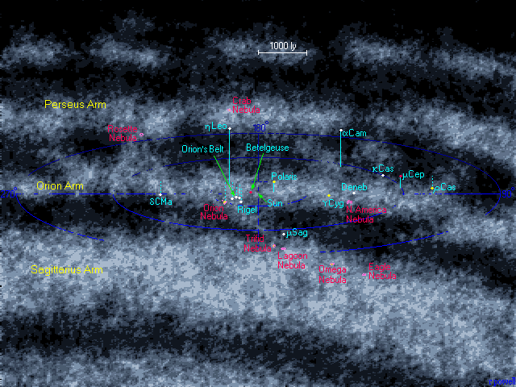
Photo at 5000 Light Years Range
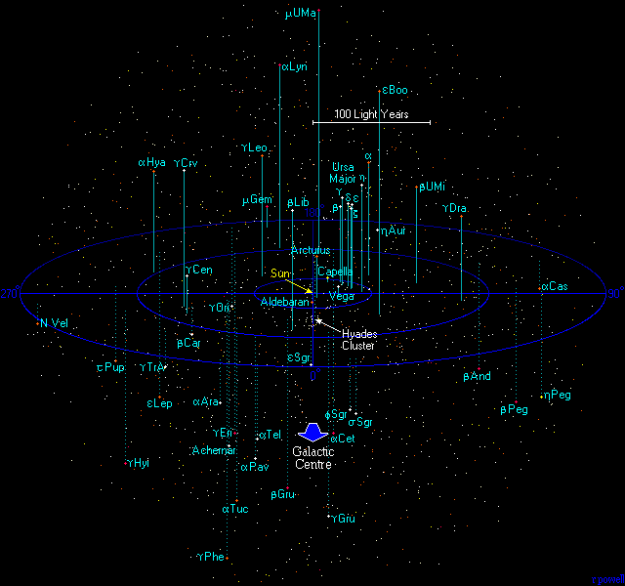
From 250 Light Year Range
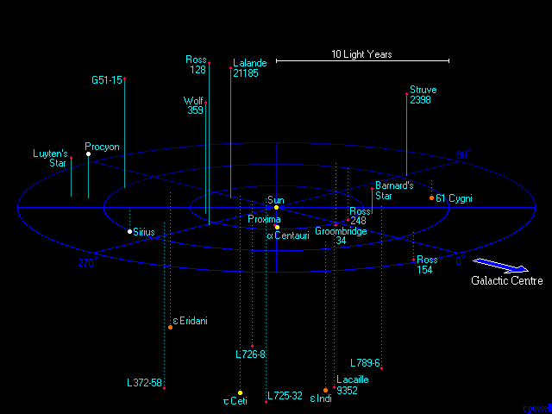View from 12 Light Years

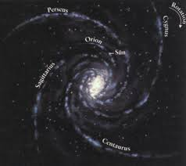
Now, let us analyse what Indian Logic says about Time and Space.

About Space Aakaasha
शब्दगुणकमाकाशम्। तच्चैकं नित्यञ्च।। ५।।
(दीपिका- आकाशं लक्षयति। शब्दगुणकमिति। नन्वाकाशमपि पृथिव्यादिवन्नाना, किं नेत्याह। तच्चैकमिति। भेदे प्रमाणाभावादित्यर्थः। एकत्वादेव सर्वत्र शब्दोपलब्धेः विभुत्वमङ्गीकर्तव्यमित्याह विभ्विति। सर्वमूर्तद्रव्यसँयोगित्वं विभुत्वम्। मूर्तत्वं परिच्छिन्नपरिमाणवत्त्वं क्रियावत्त्वं वा। विभुत्वादेव आत्मवन्नित्यमित्याह नित्यञ्चेति।)
Space is the factor which gives the scope for the co-existence of two molecules. It is responsible for the transit of Sound. It is Unitary. It cohabits and encompasses all beings. Hence, Brahman is also called आकाशशरीरं ब्रह्म।

About Time

अतीतादिव्यवहारहेतुः कालः। स चैको विभुर्नित्यश्च।। ६।।
(दीपिका- कालं लक्षयति अतीतेति। सर्वाधारः कालः सर्वकार्यनिमित्तकारणम्।)

प्राच्यादि व्यवहारहेतुर्दिक्। सा चैका विभ्वी नित्या च।। ७।।
(दीपिका- दिशो लक्षणमाह। प्राचीति। दिगपि कार्यमात्रनिमित्तकारणम्। )
काल स्स ईयते प्रथमो नु देवः। पूर्ण कुम्भोधि काल आहित स्तँ वै पश्यामो बहुधा नु सन्तम्। स इमा विश्वा भुवनानि प्रत्यङ्काल न्तमाहु परमे व्योमन्न्।।3।। स एव सं भुवना न्याभरत्स एव सं भुवनानि पर्यैत्। पिता सन्नभव त्पुत्र एषा न्तस्माद्वै नान्यत्परमस्ति तेजः। (19।53।3 अथर्ववेदः- संहिता)
Brief study of numerous such statements from Vedas lead us to think progressively about the concept of Time and Space. Though the Time Space Units such as Four Dimensional Minkowski Space were not discussed directly, several pointers of Maha Sankalpam imply the faster oscillation of lighter planets such as our Earth, in comparison with the Brahman.
Let us have a look at the Maha Sankalpam Units...
महासङ्कल्पः
- अथानन्तवीर्यस्य श्रीमदादि नारायणस्य, अचिन्त्यापरिमित शक्त्या भ्रियमाणस्य महाजलौघस्य मध्ये, परिभ्रममाणाना मनेक कोटि ब्रह्माण्डाना मेकतमे,
- अव्यक्त प्रकृति मह दहङ्कार - आकाश वायु वह्नि जल पृथिव्यावरणै स्सप्तभि रावृते, अस्मिन् महति ब्रह्माण्ड करण्डमण्डले,
- आधार शक्ति वराह कूर्मानन्ताष्ट दिग्गजोपरि प्रतिष्ठितानां, अतल वितल सुतल तलातल रसातल महातल पाताळाख्य सप्तलोकाना मूर्ध्वभागे, भुवोलोक सुवर्लोक महोलोक जनोलोक सत्यलोकाख्य षड्लोकाना मधोभागे,
- महानाळायमानस्य फणिराजस्य शेषस्य सहस्र फणा मणि मण्डल मण्डिते, ऐरावत पुण्डरीक वामन कुमुदाञ्जन पुष्पदन्त सार्वभौम सुप्रतीकाख्याष्ट शुण्डादण्डोत्तम्भिते,
- अमरावती- तेजोवती संयमनी रक्षोवती सिन्धुमती गन्धव त्यलकावती यशोवतीत्यष्ट देवपुरी विराजिते, इन्द्राग्नि यम निर्‌ऋति वरुण वायु कुबेरेशानाख्याष्ट लोकपालक परिपालिते, लोकालोकाचल वलयिते,
- लवणेक्षु सुरा सर्पि र्दधि क्षीर शुद्धोदकाख्य सप्तार्णव परिवृते, जम्बू प्लक्ष कुश क्रौञ्च शाक शाल्मलि पुष्कराख्य सप्तद्वीपै रावृते, महेन्द्र वलय सह्य शुक्तिम दृक्ष विन्ध्य पारियात्राख्य सप्तकुल पर्वत विराजिते,
- महासरोरुहाकारे पञ्चाशत्कोटि योजन विस्तीर्ण भूमण्डले, लक्षयोजन विस्तीर्णे जम्बूद्वीपे, भारत किंपुरुष हरीळावृत भद्राश्व केतुमाला हिरण्यक रमणक कुरुवर्षाख्य नववर्षाणां मध्ये सहस्रयोजन विस्तीर्णे भरतवर्षे, इन्द्र कशेरु ताम्र गभस्ति पुन्नाग गन्धर्व सौम्य वरुण भरताख्य नवखण्डानां मध्ये भरतखण्डे,
- अयोध्या काशी कुरुक्षेत्र गया प्रयाग काञ्ची श्रीरङ्ग श्री वेङ्कटाचलादि पुण्यक्षेत्रै र्विराजिते, गङ्गा यमुना सरयू नर्मदा गोदावरी कृष्णवेणी भीमरथ्यादि पुण्यनदी राजिते,
- सुमेरु निषध हेमकूट हिमाचलानां, हरिवर्ष किंपुरुष वर्षयोश्च दक्षिण दिग्भागे, सेतुबन्ध मलयाचलयो रुत्तरे,
- श्रीशैलस्य नैर्‌ऋति दिग्भागे, (श्रीमदवधूत दत्तपीठे) . . . . . . . . क्षेत्रे, (कावेरी तीरे) . . . . . . . . नदी तीरे, समस्त देवता गोब्राह्मण हरिहर सद्गुरु चरण सन्निधौ,
- सकल जगत्स्रष्टुः, परार्धद्वय जीविनः, कारण ब्रह्मणः द्वितीय परार्धे, पञ्चाशत्तम वत्सरे, प्रथमवर्षे, प्रथममासे, प्रथम पक्षे, प्रथम दिवसे, अहनि द्वितीय यामे, त्रयोदश घटिका द्विचत्वारिंश द्विघटिकासु गतासु, तृतीय मुहूर्ते, प्रथम प्राणायम काले, पुरुहूत नामधेयेन्द्र समये, पार्थिव कूर्म प्रलयानन्त श्वेतवराह ब्रह्म सावित्राख्य सप्तकल्पानां मध्ये पञ्चमे श्वेतवराह कल्पे, स्वायंभुव स्वारोचिषोत्तम तामस रैवत चाक्षुष वैवस्वत सूर्यसावर्णि धर्मसावर्णि दक्षसावर्णि रुद्रसावर्णि ब्रह्मसावर्णी - न्द्रसावर्णि वेदसावर्ण्याख्य चतुर्दश मन्वन्तराणां मध्ये सप्तमे वैवस्वत मन्वन्तरे,
- तत्रैक सप्तति महायुगानां - सप्तविंशति महायुगेष्वतीतेषु, तदुपर्यष्टाविंशतितमे महायुगे, अष्टाविंशति सहस्रान्वित सप्तदश लक्षाब्दे कृतयुगे याते, षण्णवति सहस्रान्वित द्वादशलक्षाब्दे त्रेतायुगे याते,
- चतुष्षष्टि सहस्रान्विताष्ट लक्षाब्दे द्वापरयुगे याते, द्वात्रिंशत्सहस्रान्वित चतुर्लक्षाब्दे वर्तमाने कलियुगे प्रथमपादे,
- युधिष्ठिर विक्रमार्क शालिवाहन विजयाभिनन्दन नागार्जुन कल्कि भूपाख्य षट्छकानां मध्ये तृतीये शालिवाहन शके,
- अस्मिन् देशे वर्तमान व्यावहारिक चान्द्रमानेन प्रभवादि प्रभवादि षष्टि संवत्सराणां मध्ये, श्रीमत् . . . संवत्सरे, . . अयने, . . . ऋतौ, . . . मासे, . . . . पक्षे, . . . . तिथौ, . . . . वासरे,. . . . नक्षत्रे, . . योगे, . . . करणे,
- . . . मुहूर्ते, एवं गुण विशेषण विशिष्टायां, अस्यां शुभतिथौ
  - इदानीं अनाद्यविद्या वासनया अस्मिन्महति संसार चक्रे विचित्राभि कर्मगतिभि र्नानायोनिषु पुन पुन र्जनित्वा, केनापि सुकृत विशेषेण, मनुष्यजन्म प्राप्तवतः,

Time Units



Space Units

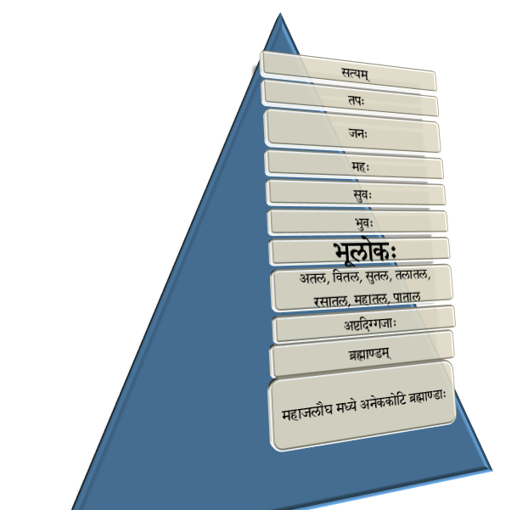

World View
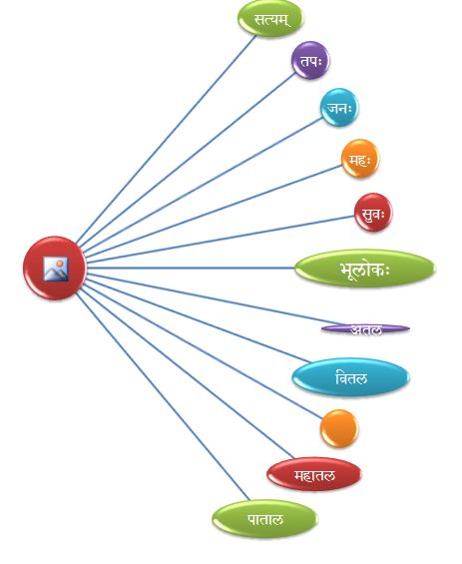

Transcending Time Limits of this Planet
Physicists such as Hawking profess that the journey towards the black holes, the energy gravity centres of the Universe opens up a new possibility of transcending the time limits of this planet.
Let us see, what are the concepts enumerated by Maha Sankalpa broach with:

Transcending Time Limits
- तिलै स्सूर्यमण्डल पर्यन्तं कृतराशे र्वर्ष सहस्रावसाने, एकैक तिलापकर्ष क्रमेण सर्वराश्यपकर्षण सम्मितकाले, श्री हरि (शिव) लोक निवास सिद्ध्यर्थं,
- यवै श्चन्द्र मण्डल पर्यन्तं कृतराशे र्वर्ष सहस्रावसाने, एकैक यवापकर्षक्रमेण सर्वराश्यपकर्षण सम्मितकाले आदित्यलोक निवास सिद्ध्यर्थं,
- गङ्गा वालुकाभि स्सप्तर्षि मण्डल पर्यन्तं कृतराशे र्वर्ष सहस्रावसाने, एकैक वालुकापकर्ष क्रमेण सर्वराश्यपकर्षण सम्मितकाले ब्रह्मलोके निवास सिद्ध्यर्थं,
- माषै र्ध्रुव मण्डल पर्यन्तं कृतराशे र्वर्ष सहस्रावसाने, एकैक माषापकर्ष क्रमेण सर्वराश्यपकर्षण सम्मितकाले ध्रुवलोके निवास सिद्ध्यर्थं,
- गोलोमभि र्नक्षत्रमण्डल पर्यन्तं कृतराशे र्वर्ष सहस्रावसाने, एकैक गोलोमापकर्ष क्रमेण सर्वराश्यपकर्षण सम्मित काले गोलोके निवास सिद्ध्यर्थं
While the elders never sought to transcend time with physical body, they taught us to cherish long life. How do you quantify longevity?
A model is provided in the terms of time distance. Even today, we use the maxim 60 km/ miles per hour. Similarly, Particles of sands, hairs or grains, piled up or brought together to form units of distance.
- If such piles or lengths are formed, the measurement should be in the way of reduction of one particle in one calendar year on this planet. Thus longevity of our life should be in the multiples of such years at each of such great celestial bodies including Nakshatra Mandala, Dhruva Mandala, Vishnu Loka, Brahma Loka, Go Loka etc.
- Hawking argues in his works that Time also has several uneven junctures or rough surfaces, similar to the pores on a supposedly smooth surface, if observed from close distance.
- He further proposes that the time taken at lighter celestial bodies such as Earth, a fraction at larger bodies.
- This corresponds to the Kaala Maana (Measurement System) proposed in the Vedic system.
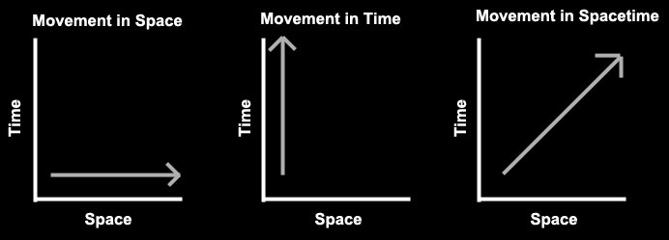
- In essence, One Breath of Brahman (Largest Body of Creation) is equivalent to the life time(s) of many lesser mortals. (We are not giving the entire translation of the Sankalpa as it is well known to scholars.)
- Thus the sojourn towards the larger Celestial Bodies such as Dhruva Mandala, Saptarshi Mandala, Nakshatra Mandala, Vishnu Loka, Go Loka, Brahma Loka will prolong the life cycle, which would remain static/ short on this planet.
In several sci-fi movies and writings, many writers have dealt with time transcending voyages hence and forth. However, this concept has its roots and references in Vedic System.
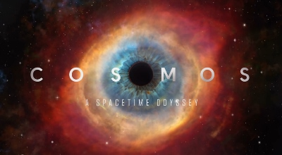
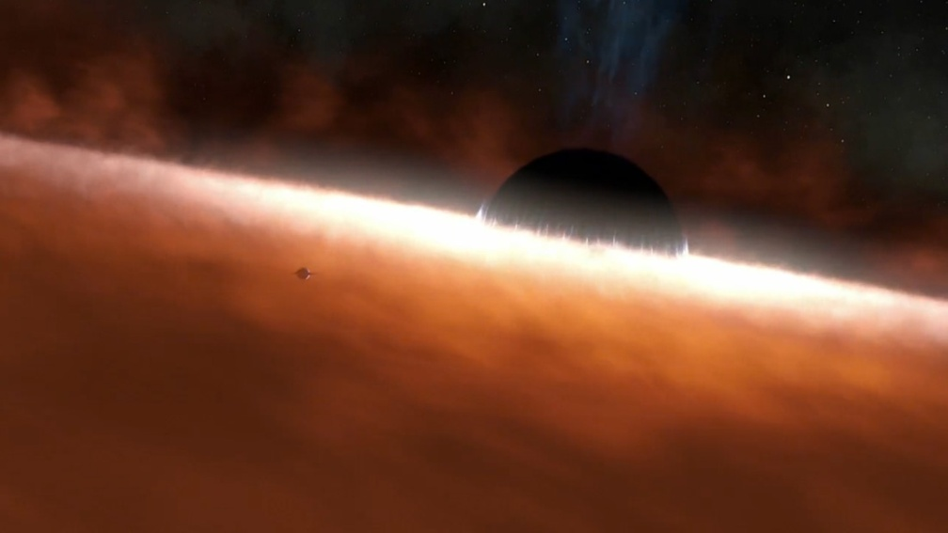

What is the feasibility and benefit of such idea?
- Longevity of life to explore the universe and enlarge the scope of individual and collective wisdom.
If the humanity can move in the direction of transcending the time limits of this planet, longevity of life will be the first mean, if not the end, to achieve something substantially beneficial to the generations.
This concept of Saptarshi Mandala is described in the Vedas and Puraanas. Paramount Bliss by the convergence with the infinite effulgence is an important goal in life, for which several sages are said to have achieved. (Yoga Sutra 2-36 also gives a succinct refer to this bliss in the form of enlightenment विशोका वा ज्योतिष्मती।)
In fact, such observer Pashyaka will be Kashyapa himself. Such observation will be very subtle to observe every being infinitely. कश्यपः पश्यको भवति। यत्सर्वं परिपश्यतीति सौक्ष्म्यात्।
कश्यपादुदितास्सूर्याः। पापान्निर्घ्नन्ति सर्वदा। रोदस्योरन्तर्देशेषु।
From the massive source called Kashyapa, Stars/ Suns take form. They appear from the rims of spatial orbits. (Taittireeya Aaranyaka, Aaruna Ketuka Prashna)
Modern Astro physicists too speak about the formation and merger/ amalgamation of Luminous stars such as Sun into the ultimate, now called the Massive BlackHole. The above verses mention about such source, from which Luminous Celestial Bodies appear.

Thus, the Maha Sankalpa enlists the Lofty goals for a Human to look beyond the obvious world and transcend the time and space to march towards immortality, relative longevity in other words, to enjoy unbounded bliss.
Mangalam Mahat.

(For beginners, the name black hole does not mean the absence of energy or light. Inversely, it is the maximum concentration of all energy enough to absorb the mass of many Suns.

