Evolution of Worship Practices - Yajnas and its varieties
Indian traditions of worship have a deep significance from the philosophical perspective. As all our traditions have emanated from the rich pantheon of Seers known for their penance spread over millennia. The earliest penance was centred on the Adwaita state of monism and gradually evolved if not degenerated into the temple worship of current society.
As the highest states of consciousness (as described in Upanishad), did not need symbolism or symbols, we have lesser scope for such references in Upanishad Statements. For the people in the lesser stages of life cycles, symbolism induced worship are introduced, thru the contemplation of unity in diversity. (Identity of Consciousness in the Finite (Jeevaatman) and Infinite (Paramaatman).
For learned scholars, subtler elements of nature were sufficient to ignite the concept of Upaasana (Being close). Gradually it required grosser elements such as articles of worship such as stones, wooden blocks, plants as well as fellow beings in advanced age and wisdom.
Inability to comprehend the ever present divinity in mundane objects at all times and all places; required a place of purity and permanence (relative to our life). This resulted in the Devata Puja in the form of Saligraama, Sphatika etc in the form of Puja place in the home. Absence of training, discipline and facilities needed further allotment of a place in the society, with few people getting trained to maintain the facility leading to the establishment of Temple System.
Further realisation about the limitation of the body and the reflected consciousness thereof, led to the elaborate description of the infinite divinity invisible to the senses. This gigantic temple establishment is designed to match the grandeur of the infinite divinity represented by it. Sociologically, the system provides livelihood to many apart from orienting the society towards the Infinity Super Natural Force, capable of doing anything under the sky or even beyond that for that matter. Hence, this temporal system assumes the all important religious stature playing the central role in the society. Thus the philosophical pursuit of the sages and seers evolved into a societal practice called religion.
However, the evolution is not detrimental to the originating concepts and practices, as long as it does not snub the growth of philosophical quest in the society. But, unfortunately the practices or symbolic actions assume all the importance, masquerading the underlying principles. Moreover, this vital point is not even a matter of concern and discussion in the society.
In order to elevate the intellectual quotient of the society, more focus should be given to the philosophical concepts of each aspect of the worship practices, which would be protect the society from superstition.

Types of Worship Forms - Evolution/ Simplification
State | Details | Comprehension | Substitute | Substitution/ Simplification
Aham Graha Upaasana/  Nirguna Upaasana | Asamprajnaata Samaadhi thru Tapasyaa | Brahman is all pervading.  I am that. |  | Substitution/ Simplification
Saguna Upaasana | Samprajnaata Samaadhi thru Shama - Dama etc. | I am reflected in other forms, but I am one. |  | Substitution/ Simplification
Prateeka Upaasana | Surya (Natural Phenomenon) including Sandhya Vandanam | I am present in this body as Chaitanya. Similarly Chaitanya is present in the celestial beings. Hence contemplate the unity. |  | Substitution/ Simplification
Prateeka Upaasana | Agni (Natural Element but to be produced including Agnihotra, Ishti, Kratu, Yajna, Agni Kaarya (where procedures laden with stage wise mental discipline lead to the upper stages) | Agni helps me achieve higher state. He is my great Companion and lifelong mate, though in different forms. | In Vedic Rituals, procedures are elaborate and the offering is concise (Number of offerings is solitary) | Substitution/ Simplification
Prateeka Upaasana | Pancha Mahaa Yajna (Deva, Pitru, Bhoota, Manushya & Brahma) | Identifying the Chaitanya in every being including other humans, creatures) and protecting the Wisdom |  | Substitution/ Simplification
Prateeka Upaasana | Pouranika Rituals | Offerings to various deities, including Puja, Homa, Tarpanam, Bhajan etc | Procedures are very short, but the number of offerings increases, with lesser controls. | Substitution/ Simplification
Prateeka Upaasana | Devataa Puja at Home | Puja at home, substituting rituals prescribed by Veda. |  | Substitution/ Simplification
Prateeka Upaasana | Service to fellow beings. | After identifying divinity in fellow beings, treat them at par with self and serve them as well, after taking care of your requirement. |  | Substitution/ Simplification
Yaajana | Temple worship, as we are not equipped or trained to offer worship ourselves. | Contracting someone better suited, to offer Archana on our behalf, and sharing the result. |  | Substitution/ Simplification

Types of Yajnas and their Purpose
In this table, we will start with the smallest denomination of rituals to the maximum effort laden ritual.
Sl | Nitya Karma | Category | Example |  | Requirement | Purpose
1 | Agni Karya  (Twice a day) | Ekagni  (Agni not retained) | Samid Aadhaanam |  | Any Brahmachari can perform | Gaining Long Life, Strength, Ability
2 | Vaishwadeva  (Once a day) | Ekagni  (Agni not retained) | Vaishwadeva |  | Any Upaneeta can perform* | Sharing your food with everyone in your circle (Deities > you, Humans = You Creatures<You
3 | Oupaasana Agni  (Twice a day) | Ekagni  (Agni retained) | Nitya Oupasana |  | Compulsory for every Gruhastha (House-Holder) | Offer a pinch of Raw Rice to Agni and Surya for the well-being of the family
4 | Nitya Agnihotra  (Twice a day) | Tretaagni  (Agni retained with the names of Gaarhapatya, Dakshinaagni, Aahavaneeya) | Agnihotra Rituals |  | Better Status for every Gruhastha (House-holder), required to become Somayaji | Offer a spoon of Cow Milk to Agni and Surya for the well-being of the family and society
5 | Nitya Agnihotra | Panchaagni  (Agni retained with the names of Gaarhapatya, Dakshinaagni, Aahavaneeya, Sabhya and Avasathya) | Narya,  Atharva, Shamsya,  Sapratha,  Ahi Budhniya Upaasana |  | Couple  No Place in the residence is devoid of the presence of the head of the family (Gruhapati) - Agni | Progeny Nutritious Food, Favourable People and Animals, Respect in the society and Great Education
5 | Ishti (Prakruti)  (Every Fortnight) | Tretaagni  Fortnight begins with Offering of Ghee, Purodaasha Baked Rice Flour) & Curd* | Darsha/ Poorna Maasa  (Basic Yajna requiring 4 Ritwiks), Chaturmaasya requires more |  | Couple (Yajamaana+ Patnee), Adhwaryu, Brahma, Hotaa and Agneet | Good Rains, Betterment of life and Heaven
6 | Ishti (Vikruti) | Tretaagni  (Offerings with different ingredients) | Sarva Prushtha, Traidhaataveeya, Aayushmat,  Putra Kaama,  Pashu Kaama etc. |  | Based on the desire of the Yajamaana, Qualified scholars will conduct the ritual | Any desire in the mind (including
7 | Soma Yaaga  (Kratu) | Tretaagni Plus Special YaagaShaala  (Spanning 6 days) | Agnishtoma, Atyagnishtoma, Ukthya, Aptoryaama, Vaajapeya |  | 17 Ritwiks are classified in 4 groups, headed by the Chiefs Adhwaryu, Hotaa, Udgaataa and Brahma apart from Yajamaana and Patnee | Each of the 7 Soma Yagas have specific benefits, apart from the general objective of Heaven and Social Welfare
8 | Chayana Yaaga | Tretaagni Plus Large YaagaShaala  (Minimum period 1 days) | Poundareeka Yaga (Dwishaahasra, Trishaahasra),  And Minor Chayana- Saavitra, Naachiketa, Vaishwasruja, Aaruna Ketuka, Chaaturhotriya |  | 17 Ritwiks are classified in 4 groups, headed by the Chiefs Adhwaryu, Hotaa, Udgaataa and Brahma apart from Yajamaana and Patnee | Chayana Yajnas have higher classification and benefits range from immortal wisdom, well being of the family and society
9 | Satra Yaaga  Longer Version of Yajnas | Minimum 7 Days | Dwiraatra, Triraatra, Chatooraatra to Samavatsara Satra (Gavaam Ayanam) |  | All the above Ritwiks have to be Soma Yaajis | Benefit is equally distributed among all the Ritwiks and no Gift shall be accepted by anyone.
Types of Karma (General Classification)
 | Nitya | Rituals include Sandhyaa Vandanam, Oupaasana, Vaishwadeva, Darsha - Poorna Maasa etc |  | Does not have specific result in mind other than the obliteration of sins and the grace of the God
 | Naimittika | Any Purpose which necessitates a special action is categorised as Naimittika. Examples include: Houses Burnt, Time Lapse for the conduct of a ritual, Impediments, Untimely Death of People in the house, or Cattle etc. |  |  |  | Achieving the specific Objective
 | Kaamya | Ishta Praapti | To attain a specific desire to benefit the family or the society |  |  | Progeny, Food, Rains, Respect etc.
 | Kaamya | Anishta Parihaara | Getting Rid of Enemies and unfavourable conditions by Divine force. These rituals are popular as Abhichaarika Karma |  |  | Obliterating Enemies in the kingdom or external forces

The rituals enumerated in Vedic Texts are elaborate and wide ranging in the process and benefits to suit:
- every stage of life (Brahmachari (Student), Gruhastha (Sustainer of the society), Vaana Prastha (Retirement Stage)
- every mental state (Happiness, Sorrow, Excitement, Anger, Jealousy, Depression)
- every requirement of individual, family, community, society and nation and
- level of expertise.

In essence, the Yajna rituals have the innate purpose to promote:
- Positive attitude of optimism in life
- Bonhomie among the team mates and community members
- Sense of detachment towards possessions
- Gratitude towards the Almighty for various favours bestowed.
Thus, the society has to find the imperative of the rituals and promote the study of Rituals (Yajnas) with greater enthusiasm and of course, follow the traditions for the general benefit at large so that the nation can prosper and witness all-round, equitable distribution of wealth in the society.
आनो भद्राः क्रतवो यन्तु विश्वतः
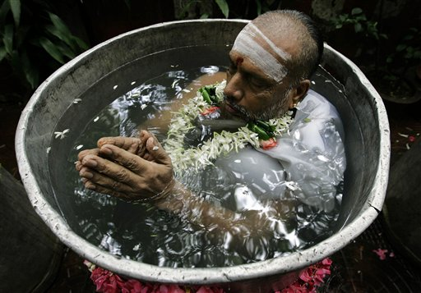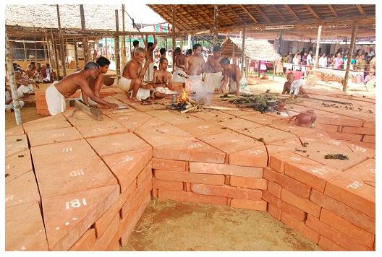
Varuna Japam Chayana Yaaga

