* Many people : gamma correction.
  + im.^(1/2.2) + im./6
  + gamma correction
* building
  + bilateral filter
  + mask 3
  + Std 50
  + Intensity 20
* Housefront
  + Half left

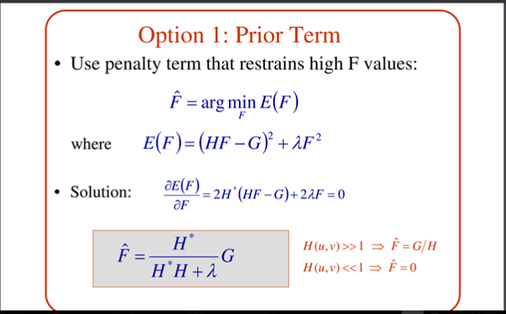

* + H\* is conj(H)
  + Lambda 0.01
  + H vertical 1/10