# Gaus Pyramid

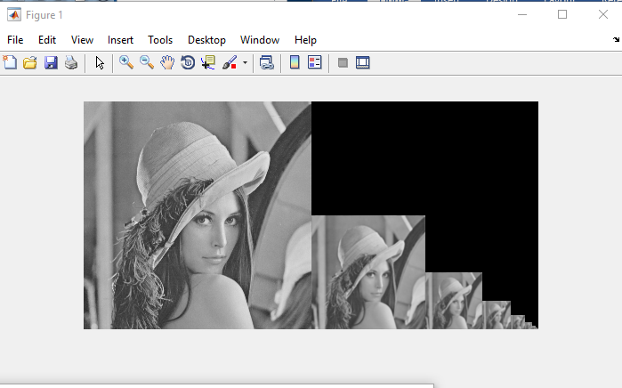

# Lap Pyramid

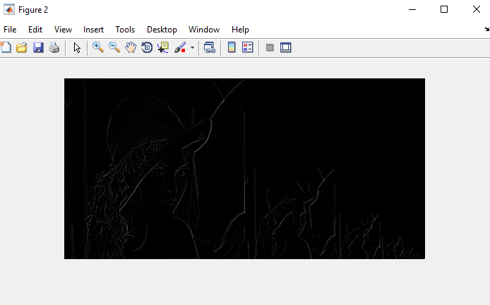

# Collapse Lap Pyramid



Multi spline

* With gaus mask

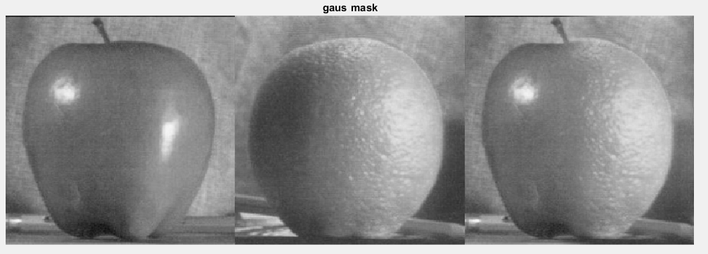

* Left side of Mask is 1
* Right side is 0

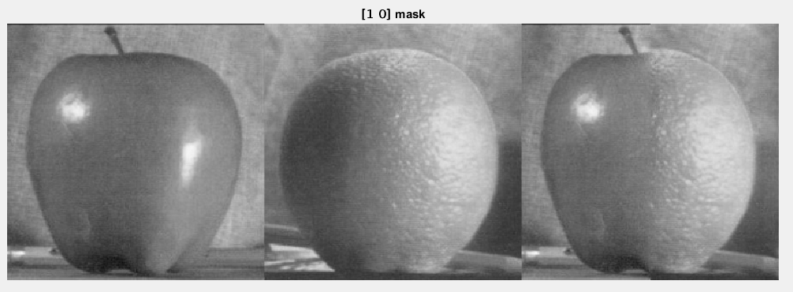

Clearly the upper one got stitched better, we can see the difference in the bottom middle.

You can see there the line.