**Part 1 – SEM**

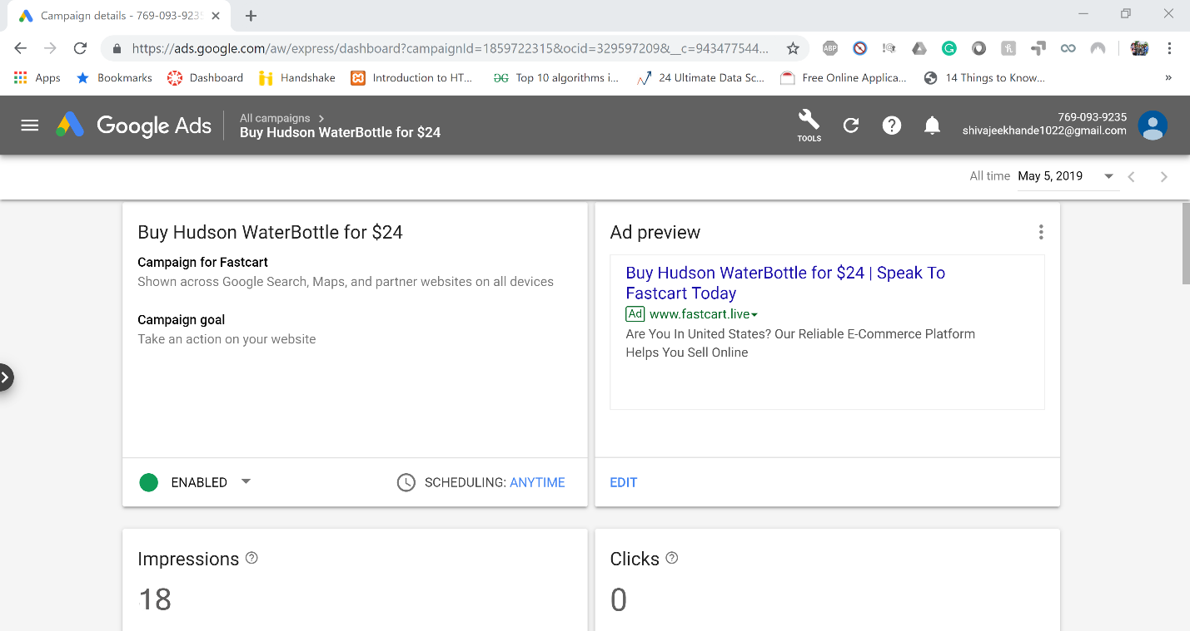

**Part 2 – SEO**

SEO Keyword: Fastcart Hudson Water

Product Page: <http://www.fastcart.live/product/hudson-water/>

Website URL: [www.fastcart.live](http://www.fastcart.live)

**Part 3 – Category page**

Categories page is in the righthand side of the home page

**Part 4 – Google Analytics Dashboard**

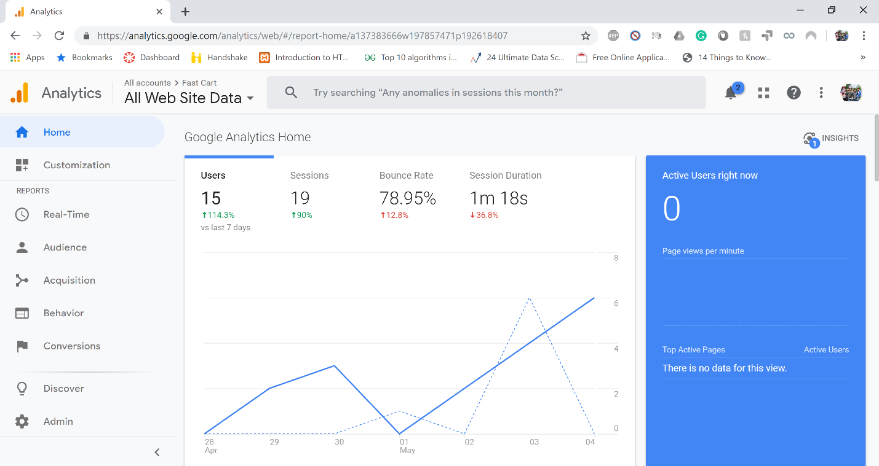

**Part 5 – A/B Testing**

A-version

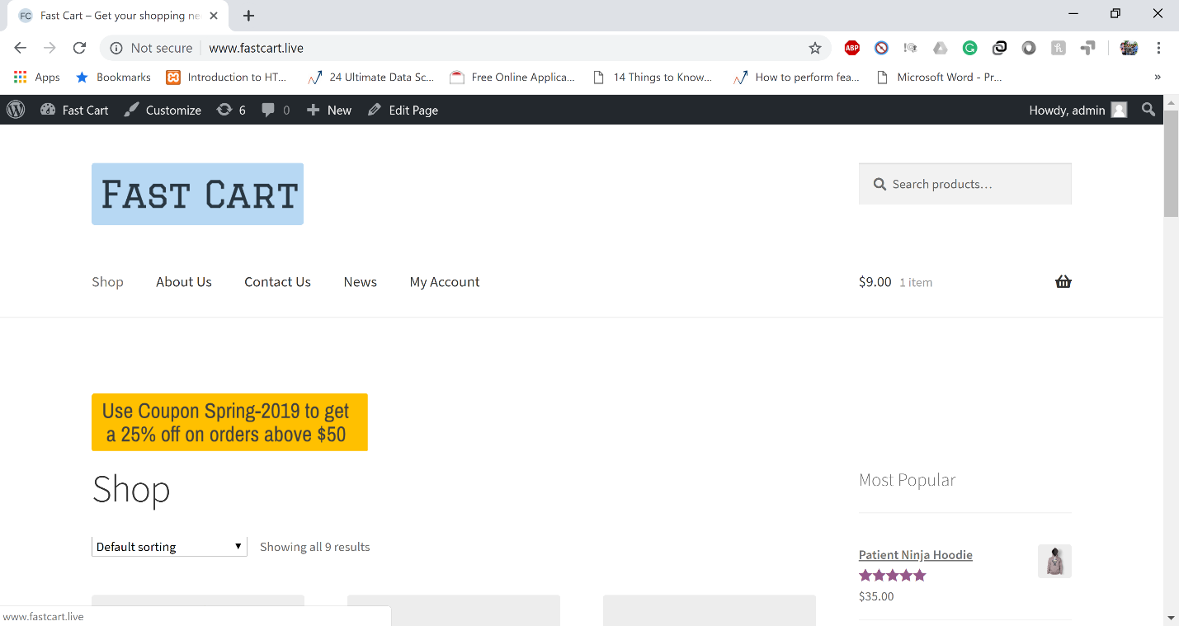

B- Version

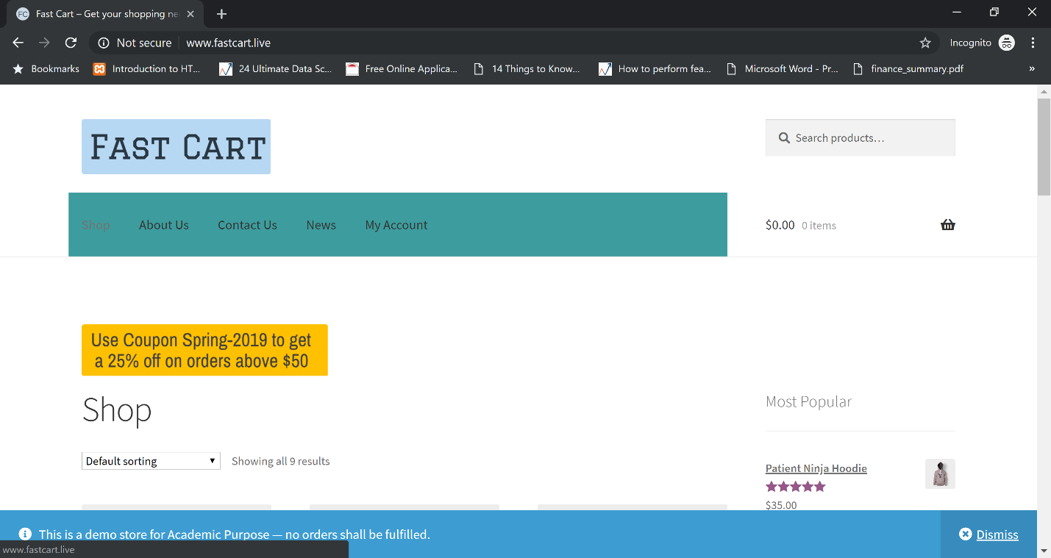

Difference between A and B version: The background color of the menu changes from white in A version to light green in B version

**A/B Test Results:**

