Exercise 2:

a)

s({e}) = 8/10 = 0.8

s({b, d}) = 2/10 = 0.2

s({b, d, e}) = 2/10 = 0.2

b)

c(bd -> e) = s({b, d, e}) / s({b, d})

=0.2/0.2 = 1

=100%

c(e −→ bd) = s({b, d, e}) / s({e})

= 0.2/0.8 = ¼

=0.25

=25%

We can see that confidence is not symmetrical

c)

s({e}) = 4/5 = 0.8

s({b, d}) = 5/5 = 1

s({b, d, e}) = 4/5 = 0.8

d)

c(bd −→ e) = s({b, d, e}) / s({b, d})

=0.8/1

=0.8

= 80%

c(e −→ bd) = s({b, d, e}) / s({e})

= 0.8/0.8

= 1

= 100%

e)

There is no relationship between S1, C1, S2, C2. S1, C1 are support and confidence values when treating each transaction ID. S2, C2 support and confidence values of an association rule r when treating each transaction ID. So, increase in S1, C1, does not mean increase in S2, C2.

6)

a)

items(unique)= {Milk, Beer, Diapers,Butter,Cookies,Bread}

countItems =6

3countItems- 2(countItems+1)+ 1

=36- 2(6+1)+ 1

=729-128+1

Number of association rules =602

b)

As the longest transaction is 4 maximum size of frequent item sets is 4.

c) $x=\frac{6!}{3!*3!}$ = 4*5=20

d)

S{Bread,Butter} is the largest

e)

c(Beer, Cookies),c(Bread, Butter) have same confidence.

8)

A)

{1, 2, 3}, {1, 2, 4}, {1, 2, 5}, {1, 3, 4}, {1, 3, 5}, {2, 3, 4}, {2, 3, 5}, {3, 4, 5}.

{1, 2, 3,4}, {1, 2, 3,5}, {1, 2, 3,6}

{1, 2, 4, 5}, {1, 2, 4, 6}, {1, 2, 5, 6}.

{1, 3, 4, 5}, {1, 3, 4, 6}, {2, 3, 4, 5}.

{2, 3, 4, 6}, {2, 3, 5, 6}

B)

{1, 2, 3,4}, {1, 2, 3,5}, {1, 2, 4,5}, (2, 3, 4, 5}, {2, 3, 4, 6}

C)

{1, 2, 3, 4} survives the pruning as it contains most frequent subsets

12)

Root:

|  |
| --- |
| NULL |
| c |

Level 1:

|  |  |  |  |  |
| --- | --- | --- | --- | --- |
| A | B | C | D | E |
| C | C | C | C | C |

Level 2:

|  |  |  |  |  |  |  |  |  |  |
| --- | --- | --- | --- | --- | --- | --- | --- | --- | --- |
| AB | AC | AD | AE | BC | BD | BE | CD | CE | DE |
| M | I | C | C | M | C | F | M | I | C |

Level 3:

|  |  |  |  |  |  |  |  |  |  |
| --- | --- | --- | --- | --- | --- | --- | --- | --- | --- |
| ABC | ABD | ABE | ACD | ACE | ADE | BCD | BCE | BDE | CDE |
| I | I | I | I | I | M | I | I | M | I |

Level 4:

|  |  |  |  |  |
| --- | --- | --- | --- | --- |
| ABCD | ABCE | ABDE | ACDE | BCDE |
| I | I | I | I | I |

Root:

|  |
| --- |
| ABCDE |
| I |

13)

{b} → {c}

|  |  |  |  |
| --- | --- | --- | --- |
|  | C+ | C- | TOTAL |
| B+ | 3 | 4 | 7 |
| B- | 2 | 1 | 3 |
| TOTAL | 5 | 5 | 10 |

{a}→{d}

|  |  |  |  |
| --- | --- | --- | --- |
|  | D+ | D- | TOTAL |
| A+ | 4 | 1 | 5 |
| A- | 5 | 0 | 5 |
| TOTAL | 9 | 1 | 10 |

{b} −→ {d}

|  |  |  |  |
| --- | --- | --- | --- |
|  | D+ | D- | TOTAL |
| B+ | 6 | 1 | 7 |
| B- | 3 | 0 | 3 |
| TOTAL | 9 | 1 | 10 |

{e} −→ {c}

|  |  |  |  |
| --- | --- | --- | --- |
|  | C+ | C- | TOTAL |
| E+ | 2 | 4 | 6 |
| E- | 3 | 1 | 4 |
| TOTAL | 5 | 5 | 10 |

{c}→{a}

|  |  |  |  |
| --- | --- | --- | --- |
|  | A+ | A- | TOTAL |
| C+ | 2 | 3 | 5 |
| C- | 3 | 2 | 5 |
| TOTAL | 5 | 5 | 10 |

B)

SUPPORT:

|  |  |  |  |  |
| --- | --- | --- | --- | --- |
| {b}→{d} | {a}→{d} | {b}→{c} | {e}→{c} | {c}→{a} |
| 0.6 | 0.4 | 0.3 | 0.2 | 0.2 |
| Rank:1 | 2 | 3 | 4 | 4 |

CONFIDENCE:

|  |  |  |  |  |
| --- | --- | --- | --- | --- |
| {b}→{d} | {a}→{d} | {b}→{c} | {c}→{a} | {e}→{c} |
| 6/7 | 4/5 | 3/7 | 2/5 | 2/6 |
| Rank:1 | 2 | 3 | 4 | 5 |

INTEREST:

Interest= $\frac{SP(xy)* sp(y)}{sp(x)}$

|  |  |  |  |  |
| --- | --- | --- | --- | --- |
| {b}→{d} | {a}→{d} | {b}→{c} | {c}→{a} | {e}→{c} |
| 0.7714 | 0.720 | 0.2142 | 0.2 | 0.17 |
| Rank:1 | 2 | 3 | 4 | 5 |

IS:

IS= $\frac{SP(xy)* sp(y)}{√suppX * suppY}$

|  |  |  |  |  |
| --- | --- | --- | --- | --- |
| {b}→{d} | {a}→{d} | {b}→{c} | {c}→{a} | {e}→{c} |
| 0.756 | 0.5962 | 0.507 | 0.4 | 0.366 |
| Rank:1 | 2 | 3 | 4 | 5 |

Klosgen:

$√suppXY$* max(confidence(suppXY, suppX) - suppY, confidence(suppXY, suppY)-suppX)

|  |  |  |  |  |
| --- | --- | --- | --- | --- |
| {b}→{d} | {b}→{c} | {c}→{a} | {a}→{d} | {e}→{c} |
| -0.033 | -0.039 | -0.044 | -0.063 | -0.074 |
| Rank:1 | 2 | 3 | 4 | 5 |

Odds Ratio:

(XY * XnotIn YnotIn) / (x YnotIn *y XnotIn)

|  |  |  |  |  |
| --- | --- | --- | --- | --- |
| {b}→{d} | {a}→{d} | {b}→{c} | {c}→{a} | {e}→{c} |
| 0 | 0 | 0.3749 | 0.43 | 0.16 |
| Rank:4 | 4 | 2 | 1 | 3 |

9)

A)

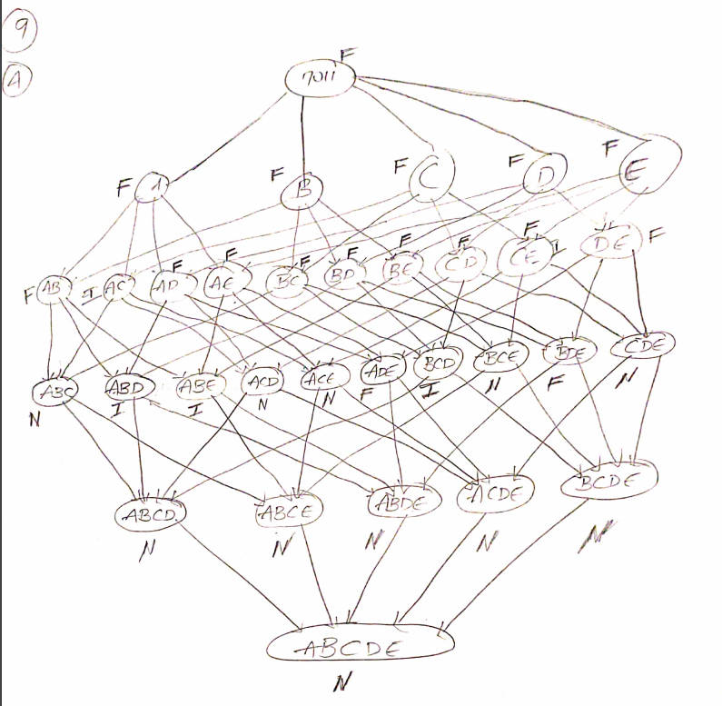

B)

Percentage =(16/32)*100

= 50%

C)

Pruning Ratio=count(N)/total=11/32*100=34.4%

D)

False Alarm Rate: (count(I)/total) *100= (5/32) *100=15.625%

20)

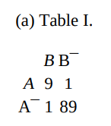

|  |  |  |  |
| --- | --- | --- | --- |
|  | B+ | B- |  |
| A+ | 9 | 1 | 10 |
| A- | 1 | 89 | 90 |
| Total | 10 | 90 | 100 |

S(A) = 10/100=0.1

S(B) = 10/100= 0.9

S(A,B) = 9/100=0.09

Interest=0.09

φ (A,B)= (9*89) – (1*1)/√(10*10*90*90)=0.89

Confidence(A→B) = 0.9

Confidence(B→A) =0.9

B)

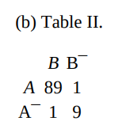

|  |  |  |  |
| --- | --- | --- | --- |
|  | B+ | B- |  |
| A+ | 89 | 1 | 90 |
| A- | 1 | 9 | 10 |
| Total | 90 | 10 | 100 |

S(A) =90/100 = 0.9

S(B) = 90/100 = 0.9

Interest=0.89

φ (A,B)= 0.89

Confidence(A→B) = 0.98

Confidence(B→A) =0.98

C)

From the result we know confidence is associative.Correlation coefficient is invariant in inverse operation. It is because coefficient considers the presence and operation of the items. The elements are positively correlated as the interest factor is close to 1.