# CSP 554—Big Data Technologies

## Assignment #1 (Modules 01a & 01b, 12 points)

**Q3)(2 points) Submit very brief answers (or bullet points) to the following questions:**

* **What location or time zone are you in when you attend the course?** 
  + Location: Chicago, Illinois.
  + Time Zone: CDT
* **Describe any prior experience you might have with use of public cloud, data mining, machine learning, statistics, data science and big data.**
  + I have previously worked in Accenture on web Development where I have used Azure SQL.
* **Share any big data interests and personal learning goals for the course.**
  + My personal goal is to become an ML Engineer I want to learn how the large data are handled and valuable insights are gathered and used to solve the real world problems
* **Indicate if there are additional topics in the scope of the course of special interest to you**
  + I am relatively new to Big data as of now the syllabus which was published is good.
* **Do you have any anticipated personal issues such as expected absences or other necessary accommodations with course impact? (Of course, these will be held in strictest confidence.)**
  + No.

**Q5)(5 points) Answer each of the following questions about the article in just one to three sentences each:**

* **What was the problem with the Google flu detection algorithm?**
  + It was predicting double the cases than what the CDC is predicting.
* **What is big data hubris?**
  + To think Big Data is substitute to traditional data collection and analysis rather than supplement is called Big Data hubris.
* **What approach could have been used to improve the Google flu detection algorithm?**
  + By combining Google flu detection Algorithm, lagged CDC data and dynamically recalibrating GFT, we can improve on the performance of Google flu detection
* **What is “algorithm dynamics?”**
  + Algorithm dynamics are the changes made by engineers to improve the commercial service and by consumers in using that service
* **What aspect of algorithm dynamics impacted the Google flu detection algorithm?**
  + The important change is blue team dynamics—where the algorithm producing the data has been modified by the service provider in accordance with their business model. Google stated it has modified its search results to provide suggested additional search terms which improved efficiency of Google flu detection

Q6

Bucket Creation:

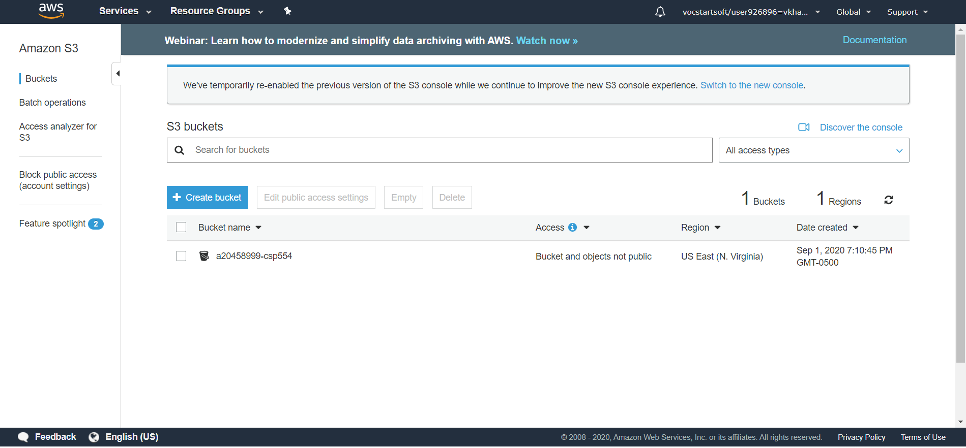

Object Upload:

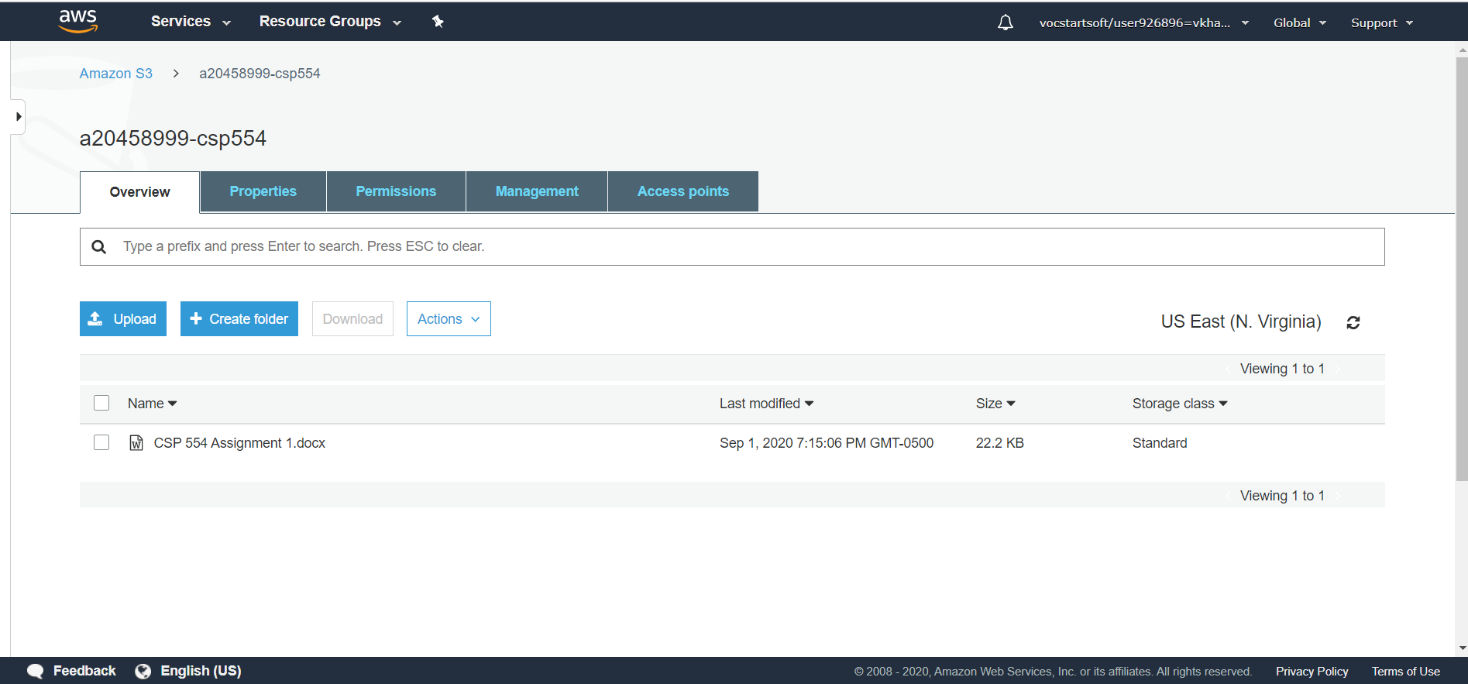

Object Deletion:

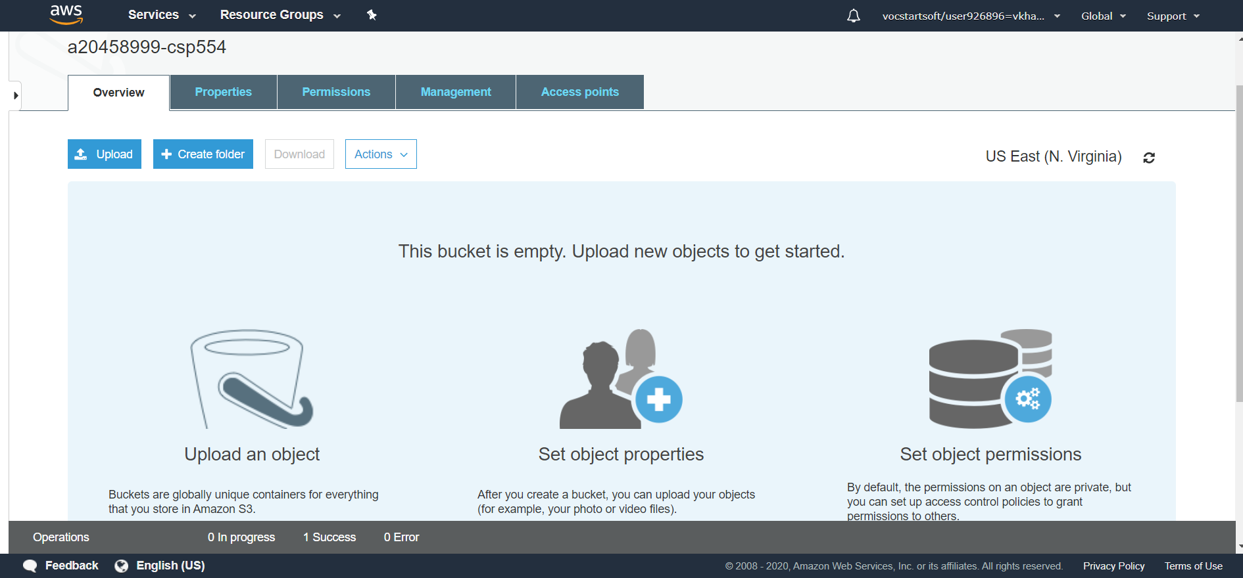

Bucket Deletion:

