***SSH EMR Cluster***

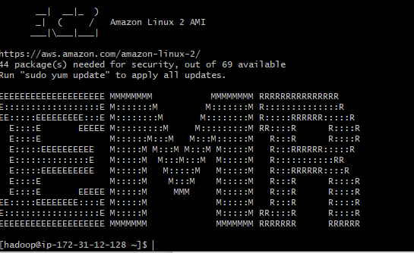

***Entering into HBase***

***Command Used: hbase shell***

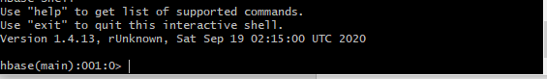

***Ex1: Creating an Hbase Table***

***Command Used: create 'csp554Tbl','cf1','cf2'***



***Execute the DESCRIBE command***

***Command Used: describe 'csp554Tbl'***

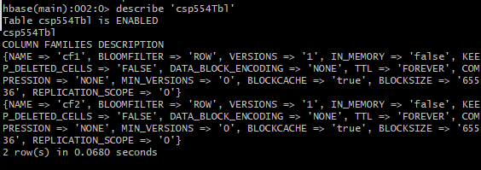

***Ex2: Putting Data into the table:***

***Command Used: put 'csp554Tbl','Row1','cf1:name','Sam'***

***put 'csp554Tbl','Row2','cf1:name','Ahmed'***

***put 'csp554Tbl','Row2','cf1:name','Ahmed'***

***put 'csp554Tbl','Row1','cf2:job','pilot'***

***put 'csp554Tbl','Row2','cf2:job','Doctor'***

***put 'csp554Tbl','Row1','cf2:level','LZ3'***

***put 'csp554Tbl','Row2','cf2:level','AR7'***

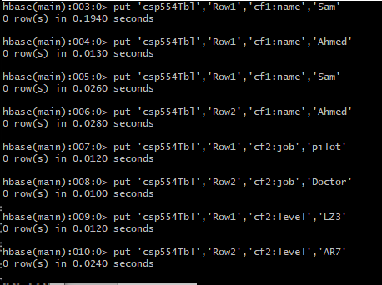

***Execute the SCAN command***

***Command Used: scan 'csp554Tbl'***

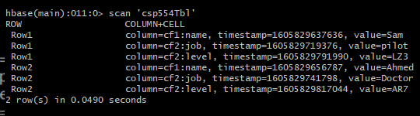

***EX3:***

***Command Used: get 'csp554Tbl', 'Row1',{COLUMN=> 'cf2:level'}***

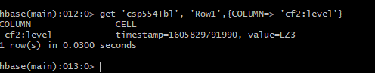

***Ex4:***

***Command Used: get 'csp554Tbl', 'Row2',{COLUMN=> 'cf1:name'}***

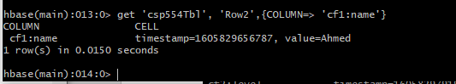

***Ex5:***

**Command Used: scan 'csp554Tbl' ,{LIMIT=> 2}**

