Creation of key value pair

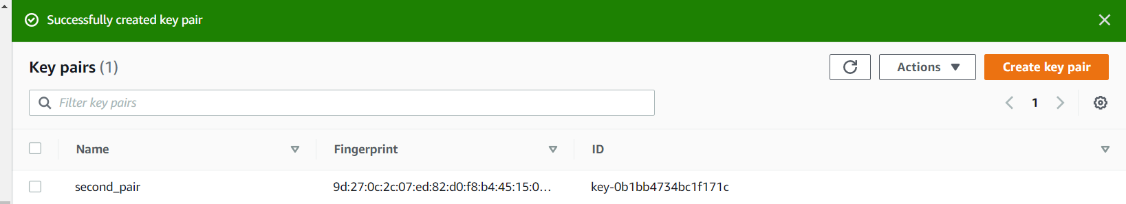

Cluster Creation

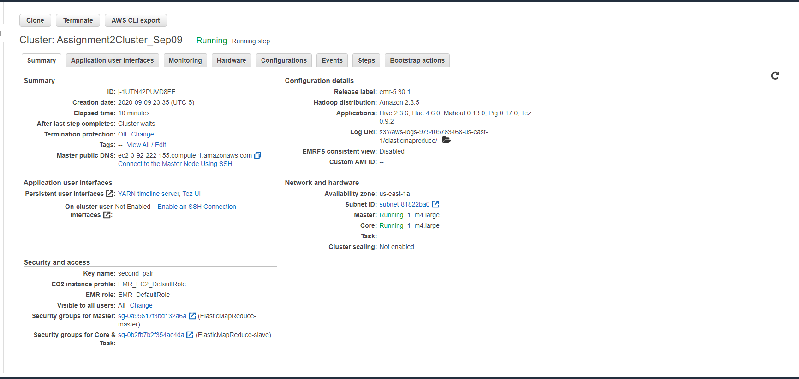

Selecting Master Security Group

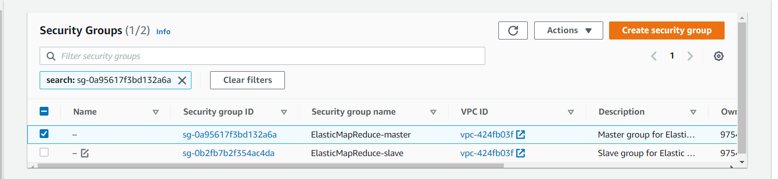

Uploading the file to Hadoop (Akshay.txt)

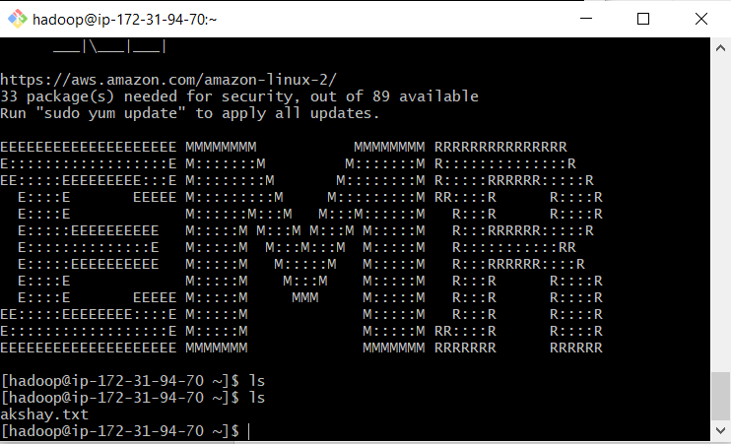

S3 bucket creation

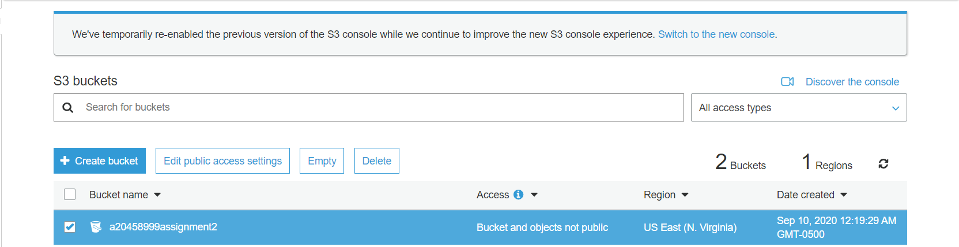

Object creation in bucket

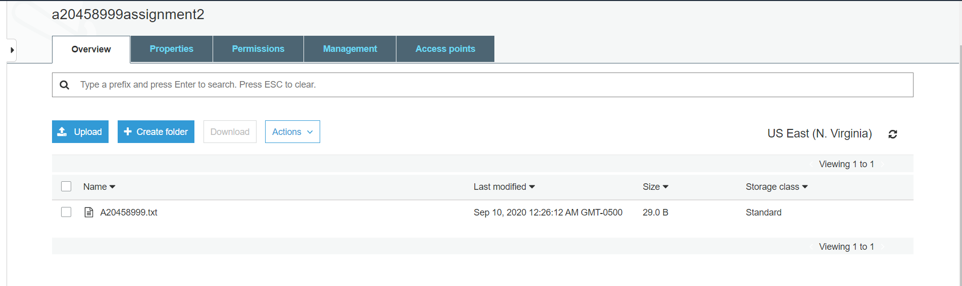

09) Listing the files under root directory

Command Used :Hadoop fs -ls /

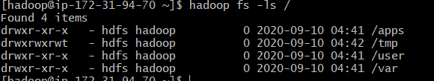

10) List of files under user

Command Used: Hadoop fs -ls /user

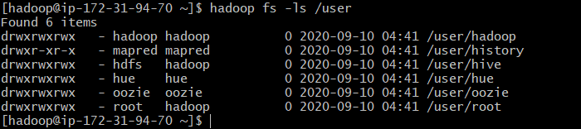

11)Creating new directory

Command Used: Hadoop fs -mkdir /user/csp554

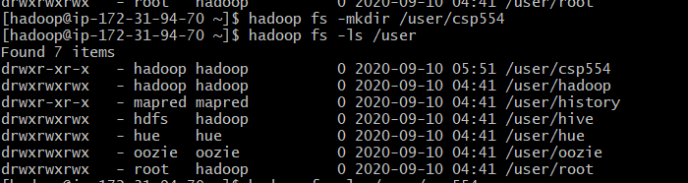

12)Creating second directory

Command Used: Hadoop fs -mkdir /user/csp554-2



13)Copy from local to user/csp554

Command Used: hadoop fs -copyFromLocal /home/Hadoop/Akshay.txt /user/csp554



14) Copy from one directory to other

Command used: Hadoop fs -cp /user/csp554/Akshay.txt /user/csp554-2

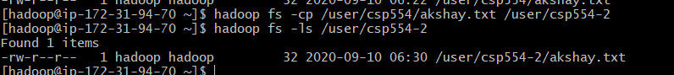

15) Object copied from S3 bucket to hadoop(Renamed file as myid.txt).

Command Used: aws s3 cp s3://a20458999assignment2/A20458999.txt /home/Hadoop/myid.txt

Command used to list the newly copied file: ls





16) Copy from s3 bucket to HDFS user/csp554-2 directory

Command Used: Hadoop fs -cp s3://a20458999assignment2/A20458999.txt hdfs://user/csp554-2

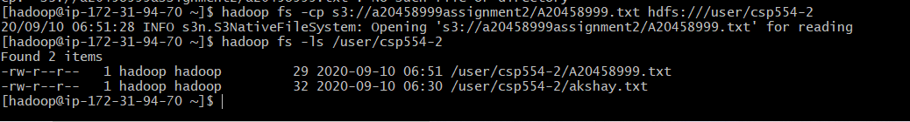

17) Reading the content of the file.

Command Used: hadoop fs -cat /user/csp554-2/A20458999.txt



18) Deleting the file

Command Used: hadoop fs -rm /user/csp554-2/A20458999.txt



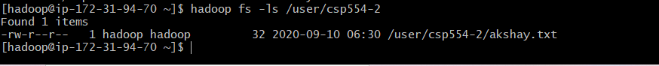

19) Cluster termination Bucket Deletion

