1. Running TestDataGen :
   1. Command used: java testDataGen

Output Used: Magic Number: 124875

Generated Files: foodplaces124875.txt foodratings124875.txt

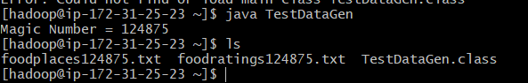

Creating Relation food_ratings:

Command Used: food_ratings= LOAD '/user/csp554V2/foodratings124875.txt' USING PigStorage(',') AS (name:chararray,f1:int,f2:int,f3:int,f4:int,placeid:int);

Displaying Food_ratings relation:

Command_Used: DESCRIBE food_ratings;

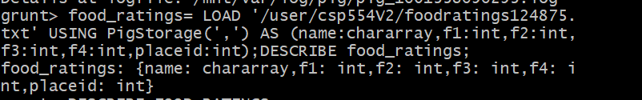

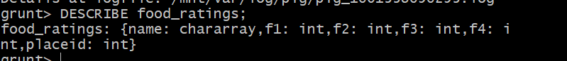

1. Creating new relation “Food_ratings_subset” from the old relation “Food_rating”

Command Used: food_rating_subset= FOREACH food_ratings GENERATE name,f4;





Displaying top 6 rows in the food_rating_subset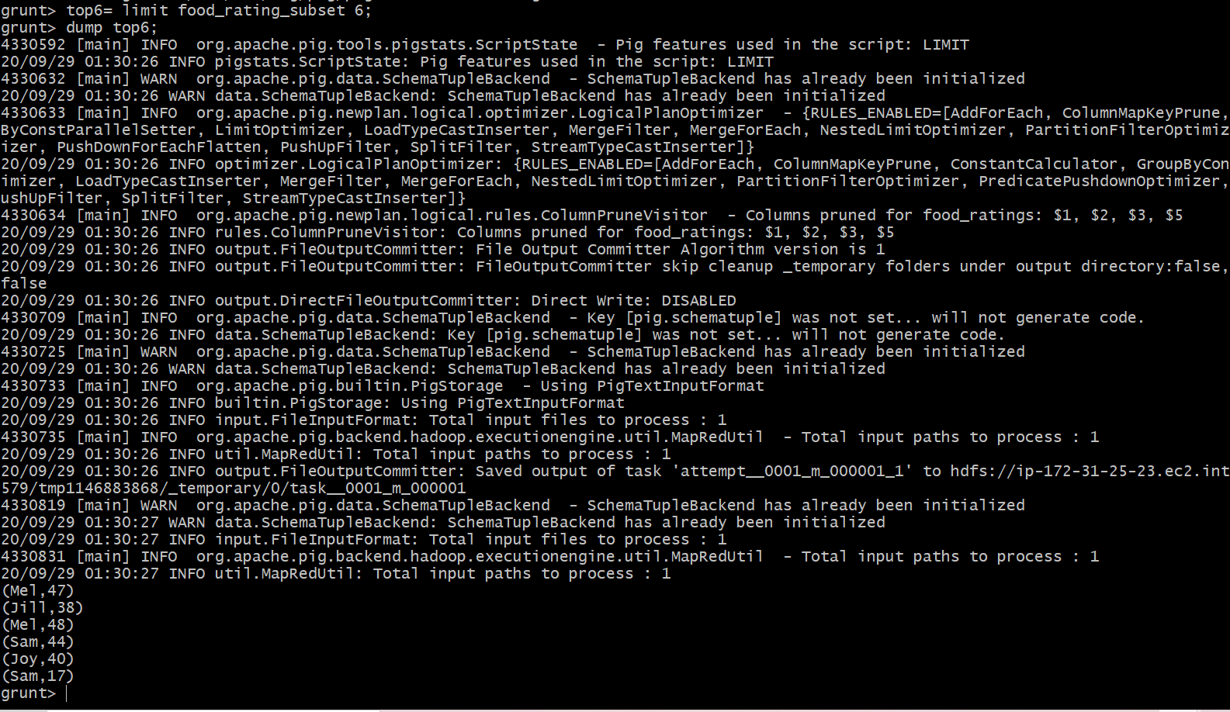

Storing the food_rating_subset to hdfs

