***1)Running TestDataGen.class***

***Magic Number:143689***



***Files Created after running***



***Created new Directory csp554***

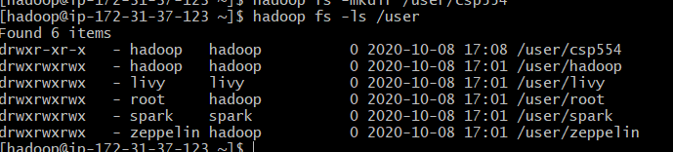

***Copied generated files foodratings143894.txt and foodplaces143894.txt into /user/csp554 as foodratings and foodplaces respectively***

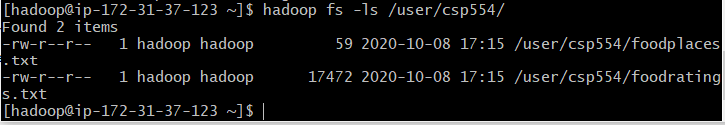

***Creating an RDD named line***

***CommandUsed: line=sc.textFile(‘/user/csp554/foodratings.txt’)***

***Line.take(5)***

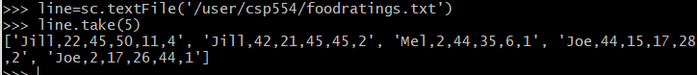

***2) Create a new RDD name ex2RDD and splitting it using “,”***

***Command Used: ex2RDD=line.map(lambda line :line.split(“,”))***

***ex2RDD.take(5)***

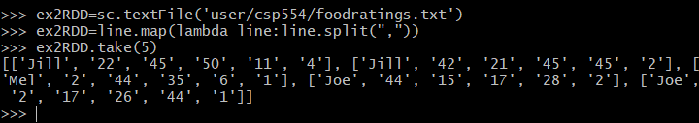

***3)*** ***Create a new RDD name ex3RDDV2 and converting third column into int***

***Command Used: ex3RDDV2=ex2RDD.map(lambda line1:[line1[0], line1[1], int(line1[2]), line1[3], line1[4], line1[5]])***

***Ex3RDDV2.take(5)***

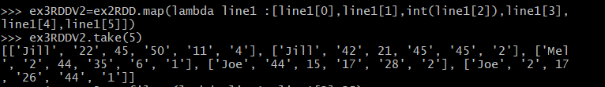

***4)*** ***Create a new RDD name ex4RDDV2 and filtering third column such that it is less than 25***

***Command Used: ex4RDDV2=ex3RDDv2.filter(lambda line1 :line1[2]<25)***

***ex4RDDV2.take(5)***

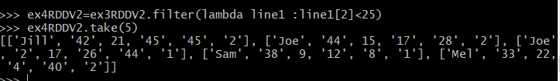

***5)*** ***Create a new RDD name ex5RDD and making the first column the key***

***Command Used: ex5RDD=ex4RDDV2.map(lambda line: [line[0],line])***

***ex5RDD.take(5)***

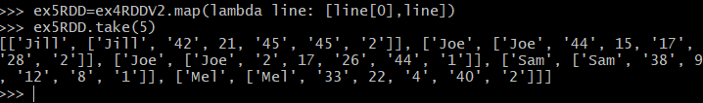

**6)** ***Create a new RDD name ex6RDD where records are ordered by ascending value of the key***

