1)

Apache Cassandra is a leading transactional, scalable, and highly-available distributed database.The wide adoption of Cassandra in big data applications is attributed to, among other things,its scalable and fault-tolerant peer-to-peer architecture, versatile and flexible data model that evolved from the BigTable data model declarative and user-friendly Cassandra Query Language (CQL), and very efficient write and read access paths that enable critical big data applications to stay always on, scale to millions of transactions per second, and handle node and even entire data center failures with ease

In RDBMS the primary focus is placed on understanding and organizing data into relations, minimizing data redundancy and avoiding data duplication. In Cassandra starts with application queries to achieve superior write and read performance

It takes a conceptual data model and maps it to a logical data model based on queries defined in an application workflow. We define the query-driven conceptual-to-logical data model mapping via data modeling principles, mapping rules, and mapping patterns

Data Modeling Principles is divided into 4 parts they are DMP1 (Know Your Data),DMP2 (Know Your Queries),DMP3 (Data Nesting),DMP4 (Data Duplication).Then we define Mapping Rules it is divided into 5 parts MR1 (Entities and Relationships),MR2 (Equality Search Attributes),MR3 (Inequality Search Attributes),MR4 (Ordering Attributes),MR5 (Key Attributes) Based on the above mapping rules, we design mapping patterns that serve as the basis for automating Cassandra database schema design

2a) Installing and starting Cassandra

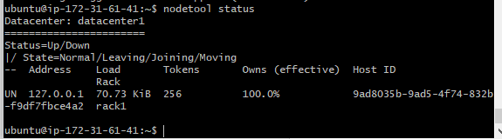

2c)

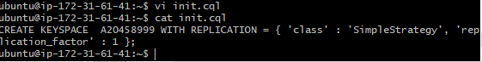

2d) 2e)

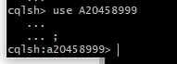

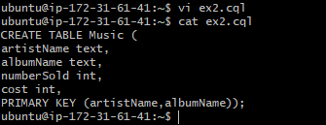

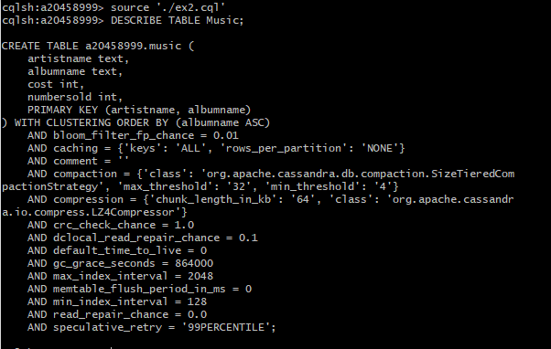

3a)

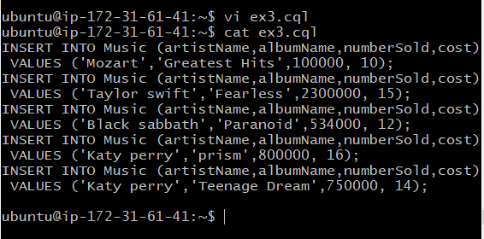

3b)

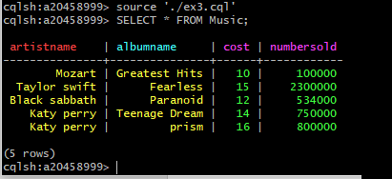

4)

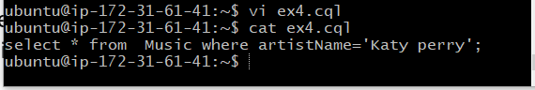

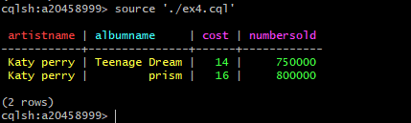

5)

