2D potential energy surface for H₂ on Si(111)
PBE-D3 single points, upright H₂ above a surface Si atom — data, method, fit and files
V. Khokhar · October 2026 · project directory Si111_H2/
This note describes a two-dimensional potential energy surface (PES) for an H₂ molecule standing upright above one surface Si atom of Si(111), computed with VASP (PBE + D3). The main data file is fit/pes_r1r2_E0.csv (1159 points). A smooth fitted surface with analytic gradients (fit/pes_model.joblib) is also available for dynamics and reaction-path work. Sections 1–3 explain how the data were made, section 4 the fit, section 5 the main results, and section 6 where everything is and how to use it.

1. System and coordinates
Surface. Si(111) slab, 24 Si atoms, periodic cell 7.680 × 6.651 × 40.406 Å (about 32 Å of vacuum). The top surface is reconstructed (Si 1, 2, 13, 14 are three-coordinated); the bottom layer is not H-passivated. All Si atoms are frozen.  Molecule. H₂ is collinear with the surface normal, directly above Si 13 (Si*), with both H atoms on that axis (a Si*–H1–H2 line).  Coordinates (Fig. 1). r1 = H1–H2 distance; r2 = height of the lower atom H1 above Si*. H2 then sits at r1 + r2 above Si*. In the scripts the same coordinates are called R (= r1) and h (= r2). All distances are in Å and energies in eV (only the figures in figs_r1r2/ use bohr).  Limits. r1 large, r2 large: two free H atoms. r1 = 0.75 Å, r2 large: gas-phase H₂. r1 large, r2 ≈ 1.5 Å: one H bonded to Si* (Si–H) and one free H. The PES connects H₂ approaching the surface with dissociative adsorption and, read backwards, with Eley–Rideal abstraction H + H–Si → H₂. | 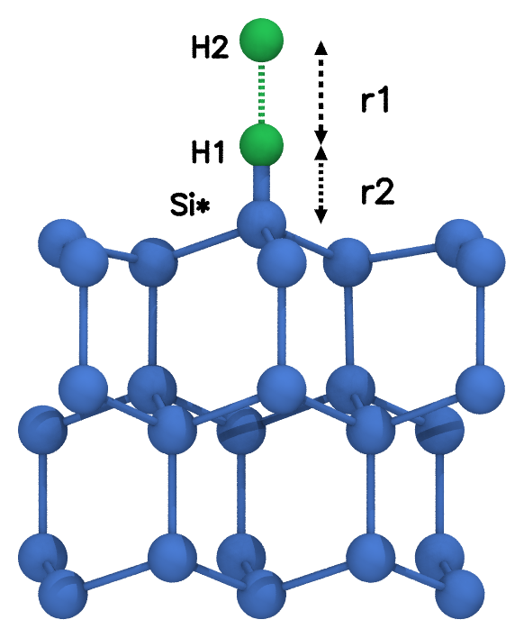  Fig. 1. Coordinates r1 and r2 (Si* = Si 13).

2. How the data were computed
Every point is a separate single-point (no relaxation) self-consistent DFT calculation. Key VASP settings:
Setting | Value | Why / note
Functional | PBE + D3(BJ) (IVDW = 12) | D3 is an additive, non-self-consistent term; PBE alone = E0 − Edisp (Edisp in OUTCAR)
Basis, precision | PAW, ENCUT = 400 eV, PREC = Normal
k-points / smearing | 16 irreducible k-points; Gaussian, SIGMA = 0.2 eV | energy used: E0 (sigma → 0)
Spin | ISPIN = 2, MAGMOM = 24*0 1 -1 | slab non-magnetic, the two H opposite (broken-symmetry singlet): correct H₂ dissociation to two atoms
Geometry | IBRION = -1, NSW = 0 | frozen slab, H positions fixed by (r1, r2)

Grid and scan procedure
29 heights r2 = 1.00–1.30 (step 0.1), 1.30–1.70 (0.05), 1.70–2.20 (0.1), 2.50–8.00 Å (0.5), each with 40 H–H distances r1 from 8.00 down to 0.25 Å (dense around 0.6–2.4 Å). Each height is one scan (directory SCF_data/<r2>/, e.g. SCF_data/1.50/): it starts at r1 = 8 Å and walks inward, each point restarting from the previous point's wavefunction and charge density. Going inward matters: starting from closed-shell H₂ and walking outward keeps the restricted solution past the point where the H₂ spin symmetry breaks and gives energies that are far too high.
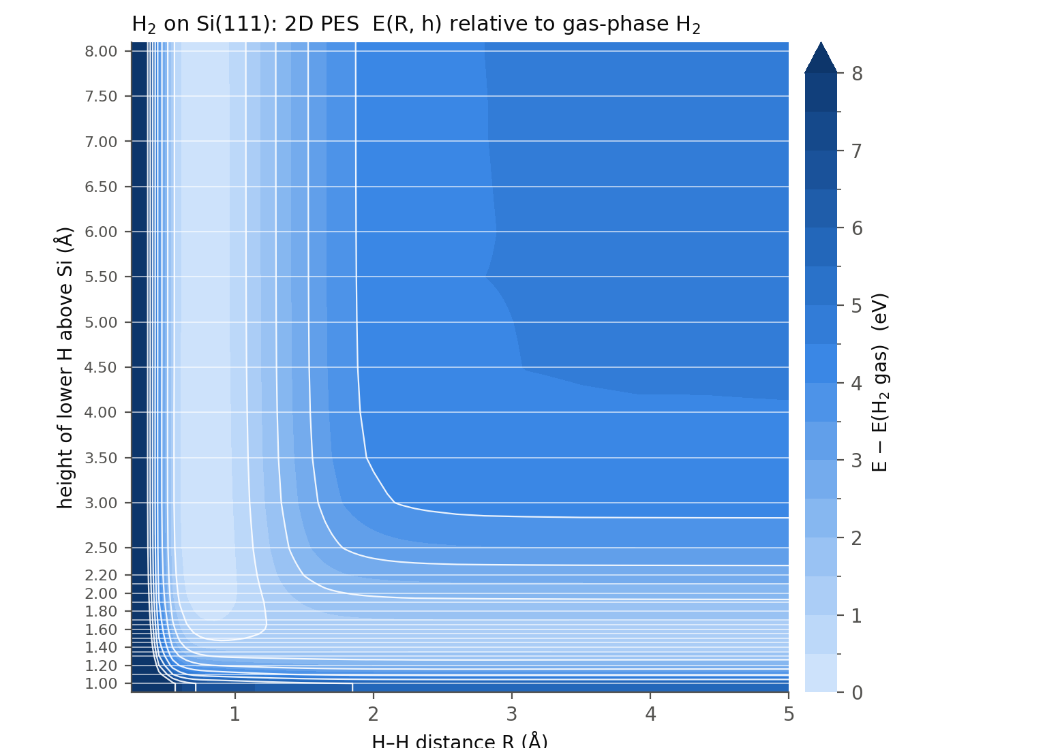
Fig. 2. The DFT data (PBE+D3) relative to gas-phase H₂. White lines: the 29 computed heights. The light valley on the left is intact H₂; the one along the bottom (r2 ≈ 1.5 Å) is H bonded to Si* with the other H free. Colours capped at 8 eV; the r1 = 0.25 Å wall reaches about 30 eV.

Slab spin state and reruns
The unpassivated slab has two nearly degenerate electronic states: a non-magnetic one and one with spin-polarized dangling bonds (about 0.2 eV lower). Almost all scan points sit in the non-magnetic state, but some SCF runs drifted partly toward polarization, which gave 10–30 meV offsets for whole rows and about 20 single points 6–42 meV too high. Decision: use the non-magnetic slab everywhere, as one consistent reference. Suspicious points were recomputed in three rerun rounds with the total spin fixed (NUPDOWN), and a rerun was accepted only if the dangling-bond Si atoms stayed non-magnetic (Σ|m| < 0.15 μ_B). 175 rerun points replaced scan values; they now live in the height directories (old scan outputs kept in R_<r1>/scan_old/). One point (r2 = 3.00, r1 = 2.60) has no trustworthy non-magnetic energy and is left out, so the data set has 1159 of 1160 points. A leave-one-out check finds no outliers (rms per row ≤ 3.1 meV).

3. The data: fit/pes_r1r2_E0.csv
Column | Meaning | Unit
r1 | H1–H2 distance (= R) | Å
r2 | height of H1 above Si* (= h) | Å
E0 | total energy of the slab + 2 H cell, PBE+D3, absolute (VASP E0) | eV

Energies are absolute; subtract a reference before use:
- Free atoms: E(r1 = 8, r2 = 8) = −129.37379 eV: two H atoms far apart and far from the surface (the zero of the fitted model).
- Gas-phase H₂: E(r1 = 0.75, r2 = 8) = −133.90415 eV, i.e. 4.530 eV below the atoms (≈ D_e of H₂). Fig. 2 and section 5 use this zero.
The full table fit/pes_data.csv has the same points with more columns: E0, Edisp (D3 part), E_pbe = E0 − Edisp, the total and H magnetic moments, SCF steps and the source (scan or rerun round). Use it to fit PBE without dispersion. Caveat: rows r2 = 3.0–4.0 Å keep 10–20 meV slab-state offsets, so features smaller than ≈ 20 meV there are within the data uncertainty.

4. Fitting the surface
The energy range (−4.5 to +30 eV) and the flat asymptotes are hard for a single machine-learning model, so the fit learns only what is left after a physical baseline (Δ-learning). With energies relative to the free atoms:
V(r1, r2) = V_HH(r1) + V_H(r2) + V_H(r1 + r2) + T(r1) T(r2) · I_GP(r1, r2) [+ D_GP(r1, r2)]
- V_HH(r1): the gas-phase H₂ curve, i.e. the r2 = 8 row of the data;
- V_H(z): one H atom against the surface, the r1 = 8 column (Si–H curve). Both 1D curves are cubic splines with an exponential repulsive wall below the grid and constant above it;
- I_GP: Gaussian-process regression (scikit-learn, Matérn 5/2 + white-noise kernel, inputs exp(−r1), exp(−r2)) on the remaining three-body part. It is exactly zero on both 1D cuts and is switched off smoothly by T between 5.5 and 8 Å, so both asymptotic channels equal the 1D curves exactly and the surface stays physical outside the grid;
- D_GP: a second, small GP for the D3 term, so dispersion can be switched off (PBE only).
Gradients are analytic (spline derivatives plus the closed-form kernel derivative; checked against finite differences to 0.01 meV/Å). The GP also returns an uncertainty σ. Quality, for energies below 3 eV above gas-phase H₂:
Test | RMSE | Max
Training error (all 1159 points) | 0.9 meV | 6.2 meV
Leave a whole height out (r2 = 1.35, 1.45, 1.55, 1.65, 2.10) | 1.0–3.4 meV | ≤ 13.4 meV
Leave out r2 = 3.50 (row with a slab-state offset) | 14 meV | 23 meV
Leave out every other r1 | 3.4 meV | 14 meV
Gas-phase H₂ from the fit | r_e 0.7509 Å, D_e 4.531 eV, ω_e 4276 cm⁻¹

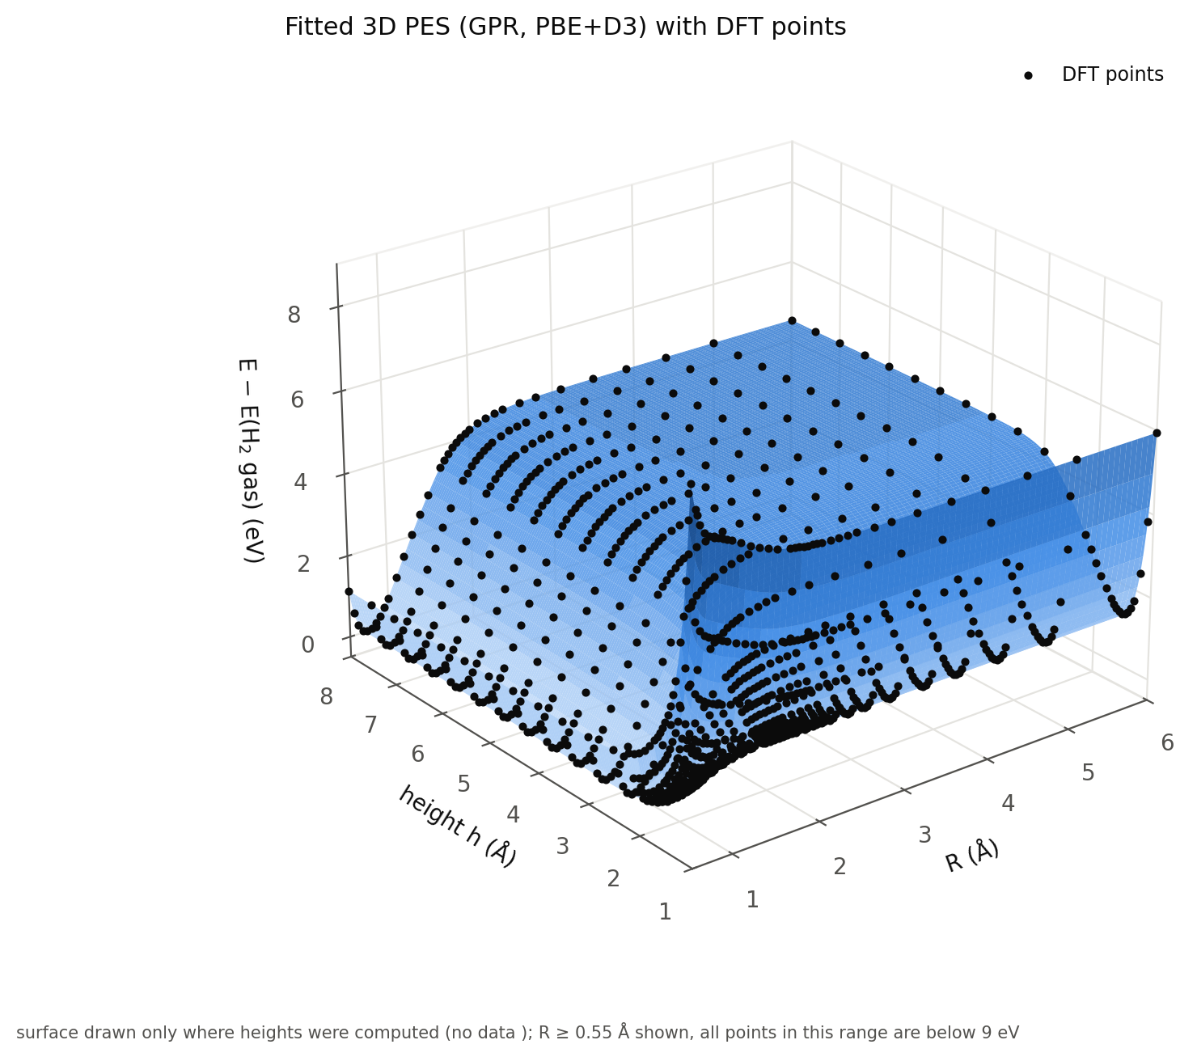  Fig. 3. Fitted surface (PBE+D3) with the DFT points. | 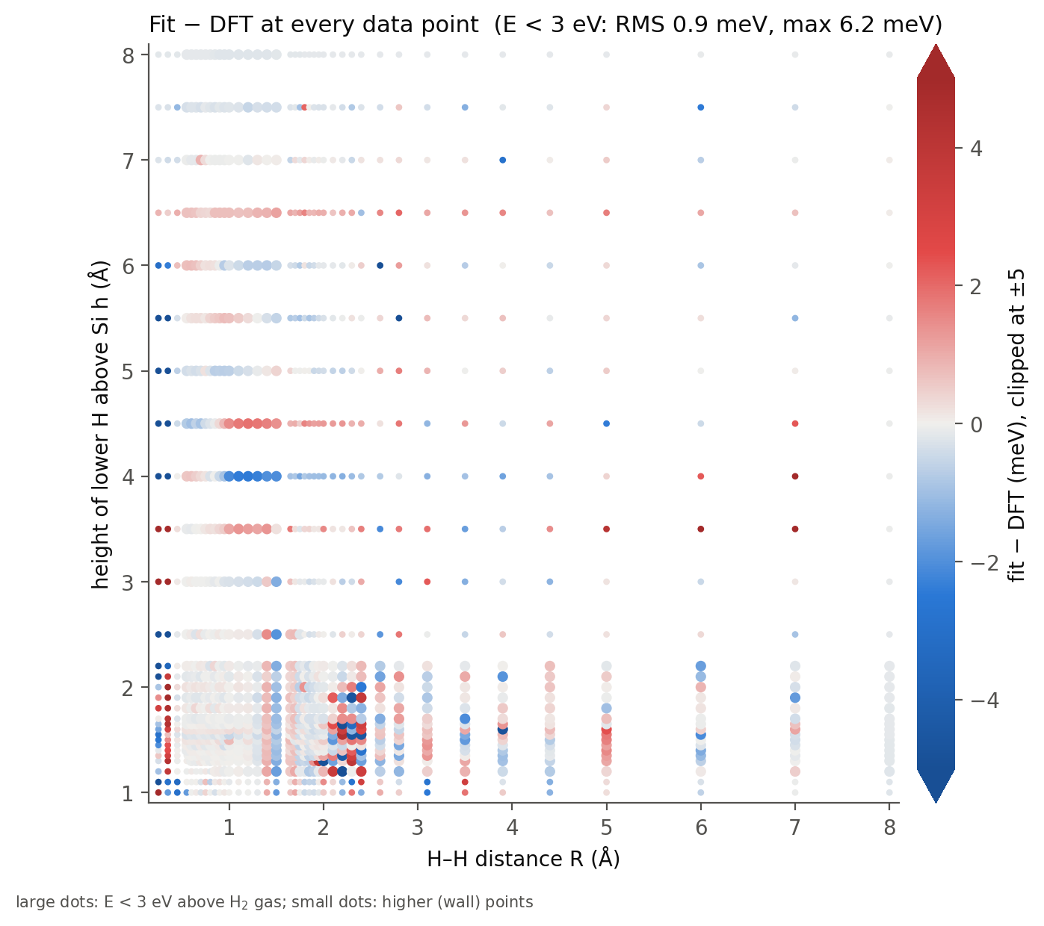  Fig. 4. Fit − DFT at every point (meV).

5. Main results (PBE+D3, relative to gas-phase H₂)
Quantity | Value
H + H–Si (r1 → ∞, r2 = 1.50 Å) | +1.277 eV (PBE: +1.245 eV)
Si–H bond (frozen slab) | 1.501 Å, binding 3.254 eV vs free H, 2022 cm⁻¹
Si–H binding with the slab relaxed (bottom bilayer fixed) | 3.159 eV (−0.095 eV)
Physisorbed H₂ | −52 meV at r2 = 2.85 Å (mostly D3)
Barrier on the minimum-energy path | none beyond 10 meV

The minimum-energy path (string method on the fitted surface, Fig. 5) has no barrier: dissociating H₂ onto Si* costs only the endothermicity of +1.28 eV, and Eley–Rideal abstraction H + H–Si → H₂ is barrierless and exothermic by the same amount in this collinear geometry. The relaxed-slab number comes from two separate relaxations (relax_*_fixbot/); the PES itself is frozen-slab.
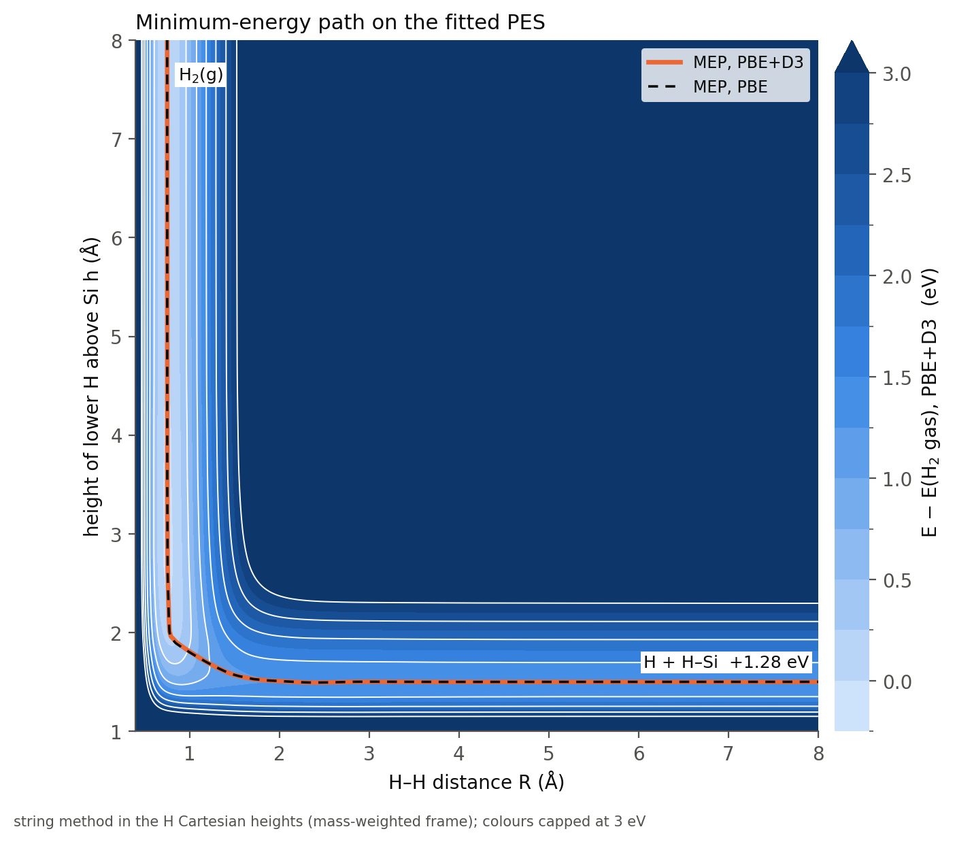  Fig. 5. Minimum-energy path on the fitted PES. | 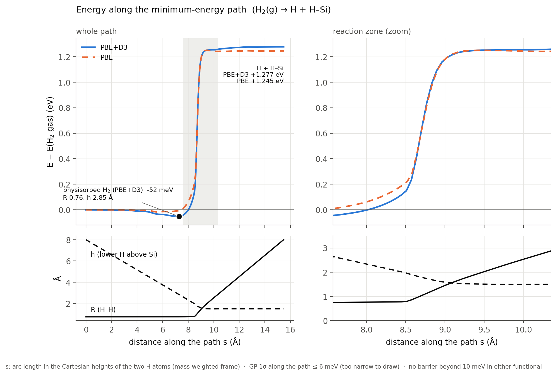  Fig. 6. Energy and coordinates along the path.

6. Where things are and how to use them
Location | Content / purpose
fit/pes_r1r2_E0.csv | main data: r1, r2, E0 (1159 points)
fit/pes_data.csv | same points, all columns (Edisp, PBE energy, moments, source)
fit/pes_model.joblib, pes_model.py | fitted PES (load with joblib; class PES)
SCF_data/<r2>/R_<r1>/ | VASP inputs/outputs of every point (INCAR, POSCAR, OUTCAR, OSZICAR); source.txt if from a rerun
SCF_data/<r2>/scan.sh, submit.example | run a height scan on the cluster (SLURM); scan.sh --check = complete?
SCF_data/<r2>/<r2>.dat | per-height table: r1, F, E0, moments, SCF steps, status
fit/collect_data.py | gathers converged points → both CSV files
fit/qc.py | leave-one-out outlier and spin-state checks → qc_report.txt
fit/fit_pes.py | fit + cross-validation → pes_model.joblib, fit_report.txt
fit/plot_fit.py, analyze.py | fit figures; MEP and energetics → analyze_report.txt
plot_pes2d3d.py, figs_r1r2/ | data maps; paper-style figures in bohr (make_figs.sh)
relax_SiH_fixbot/, relax_Si111_fixbot/ | slab relaxations, Si–H binding (summary.py, binding.py)
CLAUDE.md | detailed project notes (all settings, decisions and pitfalls)

Rebuild everything after new data: in fit/, run collect_data.py, qc.py, fit_pes.py (≈ 20 min), plot_fit.py, analyze.py. Using the fitted PES in Python (run from fit/, or put it on the path):
import joblib, pes_model # pes_model.py must be importable
pes = joblib.load('pes_model.joblib')
E = pes.energy(r1, r2, d3=True, ref='gas') # eV; ref='atoms' -> zero at free atoms
g = pes.gradient(r1, r2) # (dV/dr1, dV/dr2) in eV/A
s = pes.sigma(r1, r2) # GP uncertainty (eV)
E2 = pes.energy_com(r1, Z) # from the H2 centre-of-mass height Z
Limits of validity: frozen slab, upright H₂ on a single site (2D), PBE+D3 with a non-magnetic slab; the data cover r1 = 0.25–8 Å and r2 = 1.0–8 Å. Outside the grid the model falls back to the 1D curves (well behaved, but not checked against DFT); the gap between r2 = 2.2 and 2.5 Å and the sparser rows above are the least certain regions (see fit/sigma_map.png).

