Name Vishal Kharbanda
Class ECE 2nd Year 1
Enroll. No. 03110402816 1
x=0:0.5:4;
y=raylpdf(x,0.4);
subplot(131);
plot(x,y);
axis([0 4 0 2]);
title('alpha=0.4');
y1=raylpdf(x,0.7);
subplot(132);
plot(x,y1);
axis([0 4 0 2]);
title('alpha=0.7');
y2=raylpdf(x,1.2);
subplot(133);
plot(x,y2);
axis([0 4 0 2]);
title('alpha=1.2');
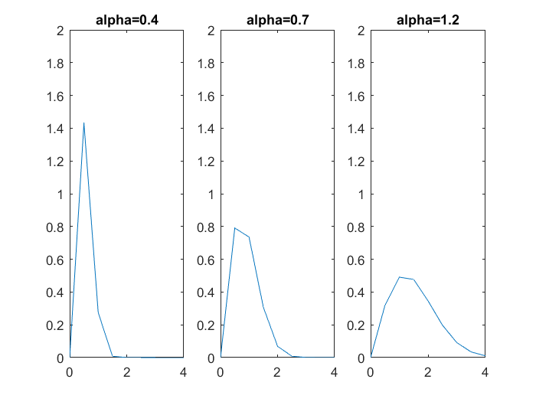
Published with MATLAB® R2016a

