Name Vishal Kharbanda

Class ECE 2nd Year

Enrollment 03110402816
x=-5:0.05:5;
y=normpdf(x,0,1); %mean=0, std deviation=1 normpdf in built function
subplot(1,3,1);
plot(x,y);
axis([-5501]);
title('mean=0,stddev=1');
y=normpdf(x,0,0.5);
subplot(1,3,2);
plot(x,y);
axis([-5501]);
title('mean=0,stddev=1');
y=normpdf(x,1,1);
subplot(1,3,3);
plot(x,y);
axis([-5501]);
title('mean=1, std dev=1');
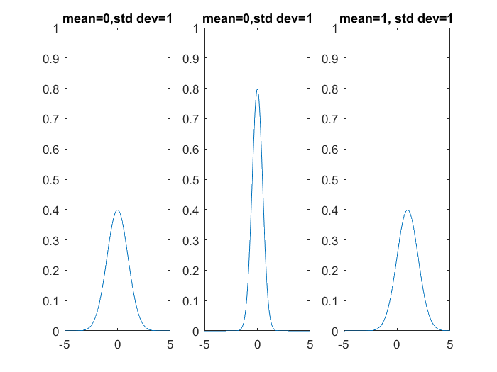
Published with MATLAB® R2016a

