Aim Generating sample values for random distributions and use of

histogram

Name Vishal Kharbanda

Class ECE 2nd Year

Enroll. No. 03110402816
y=normrnd(0,1,1,100);%Mean=0, standard deviation=1 Generates data for
x=min(y):(max(y)-min(y))/50:max(y);
subplot(1,4,1);
hist(y,x);
xlabel('samplevalues');
ylabel('no.ofsamples');
title('100samples');
y=normrnd(0,1,1,1000);
x=min(y):(max(y)-min(y))/50:max(y);
subplot(1,4,2);
hist(y,x);
xlabel('samplevalues');
ylabel('no.ofsamples');
title('1000samples');
y=normrnd(0,1,1,10000);
x=min(y):(max(y)-min(y))/50:max(y);
subplot(1,4,3);
hist(y,x);
xlabel('samplevalues');
ylabel('no.ofsamples');
title('10000samples');
y=normrnd(0,1,1,100000);
x=min(y):(max(y)-min(y))/50:max(y);
subplot(1,4,4);
hist(y,x);
xlabel('samplevalues');
ylabel('no.ofsamples');
title('100000 samples');
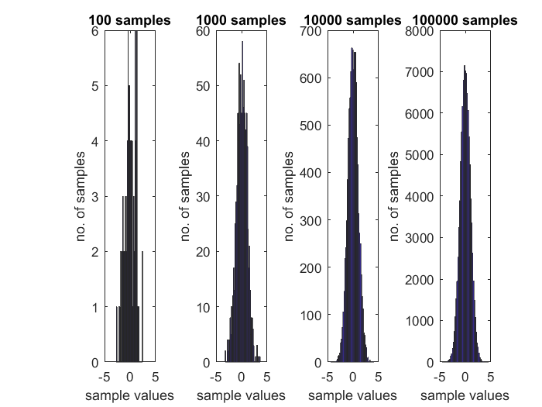
Published with MATLAB® R2016a

