Amplitude modulation : DSB-SC and SSB

Name-Vishal Kharbanda

encrolment no -03110402816
fc=2000;
fs=10000;
f=200
t=0:1/fs:((2/f)-(1/fs));
x=cos(2*pi*f*t);
y_dsb_sc=modulate(x,fc,fs,'amdsb-sc');
y_ssb=modulate(x,fc,fs,'amssb');
subplot(221);
plot(t,x);
y=cos(2*pi*fc*t);
subplot(222);
plot(t,y);
y1=x.*y;
subplot(223);
plot(t,y_ssb);
subplot(224);
plot(t,y_dsb_sc);
f =
200
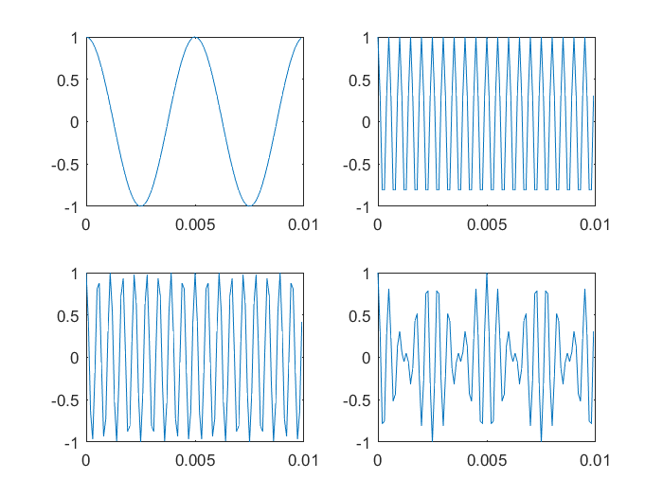
Published with MATLAB® R2016a

