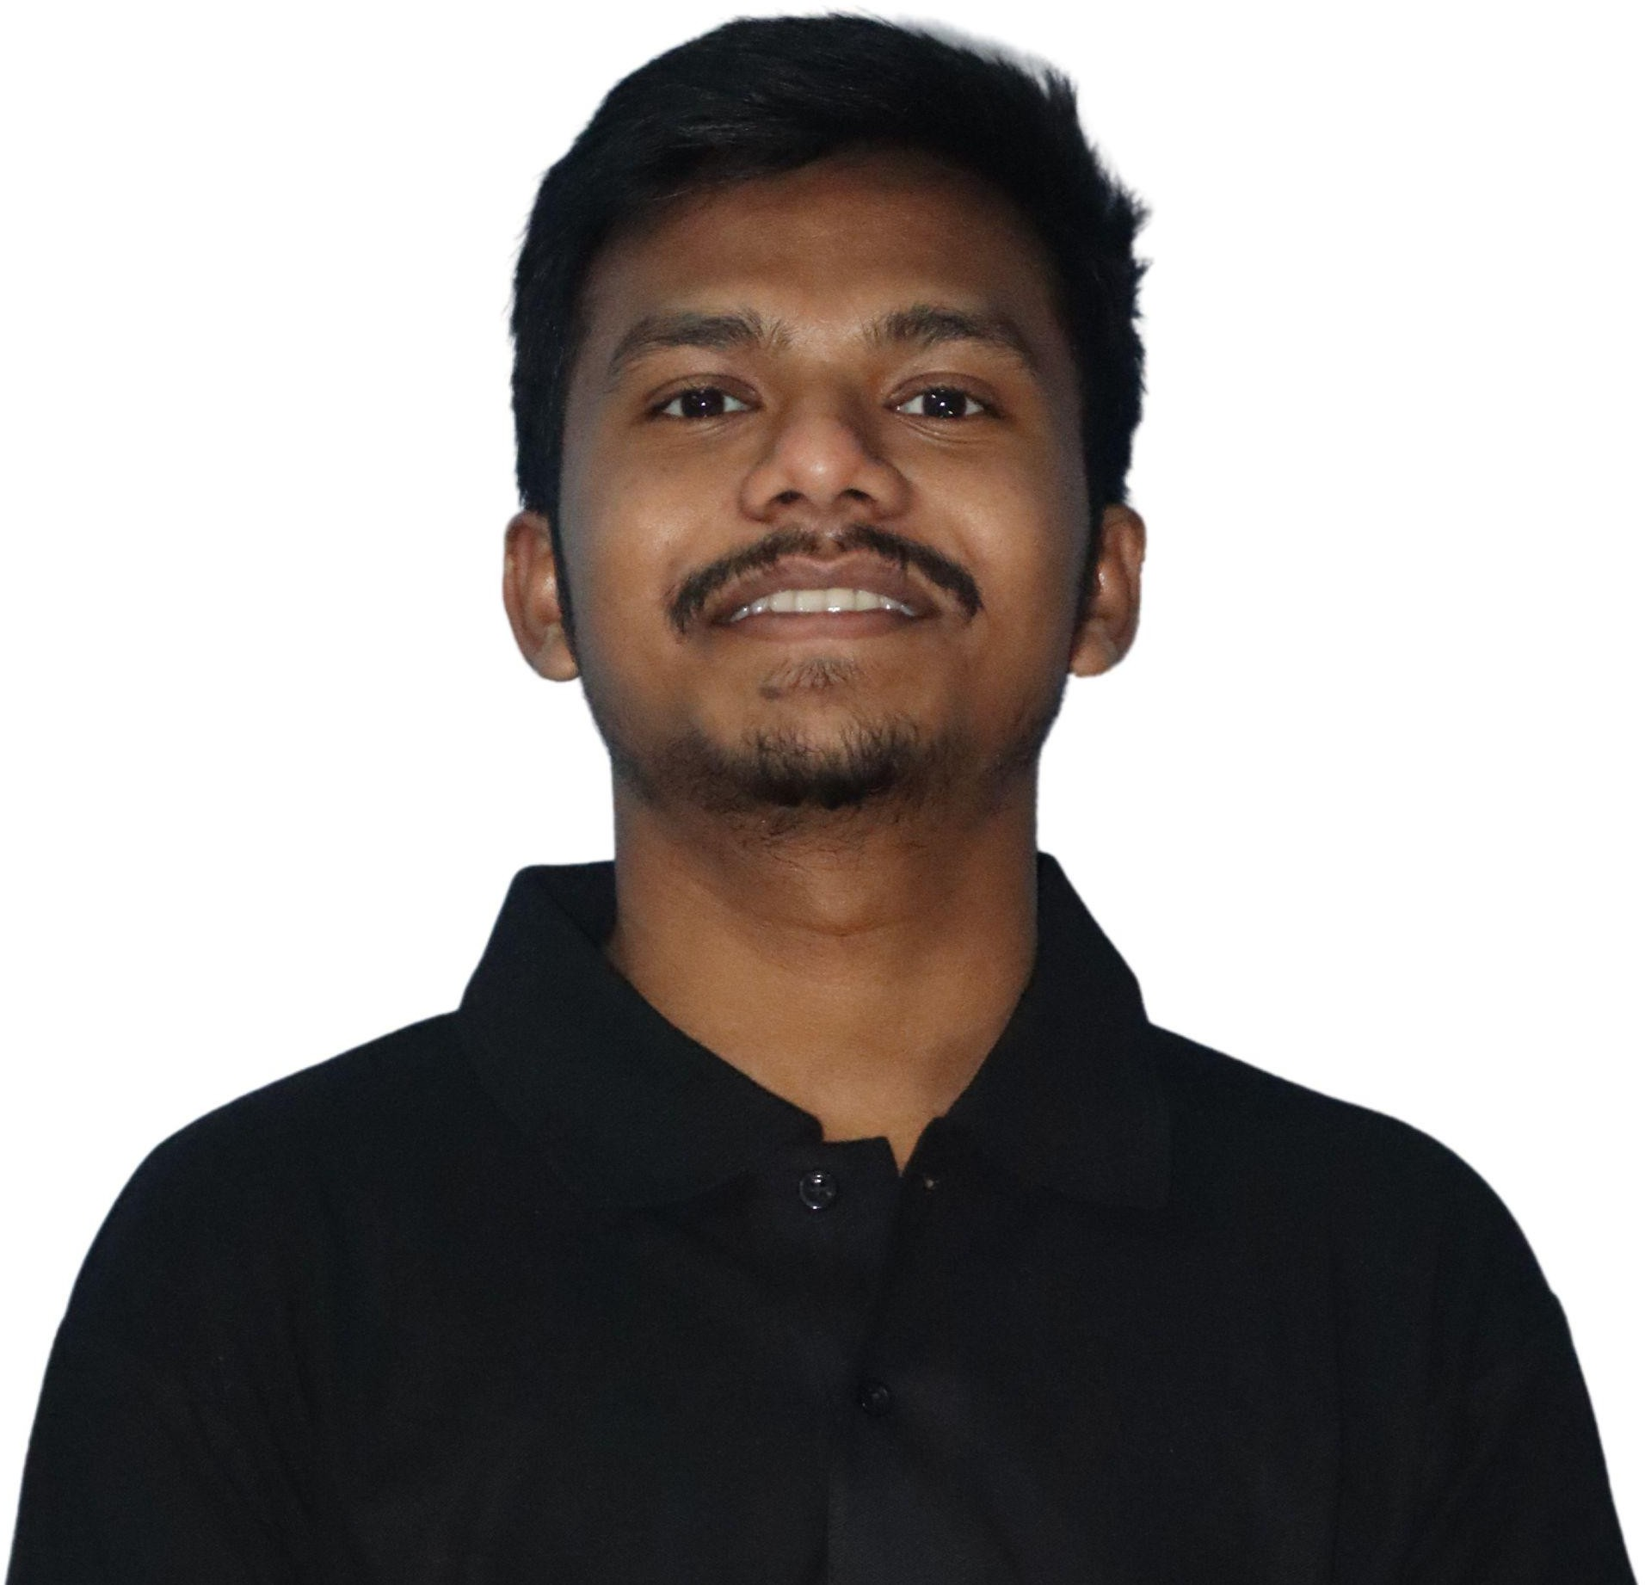

**Vishal Bhojraj Khandate**

• +91 7263934782 • [khandate.vishal03@gmail.com](mailto:khandate.vishal03@gmail.com) • [LinkedIn](https://www.linkedin.com/in/vishal-khandate-a059831a0/) • [GitHub](https://github.com/vkinsane) • [LeetCode](https://leetcode.com/vishal_khandate2001/)

**OBJECTIVE**

A motivated fresher capable of fast learning and innovative thinking. I am seeking a role in an organization where I can contribute to my fullest potential.

**EDUCATION**

**Vishwakarma Institute of Technology, Pune CGPA: 8.83**

Bachelor of Technology August 2019 - May 2023

**Dr. Ambedkar College, Nagpur** **71.23%**

12th State Board July 2017 - May 2019

**Jawahar Navodaya Vidyalaya, Gondia** **91%**

10th CBSE Board July 2012 - May 2017

**TECHNICAL SKILLS**

**Programming Languages**: C, C++, Python 3.6, JavaScript, HTML, CSS, MERN.

**Databases**: MySQL, MongoDB.

**Tools and Frameworks**: Netlify, Heroku, React, Express.js, Flask.

**PROJECTS**

**Event Management Platform**

* Developed a web application in the 4-person team for managing the attendance of the audience in events/bootcamps organized by the club. (Developer Students Club - HTML, CSS, JS)

**Promotional Website**

* Developed a website for cold-pressed oil company Arogyam for business purposes. (Developer Students Club - HTML, CSS, JS)

**Time Table Linker**

* A software used to make convenient timetables for joining any online meet with a single click. (C++).

**ComicCart**

* A web application for a comic seller to sell comics online. (MERN).

**EXPERIENCE**

**Developer Students club** Jun 2020 – May 2022

Web Developer

* Taught Encapsulation concept (OOP) to 100+ students virtually on Bevy in C++ Bootcamp organized in March 2021.
* Taught React Lifecycle Methods to 110+ students virtually on Bevy in Web Bootcamp organized in April 2021
* Created full-stack production-grade applications as a full-stack developer in the club.

**EXTRACURRICULAR ACTIVITIES**

* Volunteered in Atmabodh, a digital literacy program to teach primary school teachers to use online teaching platforms.
* Donated Blood to a regional blood bank in a college campaign.