Review of Random Variables and Random Process

- Mathematically a random variable is neither random nor a variable
- It is a mapping from sample space into the realline ( “real-valued ”random variable) or the complex plane ( “complex-valued ”random variable) .

Suppose we have a probability space 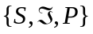).
Let 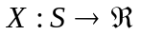be a function mapping the sample space into the real line such that
For each 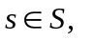there exists a unique 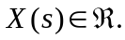 Then  is called a random variable.
Thus the a random variable associates the points in the sample space with real numbers.

Probability Distribution Function
We can define an event 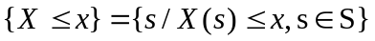
- 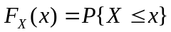 is called the probability distribution function.
- 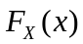 is a nondecreasing function of 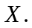
- is right continuous
=> approaches to its value from right.
- 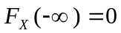
- 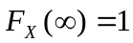

Probability Density Function
If is differentiable 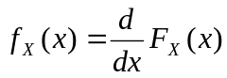 is called the probability density function and has the following properties.
- 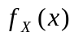 is a non- negative function
- 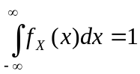
- 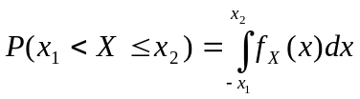

Joint random variable

and are two random variables defined on the same sample space .
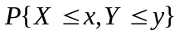 is called the joint distribution function and denoted by 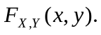
Given we have a complete description of the random variables and 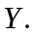

- 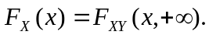

To prove this

Similarly 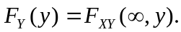
- Given each of 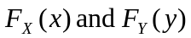 is called a marginal distribution function.

We can define joint probability density function
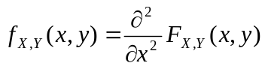
- 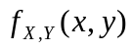is always a positive quantity.
- 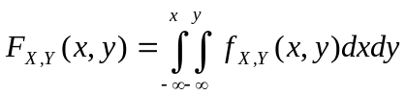

Conditional density function: -

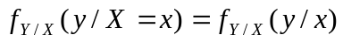 is called conditional density of given
The conditional density is defined in the limiting sense as follows
Because 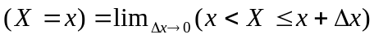

The right hand side in equation (1) is
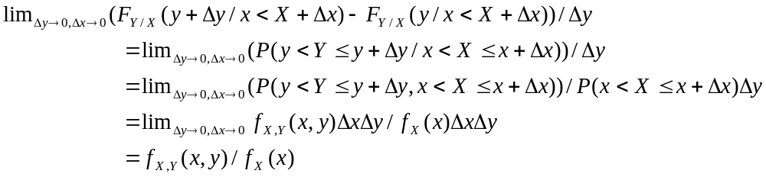

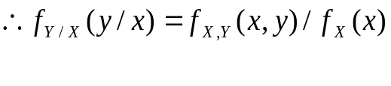 (2)

Similarly we have

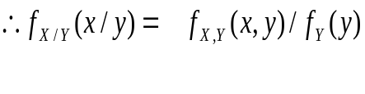 (3)

From (2) and (3) we get Baye’s rule

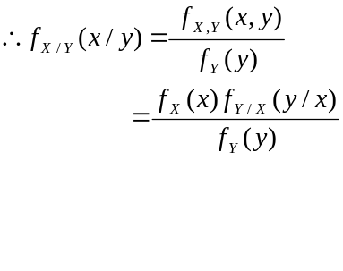 (4)
Given the joint density function we can find out the conditional density function.

Marginal density functions

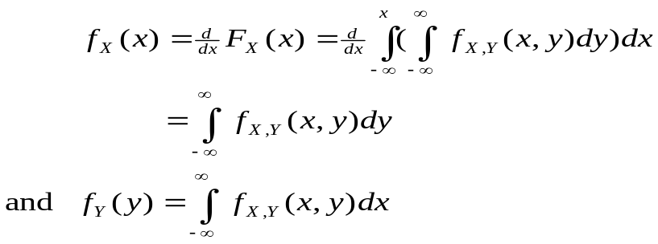
Independent R.V.

Let and be two random variables characterised by the joint densify junction

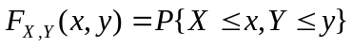
and 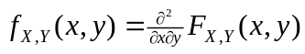

Then and are independent if
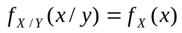
and equivalently
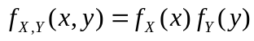
where 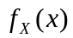 and 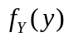 are called the marginal density functions.

Moments of Random Variables

Expected value

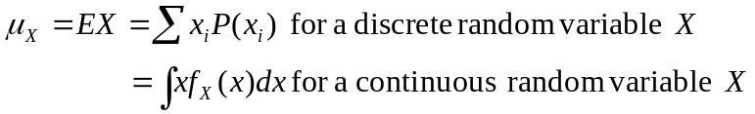

Second moment
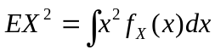

Variance 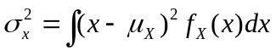

Central moment

For two random variables and

The joint expectation is defined as
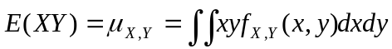

The correlation between random variables and 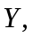 measured by the covariance , is given by

The ratio 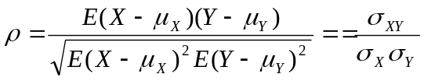
Correlation measures how much two random variables are similar.
Uncorrelated random variables

Random variables and are uncorrelated if covariance
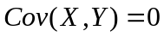

Two random variables may be dependent, but still they may be uncorrelated. If there exists correlation between two random variables, one may be represented as a linear regression of the others or not. Correlation in terms of linearity

Linear prediction 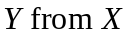
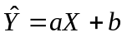 Regression
Prediction error 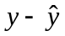
Mean square prediction error
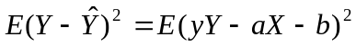
For minimising the error will give optimal values of 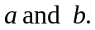 Corresponding to the optimal solutions for 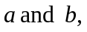 we have
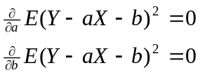
Solving for 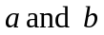
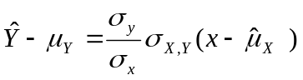
and 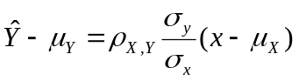
where 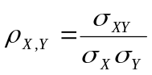 is the correlation coefficient.
If 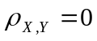then 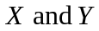are uncorrelated.
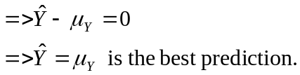

Note that independence => Uncorrelatedness. But uncorrelated generally does not imply independence (except for jointly Gaussian random variables).

Example:
are dependent, but they are uncorrelated.
Because 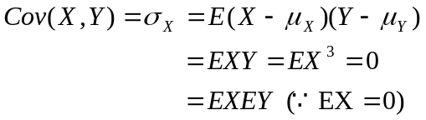
In fact for any zero- mean symmetric distribution of X, 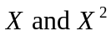are uncorrelated .

Vector space Interpretation of Random Variables

The set of all random variables defined on a sample space form a vector space with respect to addition and scalar multiplication.
This is very easy to verify.

Linear Independence
Consider the sequence of random variables 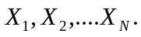
If 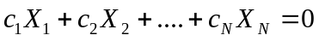 implies that
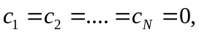 then are linearly independent.

Statistical Independence.
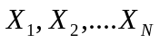 are statistically independent if

Statistical independence in the case of 0- mean random variables also implies
linear independence

Inner Product

If and are real vectors, the inner product 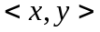 is a scalar such that
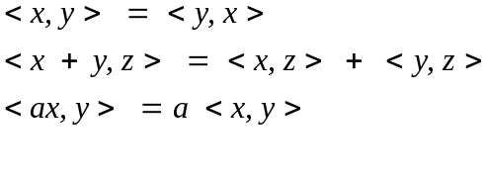
In the case of RVs, inner product between x & y is defined as
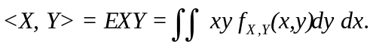

Magnitude / Norm of a vector
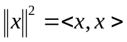
So for R.V.
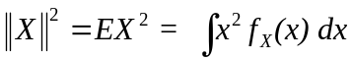

The set of RVs along with the inner product defined through the joint expectation operation and the corresponding norm defines a Hilbert Space.

Schwary Inequality :
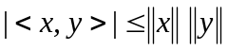

For RV
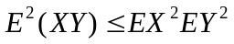
Proof:
Consider the random variable 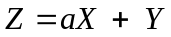
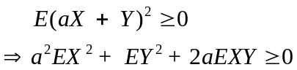.
Nonnegatively of the left-hand side => its minimum also must be non negative.
For the minimum value,
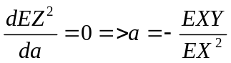
so the corresponding minimum is
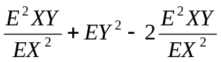
Minimum is nonnegative =>
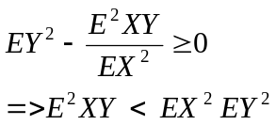

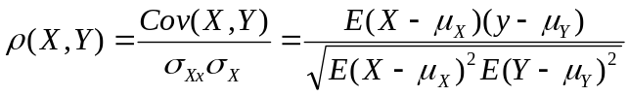
From schwarz inequality
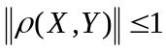

Orthogonal RVs

Recall the definition of orthogonality. Two vectors 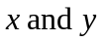 are called orthogonal if
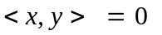
Similarly two random variables are called orthogonal if
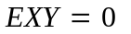
If each of is zero-mean

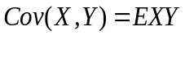
Therefore if 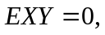then 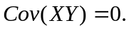

For zero-mean random variables,
Orthogonal ⬄ uncorrelatedness

Orthogonality Principle
is a random variable which is not observable.
is another observable random variable which is statistically dependent on .
Given a value of what is the best guess for ? (Estimation problem).

Let the best estimate be 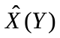

Then 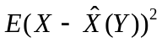 is a minimum with respect to .
And the corresponding estimation principle is called minimum mean square error principle. For finding the ninimum, we have

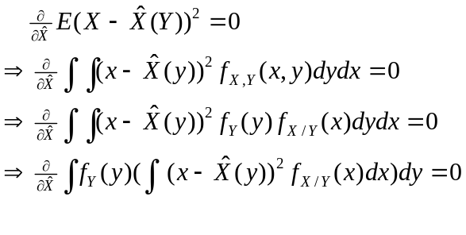
Since 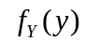 in the above equation is always positive, therefore the minimization is equivalent to

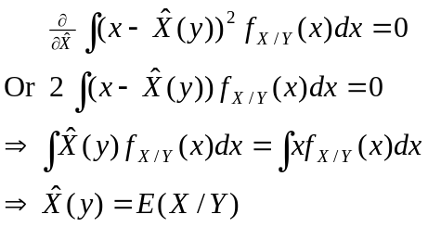

Thus the minimum mean-square error estimation involves conditional expectation which is difficult to obtain numerically.

Let us consider a simpler version of the problem. We assume that 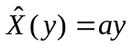and the estimation problem is to find the optimal value for Thus we have the linear minimum mean-square error criterion which minimizes 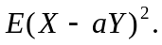

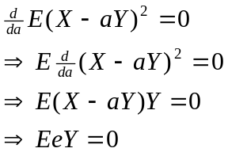

where is the estimation error.

The above result shows that for the linear minimum mean-square error criterion, estimation error is orthogonal to data. This result helps us in deriving optimal filters to estimate a random signal buried in noise.

