Chebysev Inequality

The standard deviation gives us an intuitive idea how the random variable is distributed about the mean. This idea is more precisely expressed in the remarkable Chebysev Inequality stated below.
For a random variable with mean 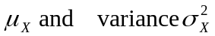

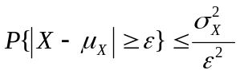
Proof:
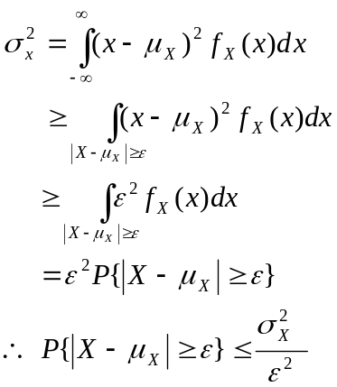

Convergence of a sequence of random variables
Consider a deterministic sequence 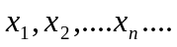 The sequence onverges to a limit if correspond to any 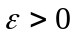we can find n₀ such that
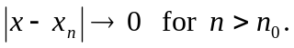
Convergence of a random sequence 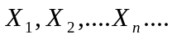 cannot be defined as above. A sequence of random variables is said to converge everywhere to if
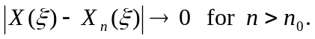
Almost sure (a.s.) convergence
For the random sequence
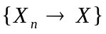this is an event.
If 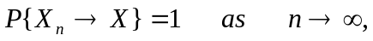 then the squence is said to converge t o almost sure or with probability 1.

Convergence in mean square sense:
If 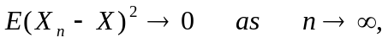we say that the squence convergence to in mean .

Convergence in probability: -
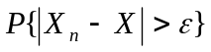is a sequence of probability. If this sequence of probability is convergent that is
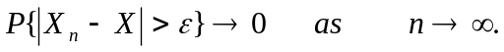
If a sequence is convergent in mean, then it is convergent in probability also

Because
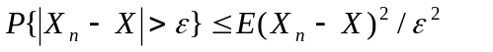
If 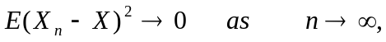 (mean square convergent) then 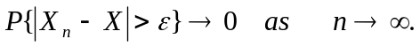

Convergence in distribution: -
The sequence is said to converge to in distribution if
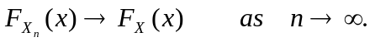
The two distribution function coincides.

Central Limit Theorem
Consider independent random variables 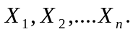
Let 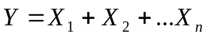
Then 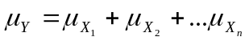
And 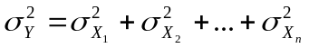
The central limit theorem states that under very general conditions converges to 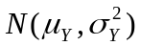 as .

Jointly Gaussian Random variables

Two random variables 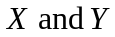 are called jointly Gaussian if their joint density function is
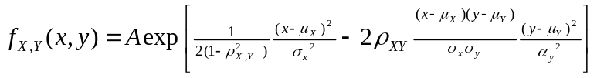
where 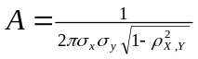
Properties :
(1) If and are jointly Gaussian, then for any constants and 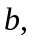 then the random variable 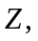
given by 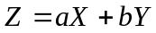 is Gaussian with
mean 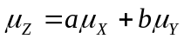
and variance 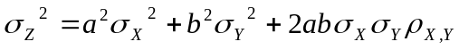
- If two jointly Gaussian r.v.s. are uncorrelated, 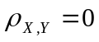 then they are statistically independent.
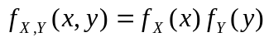.
- If 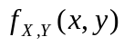 is a jointly Gaussian distribution, then the marginal densities
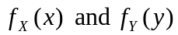 are also Gaussian.

- If and are joint by Gaussian random variables then the optimum nonlinear estimator 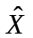 of that minimizes the mean square error 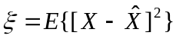
is a linear estimator 