**Step-by-step guide**

The process is identical for both Designer and server (except one will need credentials in order to remote into an administrator account on the server machine)

In order to build an Alteryx workflow which can extract text from PDFs, first we need to have the packages pdftools and Rcpp installed

In order to install the above packages in R console of the Alteryx

We need to navigate to the following file path…

C:\Program Files\Alteryx\R-3.4.4\bin ( the path may be different on Server but Analogy Is same, in the Alteryx folder there will be R folder)

*The R version may change, so R-3.4.4 may not always be the correct sub-folder, in fact the path should be seen as…

C:\Program Files\Alteryx\R-VERSIONNUMBER\bin*

Find the following file ‘R.exe’ (if you have file extensions hidden, this will just be ‘R’.

Right click on this executable file and hit ‘Run as administrator’. As seen below

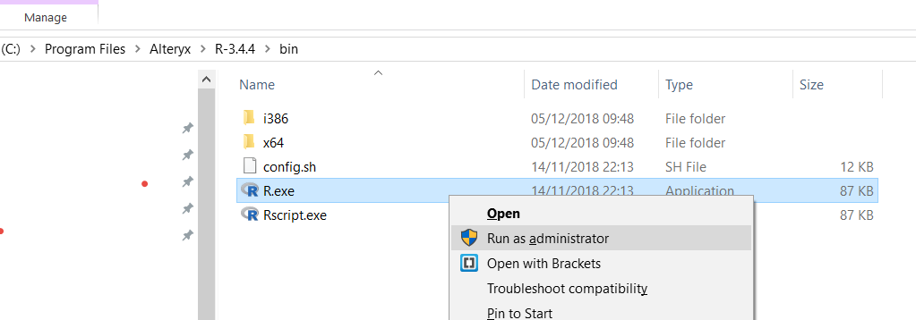

You may get a windows prompt asking if you want to allow this app to make changes, hit ‘Yes’.

Then R Console will open

Then install the packages **Rcpp** and **pdfTools** by using the following Commands

install.packages(“Rcpp”)

install.packages(“pdftools”)

It may ask for choosing Source CRAN Mirrors Choose **USA Ca** or any USA source

Once installation successful you can see the messages as follows

