***ENGINE DATA ACQUISITION AND CONTROL SYSTEM***

***SOP***

# INDEX

**1. Start the Application**

**2. Select Project**

**2.1 Reset**

**2.2 Select Testing Parameters**

**2.3 Start Engine**

**2.4Stop Engine**

**3. Engine Running Status**

**4. Show Data Files**

**5. Login**

**Login -> Supervisor**

**6. Close the application after Test Completion**

**GUIDELINES:**

This document provides engine testing procedure for operators. This document contains information and instructions.

**INTRODUCTION:**

The Engine Data Acquisition & Control System

**OVERVIEW:**

1. **Start the Application.**
2. **Select Project.**
3. **AutoCycle**
4. **Start the cycle.**
5. **Close the Application after test completion.**

# 1. Start the Application

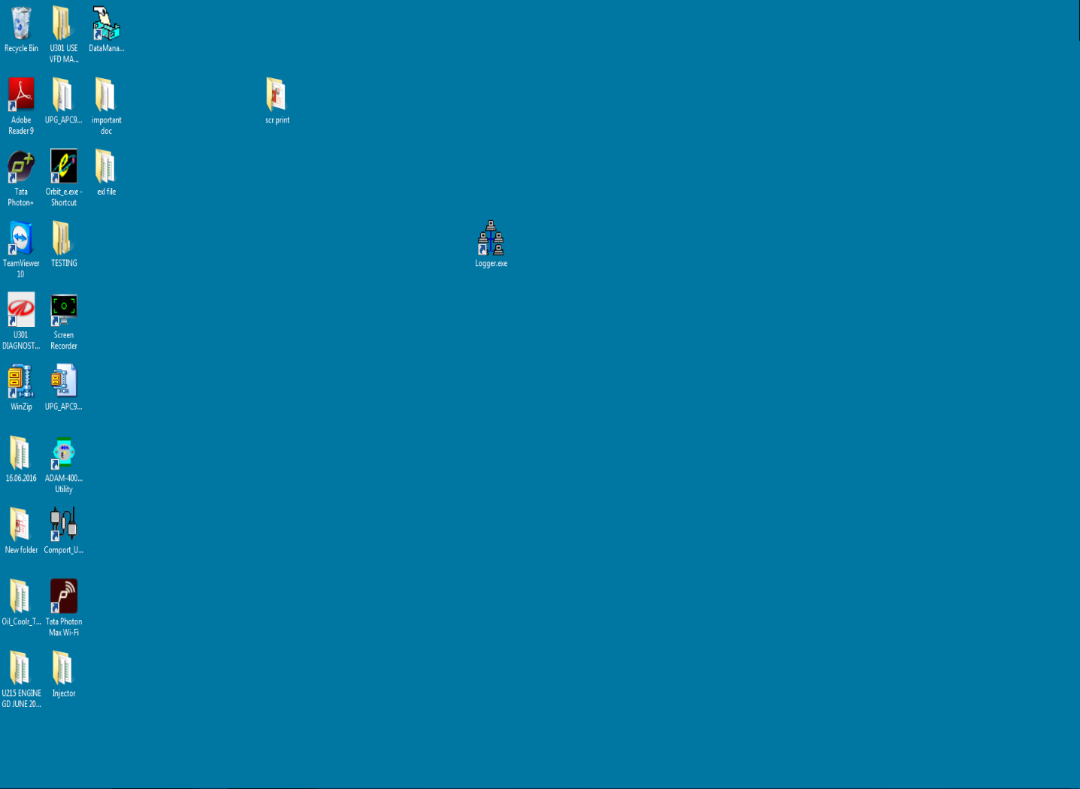

### Start the Application by clicking on the icon Logger.exe (highlighted in a box)

# 2. Select Project

## 2.1 Reset (Auto)

Click on Reset Button to select testing parameters.

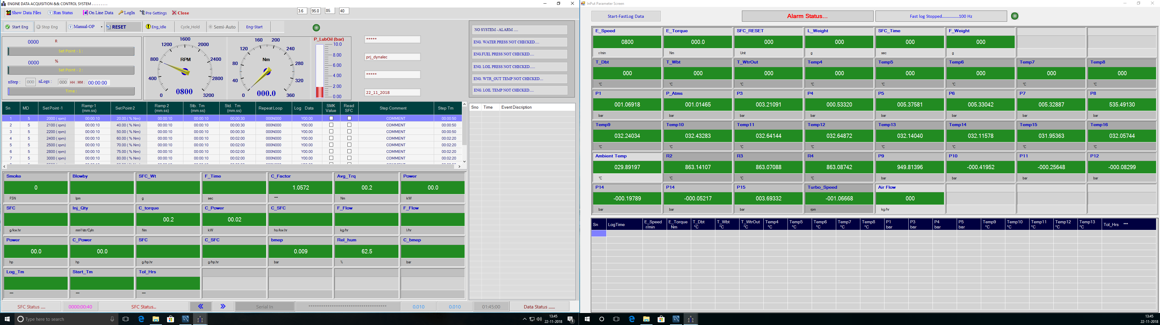

## 2.2 Select Testing Parameters.

Select testing Parameters.

Select Project here.

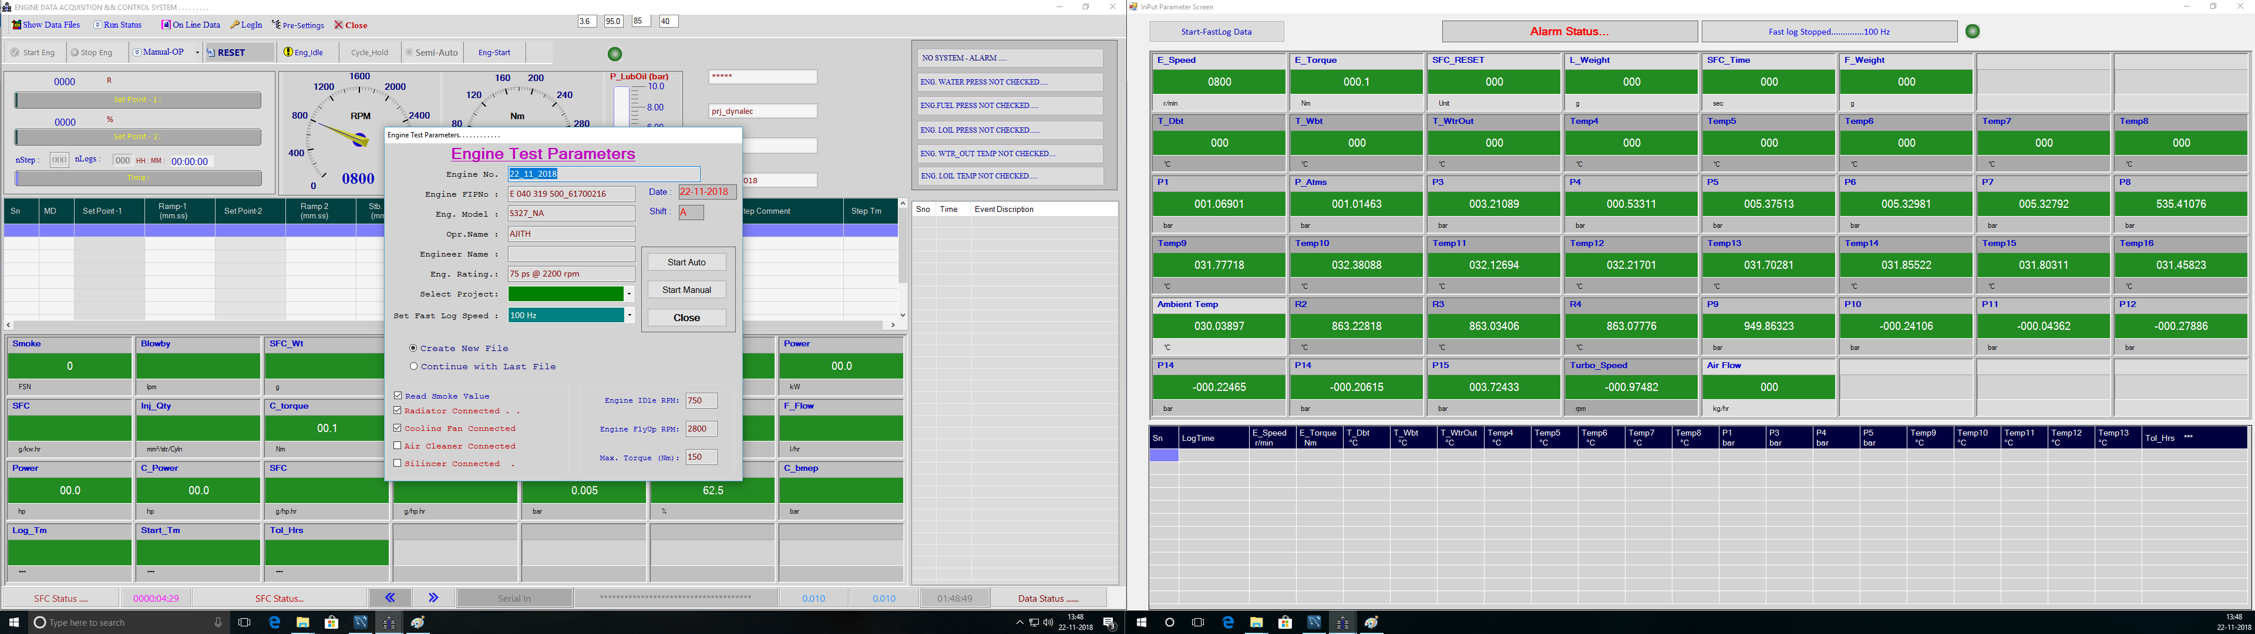

Click on Start Auto after selecting engine test Parameters

## 2.2 Begin Cycle/Click on Start

F

Steps Loaded.



## 2.3 Start Engine by clicking on Start Eng. Button.

F

Click on Start button to start the cycle after steps loaded.



Start Eng button gets enabled after Reset.

## 2.4 Stop the Engine

F

Click here to stop the engine.

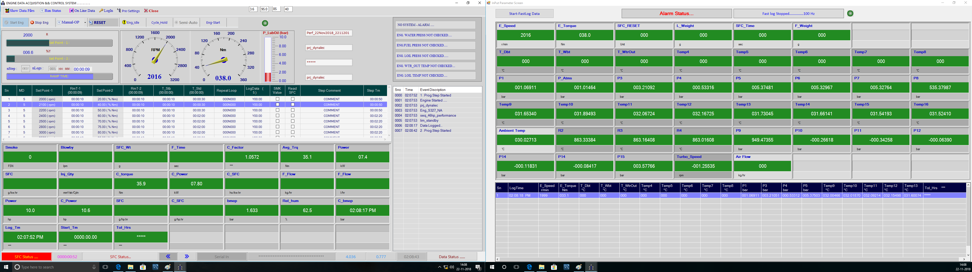

## 2.5 Engine OK

F

Click on OK.

F

Click on Yes.

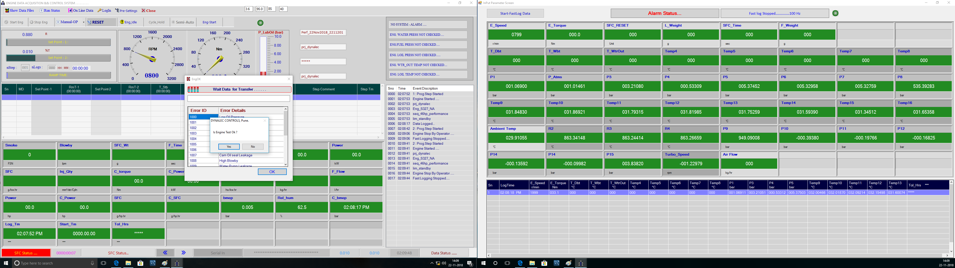

## 2.6 Reset (Manual)

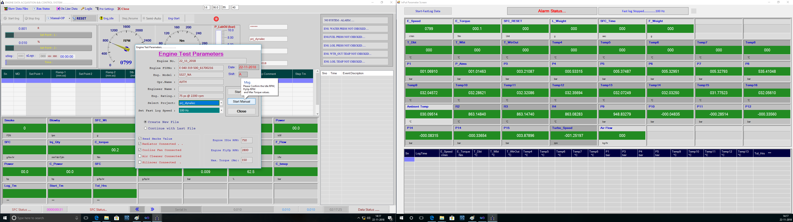

Click on Start Manual after selecting Project name.

### **Manual Test Mode**

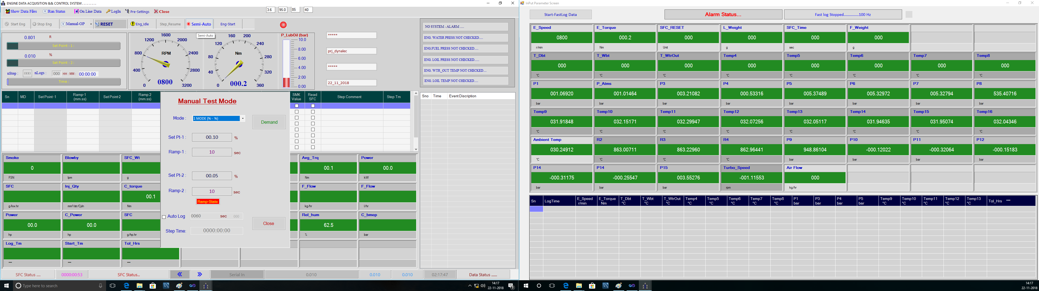

Enter values for set points and ramp time and click on Demand button.

# 3. Engine Running Status

Click on Run Status to see the saved data.

F

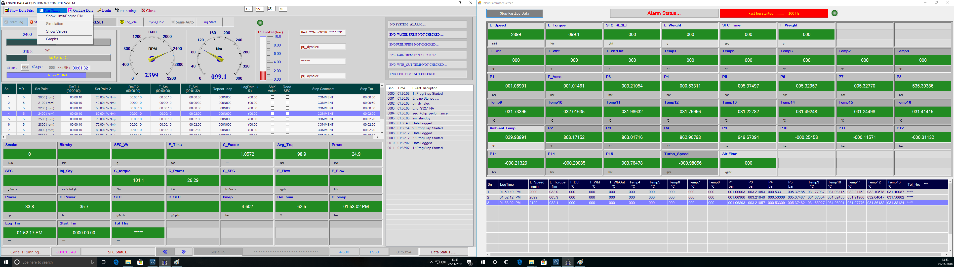

* Engine running status includes general saved data, PM data.

# 4. Show Data Files

Show Data Files -> Excel Formats -> Select File

Select month to open files of respective month.

F

Saved Data Files. Click on the file name to be open.

F

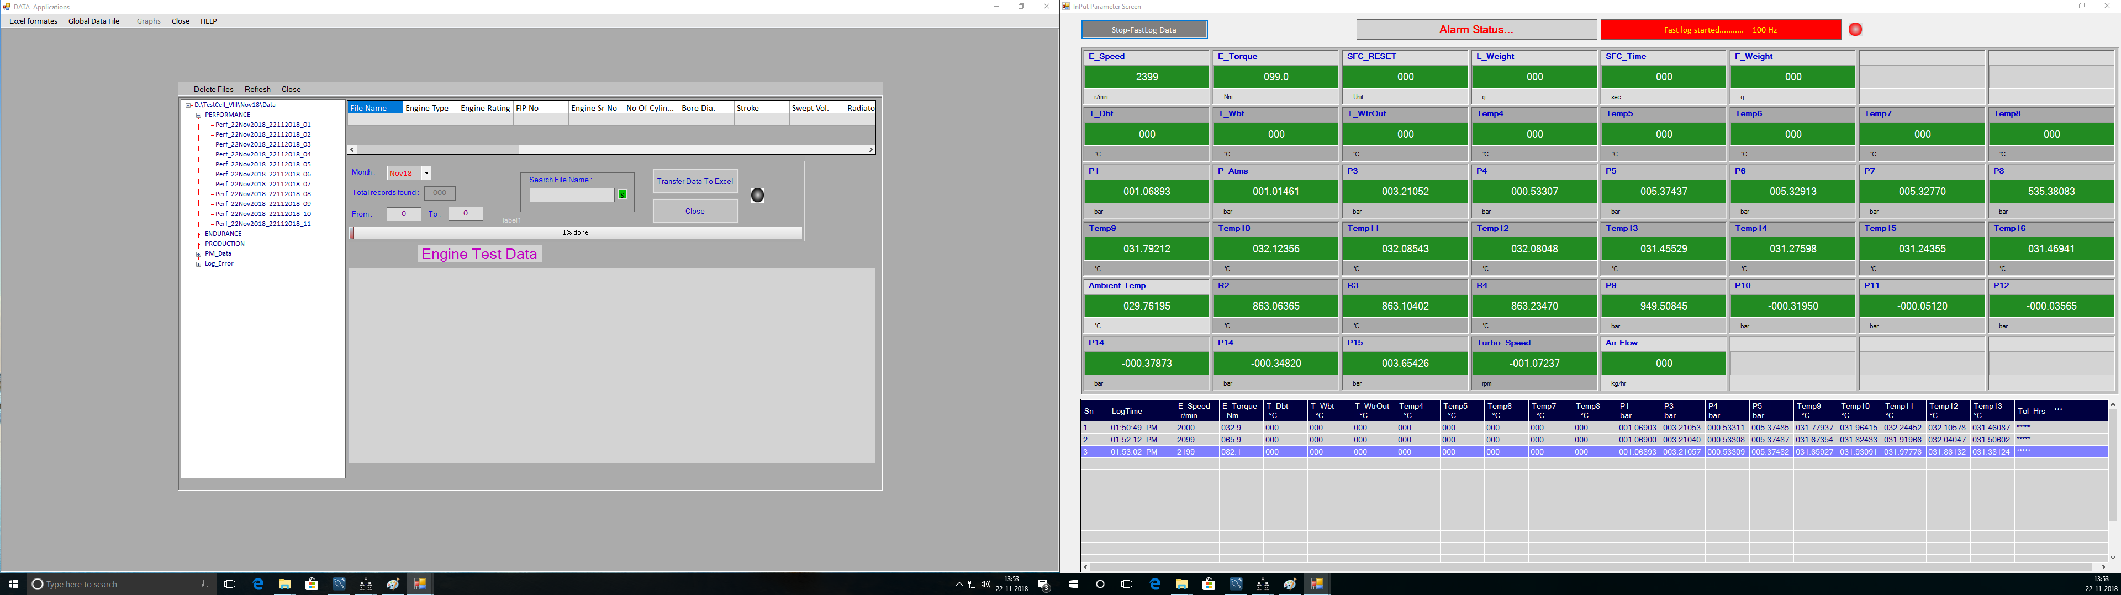

# 5. Login

## Login -> Supervisor

Click on Login Menu it will open login window. Select Supervisor as user name and enter password click on Ok to login as Supervisor for Port Configuration.

F

Click on Login to login as Supervisor.

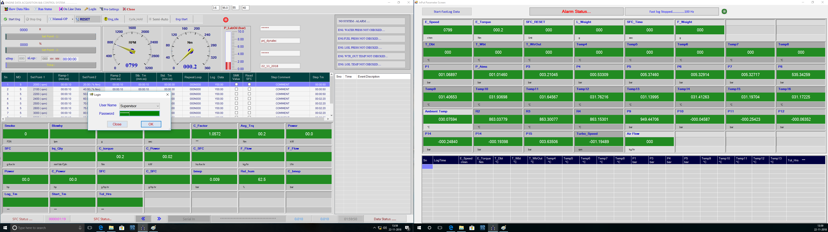

By login as a Supervisor **Project** and **Editor** will get enabled.

# 6. Close the Application after Test Completion.

F

Close the Application After Test Completion.

