**I – Flow Chart (sơ đồ luồng xử lý)**

**1 – Sign In**



**2 – Create Tour Category**



**3 – Update Tour Category**



**4 – Create Tour**



**5 – Update Tour**



**6 – Search Tour**



**7 – Search Comment**



**8 – Delete Tour**



**II – Entity Attribute**













**III – Table Definition**

**1 – Tour_Category**

|  |  |  |  |  |  |  |  |
| --- | --- | --- | --- | --- | --- | --- | --- |
| **Key** | **Field Name** | **Data Type** | **Length** | **Allow Null** | **Default value** | **Table-Field-Ref** | **Description** |
| PK | **TourCTID** | varchar | 30 | No |  |  | Tour Category ID |
|  | TourCGTitle | nvarchar | 50 | No |  |  | Tour Category Title |
|  | Destination | nvarchar | 50 | No |  |  | Tour Destination |
|  | DurationFrom | Smallint |  | No |  |  | Smallest Tour Duration Allowed |
|  | DurationTo | smallint |  | No |  |  | Biggest Tour Duration Allowed |
|  | PriceFrom | float |  | No |  |  | Lowest Tour Price Allowed |
|  | PriceTo | float |  | No |  |  | Highest Tour Price Allowed |
|  | Vehicles | nvarchar | 100 | No |  |  | Sorts Of Vehicles Allowed |
|  | Status | nvarchar | 20 | No |  |  | Tour Category’s Status |

**2 – Tours**

|  |  |  |  |  |  |  |  |
| --- | --- | --- | --- | --- | --- | --- | --- |
| **Key** | **Field Name** | **Data Type** | **Length** | **Allow Null** | **Default value** | **Table-Field-Ref** | **Description** |
| PK | **TourID** | varchar | 30 | No |  |  | Tour ID |
|  | TourCGID | varchar | 30 | No |  | Tour_Category(TourCGID) | Tour Category ID |
|  | TourTitle | nvarchar | 70 | No |  |  | Tour Title |

**3 – Schedule**

|  |  |  |  |  |  |  |  |
| --- | --- | --- | --- | --- | --- | --- | --- |
| **Key** | **Field Name** | **Data Type** | **Length** | **Allow Null** | **Default value** | **Table-Field-Ref** | **Description** |
| PK | **ScheduleID** | varchar | 30 | No |  |  | Schedule ID |
|  | Title | nvarchar | 100 | No |  |  | Title |
|  | Content | nvarchar | max | No |  |  | Actiity content in a specific duration or day |
|  | Image | varchar | 100 | Yes |  |  | Representation Image of a specific day or activity |

**4 – TourDetail**

|  |  |  |  |  |  |  |  |
| --- | --- | --- | --- | --- | --- | --- | --- |
| **Key** | **Field Name** | **Data Type** | **Length** | **Allow Null** | **Default value** | **Table-Field-Ref** | **Description** |
| PK | **TourDTID** | varchar | 30 | No |  |  | Tour Detail ID |
|  | TourID | varchar | 30 | No |  | Tours  (TourID) | Tour ID |
|  | EvenTourPrice | float |  | No |  |  | Tour Price For Group Reserve Customers |
|  | OddTourPrice | float |  | No |  |  | Tour Price for Odd Reserve Customers |
|  | DepartureDate | nvarchar | 100 | No |  |  | Available Days To Departure |
|  | HotelRank | tinyint |  | No |  |  | Hotel Rank |
|  | DeparturePoint | nvarchar | 50 | No |  |  | Departure Place |
|  | Destination | nvarchar | 50 | No |  |  | Destination |
|  | Vehicle | nvarchar | 50 | No |  |  | Vehicle Used To Move To The Tour’s Destination |
|  | Duration | tinyint |  | No |  |  | Total Time The Tour Will Be Last |
|  | ScheduleID | varchar | 100 | No |  | Schedule  (ScheduleID) | Schedule |
|  | MaximumTicket | tinyint |  | No |  |  | Maximum Of Ticket Could Receive On A Tour |
|  | Status | varchar | 30 | No | Activating |  | Tour Status |

**5 – SmallOddReserveTour**

|  |  |  |  |  |  |  |  |
| --- | --- | --- | --- | --- | --- | --- | --- |
| **Key** | **Field Name** | **Data Type** | **Length** | **Allow Null** | **Default value** | **Table-Field-Ref** | **Description** |
| PK | **SmallORTID** | varchar | 30 | No |  |  | Small Group Of Odd Reserve Customer’s ID |
|  | CustomerID | varchar | 30 | No |  | Customers  (CustomerID) | Customer ID |
|  | ReserveDate | datetime |  | No |  |  | Tour Reserved Date |
|  | DepartureDate | datetime |  | No |  |  | Departure Date |
|  | IsKid | tinyint |  | No |  |  | Number Of Kid between 5 To 12 Years Old |
|  | IsBaby | tinyint |  | No | 0 |  | Number Of Kid Under 5 Years Old |
|  | NumberOfPeople | tinyint |  | No |  |  | Number Of Customer |
|  | TourID | varchar | 30 | No |  | Tours  (TourID) | Reserved Tour ID |
|  | Status | nvarchar | 100 | No |  |  | Status Of Customer Group Reserved Tour |

**6 – OddReserveTour**

|  |  |  |  |  |  |  |  |
| --- | --- | --- | --- | --- | --- | --- | --- |
| **Key** | **Field Name** | **Data Type** | **Length** | **Allow Null** | **Default value** | **Table-Field-Ref** | **Description** |
| PK | **OddRTID** | varchar | 30 | No |  |  | Odd Reserve Customer’s ID |
|  | TourID | varchar | 30 | No |  | Tours  (TourID) | Tour ID |
|  | CustomerID | varchar | 30 | No |  | Customers  (CustomerID) | Customer ID |
|  | SmallORTID | varchar | 30 | No |  | SmallOddReserveTour  (SmallORTID) | Small Group Of Odd Reserve Customer’s ID |
|  | IsKid | tinyint |  | No |  |  | Number Of Kid between 5 To 12 Years Old After Merged Into A Group |
|  | IsBaby | tinyint |  | No | 0 |  | Number Of Kid Under 5 Years Old After Merged Into A Group |
|  | NumberOfPeople | tinyint |  | No |  |  | Number Of Customer After Merged Into A Group |
|  | DepartureDate | datetime |  | No |  |  | Departure Date |
|  | Status | nvarchar | 100 | No |  |  | Status Of Customer Group Reserved Tour |

**7 – EvenReserveTour**

|  |  |  |  |  |  |  |  |
| --- | --- | --- | --- | --- | --- | --- | --- |
| **Key** | **Field Name** | **Data Type** | **Length** | **Allow Null** | **Default value** | **Table-Field-Ref** | **Description** |
| PK | **EvenRTID** | varchar | 30 | No |  |  | Group Of Reserve Customer’s ID |
|  | TourID | varchar | 30 | No |  | Tours  (TourID) | Tour ID |
|  | CustomerID | varchar | 30 | No |  | Customers  (CustomerID) | Customer ID |
|  | RerserveDate | datetime |  | No |  |  | Small Group Of Odd Reserve Customer’s ID |
|  | IsKid | tinyint |  | No |  |  | Number Of Kid between 5 To 12 Years |
|  | IsBaby | tinyint |  | No | 0 |  | Number Of Kid Under 5 Years Old |
|  | NumberOfPeople | tinyint |  | No |  |  | Number Of Customer |
|  | DepartureDate | datetime |  | No |  |  | Departure Date |
|  | Status | nvarchar | 100 | No |  |  | Status Of Customer Group Reserved Tour |

**8 – RatingTour**

|  |  |  |  |  |  |  |  |
| --- | --- | --- | --- | --- | --- | --- | --- |
| **Key** | **Field Name** | **Data Type** | **Length** | **Allow Null** | **Default value** | **Table-Field-Ref** | **Description** |
| PK | **RatingID** | varchar | 30 | No |  |  | Rating ID |
|  | RerservedTourID | varchar | 30 | No |  | Tours  (TourID) | Reserved Tour ID |
|  | CustomerID | varchar | 30 | No |  | Customers  (CustomerID) | Customer ID |
|  | Title | nvarchar | 100 | No |  |  | Title Of Rating Content |
|  | Description | nvarchar | max | No |  |  | Content Of Rating |
|  | Status | Varchar | 20 | No | Valid |  | Status Of Rating |
|  | StarsRated | float |  | No |  |  | Number Of Star Rated |

**VI – Sequence Diagram**

**1 – Create New Tour Category**

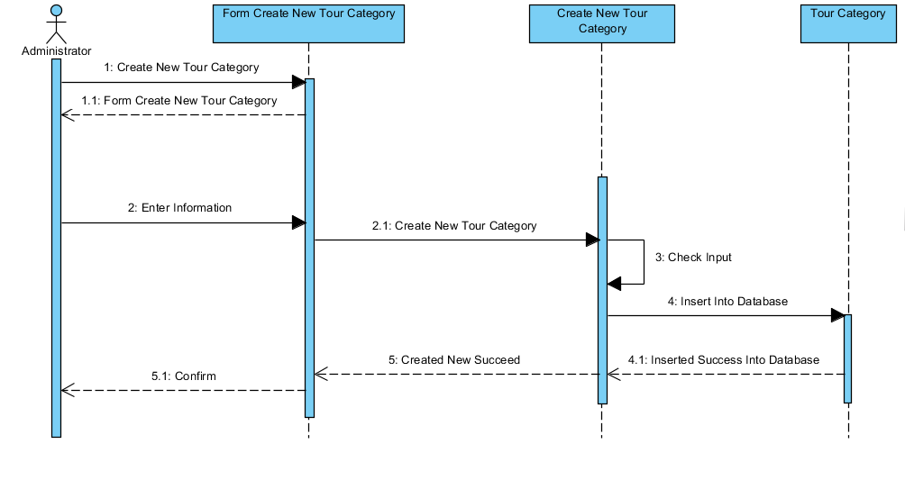

**2 – Update Tour Category**

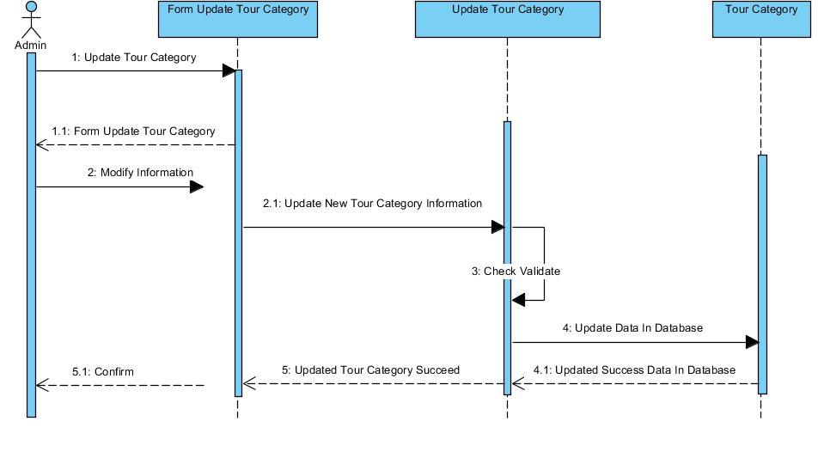

**3 – Create New Tour**

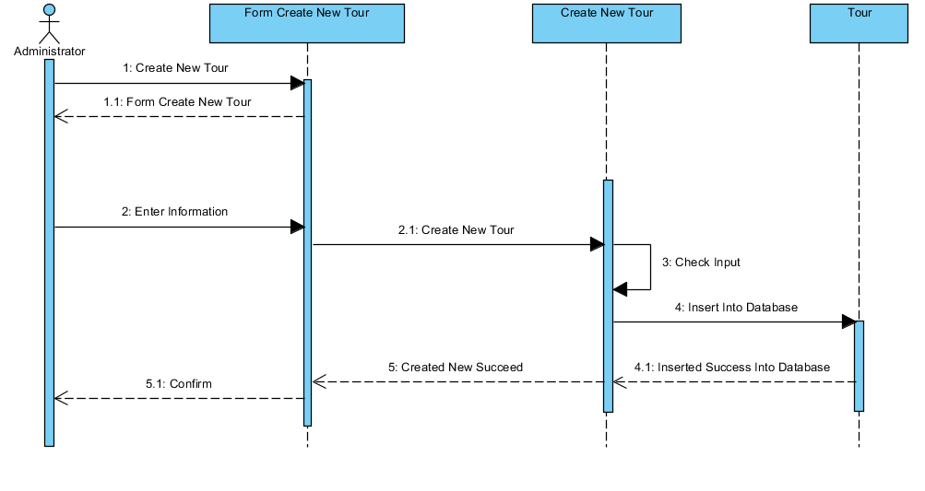

**4 – Update Tour**

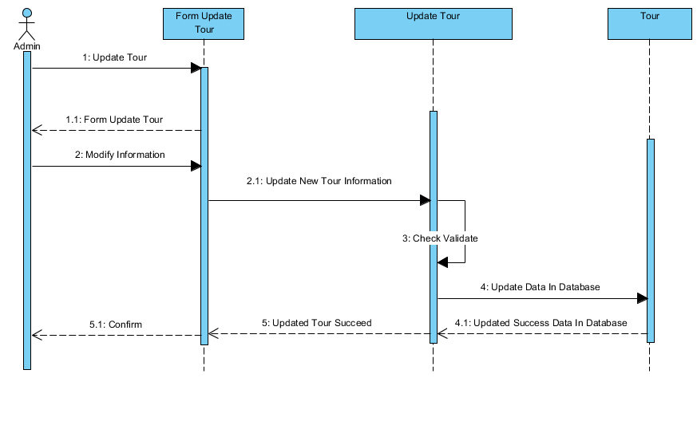

5 – Delete Tour Category

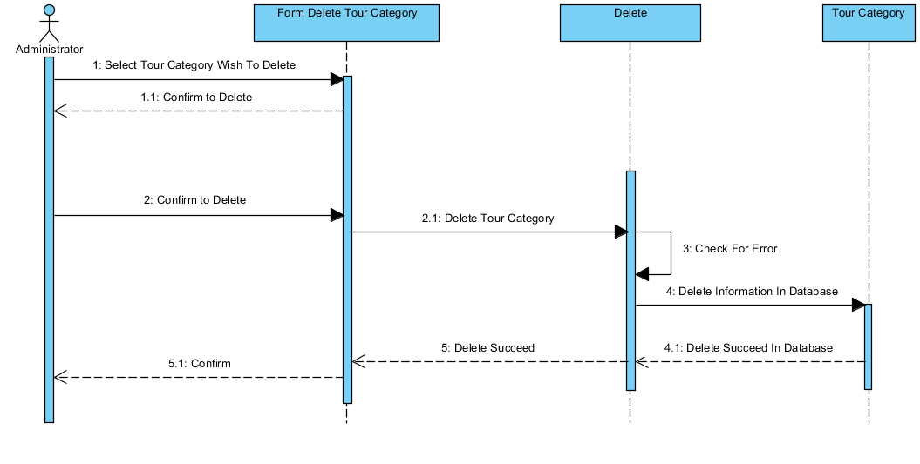

6 – Delete Tour

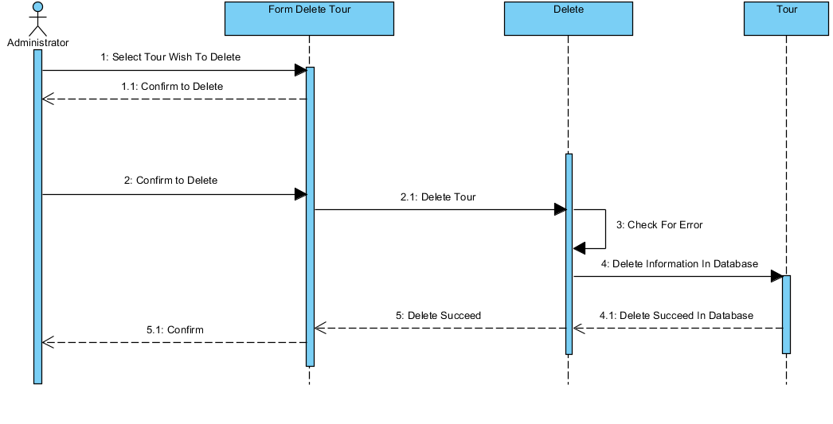

7 – Search Tour

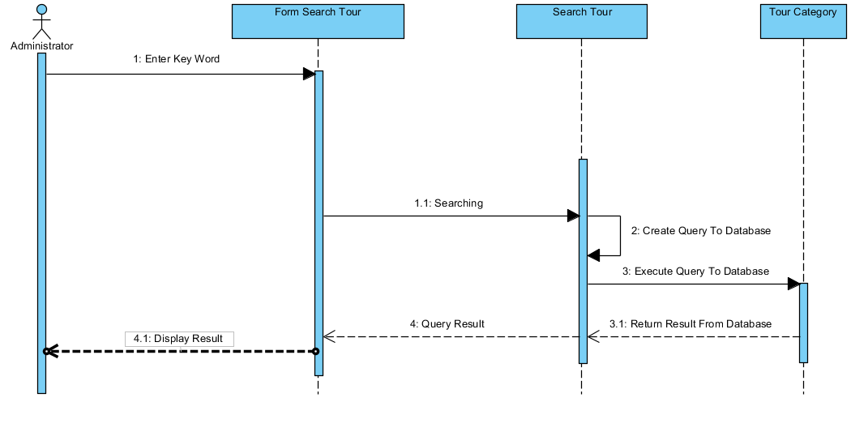

**8 – Search Comment**

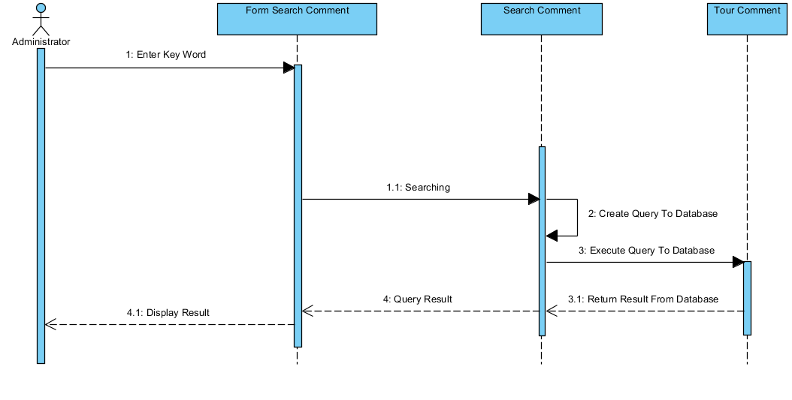

**V – Admin Use Case**

