**HỌC VIỆN QUỐC TẾ FPT**

FPT-ACADEMY INTERNATIONAL

_____________________________________________________

**Wonder Travelling**

**Development’s Guide**

**Faculty: …**

**Batch No: …**

**Group No: 1**

**Student:**

|  |  |  |
| --- | --- | --- |
| **No** | **Full Name** | **Roll No** |
| **1** | **Duong Dinh Vu** | Student921581 |
| 2 | Pham Phan Nhat Khanh | Student920469 |
| 3 | Dieu Van Toan | Student912384 |
| 4 | Pham Dang Khoa | Student924942 |

Contents

REVIEW 2 3

1. Data Flow Diagrams 4

2. Use Case Diagrams 5

4. Entities Relationship Diagrams 20

4.1. Entities 21

5. SQL Tables 25

5.1. Relationship 25

5.2. Tables 26

5.2.1 Car 26

5.2.2 Tours 27

5.2.3 TourCategory 27

5.2.4 Schedule 27

5.2.5 TourBookedDetail 28

5.2.6 Booked 28

5.2.7 CarBookedDetails 29

5.2.8 CustomerUser 29

5.2.9 Role 29

5.2.10 Promotion 30

5.2.11 Review 30

5.2.12 ReviewDetails 30

6. Flow Chart 30

REVIEW 2

# Data Flow Diagrams

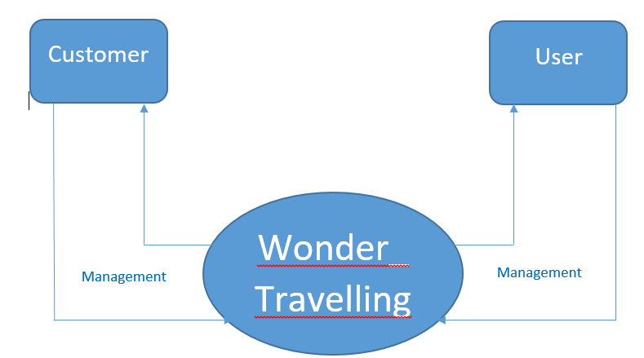

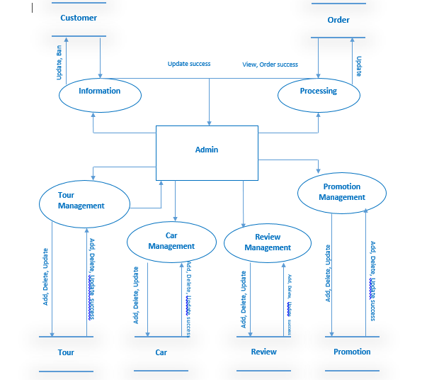

# Use Case Diagrams

* **Administrator Permission**

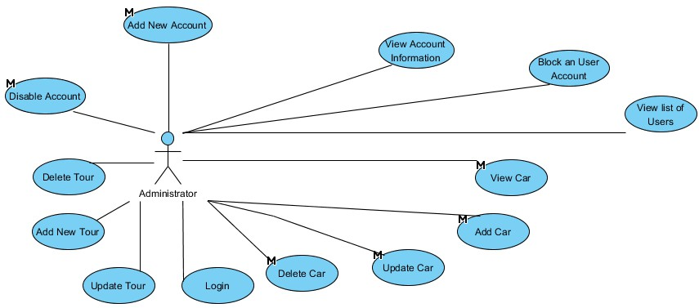

* **Super Moderator Permission**

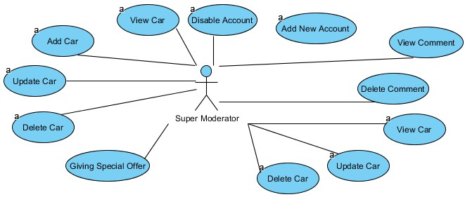

* **Moderator Permission**

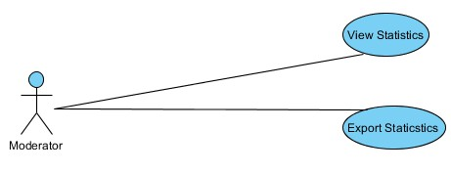

1. **Sequence Diagrams**

*User Search Car

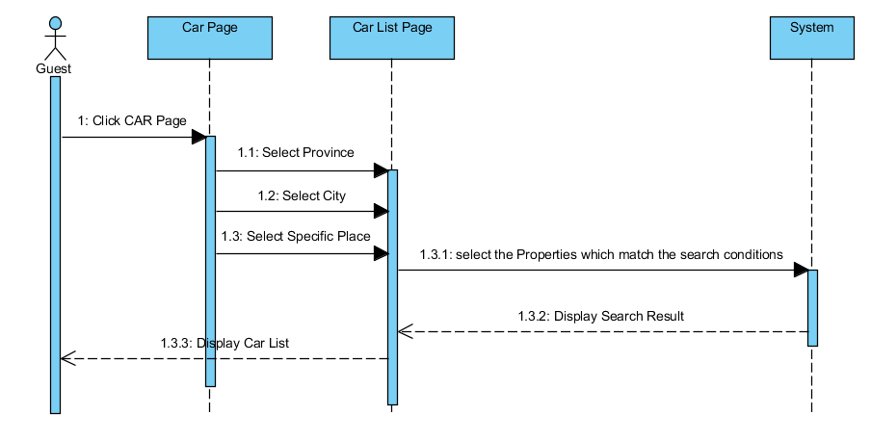

*User Booking Car

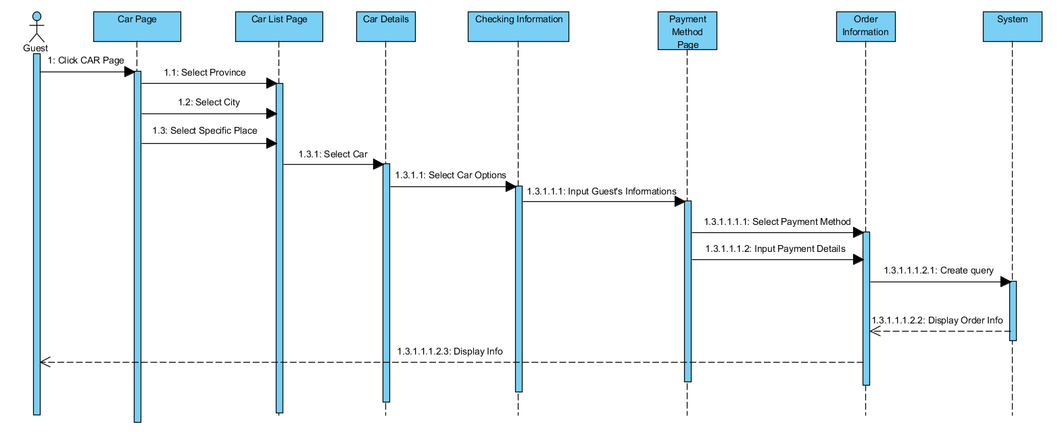

*Admin Add New Car

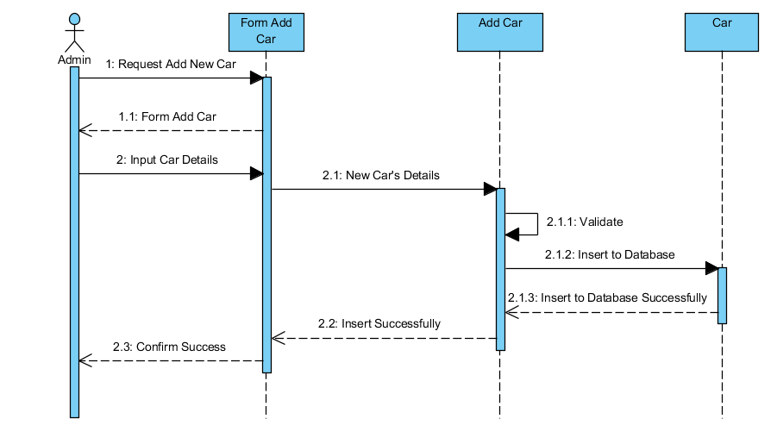

*Admin Edit Car

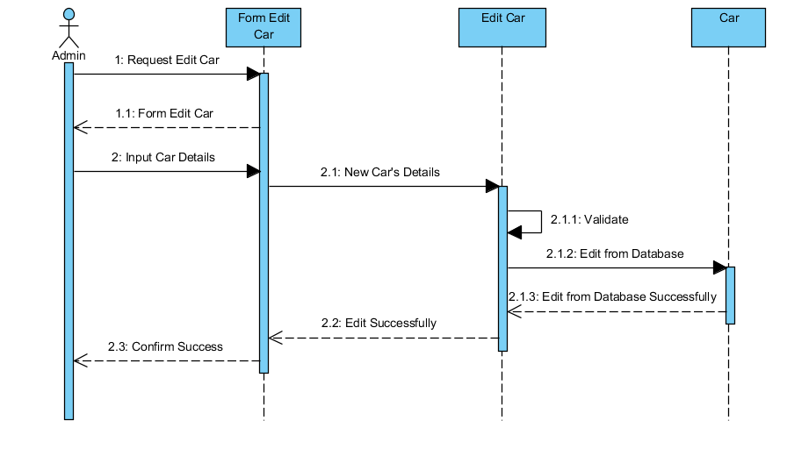

*Admin Delete Car

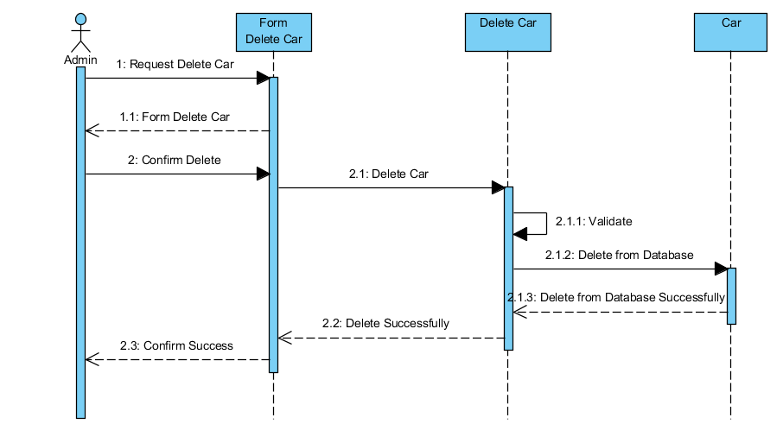

*Add Tour or Car into Cart

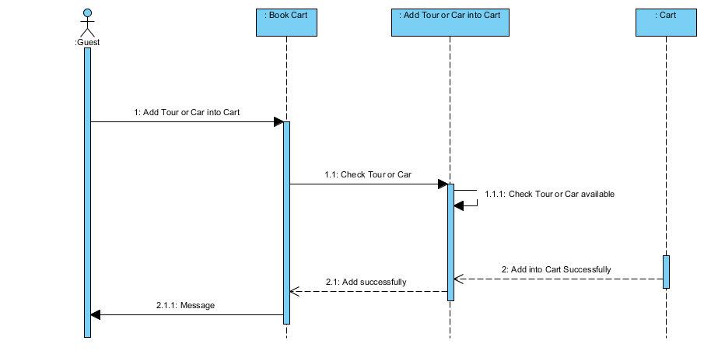

*Search Tour

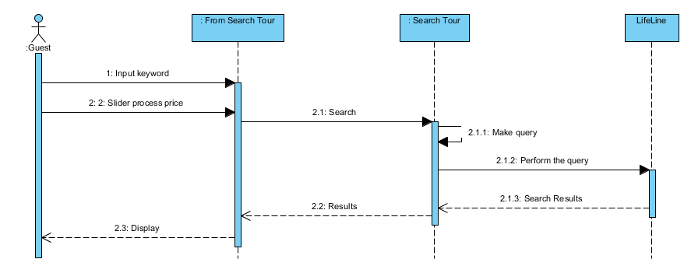

*Admin Create New Tour Category

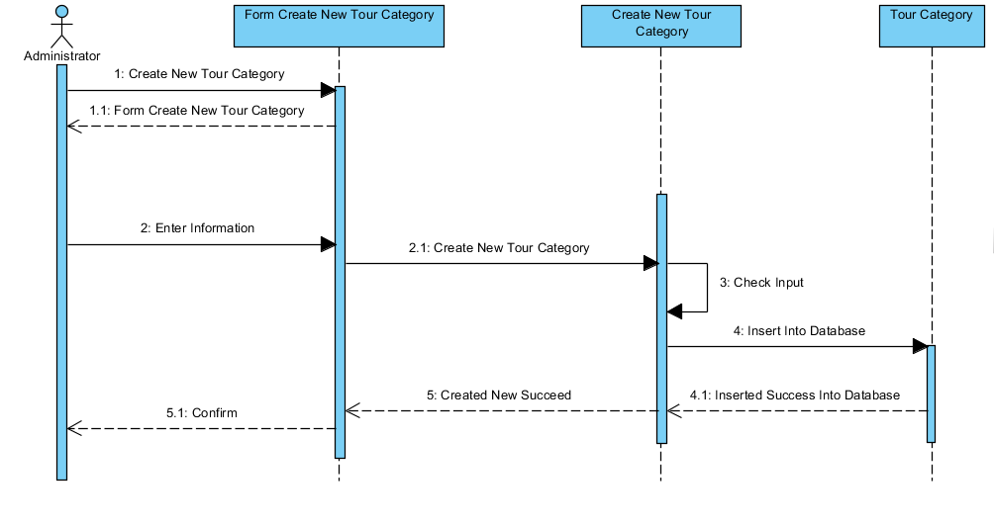

*Admin Update Tour Category

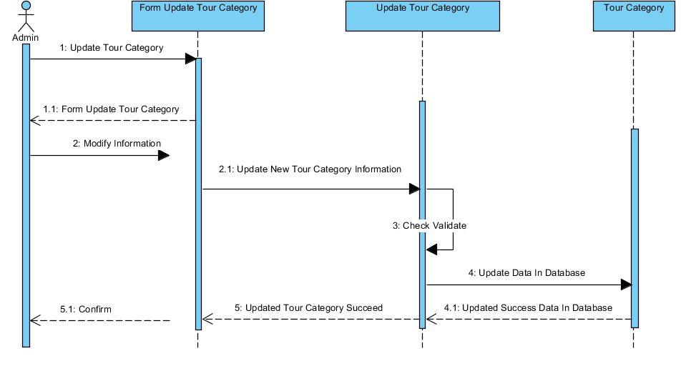

*Admin Create New Tour

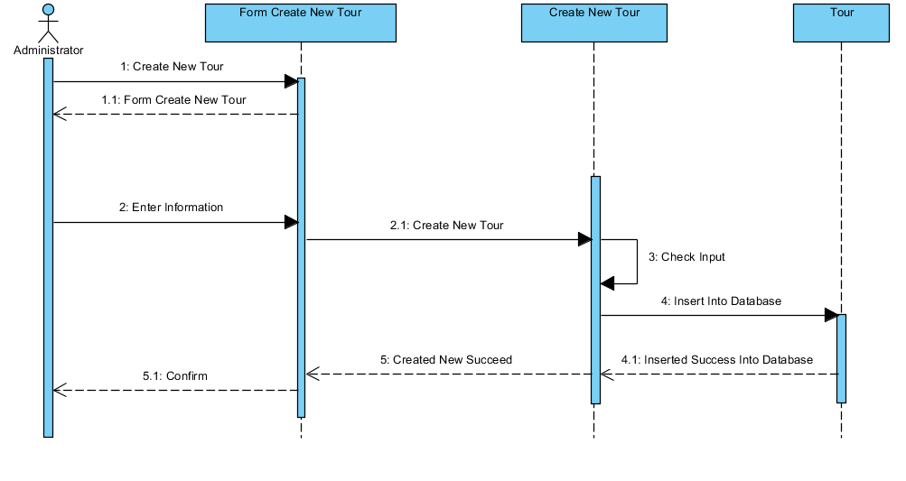

*Admin Update Tour

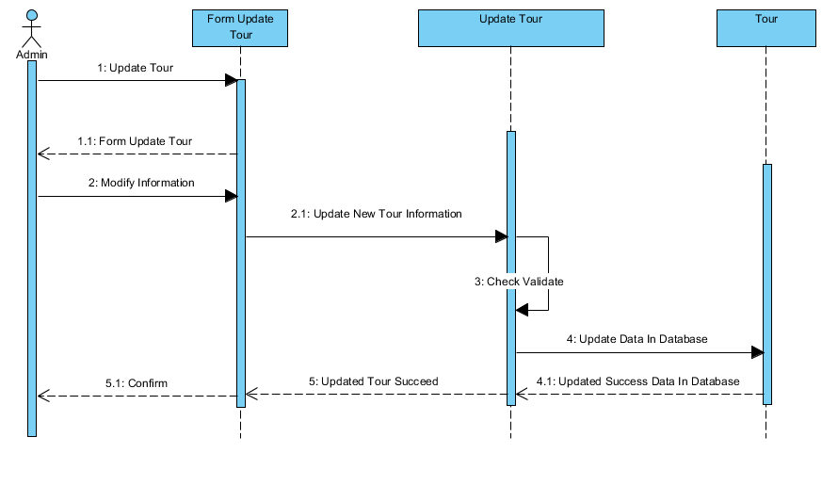

*Admin Delete Tour Category

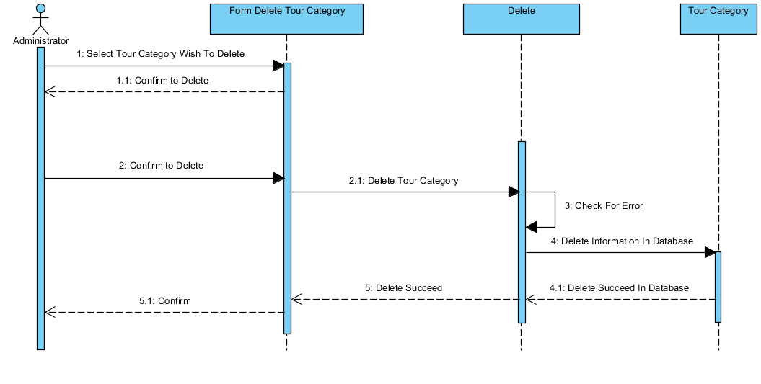

*Admin Delete Tour

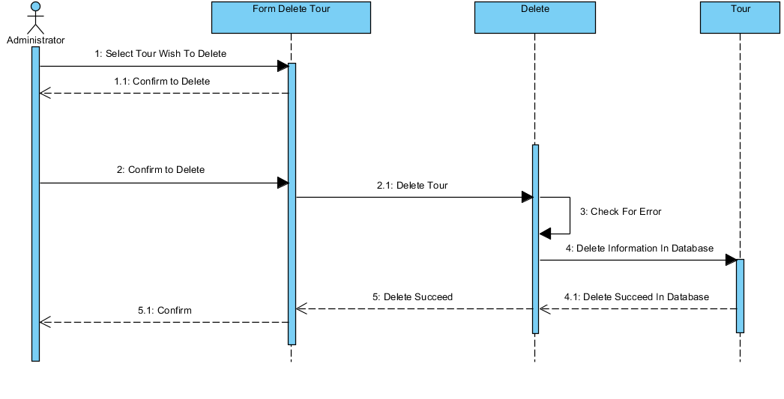

*Admin Search Tour

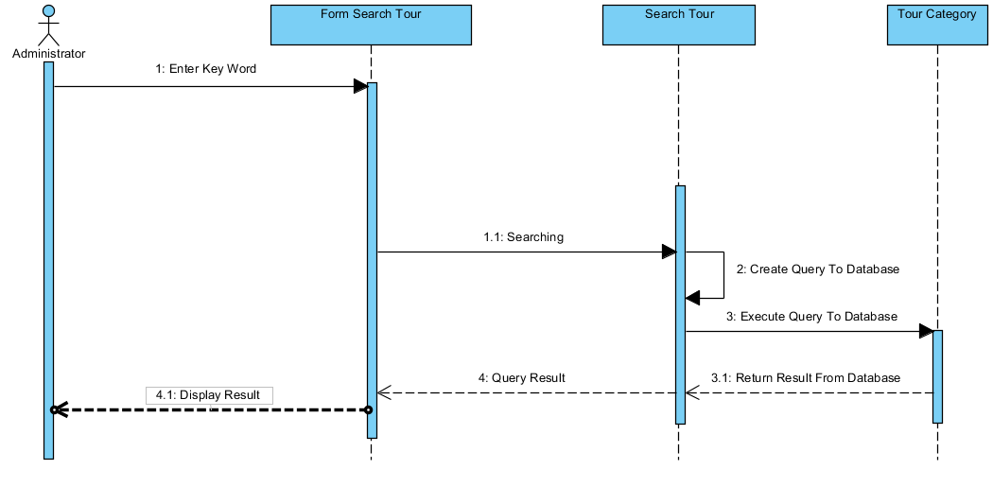

*Admin Search Comment

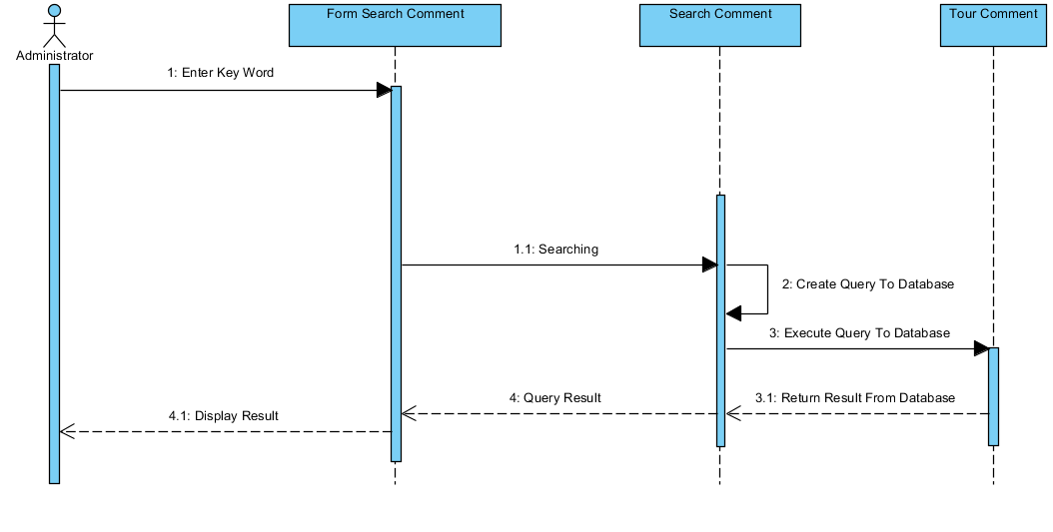

*User Comment

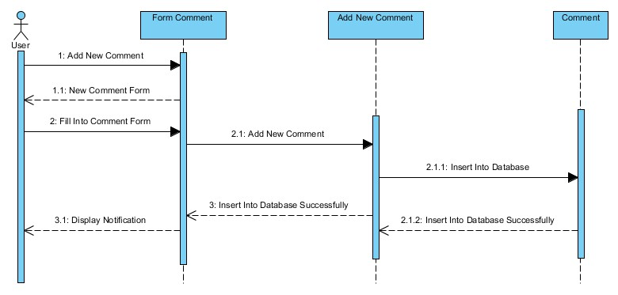

*Admin Search Booked Car

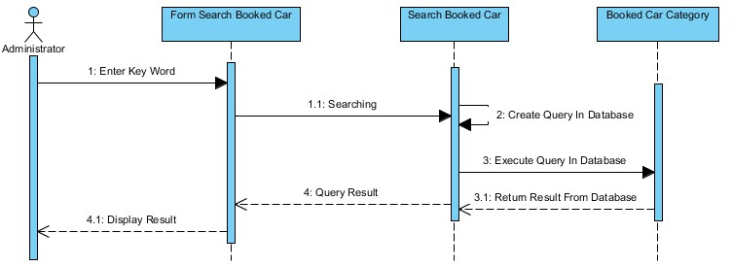

*Admin Login

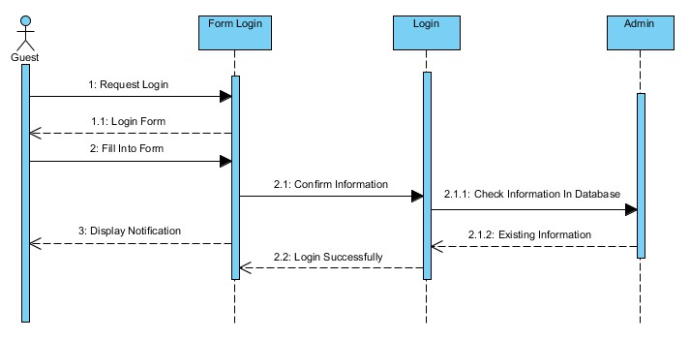

*User Rating Car

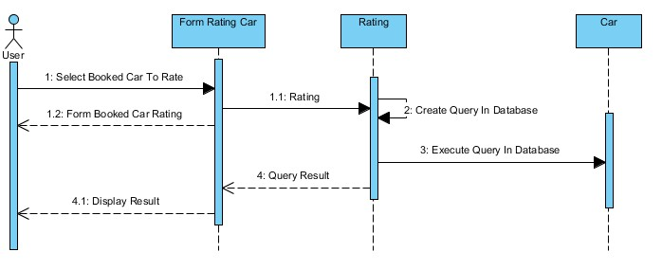

*Admin Disable User Account

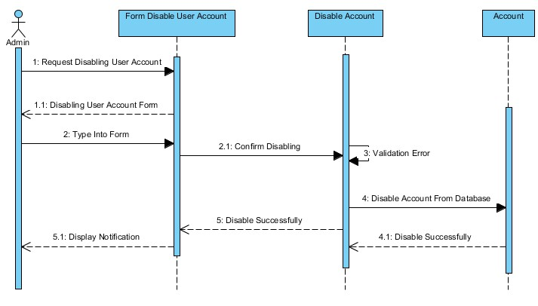

*Admin Delete Booked Car

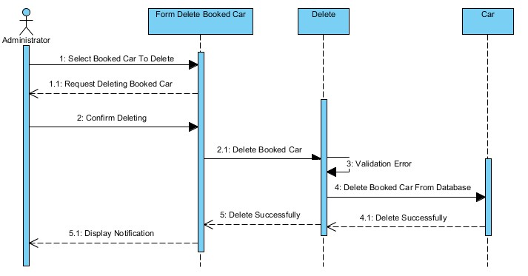

*Admin Create New Booked Car

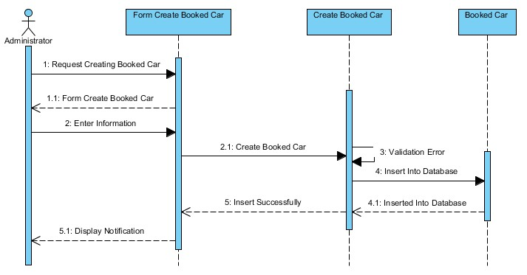

# Entities Relationship Diagrams

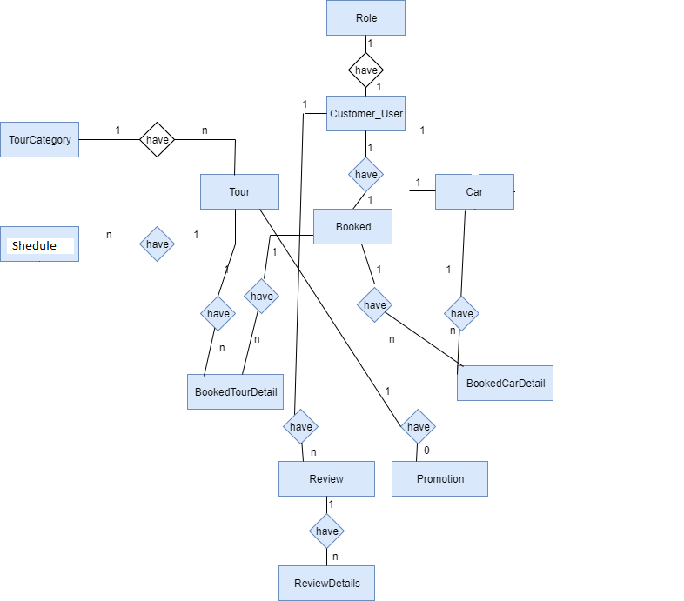

## Entities











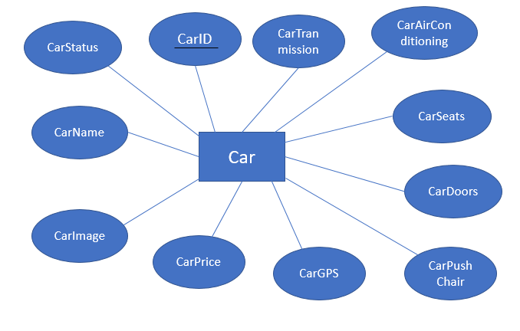

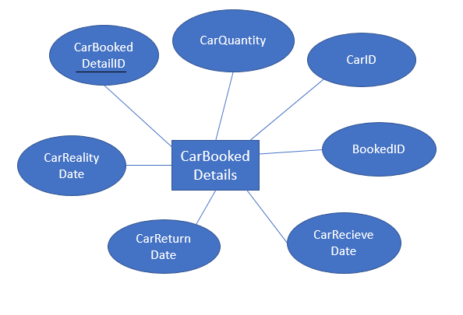

# SQL Tables



## Relationship

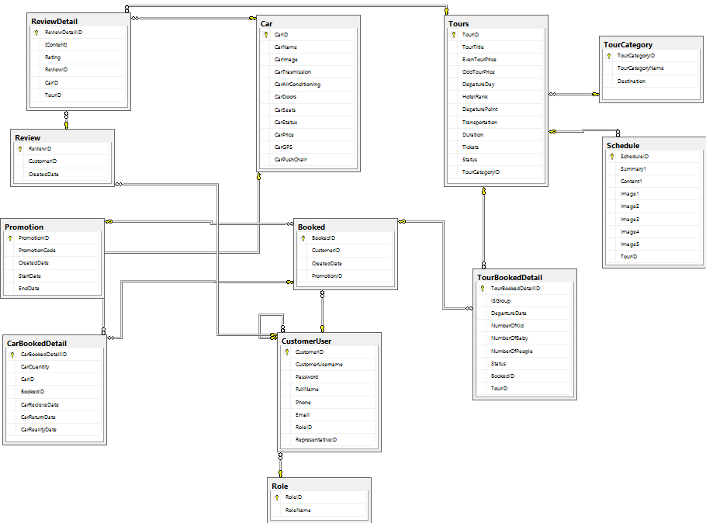

## Tables

## 5.2.1 Car

|  |  |  |  |  |  |  |  |
| --- | --- | --- | --- | --- | --- | --- | --- |
| **Key** | **Field Name** | **Data Type** | **Length** | **Allow Null** | **Default value** | **Table-Field-Ref** | **Description** |
| PK | **CarID** | int |  | No |  |  | Car ID |
|  | CarPrice | Int |  | No |  |  | Car Price |
|  | CarGPS | bit |  | no | 0 |  | Car Add-on  0: None  1: Have |
|  | CarPushChair | Bit |  | No | 0 |  | Car Add-on  0: None  1: Have |
|  | CarName | varchar | 50 | No |  |  | Car Name |
|  | CarImage | varchar | 100 | No |  |  | Car Images |
|  | CarTranmission | Varchar | 100 | No |  |  | Car Transmission |
|  | CarAirConditioning | bit |  | No | 1 |  | Car Add-on  0: None  1: Have |
|  | CarDoors | tinyint |  | No |  |  | Numbers of car doors |
|  | CarSeats | tinyint |  | No |  |  | Numbers of car seats |
|  | CarStatus | bit | 1 | No | 0 |  | Status of Car  0: Deactivate  1: Available |

## Tours

|  |  |  |  |  |  |  |  |
| --- | --- | --- | --- | --- | --- | --- | --- |
| **Key** | **Field Name** | **Data Type** | **Length** | **Allow Null** | **Default value** | **Table-Field-Ref** | **Description** |
| PK | **TourID** | varchar | 30 | No |  |  | Tour ID |
|  | TourTitle | varchar | 50 | No |  |  | Tour Title |
|  | EvenTourPrice | float |  | No |  |  | Tour price for Booking by group |
|  | OddTourPrice | float |  | No |  |  | Tour price for Booking by Individual |
|  | DepartureDay | varchar | 50 | No |  |  | Tour Departure Day |
|  | HotelRank | tinyint |  | No |  |  | Hotel Rank |
|  | DeparturePoint | nvarchar | 100 | No |  |  | Departure Point |
|  | Transportation | tinyint |  | No |  |  | Transportation |
|  | Duration | tinyint |  |  |  |  | Duration |
|  | Tickets | Tinyint |  |  |  |  | Tickets |
|  | Status | bit |  |  |  |  | Tour status |
|  | TourCategoryID | varchar | 20 | No |  | TourCategory.TourCategoryID | Tour Category ID |
|  | ScheduleID | int |  | No |  | Schedule.ScheduleID | Schedule ID |

## TourCategory

|  |  |  |  |  |  |  |  |
| --- | --- | --- | --- | --- | --- | --- | --- |
| **Key** | **Field Name** | **Data Type** | **Length** | **Allow Null** | **Default value** | **Table-Field-Ref** | **Description** |
| PK | **TourCategoryID** | varchar | 30 | No |  |  | Tour Category ID |
|  | TourCategoryName | nvarchar | 20 | No |  |  | Tour Category Title |
|  | Destination | nvarchar | 100 | No |  |  | Tour Destination |

## Schedule

|  |  |  |  |  |  |  |  |
| --- | --- | --- | --- | --- | --- | --- | --- |
| **Key** | **Field Name** | **Data Type** | **Length** | **Allow Null** | **Default value** | **Table-Field-Ref** | **Description** |
| PK | **ScheduleID** | varchar | 30 | No |  |  | Schedule ID |
|  | Summary | nvarchar | 100 | No |  |  | Title |
|  | Content | nvarchar | max | No |  |  | Activity content in a specific duration or day |
|  | Image1 | varchar | 100 | Yes |  |  | Representation Image of a specific day or activity |
|  | Image2 | varchar | 100 | Yes |  |  | Representation Image of a specific day or activity |
|  | Image3 | varchar | 100 | Yes |  |  | Representation Image of a specific day or activity |
|  | Image4 | Varchar | 100 | Yes |  |  | Representation Image of a specific day or activity |
|  | Image5 | Varchar | 100 | Yes |  |  | Representation Image of a specific day or activity |
|  | TourID | varchar | 20 | No |  | Tours.TourID | Tour ID |

## TourBookedDetail

|  |  |  |  |  |  |  |  |
| --- | --- | --- | --- | --- | --- | --- | --- |
| **Key** | **Field Name** | **Data Type** | **Length** | **Allow Null** | **Default value** | **Table-Field-Ref** | **Description** |
| PK | **TourBookedDeTailID** | varchar | 20 | No |  |  | Tour Booked Detail ID |
|  | IsGroup | bit |  | No |  |  | Booked By group or individual |
|  | DepartureDate | Datetime |  | No |  |  | Departure Date |
|  | NumberOfKid | Tinyint |  | No |  |  | Number Of Kid |
|  | NumberOfBaby | tinyint | 100 | No |  |  | Number Of Baby |
|  | NumberOfPeople | tinyint |  | No |  |  | Number Of People |
|  | Status | tinyint | 50 | No |  |  | Tour Status |
|  | TourID | varchar | 20 | No |  | Tours.TourID | Tour ID |
|  | BookedID | varchar | 20 | No |  | Booked.BookedID | Tour Booked ID |

## Booked

|  |  |  |  |  |  |  |  |
| --- | --- | --- | --- | --- | --- | --- | --- |
| **Key** | **Field Name** | **Data Type** | **Length** | **Allow Null** | **Default value** | **Table-Field-Ref** | **Description** |
| PK | **BookedID** | varchar | 20 | No |  |  | Booked ID |
| FK | CustomerID | int |  | No |  | Customer.  CustomerID | Customer ID  FK of Customer table |
|  | CreatedDate | Datetime |  | No |  |  | The date which customer begin to book tour |

## CarBookedDetails

|  |  |  |  |  |  |  |  |
| --- | --- | --- | --- | --- | --- | --- | --- |
| **Key** | **Field Name** | **Data Type** | **Length** | **Allow Null** | **Default value** | **Table-Field-Ref** | **Description** |
| PK | **CarBookedDTID** | varchar | 20 | No |  |  | Car Booking Details ID |
| FK | CarID | int |  | No |  | Car.  CarID | Car ID  FK of Car table |
| FK | BookedID | Varchar | 20 | No |  | Booked.  BookedID | Book ID  FK of Booked table |
|  | CarQuantity | tinyInt |  | No |  |  | Numbers of booked cars per user. |
|  | CarRecieveDate | Datetime |  | No |  |  | The Day user receive cars |
|  | CarReturnDate | Datetime |  | No |  |  | The Day user return cars. |
|  | CarRealityDate | Datetime |  | Yes |  |  | Extra dates. |

## CustomerUser

|  |  |  |  |  |  |  |  |
| --- | --- | --- | --- | --- | --- | --- | --- |
| **Key** | **Field Name** | **Data Type** | **Length** | **Allow Null** | **Default value** | **Table-Field-Ref** | **Description** |
| PK | **CustomerUserID** | Int |  | No |  |  | Customer ID |
| FK | RepresentativeID | Int |  | No |  | Customer.  CustomerID | Representative ID  FK of Customer table |
| FK | RoleID | Int |  | No |  | Role.  RoleID | Role ID  FK of Role table |
|  | CustomerUsername | Varchar | 20 | Yes |  |  | User’s username |
|  | Password | Varchar | 20 | Yes |  |  | Users password |
|  | Fullname | Nvarchar | 50 | No |  |  | Fullname |
|  | Phone | Varchar | 20 | No |  |  | Phone number |
|  | Email | Varchar | 50 | Yes |  |  | User Email |

## Role

|  |  |  |  |  |  |  |  |
| --- | --- | --- | --- | --- | --- | --- | --- |
| **Key** | **Field Name** | **Data Type** | **Length** | **Allow Null** | **Default value** | **Table-Field-Ref** | **Description** |
| PK | **RoleID** | Int |  | No |  |  | Role ID |
|  | RoleName | nVarchar | 20 | No |  |  | Role Names |

## Promotion

|  |  |  |  |  |  |  |  |
| --- | --- | --- | --- | --- | --- | --- | --- |
| **Key** | **Field Name** | **Data Type** | **Length** | **Allow Null** | **Default value** | **Table-Field-Ref** | **Description** |
| PK | **PromotionID** | Int |  | No |  |  | Promotion ID |
|  | PromotionCode | Varchar | 20 | No |  |  | Promotion Codes |
|  | CreatedDate | Datetime |  | No |  |  | Day Create Promotion |
|  | StartDate | Datetine |  | No |  |  | Start of Promotion |
|  | EndDate | Datetime |  | No |  |  | End of Promotion |

## Review

|  |  |  |  |  |  |  |  |
| --- | --- | --- | --- | --- | --- | --- | --- |
| **Key** | **Field Name** | **Data Type** | **Length** | **Allow Null** | **Default value** | **Table-Field-Ref** | **Description** |
| PK | **ReviewID** | int |  | No |  |  | Review ID |
| FK | CustomerID | int |  | No |  | Customer.  CustomerID | Customer ID  FK of Customer table |
|  | CreatedDate | Datetime |  | No |  |  | The date which customer leave a review |

## ReviewDetails

|  |  |  |  |  |  |  |  |
| --- | --- | --- | --- | --- | --- | --- | --- |
| **Key** | **Field Name** | **Data Type** | **Length** | **Allow Null** | **Default value** | **Table-Field-Ref** | **Description** |
| PK | **ReviewDTID** | int |  | No |  |  | Review Details ID |
| FK | ReviewID | int |  | No |  | Review.  ReviewID | Review ID  FK of Review table |
| FK | CarID | Varchar | 20 | No |  | Car.  CarID | Car ID  FK of Car table |
| FK | TourID | Varchar | 20 | No |  | Tour.  TourID | Tour ID  FK of Tours table |
|  | Content | Nvarchar | 300 | No |  |  | Content of review |
|  | Rating | tinyint |  | No |  |  | Rating |

# Flow Chart

*Add Car

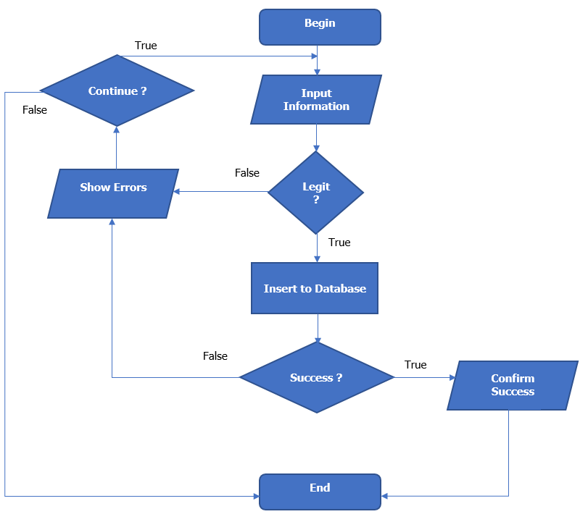

*Edit Car

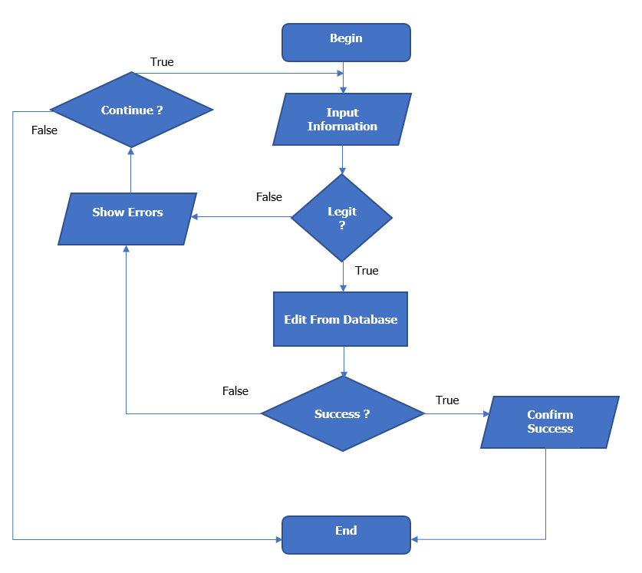

*Delete Car

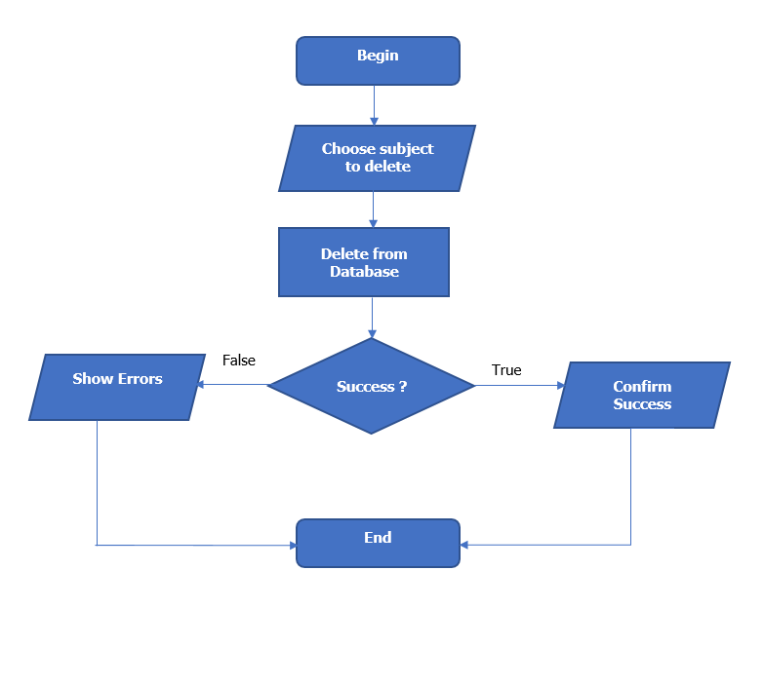

*Create Tour Category



*Update Tour Category

*Create Tour

*Update Tour

*Search Tour

*Search Comment

*Delete Tour



1. **Class Diagram**

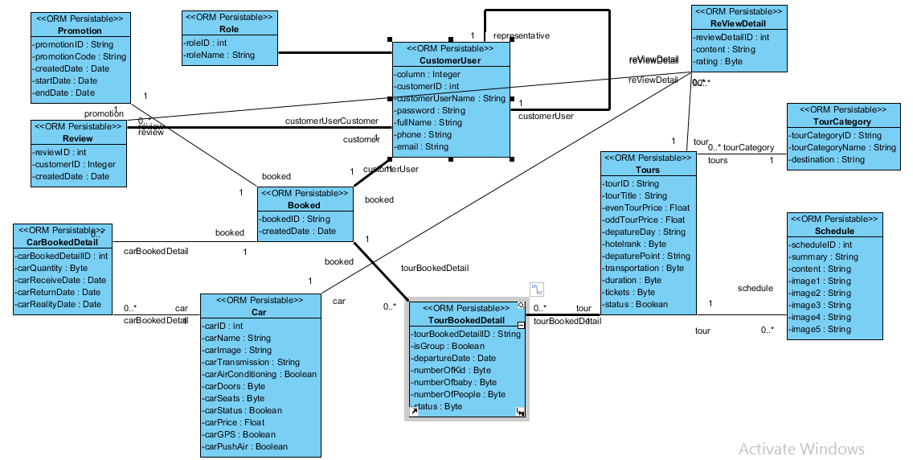

|  |  |  |
| --- | --- | --- |
|  | **Prepared by (Student)** | **Approved by (Faculty)** |
| **Signature** | Team leader  **Duong Dinh Vu** | **Phan Minh Tam** |
| **Date** |  |  |