[The Topic Of Your Paper Goes Here]
by
Your_First_Name Your_Last_Name
Submitted This_Month This_Number_Day, This_Year
CORS456, Course_Title_As_Listed_In_Course_Catalog

Abstract
[Provide 75 to 150 words in paragraph form describing the main idea or "big picture". Your text should summarize the main point(s) of your topic as an "abstract". Don't use more than 150 words. Don't use less than 75 words. This title page should fit on this page. You may add an appropriate graphic if you like below.]
Your Paper

- Edit this document. Replace any text in brackets with your own; then, delete all brackets: [ ]
- Edit the footer. Replace "CORS456" with the course name and catalog number of this course. Include your name and your topic title.
- Save the edited file in this way: CORS456-YourFirstName-YourLastName-YourAssignmentName-ThisSemester-ThisYear--01.doc ("01, 02, 03…" are version numbers. When you modify your file, always save the file using "SAVE AS" using the next version number. This eliminates the chance of accidentally overwriting your previous work.
- If you use Office 2007, save the file as an "Office 2003" file. (Click on the "circle" in the upper left-hand of the screen and use the "Save As" command to save as an Office 2003 file.)
- Spell check by pressing the "F7" key. Check your grammar. Your sentences should be clear and complete.
- For full credit, always submit by the deadline.
- Delete/replace all existing images and text in this template. Always use your own work. Never use copied text as your own. Use quotes or citations; examples are provided. Even if you cite or quote a source, do NOT use more than 2 sentences verbatim from any source. If you paraphrase, any "paraphrased text" should use sentences that are 75% different in sentence structure and word usage from the original.
- Images are tricky in a Word document. You need to change the "layout" of an image. After you paste or insert an image, select it and then right-click to select a format for the layout . Many people prefer the "Tight" layout. You will find directions for modifying the layout of an image in this document.

Delete this "textbox" by clicking on the border twice.
Then, press the Delete key.

(Version 11.9.09 /mb)

[Put a "mind map" or "cognitive web" that you create here with at least a dozen linked "bubbles". You may use any tool to create that. Recommended: bubbl.us, a free online application that helps you to create mind maps.]

Introduction
[Start typing the text of your paper here. To save paper, It is recommended that you do NOT indent the first line of your text for each paragraph. And, there is no reason to double-space lines. Please use this format for writing a paper in this course. All you have to do is type over the text in this paragraph and delete all of the brackets.]

[Feel free to include relevant images in your paper; this is encouraged and even expected. If you insert or paste images in Word, you will have to modify its "layout". In Word 2003, select the image, then right-click to see options. Choose "Format Picture" in order to change the layout. To keep things simple, you may want to use "tight, a popular choice.]

[Use a third-person narrative for the paper. That is, don't use "I", "me", "my", "you" pronouns. Keep focused on the professional nature of sharing information or ideas with busy teaching professionals. As a strategy, state the important idea right away and then discuss it and how it impacts teaching and learning. Be visual whenever you can by explaining with a relevant image. Try to include at least 2 images per page, if possible.]

[In your paper, when you make a key statement, provide a reference to your source, using APA format. Below, you will see some links to online references to APA format. As an effective strategy, provide evidence when you write by providing references, facts, and even active links. When you provide a link, please use the complete URL as text and then link it; there are advantages in providing your links in this way.]

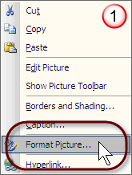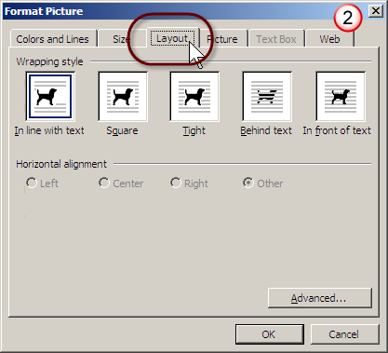
How to modify the "layout" of an image in Word 2003.
Instructions
- Your work must be original. Do your own work. Do NOT copy and paste unless you quote a source directly. If you quote directly, you need to use quotation marks. Refer to the ULM regulations on plagiarism:
Filename: Student Policy Manual 2007-2008_03-19-2008.pdf (See pages 7 and 8.) Permanent address: https://webservices.ulm.edu/policies/document.php?i=33814
The consequences for plagiarism are severe.
- Edit this document by replacing any text in brackets with your own; then, delete all brackets. Whenever you see "CORS567", replace it with the course name and number of this course.
- Edit the footer. To do this in Word 2003, click on View => Header and Footer
- Save this file in this way: CORS567-YourFirstName-YourLastName-TheAssignmentName-ThisSemester-ThisYear--01.doc ("01" is the version number. You will almost certainly have versions. In fact, it is recommended that you use and keep versions. When you modify your file, instead of saving the file with the same name, save the file using "SAVE AS" as the next version number. This is an effective way to determine your latest version, especially when you submit revisions. This eliminates the possibility of accidentally overwriting your previous work. Always save the file as an Office 2003 file. If you use Office 2007, save it as an "Office 2003" file. This is important.)
- Spell check by tapping the F7 key on your keyboard. Check your grammar. Every sentence should be clear and complete.
- Use APA for citations. Here are some APA citation references:
http://trackstar.4teachers.org/trackstar/ts/viewTrack.do?number=233778
- For full credit, always submit by the deadline.
- If you submit an assignment early or come during regularly scheduled office hours, well before an assignment deadline, you will get help with your writing. And, you will receive a complimentary soft drink.

Delete this "textbox" by clicking on the border twice. Then, press the Delete key.

[Section Heading]
[Feel free to include a section heading for a particular section of your narrative text. This paragraph has an example of such a heading directly above; you can see the section heading is called "Section Heading". A section heading, of your choice, can organize your writing effectively by breaking up complex content into related "chunks". It is recommended that you use a section heading to help organize your ideas. Usually, you will find this type of formatting in popular journals, newsletters, and in online text. It's very effective in keeping the attention and focus of your audience because it helps your reader understand how content is integrated and organized. A section heading is simply bold text on its own line, just as you see here, above, with all of the first letters capitalized; there is no punctuation. Please note: This is non-standard academic writing. Please use this format for this course.]

[Recommended Requirements]
[Your paper should be "topical"; that is, it should have professional relevance about a particular subject. It should inform, persuade, explore, predict, analyze, or integrate ideas… thoughtfully. The intended audience of your paper would be busy practicing teachers and administrators. You should write something that your reader would want to know more about after scanning the abstract on the title page. ]

- [Don't write about an excessively broad subject. Instead, choose a perspective that has the professional interest of your audience.
- Be as visual as possible. Use images when appropriate. If an image helps to communicate an idea effectively, use it.
- Provide active links whenever possible.
- Choose a topic that people, like yourself, would want to learn more about. This is particularly important in "New Media" communication. Be interesting!
- At a minimum, your entire single-spaced paper should be between 3 and 7 pages long. Don't create a paper that is more than 7 pages long. As a recommendation, try to make your paper about 4 pages long with at least 2 images per page.
- Use this format.
- Use bullets, when appropriate. For example, this is a bulleted item.
- Highly recommended: When you use a larger image, provide a centered caption in a slightly smaller font size directly below it. Caption text can be a brief descriptive phrase; use a phrase that ends with a period.
- In Word 2003, to add an active link to the Internet, highlight the complete Internet address that you typed in as part of your narrative. Then, right-click to see options. Click on "Hyperlink"; you will then see a window appear, as shown below. There are two steps to add a text link to an Internet address:]
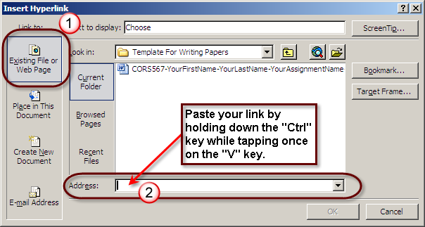
How to insert a hyperlink in Word 2003.

[Editing Images]
[There are various ways to capture images. One "free" way is described here, using Paint and the "Print Screen" key on the keyboard of a Windows computer:
http://ulm.edu/~beutner/2007/Handout-Capturing-Images-2007.ppt]

[If you want a tool that you will always use, consider capturing and editing images with a commercial product called "Snagit". This software application has many useful features. You can download a 30-day trial version. There is an educational discount available for students. This product is one of the very few commercial products that I highly recommend. The included graphics editor allows you to create highly professional educational graphics very quickly. For example, the images used on this page took about a minute to capture and edit with Snagit. Of course, you may use any type of graphics editor. The link for Snagit: http://www.techsmith.com/screen-capture.asp]

[Format]
[In this modified non-standard format, we will try to conserve paper. Every paper should be at least 3 pages long. Every paper includes

- [a title page with title and abstract
- an "introduction" section
- a narrative divided up into various section headings of your choice
- at least 2 relevant images per page (Recommended: if you refer to a website, provide a screen capture!)
- a summary
- a bibliography section containing at least 5 sources ]

[Please "break" a page so that each section of related text does not trail by just a line or two on another page. This is considered good professional practice. To do this, just insert a page break.]

[Paragraph Format]
[Each of your paragraphs should have 3 or more related sentences. Each sentence should be spell checked by using the F7 spell check key. Each sentence should be grammatically correct and complete. Use just one space after every period; there is no need to use two spaces between sentences.]

[Bibliography]
[Your bibliography should be in its own section. Your bibliography citations should be in APA format. You can find information about formatting your citations here:
http://trackstar.4teachers.org/trackstar/ts/viewTrack.do?number=233778]

[In every paper you write, you need to use at least 3 citations of peer-reviewed articles from authoritative academic journals or published academic books and at least 2 references from other credible sources, including references on the Internet. Generally, citations should be recent. In the field of Instructional Technology, try to avoid citations that are more than 5 years old unless the content is not sensitive to recent changes. If you are discussing a technology innovation, your citations should be quite recent, certainly within the last year or so.]

[ULM Online Database]
[It is recommended that you use online references for your citations. You may use references to ULM online materials: http://www.ulm.edu/library/ Click on the link called "Ebsco Host - abstracts, indexes, full text journals". Keep in mind that you will need to contact the ULM Library in order to register so that you can access Ebsco Host resources from off-campus; this involves free registration. Please contact the ULM Library directly. The phone number is: (318) 342-1071 Why do you need to register? The resource is an expensive subscription that stipulates that only students can use this service. When you do access Ebsco Host, you will see this screen appear:]
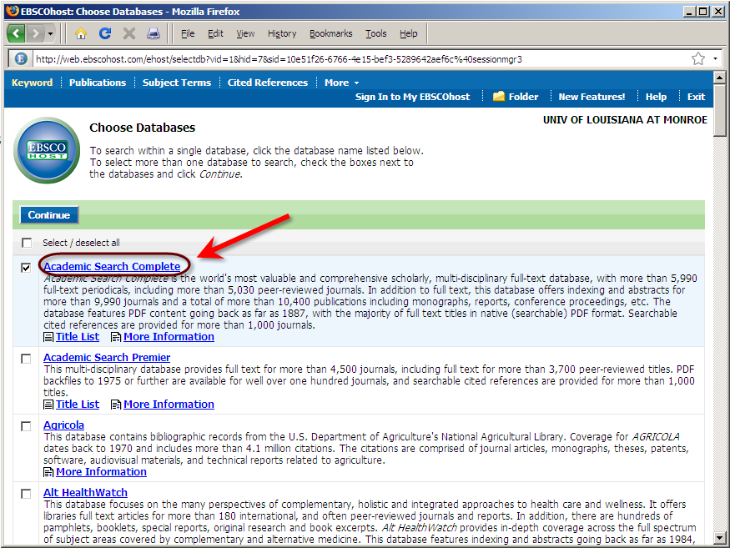
An online database of many thousands of peer-reviewed journals.

[After you access Ebsco, click on the link to "Academic Search Complete"; the database is described above in the image. Some, but not all of the entries include the full text of the articles. Use the advanced search feature, as shown below. Search for peer-reviewed articles with full text:]

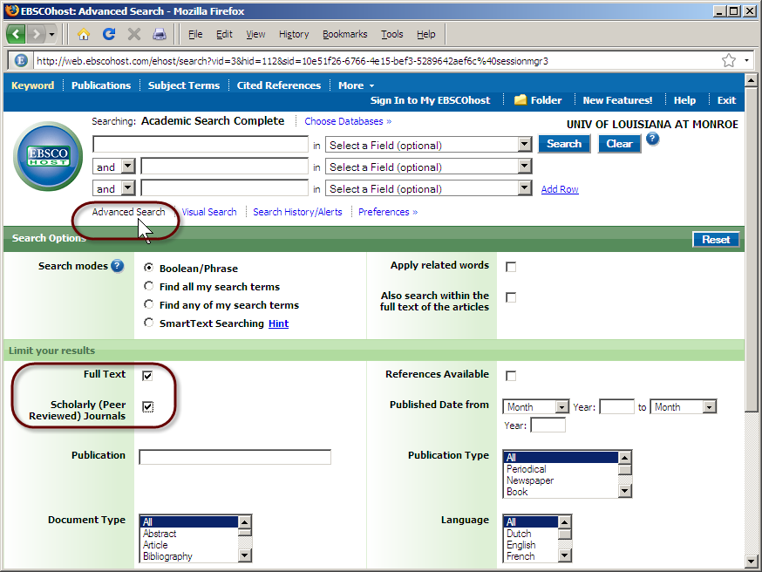
Selecting full text peer-reviewed articles.
[File Naming]
[Save your document with this file name:
CORS567-YourFirstName-YourLastName-YourAssignmentName-ThisSemester-ThisYear--01.doc
(YourAssignmentName is the name of this assignment. For example, this could be something called Critique 2, Case Study, or Paper. "01" is the version number. You should keep your versions; this is highly recommended! When you modify your file, instead of saving the file with the same name that overwrites previous work, save your work using "SAVE AS" with the next version number, as a separate file. This is an effective way to easily determine the latest version, especially when you submit revisions. This strategy completely prevents accidental overwriting of work on a file. Please save the file as an Office 2003 file. If you use Office 2007, save the file in an "Office 2003" file format. This is important.]

[Checklist
- Edited the title page?
- Edited the footer?
- Made a clear abstract?
- Made an interesting summary suitable for busy teaching professionals?
- Bibliography: At least 3 recent citations of peer-reviewed articles in APA format that are "full text" accessible and at least 2 more credible references?
- Spell checked?
- Grammar checked?
- Saved the file with the recommended file name?
- Uploaded the finalized file to Moodle?]

[Summary]
[Always include a summary for your paper at the end of your narrative section. It should NOT be identical to your abstract. Use a section heading, just like you see directly above this paragraph, for your summary. This is very good professional practice. Your summary paragraph should include up to 150 words. Avoid providing new material, content, or facts in a summary!]

References
[This link provides an excellent summary for citing a reference within your narrative: http://www.dianahacker.com/pdfs/Hacker-Shaw-APA.pdf ]

[This link describes the APA format nicely and includes examples for citing online references: http://www.liu.edu/cwis/cwp/library/workshop/citapa.htm ]

In this example, very detailed examples of APA format writing are described:
http://valencia.cc.fl.us/lrcwest/apapaper.html ]

Begley, S. (1998, January 19). Aping language. Newsweek, 131, 56-58.

Booth, W. (1990, October 29). Monkeying with language: Is chimp using words or merely aping handlers? The Washington Post, p. A3.

Eckholm, E. (1985, June 25). Kanzi the chimp: A life in science. The New York Times, pp. C1, C3.

Fouts, R. (1997). Next of kin: What chimpanzees have taught me about who we are. New York: William Morrow.

Gardner, & T. E. Van Cantfort (Eds.), Teaching sign language to chimpanzees (pp. 269- 279). Albany: SUNY Press.

Gibbons, A. (1991). Déjà vu all over again: Chimp-language wars. Science, 251, 1561- 1562.

Greenfield, P. M., & Savage-Rumbaugh, E. S. (1990). Grammatical combination in Pan paniscus: Processes of learning and invention in the evolution and development of language. In S. T. Parker & K. R. Gibson (Eds.), “Language” and intelligence in monkeys and apes: Comparative developmental perspectives (pp. 540-578). Cambridge: Cambridge University Press.

Hall, K. G. (2005, August 29). Web page title. Website title. Retrieved September 25, 2005, from http://www.kansas.com/mld/kansas/12506343.htm.

Leakey, R., & Lewin, R. (1992). Origins reconsidered: In search of what makes us human. New York: Doubleday.

O’Sullivan, C., & Yeager, C. P. (1989). Communicative context and linguistic competence: The effect of social setting on a chimpanzee’s conversational skill. In R. A. Gardner, B. T.

Smith, A. (1999). Article title. Journal name, 8, 243.

Wilson, J. B. (1999). Book title. Place of publication: Publisher.

