GRADUATE SCHOOL REFERENCE GUIDE

Please use this checklist to verify your paper prior to submitting it to the Graduate School.
NOTE: Research paper template begins on the next page; delete this checklist before submitting.

Pagination
All page numbers are in Times New Roman 12 pt. and are Arabic numbers (1,2,3...)
The title page is #1 and the number is typed on the upper right hand side of the page.
All pages are counted and listed and the total number is listed in the appropriate space on the title page.
No title information (aka running header) is included next to the page number.

Title/Submission information/Abstract pages
Use correct spelling and grammar [(particularly possessives, e.g. student’s vs. students’ or teacher’s vs. teachers’) as well as affect vs. effect)].
Abstract page
Check for misspellings.
200 words in length (or less).
First paragraph does NOT have an indent, but the subsequent paragraphs are indented.
Title is formatted using bold and italics. (Smith, Jane. Title ABC)

Table of Contents (TOC)
Table of Contents heading is centered on the page and formatted in bold.
No entry for Acknowledgements or Table of Contents.
1st level headings are left justified; 2nd level headings are indented 0.5”; 3rd level headings are indented 1”; 4th level headings are indented 1.5”; and so on.
Entries should be included for List of Tables and/or List of Figures if you have created those.
If 4 or more tables and/or figures appear in the paper, then they get a list; otherwise if 3 or less tables and/or figures appear in the paper, incorporate them in the TOC; Table #: Title Here, followed by page # listed directly in the TOC according to where it appears within the body of the paper.
Each Appendix has a title, e.g. Appendix A: How I Survived Graduate School (should be the same title used in the paper)
Citations (in-text)
APA format
All in-text citations are listed in the References section except personal communications.

Tables and Figures
List(s) of Tables and/or Figures are used only when the paper contains 4 or more tables and/or figures.
List(s) of Tables and/or Figures appear on separate pages.
The format for listing tables (or figures) is as follows:
Table (or Figure) #: Title of Table/Figure…….pg #
Margins
Margins should be 1 inch all around the paper;

Body of the Work
“Introduction” should not be a sub-heading.
In Page layout, paragraph spacing before and after needs to be 0pt.
Definitions in Definition of Terms should be formatted like they were 3rd level headings, but NOT included in TOC (indented 0.5”, bolded, and sentence cased (first letter of first word only is Uppercased or if colon precedes the word; e.g. Third level heading: Sentence cased followed by a period.)
PROOFREAD (spelling, grammar, style consistency, format consistency) before turning into Research Adviser AND again before turning into the Graduate School.
Reference List
A-Z order
0.5” Hanging indent format (use ruler or paragraph menu to set, not the TAB key)
Insert one space after each period that separates each part of the reference (be consistent)
Use italics according to APA.
Include digital object identifier (DOI) for reference citations from on-line databases. If no DOI number exists, find the journal homepage and provide that URL. (See: APA manual p. 198-199)

All web pages appear in black type (not blue). Hint: Web addresses that appear in blue are “hyperlinked” addresses; once the hyperlink is removed the text will appear in black. (Right click on the hyperlink and select remove hyperlink)
Appendices
Appendices are titled and paginated (should be the same title used in the TOC)
e.g. Appendix A: Title ABC (If there is only one appendix, then the appendix title should be—Appendix: Title ABC).

The following Research Paper Blank Template is for you, the student, to use and build off of as desired. Look through the Research Paper Reference Guide also found under the Templates tab for more information on instructions for formatting different level headings, table of contents, expectations of the Graduate School, and writing.
NOTE: This thesis template is meant to guide you in formatting your paper according to APA (6th ed.). The number of chapters as well as the chapter headings and sub-headings contained in a research paper will vary depending on the type of research project. Plan B projects, in particular, vary by discipline and, depending on the topic and the kind of research project, will use a variety of appropriate headings and sub-headings; students should work closely with their advisor when creating the research paper structure for their project.

*Delete this page before submission.*

Author: Last Name, First Name Middle Initial.
Title: Title of Paper
The accompanying research report is submitted to the University of Wisconsin-Stout, Graduate School in partial completion of the requirements for the
Graduate Degree/ Major: MS Degree
Research Advisor: First Name Last Name, Title
Submission Term/Year:
Number of Pages:
Style Manual Used: American Psychological Association, 6th edition
I have adhered to the Graduate School Research Guide and have proofread my work.
I understand that this research report must be officially approved by the Graduate School. Additionally, by signing and submitting this form, I (the author(s) or copyright owner) grant the University of Wisconsin-Stout the non-exclusive right to reproduce, translate, and/or distribute this submission (including abstract) worldwide in print and electronic format and in any medium, including but not limited to audio or video. If my research includes proprietary information, an agreement has been made between myself, the company, and the University to submit a thesis that meets course-specific learning outcomes and CAN be published. There will be no exceptions to this permission.
I attest that the research report is my original work (that any copyrightable materials have been used with the permission of the original authors), and as such, it is automatically protected by the laws, rules, and regulations of the U.S. Copyright Office.
My research advisor has approved the content and quality of this paper.
STUDENT:
NAME: DATE:
ADVISOR: (Committee Chair if MS Plan A or EdS Thesis or Field Project/Problem):
NAME: DATE:
---------------------------------------------------------------------------------------------------------------------------------
This section for MS Plan A Thesis or EdS Thesis/Field Project papers only
Committee members (other than your advisor who is listed in the section above)

1. CMTE MEMBER’S NAME: DATE:
2. CMTE MEMBER’S NAME: DATE:
3. CMTE MEMBER’S NAME: DATE:
---------------------------------------------------------------------------------------------------------------------------------
This section to be completed by the Graduate School
This final research report has been approved by the Graduate School.
Director, Office of Graduate Studies: DATE:
LastName, FirstName MiddleInitial. Title of the Paper

Abstract
(No more than 200 words)
Acknowledgments
(Optional – here’s where you get to thank those people who helped you reach this goal)
Table of Contents
Abstract 2
List of Tables 6
List of Figures 7
Chapter I: Introduction 8
Statement of the Problem 8
Purpose of the Study 8
Assumptions of the Study 8
Definition of Terms 8
Limitations of the Study 8
Methodology 8
Chapter II: Literature Review 9
First Topic to be Presented 9
Third Level Heading 9

Fourth Level Heading 9
Fifth Level Heading 9
Second Topic to be Presented 9
Chapter III: Methodology 10
Subject Selection and Description 10
Instrumentation 10
Data Collection Procedures 10
Data Analysis 10
Limitations 10
Summary 10
Chapter IV: Results 11
Demographic 11
Item Analysis 11
Research Questions 12
Research Question 1: Is There a God? 12
Chapter V: Discussion, Conclusion and Recommendation 13
Discussion 13
Conclusions 13
Recommendations 13
References 14
Appendix A: First Appendix 15
Appendix B: Second Appendix 16

List of Tables
Table 1: This is an Example of how a Table Title Should Look 11
Table 2: Must Have at Least Four Tables for a List of Tables 12
Table 3: Examples of Tables 13
Table 4: Table 2 Through Table 4 are Fake Table Titles Helping to Display a Proper List of Tables 14

List of Figures
Figure 1: This is an Example of how a Figure Title Should Look 12
Figure 2: Must Have at Least Four Tables for a List of Tables 13
Figure 3: Examples of Tables 14
Figure 4: Figure 2 Through Figure 4 are Fake Table Titles Helping to Display a Proper List of Tables 15

Chapter I: Introduction
(Usually a page or two leading into the statement of problem)

Statement of the Problem

Purpose of the Study

Assumptions of the Study

Definition of Terms
First term here. Type its definition, here. Format each new term just as you would any new paragraph.
Next term. Definition ……..

Limitations of the Study

Methodology

Chapter II: Literature Review
(Usually a short intro here)

First Topic to be Presented
(Topic discussed)
Third level heading. For further explanation see the Reference Guide.
Fourth level heading. For further explanation see the Reference Guide.
Fifth level heading.

Second Topic to be Presented

Chapter III: Methodology
(Usually a short intro here)

Subject Selection and Description

Instrumentation

Data Collection Procedures

Data Analysis

Limitations

Summary

Chapter IV: Results
(Usually a short intro here)

Demographic

Item Analysis
Table 1
This is an Example of how a Table Title Should Look
Response | Frequency | Percentage
Disagree | ## | %%.%
Neutral | ## | %%.%
Agree | ## | %%.%
Note. This is an example of how to format a table as well using size 12 Times New Roman font and this note is also double spaced and is not single spaced like the examples in the APA manual (6th ed.).
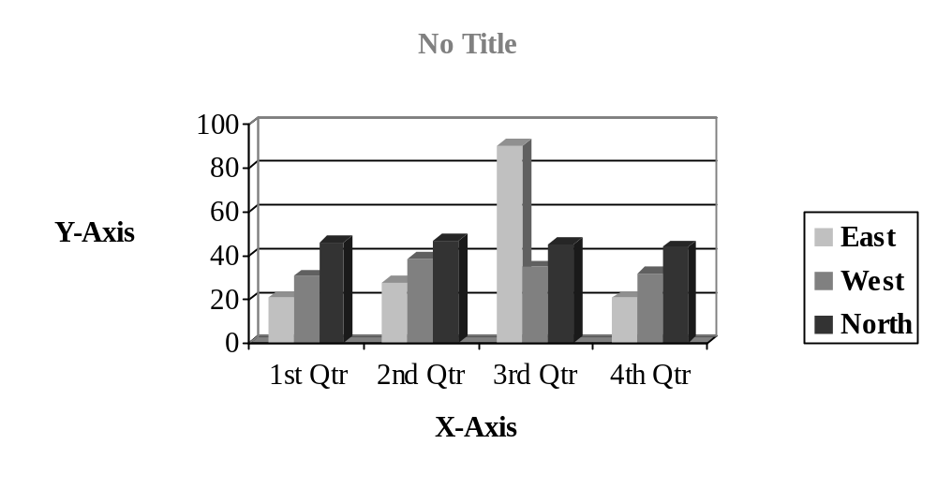
Figure 1. This is an Example of how a Figure Title Should Look. This is also how a figure should be formatted with a serif font, limited bolding, limited color, and sizes no smaller than 8 pt. and no larger than 14 pt. See page 161 in the APA Manual (6th ed.) for more details, but know there are some liberties the Graduate School has modified.

Research Questions
Research Question 1: Is There a God?

Chapter V: Discussion, Conclusion and Recommendation
(Usually a short intro here)

Discussion

Conclusions

Recommendations

(You’re done with the main body of your research paper.)

References
American Psychological Association. (Producer; 2000). Responding therapeutically to patient expressions of sexual attraction [DVD]. Available from: www.apa.org/videos/

Appendix A: First Appendix
[If there is only one appendix in the paper, THEN the format should be - Appendix: Title (no need for the A) otherwise the formatting is the same.]

Appendix B: Second Appendix

