3) SELECT DISTINCT p.pname
FROM Part p
JOIN Catalog c ON p.pid = c.pid;



4)
SELECT s.sname
FROM Supplier s
WHERE NOT EXISTS (
SELECT p.pid
FROM Part p
WHERE p.pid NOT IN (
SELECT c.pid
FROM Catalog c
WHERE c.sid = s.sid
)
);


5) SELECT s.sname
FROM Supplier s
WHERE NOT EXISTS (
SELECT p.pid
FROM Part p
WHERE p.color = 'Red'
AND p.pid NOT IN (
SELECT c.pid
FROM Catalog c
WHERE c.sid = s.sid
)
);
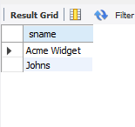

6) SELECT DISTINCT p.pname
FROM Part p
JOIN Catalog c ON p.pid = c.pid;
SELECT p.pname
FROM Part p
JOIN Catalog c ON p.pid = c.pid
JOIN Supplier s ON s.sid = c.sid
WHERE s.sname = 'Acme Widget'
AND p.pid NOT IN (
SELECT c1.pid
FROM Catalog c1
JOIN Supplier s1 ON s1.sid = c1.sid
WHERE s1.sname <> 'Acme Widget'
);
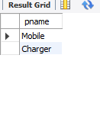

7) SELECT DISTINCT c1.sid
FROM Catalog c1
WHERE c1.cost > (
SELECT AVG(c2.cost)
FROM Catalog c2
WHERE c2.pid = c1.pid
);
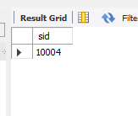

8) SELECT c.pid, s.sname
FROM Catalog c
JOIN Supplier s ON c.sid = s.sid
WHERE c.cost = (
SELECT MAX(c2.cost)
FROM Catalog c2
WHERE c2.pid = c.pid
)
ORDER BY c.pid;


