Designed & Developed by:

Valerie Montalvo



Personal Goal Tracking

Table of Contents

1. Version History 2
2. Strategy 3
3. Features 3

Goal Setting

Progress Tracking

Reward System

1. Users & User Needs 3

User Stories

Technologies & User Interaction

Administrators

Users

1. Site Structure 5
2. Webpage Wireframes 7

# Version History

|  |  |  |  |
| --- | --- | --- | --- |
| Version | Date | Updates | Author |
| 0.1 | 1/21/18 | Created document. | Valerie Montalvo |
| 0.2 | 1/22/18 | Added Strategy and sub-sections. | Valerie Montalvo |
|  |  |  |  |
|  |  |  |  |
|  |  |  |  |

# Strategy

With the number of apps and websites available to users to be able to track their goals, it’s difficult to find one that allows users to track multiple goals from all aspects of their personal life efficiently—especially one that’s free to use.

I’m proposing a dynamic web site that will allow users to store, save and track personal goals, including, but not limited to, health, finance and happiness. This project will create a valuable tool for our increasingly hectic lives that will at least help people keep their goals within sight, and make them achievable.

# Features

All of the website features will be easily navigable and visually pleasing while delivering a friendly and intuitive user experience.

## Goal Setting

Using mySQL databases, all users can easily input their own goals through use of an intuitive user interface. The goals will be sorted by a user-selected type: Fitness, Health, Education, Career, Financial, Leisure, or Other. These types will help organize the user’s goals so they can easily search and track them.

## Progress Tracking

Along with goals, users can create tasks and assign them to their goals to monitor their progress and take steps toward their dreams. Each task completed adds to their progress percentage towards their goal, and adds a user-set amount of points to their score.

## Reward System

Everyone needs incentive to really get them motivated. A user can assign points to each task they create, which adds to their score when completed. These points can be used to redeem rewards that the user has made for themselves. These can include anything the user wants, from shopping to dining out and more.

# Users & User Needs

Keeping in mind that the website is designed for use by everyone of every skill level to help track their goals, the interface will be designed to be simple and easy to navigate.

## User Stories

*“As a user, I want to be able to see and track my goals and the progress I’m making on each one, and be able to edit them if I need to without being an experienced web user.”*

*“As an administrator of the website, I want to be able to see certain type of records on the screen and be able to quickly and easily sort, filter and search for a particular one if needed.”*

*“As an interested potential user, I want to see pictures and a design that really grabs my attention and inspires me, and an easy-to-find About section with screenshots, user stories and a description of what you offer.”*

*“As a casual user, I want a easy to understand and achievable reward system that will keep me motivated on my goal track.”*

## Technologies & User Interaction

The website will be coded in PHP with MySQL as the DBMS. The site will initially be hosted on ict.neit.edu as a web-based solution, with possibility of linking to a desktop application once sufficiently tested and implemented, and will have two user groups that will require a secure login. Each login (both successful and unsuccessful) will be recorded in the database. For visitors to the website, they can access the Sign Up, About and Contact pages, where they can gather information about the website and services.

## Administrators

Administrators will be able to see all user data through the website and add, update, search and delete as needed. They will also be able to create, modify and delete accounts when needed, but will not inherently have full access to the DBMS or core code. For any changes to the website or databases, they will submit and IT Request through the website, which will send an email notification to the developer. Administrator functionalities include:

* + Add/Edit/Delete/Search accounts
  + Add/Edit/Delete/Search goals
  + Add/Edit/Delete/Search goal categories
  + Add/Edit/Delete/Search progress records
  + Add/Edit/Delete/Search rewards
  + View login attempts

## Users

Users will only be able to see their own information and goals stored in the databases, and will be able to add, update, search and delete their own records as they choose.

* + Add/Delete/Update/Search their own goals
  + Add/Delete/Update/Search their progress records
  + Add/Delete/Update/Search their rewards
  + Update/View their personal information
  + Delete their own account

# Site Structure

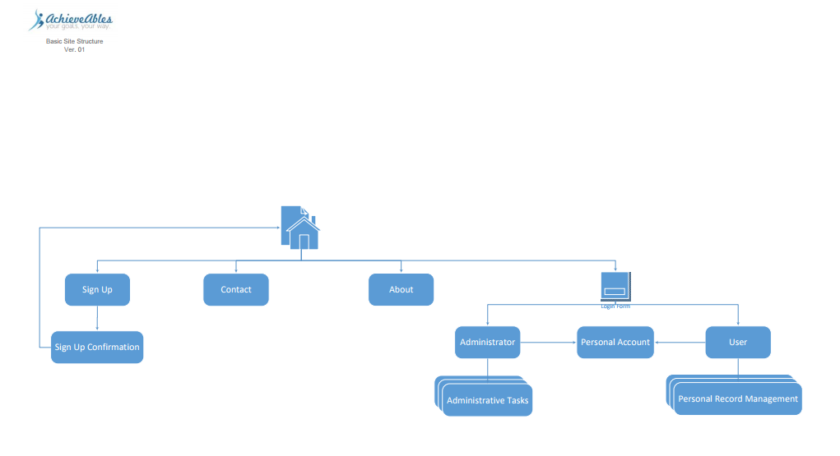

Figure 1: basic site structure

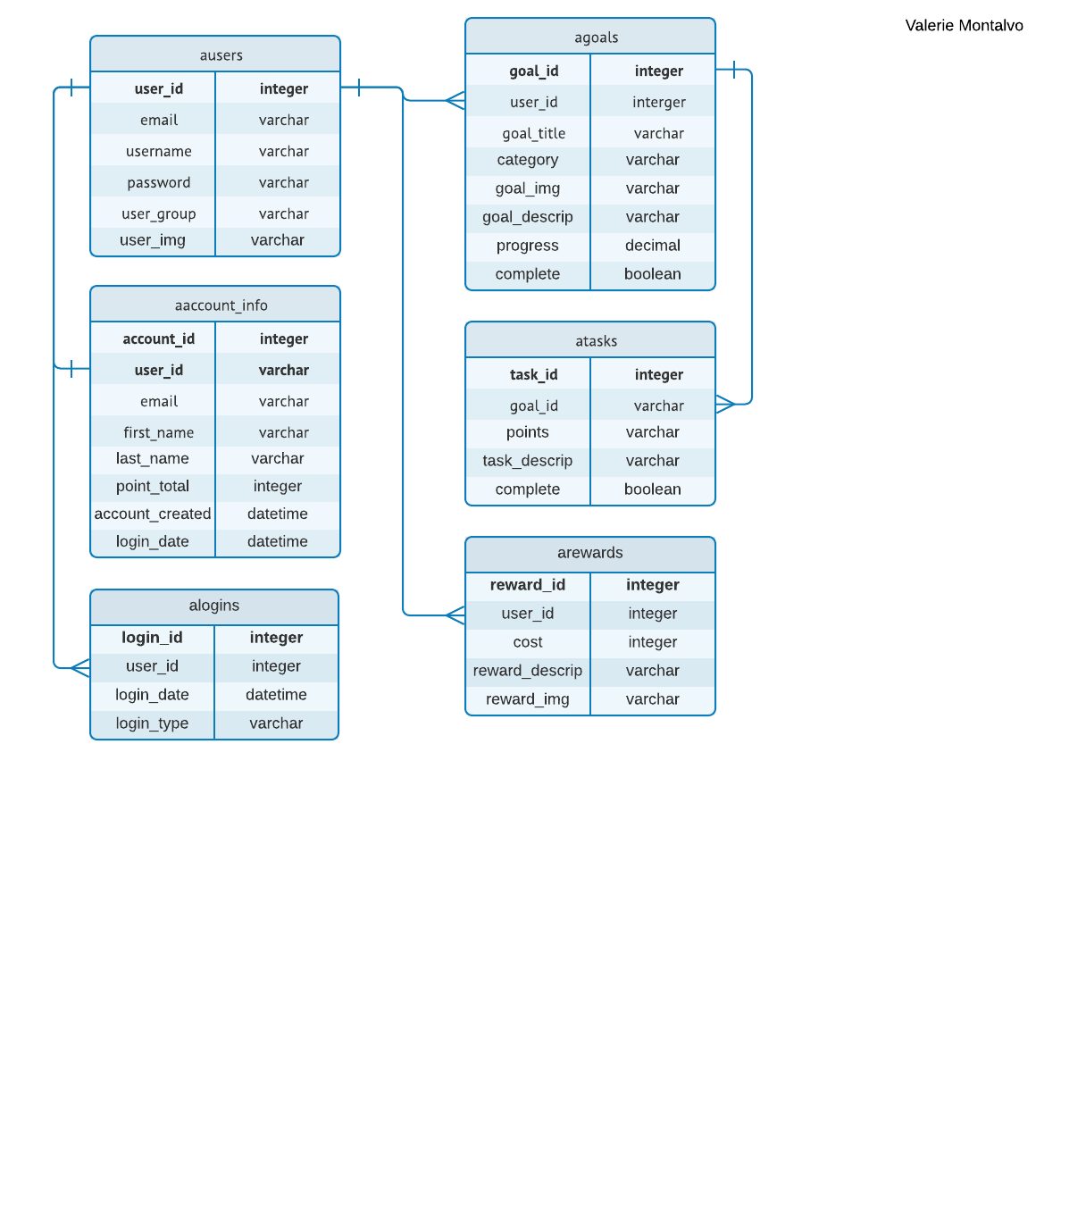

Figure 2: Database Structure

# Webpage Wireframes

For initial concept wireframes, download the below linked zip file:

[AchieveAbles Concept Wireframes](http://ict.neit.edu/005503922/AS_Capstone/Wireframes/AchievAbles_Wireframes.zip)