|  |  |
| --- | --- |
| ATM  BA part for ATM project | Abstract  Here are some stories for ATM project. The list of US you can find below. Additionally, there some diagrams like sequence and components  Kniazeva Viktoriia |

# User Stories list

1. User authentication on ATM
2. Money withdrawal (without authentication)
3. Checking account balance (without authentication)
4. Changing PIN number (without authentication)

# Architecture suggestion

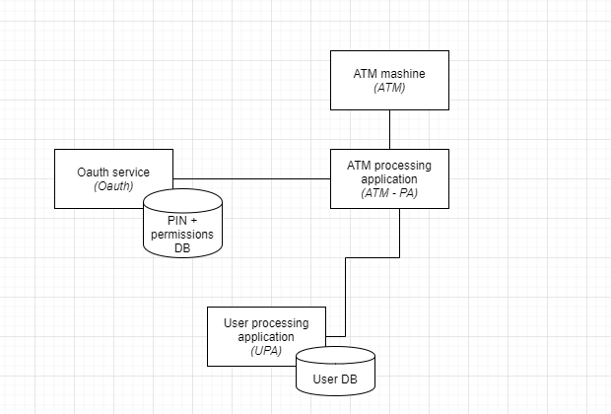

Picture 1. Components diagram: architecture draft

# User Stories:

## US-1: user authentication on ATM

| Business Scope | As a user I want to have authentication concept implemented for my card protection so that I can take some actions with my account via ATM only after being authenticated |
| --- | --- |
| Acceptance criteria | * User can login by swiping the card to the ATM * PIN mask is displayed, PIN is masked with “****” after 2 seconds (mockup 1) * PIN is checked * In case of incorrect PIN, the error notification in displayed (mockup 3) * After 3 attempts (PIN), session is closed, and corresponding error is displayed (mockup 4) * All scenarios are covered by tests and work as described |
| Test scenarios | **Scenario 1 – success case:**  GIVEN: ATM works and card reader is ready to be used GIVEN: swiped card and card owner can be recognized WHEN: card is swiped AND ATM recognized the owner THEN: ATM sends GET/permissions ?cardNumber = “given”&PIN = “given” request to ATM-PA  THEN: ATM-PA sends to Oauth GET/permissionList?cardNumber = “given”&PIN=”given”  redirecting it to Oauth ->  THEN: Oauth checks:  If (givenPIN.equals(PINFromDB)) { return listOfPermissions; }  Else { return errorMessage;} – *part of sc. 2*  THEN: Oauth returns 200 with GET response body to ATM-PA  THEN: ATM-PA returns 200 with GET response body to ATM THEN: ATM displays the list of available options to the user  **Scenario 2 – fail case:**  GIVEN: ATM works and card reader is ready to be used GIVEN: swiped card and card owner can be recognized WHEN: card is swiped AND ATM recognized the owner (1)THEN: ATM sends GET/permissions ? cardNumber = “given”&PIN = “given” request to ATM-PA  (2)THEN: ATM-PA sends to Oauth GET/permissionList?cardNumber = “given”&PIN=”given”  redirecting it to Oauth ->  (3)THEN: Oauth checks:  If (givenPIN.equals(PINFromDB)) { return listOfPermissions; } – *part of sc. 1*  Else { return errorMessage;}  (4)THEN: Oauth returns 401 with GET error response body to ATM-PA (5)THEN: ATM-PA returns 401 with GET error response body to ATM (6)THEN: ATM displays error notification with PIN input field THEN: repeat steps from (1) to (5) 3 times THEN: after 3rd time session is closed and error notification without PIN input is displayed |
| Description | Authentication process:   1. Swipe card to the ATM reader 2. Enter PIN 3. If PIN is correct -> show available actions 4. If PIN is incorrect -> retry logic -> fails – error and end of session |
| Precondition | * Card reader is in place * User can be recognized by a swiped card to the ATM * User is always known (has bank card) |
| Dev notes | Env.: dev, test. No deploy to prod |

### US-1 attachment

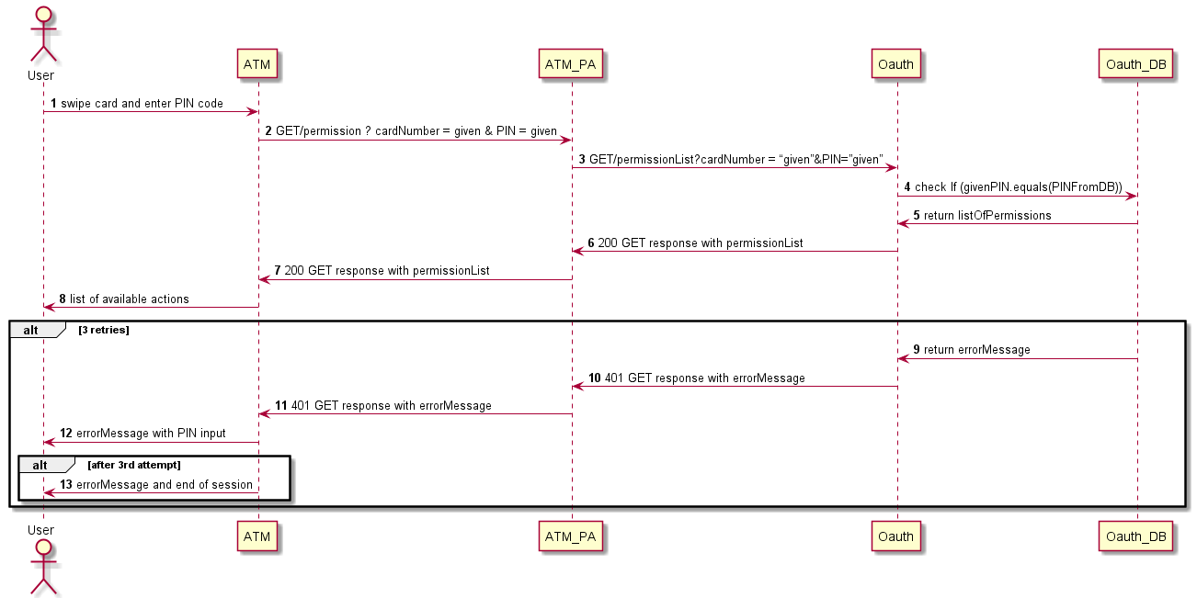

Picture 2. Sequence diagram: authorization flow with alternative. For components shortcuts please look at architecture diagram

## US-2: Money withdrawal (without authentication)

| Business Scope | As a user I want to have implemented feature with money withdrawal so that I am able to withdraw money from my card but only within my limits |
| --- | --- |
| Acceptance criteria | * ATM dispenses cash according to requested sum entered by the user but only within some limits defined by a bank and within balance limitations * Cash withdraw mask is displayed (mockup 5) * In case of negative balance or exceeding bank limits specified error notification should be displayed (mockup 6) * After end of operation main menu should be displayed * All scenarios are tested and following sequence diagram logic (see picture 3) |
| Test scenarios | See diagram (picture 3)  To be tested  Scenario 1: success case  Scenario 2: entered sum exceeds ATM available sum -> ATM technical error  Scenario 3: entered sum exceeds balance -> balance error  Scenario 4: entered sum exceeds bank limit –> bank limit error  Scenario 5: entered sum exceeds balance and bank limit -> result: balance error to be returned |
| Description | Error description:  *ATM technical error*: “Sorry, requested amount is not available in this ATM. Please, contact your bank”  *Balance error*: “Sorry, not enough money. Please, try different sum or contact your bank”  *Bank limit error*: “Sorry, requested amount exceeds your limits. Please, try different sum or contact your bank” |
| Precondition | * ATM physical money withdrawing functionality is in place * Bank limits and authorization features are in place * Technical error handling is out of scope |
| Dev notes | Env.: dev, test. No deploy to prod |

### US-2 attachment

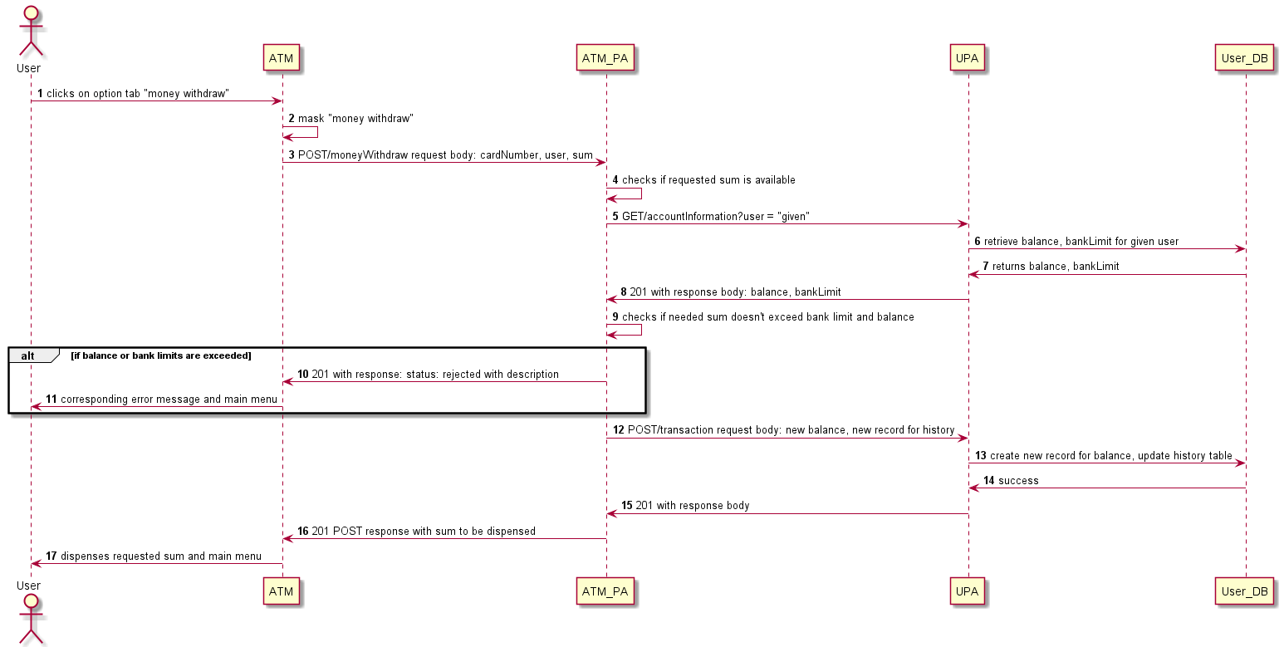

Picture 3. Sequence diagram: money withdrawal flow with alternative. For components shortcuts please look at architecture diagram

## US-3: Checking account balance

### US-3 attachment

| Business Scope | As a user I want to have implemented feature for checking account balance so that I can check balance of my bank account by swiping the card |
| --- | --- |
| Acceptance criteria | * Balance is correctly displayed if the “check balance” option is selected (mockup 7) * Amount to be displayed should be rounded with DecimalFormat(#.##) – Math rounding * In case of some error - standard error notification should be displayed (error handling is out of scope) (mockup 6) |
| Test scenarios | See diagram (picture 4)  To be tested  Scenario 1: success case -> balance is displayed (check with data from DB)  Scenario 2: rounding check to lower number -> mock with 9.914 – should be 9.91  Scenario 3: rounding check to upper number -> mock with 9.916 – should be 9.92 |
| Description | Standard error notification: “Sorry, the operation is not available for the moment. Please, try again later” |
| Precondition | * Authorization features are in place * One card – one account (it’s not possible to reassign the card to different account during the session) * Technical errors are out of scope |
| Dev notes | Env.: dev, test. No deploy to prod |

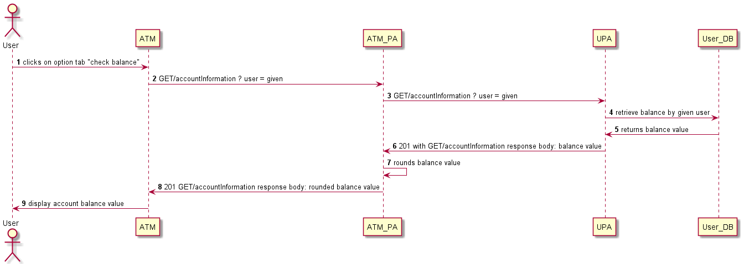

Picture 4. Sequence diagram: Check account balance. For components shortcuts please look at architecture diagram

## US-4: Change PIN number

| Business Scope | As a user I want to have implemented feature for changing my PIN number via ATM so that I can change my PIN number of my card via ATM |
| --- | --- |
| Acceptance criteria | * Mask for “change PIN number” and “confirm entered PIN” are displayed as designed (mockup 8, 9) * PIN number is masked by “****” * After PIN is changed success message is displayed * In case of error corresponding error message is displayed (mockup 10, 11) |
| Test scenarios | See diagram (picture 5)  To be tested  Scenario 1: success case -> success message  Scenario 2: PIN1 != PIN2 -> not matching PIN error message |
| Description | Success notification: “Great! Your PIN number is successfully changed”  Not matching PIN error message: “Sorry, PIN codes you entered are not matching. Please, try again” |
| Precondition | * Authorization features are in place * User always has permissions to change PIN number * Technical errors are out of scope |
| Dev notes | Env.: dev, test. No deploy to prod |

### US-4 attachment

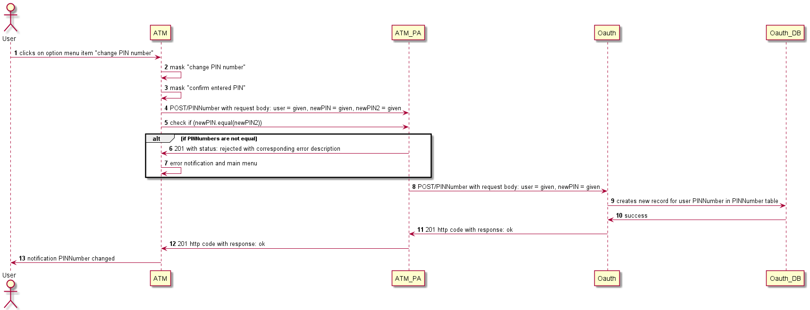

Picture 5. Sequence diagram: Check account balance. For components shortcuts please look at architecture diagram

# Mockups:

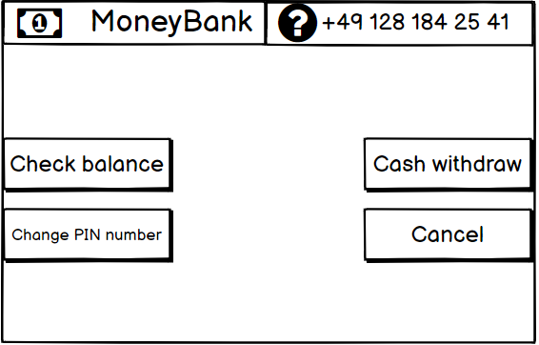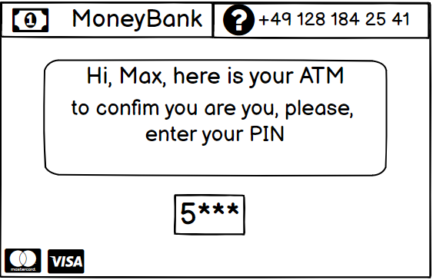

Mockup 2: main menu

Mockup 1: welcome mask

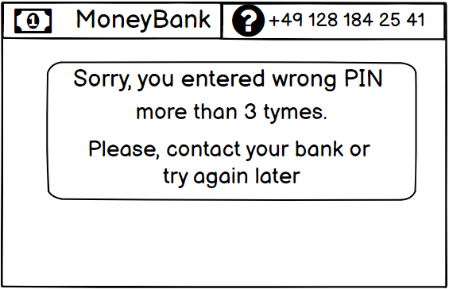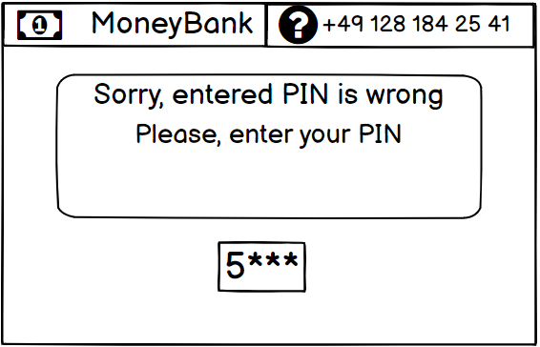

Mockup 4: authentication – error end of session

Mockup 3: authentication – wrong PIN

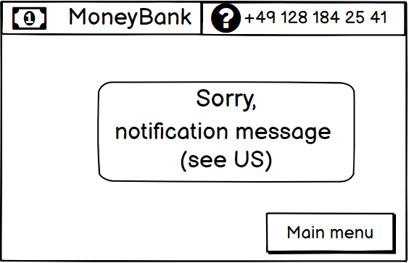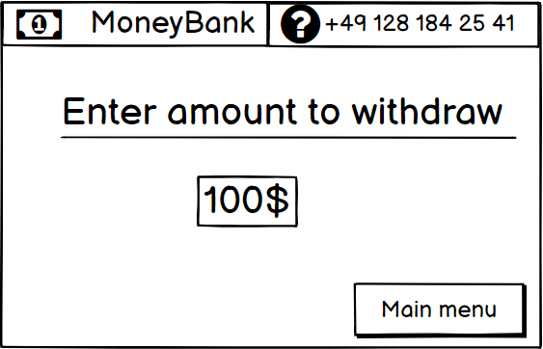

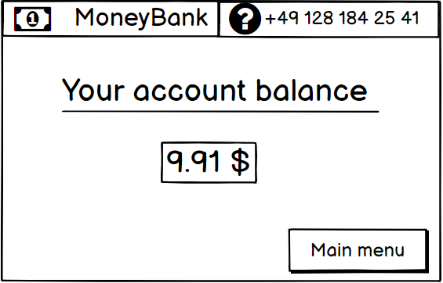

Mockup 6: standard error mask (text see in US description)

Mockup 7: check account balance

Mockup 5: cash withdraw – enter amount

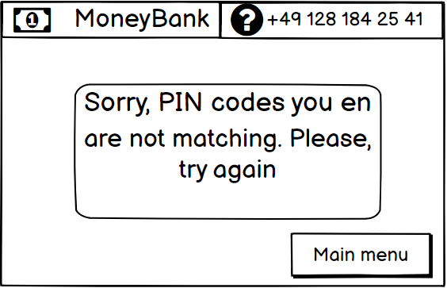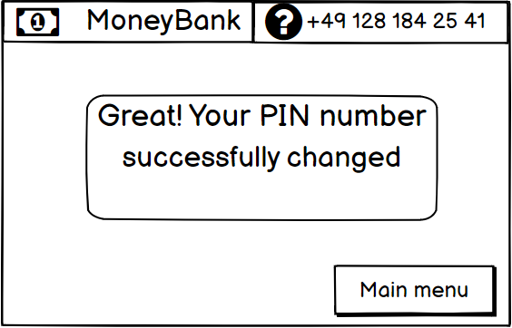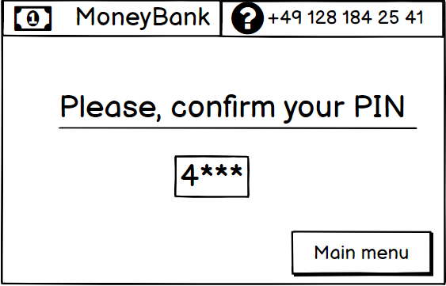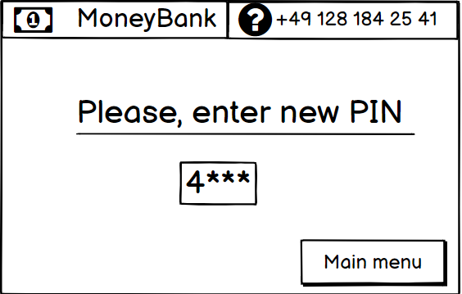

Mockup 11: Change PIN number – error

Mockup 10: Change PIN number – success

Mockup 9: Change PIN number – confirm entered PIN number

Mockup 8: Change PIN number – enter PIN number