The V.E.N.K.A.T Framework™
Enterprise Architecture for the Agentic AI Era
A Reference Architecture for Trusted Autonomous Enterprise Systems

Field | Value
Version | 1.0
Publication Date | June 2026
Author | Venkata (Venkat) Kondepati
Website | https://venkatframework.com
GitHub Repository | https://github.com/vkondepati/venkat-framework-agentic-ai
Document Classification | Public Release

“The future of AI will not be defined by models alone. It will be defined by the architectures that enable AI to act responsibly at scale.”

Recommended Citation and Publication Information
This document introduces Version 1.0 of the V.E.N.K.A.T Framework™, an original enterprise architecture methodology developed by Venkata Kondepati for designing trusted Agentic AI systems. The framework is intended to serve as a practical reference model for enterprise architects, data leaders, AI platform teams, cloud architects, digital transformation leaders, and technology executives.
Citation Element | Details
Recommended citation | Kondepati, V. (2026). The V.E.N.K.A.T Framework™: Enterprise Architecture for the Agentic AI Era - A Reference Architecture for Trusted Autonomous Enterprise Systems (Version 1.0). Venkat Framework Initiative.
Persistent website reference | https://venkatframework.com
Source repository | https://github.com/vkondepati/venkat-framework-agentic-ai
License intent | Public reference and implementation guidance with appropriate attribution.
Trademark note | V.E.N.K.A.T Framework™ is used as a framework name and publication mark by the author.

Important positioning note
The V.E.N.K.A.T Framework is not positioned as a replacement for TOGAF, DAMA-DMBOK, Data Mesh, NIST AI RMF, ISO/IEC 42001, Snowflake, Databricks, or any vendor-specific architecture. It is positioned as an Agentic AI architecture extension that complements these bodies of work by connecting trusted data, events, spatial intelligence, knowledge graphs, orchestration, and governance into an execution-oriented operating model.

Abstract
Artificial Intelligence is moving from systems that generate information to systems that can reason, coordinate, and take action. This transition creates a new architectural challenge. Enterprises have invested heavily in cloud platforms, data lakes, lakehouses, data warehouses, dashboards, machine learning, and generative AI tools, but many of these investments were designed around human-centered decision cycles. They inform humans, but they do not always enable AI systems to act safely, contextually, and responsibly.
The V.E.N.K.A.T Framework™ defines a six-layer enterprise architecture model for the Agentic AI era: Verified Data, Event-Driven Architecture, Native Spatial Intelligence, Knowledge Graphs, AI Orchestration, and Trust & Governance. Together these layers enable a repeatable execution cycle: Signal -> Context -> Reasoning -> Action -> Feedback.
The framework addresses the gap between traditional enterprise architecture and autonomous enterprise operations. It extends established thinking from TOGAF, DAMA-DMBOK, Data Mesh, cloud adoption frameworks, and AI governance models by focusing on the practical capabilities required before AI agents can observe business conditions, interpret context, reason across relationships, initiate workflows, and learn from outcomes under governance. This whitepaper presents the framework, reference architecture, comparative analysis, technology mappings, maturity model, and industry use cases in logistics, manufacturing, and energy.

Table of Contents
- Executive Summary
- Industry Problem Statement
- The Evolution from Analytics to Agentic AI
- The V.E.N.K.A.T Framework Overview
- Agentic AI Reference Architecture
- Framework Layer Details
- Comparative Analysis: TOGAF, DAMA-DMBOK, Data Mesh
- Industry Use Cases
- Technology Mapping: Snowflake and Databricks
- Knowledge Graph Architecture
- AI Agent Orchestration Patterns
- Adoption Maturity Model
- Governance and Trust Model
- Implementation Roadmap
- Versioned Framework Roadmap
- References
- Author Biography
- Change Log

1. Executive Summary
Enterprise Artificial Intelligence is entering a new operating phase. The first major wave of enterprise data platforms focused on transaction processing and operational systems of record. The second wave focused on reporting and business intelligence. The third wave focused on analytics, machine learning, and prediction. The fourth wave, accelerated by Generative AI, made AI accessible to a broader set of users through natural language interfaces, copilots, and content generation tools. The next wave is Agentic AI: systems that observe, understand, reason, coordinate, execute, and learn.
This shift is profound because it changes the purpose of architecture. Traditional enterprise architectures were optimized to move data into systems where humans could consume it through dashboards, reports, workflows, and alerts. Agentic AI requires architectures that allow autonomous or semi-autonomous agents to identify events, understand business context, evaluate trade-offs, interact with enterprise systems, take governed actions, and generate feedback for continuous improvement.
Most enterprises are not architecturally ready for that transition. They may have data warehouses, lakehouses, data products, API platforms, cloud infrastructure, AI models, and automation tools, but these capabilities often remain disconnected. The result is a gap between AI intelligence and enterprise execution. The V.E.N.K.A.T Framework was developed to address this gap.
The framework defines six foundational layers:
- Verified Data: data quality, contracts, lineage, observability, metadata, and trust at the source.
- Event-Driven Architecture: real-time business signals, streaming events, change data capture, and reactive workflows.
- Native Spatial Intelligence: location, proximity, movement, routes, territories, infrastructure, and geographic constraints as first-class context.
- Knowledge Graphs: connected representation of customers, assets, products, locations, policies, events, risks, and dependencies.
- AI Orchestration: coordination of agents, tools, APIs, models, workflows, and human approvals.
- Trust & Governance: policy enforcement, explainability, compliance, security, auditability, and responsible autonomy.
These layers enable the operating cycle of Agentic AI: Signal -> Context -> Reasoning -> Action -> Feedback. In this model, AI is not merely answering a question. It is participating in an enterprise control loop that must be trustworthy, explainable, and aligned with business rules.
The V.E.N.K.A.T Framework complements existing frameworks. TOGAF provides governance and architecture development discipline. DAMA-DMBOK provides a globally recognized body of knowledge for data management. Data Mesh provides principles for decentralized data ownership and data products. NIST AI RMF and ISO/IEC 42001 provide important guidance for AI risk and management systems. V.E.N.K.A.T sits at the intersection of these ideas and focuses specifically on the architecture required for Agentic AI execution.
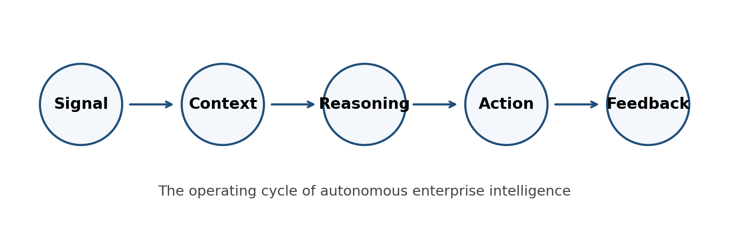
Figure 1. Agentic AI execution cycle enabled by the V.E.N.K.A.T Framework.
The significance of the framework is that it treats Agentic AI as an enterprise architecture problem rather than only a model selection or application development problem. The most capable model cannot act responsibly if the enterprise lacks trusted data, real-time signals, spatial context, relationship intelligence, orchestration, and governance. The V.E.N.K.A.T Framework provides a practical blueprint for closing that architecture gap.

2. Industry Problem Statement
Many organizations have adopted AI faster than they have modernized the architecture beneath it. They may deploy copilots, prompt-based assistants, retrieval-augmented generation, and automation scripts, but the enterprise operating model often remains fragmented. Data may be stored in multiple platforms, business events may be delayed through batch jobs, geospatial context may be handled outside core data pipelines, and governance may be implemented after an AI application is already in production.
This creates the enterprise AI paradox: organizations can demonstrate impressive AI prototypes, yet struggle to turn those prototypes into reliable business execution. The problem is rarely the model alone. In many cases, the model is only the visible layer. The deeper challenge is the architecture that surrounds the model.

2.1 The Six Common Gaps
Gap | Typical Symptom | Why It Matters for Agentic AI
Data Trust Gap | AI consumes inconsistent, duplicated, stale, or unverified data. | Agents can make incorrect decisions faster than humans can detect them.
Real-Time Awareness Gap | Important events are processed hours later through batch pipelines. | Agents cannot act on a disruption they cannot see in time.
Context Gap | Location, asset state, customer priority, inventory position, and operational constraints are not available together. | Agents may optimize locally while harming enterprise outcomes.
Relationship Gap | Dependencies between customers, assets, suppliers, policies, SLAs, and risks are hidden across systems. | Agents cannot reason over cause, impact, and business trade-offs.
Execution Gap | AI recommendations are manually copied into workflows or operational systems. | AI remains advisory rather than operational.
Governance Gap | Decisions are not logged, explainable, policy-bound, or auditable. | Autonomy creates risk instead of trusted scale.

Agentic AI compresses the decision cycle. A human-centered dashboard cycle may tolerate delays because the system is primarily informational. An AI-driven execution cycle does not have that luxury. The system needs to know what happened, where it happened, what relationships are affected, what actions are permitted, which workflows must be triggered, and whether the action should be automatic or require human approval.
This is why architecture must evolve from data delivery to decision execution. The enterprise needs a foundation that allows AI agents to act without losing the trust, security, compliance, and operational controls that business-critical systems require.
Core problem statement
Most enterprises are attempting to deploy Agentic AI on architectures designed for dashboards, reports, and human-centered decision cycles. The V.E.N.K.A.T Framework defines the missing execution architecture required for trusted autonomous action.

3. The Evolution from Analytics to Agentic AI
Enterprise architecture has always evolved in response to changes in how organizations create value. Transactional systems created reliable records. Data warehouses created enterprise reporting. Data lakes and lakehouses created scalable analytics. Cloud platforms improved elasticity and speed. Generative AI created new human-computer interaction patterns through natural language. Agentic AI now extends this progression by shifting from insight generation to action execution.

The shift can be summarized as follows:
Era | Primary Capability | Human Role | Architecture Focus
Transaction Systems | Record business activity | Enter and validate transactions | Reliability, integrity, availability
Reporting / BI | Summarize what happened | Interpret reports | Warehousing, semantic models, dashboards
Analytics / ML | Predict what may happen | Evaluate predictions | Feature engineering, model lifecycle, experimentation
Generative AI | Generate language, code, summaries, and insights | Prompt, review, refine | RAG, model serving, prompt governance
Agentic AI | Observe, reason, coordinate, and act | Set goals, approve exceptions, govern outcomes | Trusted data, events, context, graphs, orchestration, governance

The move to Agentic AI does not eliminate the need for traditional systems. It increases the need for stronger foundations. A governed AI agent depends on high-quality data, real-time eventing, contextual awareness, policy controls, system integration, and feedback loops. In other words, Agentic AI makes architecture more important, not less important.

4. The V.E.N.K.A.T Framework Overview
The V.E.N.K.A.T Framework is an architecture model for enabling AI systems to move from information to action. It is intentionally simple as a mental model, but comprehensive enough to guide enterprise design. Each letter represents a foundational capability. The sequence is not merely alphabetical; it reflects a dependency chain.
Trusted action begins with trusted data. Real-time action requires event awareness. Context-aware action requires spatial and operational context. Reasoned action requires relationship intelligence. Coordinated action requires orchestration. Responsible action requires governance.
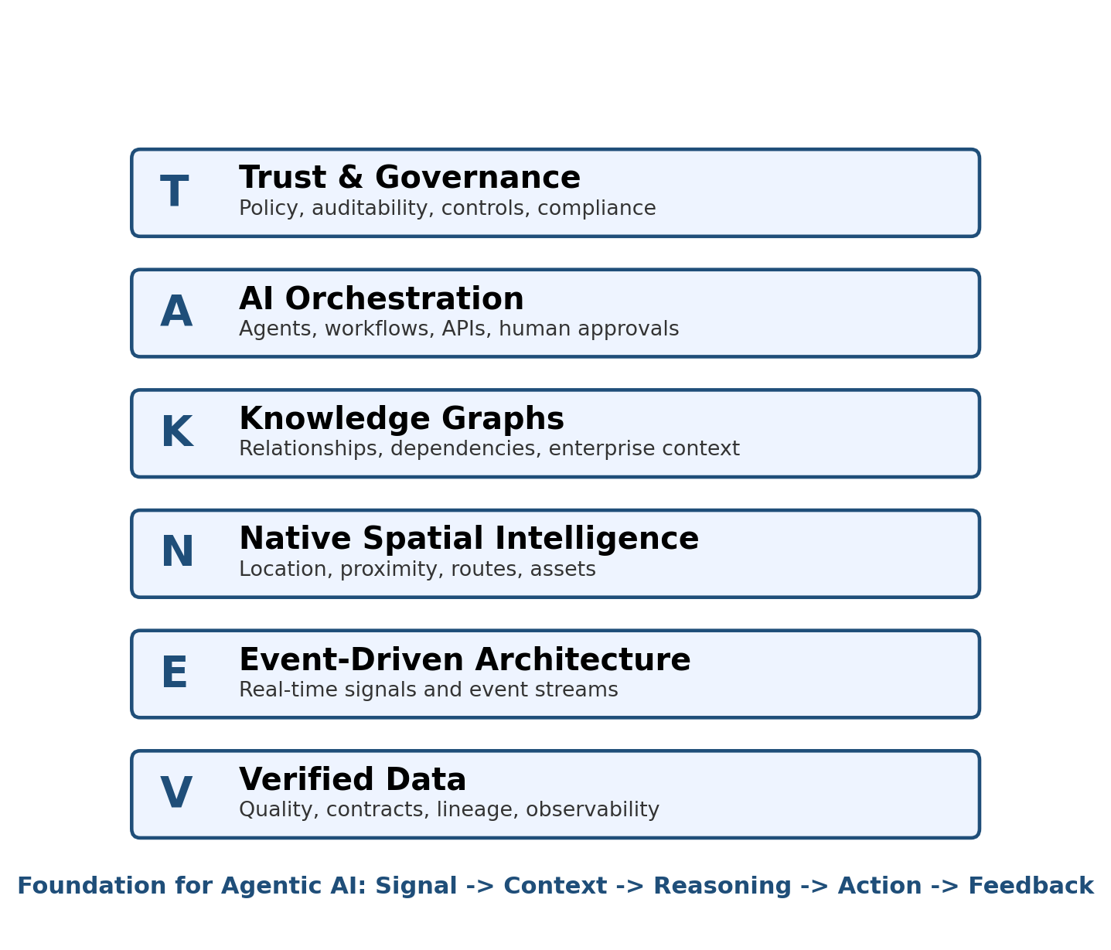
Figure 2. The V.E.N.K.A.T Framework stack.
Layer | Capability | Primary Question
V | Verified Data | Can the AI trust the facts it is using?
E | Event-Driven Architecture | Can the AI observe relevant business changes in time?
N | Native Spatial Intelligence | Does the AI understand where things happen and how location changes the decision?
K | Knowledge Graphs | Does the AI understand relationships, dependencies, and business meaning?
A | AI Orchestration | Can the AI coordinate tools, agents, APIs, workflows, and human approvals?
T | Trust & Governance | Can the enterprise explain, control, audit, and improve AI-driven actions?

The framework can be used in three ways. First, it can serve as an assessment model to evaluate whether an enterprise is ready for Agentic AI. Second, it can serve as a reference architecture to design new AI-enabled platforms. Third, it can serve as an adoption roadmap to modernize existing data and cloud platforms toward governed autonomous execution.

5. Agentic AI Reference Architecture
The reference architecture connects enterprise systems, trusted data foundations, event streams, spatial context, knowledge graphs, AI orchestration, and governed business actions. The architecture is intentionally vendor-neutral. It can be implemented using Snowflake, Databricks, cloud-native services, open-source technologies, commercial graph platforms, GIS systems, workflow platforms, or hybrid combinations.
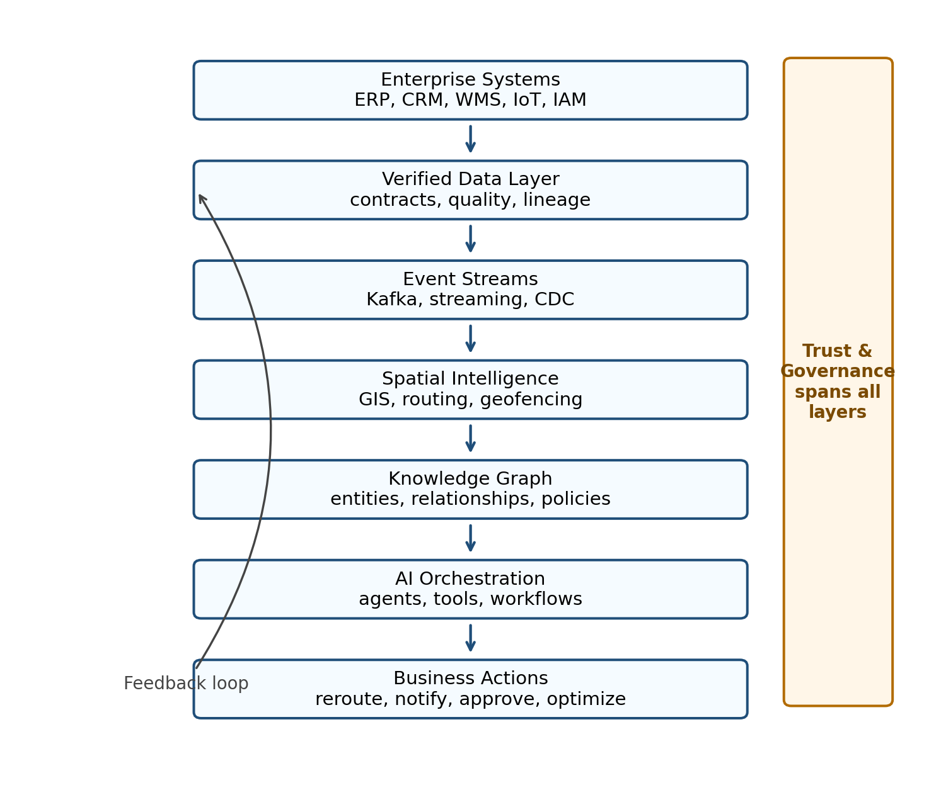
Figure 3. V.E.N.K.A.T Agentic AI reference architecture.
The architecture should be understood as a control loop. Enterprise systems produce data and events. The verified data layer ensures quality, lineage, and trust. The event layer converts business changes into real-time signals. The spatial layer enriches the signal with where, proximity, route, territory, and infrastructure context. The knowledge graph layer connects the event to business relationships, policies, dependencies, and impact. The AI orchestration layer coordinates the decision and execution. Governance spans the entire flow.
This is different from a traditional reporting architecture. In a reporting architecture, the endpoint is often a dashboard. In an Agentic AI architecture, the endpoint is a governed action and a feedback signal that improves future decision quality.

6. Framework Layer Details

6.1 V - Verified Data
Verified Data is the foundation of the framework. Agentic AI cannot be trusted if it reasons from incorrect, stale, inconsistent, incomplete, or unauthorized data. In human-centered analytics, a data quality issue may result in a wrong report. In Agentic AI, a data quality issue may trigger an incorrect workflow, a financial loss, a compliance breach, or a safety incident.
Verified Data establishes confidence before reasoning. It includes data contracts, schema validation, data quality rules, lineage, observability, metadata management, source certification, master and reference data discipline, access controls, and data product accountability. The objective is not perfection; the objective is evidence-based trust. Every AI action should be traceable to the data inputs and confidence levels that supported it.
- Data contracts define expected schemas, semantics, freshness, and ownership.
- Data observability detects anomalies, drift, late arrivals, quality violations, and pipeline failures.
- Lineage shows where data originated, how it was transformed, and which decisions used it.
- Confidence scoring helps agents decide whether to act, escalate, or request human review.

6.2 E - Event-Driven Architecture
Event-Driven Architecture enables AI systems to observe the business as it changes. Traditional batch pipelines are valuable for analytics and historical reporting, but Agentic AI requires timely signals. A delayed signal can convert a manageable disruption into a business failure.
Events represent meaningful changes: a truck is delayed, a sensor crosses a threshold, a customer order is modified, an identity risk score changes, a grid feeder becomes overloaded, a warehouse slot becomes unavailable, or a supplier misses a shipment. Event-driven systems such as Apache Kafka are designed to capture, store, process, and route streams of events in real time. Kafka documentation describes event streaming as the practice of capturing real-time data from sources such as databases, sensors, cloud services, and applications, and routing those streams to destinations for real-time processing and reaction [4].
- Events should be meaningful business signals, not just low-level technical messages.
- Event schemas should be versioned and governed.
- Critical events should be prioritized by business impact and latency requirements.
- Event processing should include replay, traceability, idempotency, and failure handling.

6.3 N - Native Spatial Intelligence
Native Spatial Intelligence is the most differentiated layer of the V.E.N.K.A.T Framework. Many enterprise AI architectures treat location as just another column in a table. The framework treats spatial context as a first-class architectural capability.
This matters because most enterprise operations occur in physical space. Trucks move through routes. Warehouses have layouts. Utility assets exist on networks. Customers live in service territories. Retail stores have trade areas. Pipelines cross geographic risk zones. Healthcare resources are constrained by location. Manufacturing plants have spatial bottlenecks. Without spatial intelligence, an AI agent may know that a delay occurred but not understand where the delay occurred, which assets are nearby, which routes are feasible, and which constraints matter.
Native Spatial Intelligence includes geocoding, routing, proximity analysis, geofencing, network analysis, spatial joins, 3D context, indoor mapping, asset location, and integration with GIS and digital twin platforms. Apache Sedona, for example, provides distributed geospatial processing capabilities across Spark, Flink, Snowflake, SQL, Python, Java, Scala, and R environments [5].
- Spatial context connects enterprise decisions to the real world.
- GeoAI and digital twins become more valuable when linked to events and knowledge graphs.
- Spatial constraints should be available to AI agents as native decision inputs.
- Routing, proximity, capacity, risk zones, and service territories should be modeled as actionable context.

6.4 K - Knowledge Graphs
Knowledge Graphs convert disconnected data into connected understanding. They represent entities and relationships such as customers, products, orders, assets, locations, suppliers, policies, risks, contracts, service commitments, and events. This matters because enterprise decisions are rarely based on one table or one fact. They depend on relationships.
For example, a highway closure is not only a traffic event. It affects shipments. Shipments affect orders. Orders affect customers. Customers may have service-level agreements. Some shipments may contain high-priority medicine. Some alternate warehouses may have compatible inventory. Some route alternatives may violate weight or hazardous material restrictions. A knowledge graph allows an AI agent to reason across this network.
Knowledge graphs also support retrieval-augmented generation and GraphRAG patterns by grounding AI responses in structured relationships rather than only unstructured documents. Academic literature describes knowledge graphs as representations where entities are modeled as nodes and relationships as edges [10].
- Graphs make dependencies explicit.
- Entity resolution links records across systems.
- Relationship context improves reasoning and impact analysis.
- Policy and risk nodes can be linked directly into operational decisions.

6.5 A - AI Orchestration
AI Orchestration is the execution layer. It coordinates agents, models, tools, APIs, workflows, decision services, human approvals, and operational systems. Without orchestration, AI remains a recommendation engine. With orchestration, AI becomes part of the business operating model.
Orchestration should not mean uncontrolled autonomy. It should define what agents are allowed to do, what tools they can access, which evidence they must retrieve, when they must ask for approval, how failures are handled, and how outcomes are logged. Different workflows require different levels of autonomy. A low-risk notification may be automated. A high-cost reroute, financial transaction, customer-impacting decision, or safety-related action may require human-in-the-loop approval.
Agent orchestration patterns include coordinator agents, specialist agents, hierarchical agents, swarm-style collaboration, tool-routing agents, planner-executor patterns, and human approval checkpoints. The V.E.N.K.A.T Framework places orchestration above data, events, spatial context, and graphs because agents should act from verified, contextualized, connected intelligence.
- Agents must have clearly scoped responsibilities.
- Tool access should be governed by role, policy, data sensitivity, and risk level.
- The orchestration layer should log prompts, inputs, outputs, tool calls, decisions, approvals, and exceptions.
- Human-in-the-loop should be designed as a policy-based control, not an afterthought.

6.6 T - Trust & Governance
Trust & Governance spans every layer of the framework. As AI systems gain more autonomy, governance becomes more important, not less important. Governance ensures that AI-driven actions are secure, compliant, explainable, auditable, policy-bound, and aligned with organizational objectives.
The NIST AI Risk Management Framework is intended to help organizations incorporate trustworthiness considerations into the design, development, use, and evaluation of AI systems [11]. ISO/IEC 42001 provides requirements for establishing and continually improving an Artificial Intelligence Management System and emphasizes responsible development and use of AI systems [12]. The V.E.N.K.A.T Framework complements these governance standards by translating trust principles into architecture layers and execution controls.
Trust & Governance includes access control, data classification, policy enforcement, approval workflows, explainability, model monitoring, prompt logging, output review, compliance reporting, audit trails, risk thresholds, segregation of duties, and continuous improvement.
- Every autonomous action should have an evidence trail.
- Decision rights must be explicit: what can AI do, what must a human approve, and what is prohibited?
- Governance policies should be executable where possible, not only documented.
- Feedback loops should monitor outcomes, exceptions, risk, and business value.

7. Comparative Analysis with Existing Frameworks
The V.E.N.K.A.T Framework should be understood as an extension to existing architecture and data frameworks, not a replacement. Each established framework solves a different class of problem. The value of V.E.N.K.A.T is that it addresses a gap created by the rise of AI systems that can act.
Framework | Primary Strength | Limitation for Agentic AI | How V.E.N.K.A.T Complements It
TOGAF | Enterprise architecture method, governance, architecture development, business/application/data/technology domains. | Does not explicitly define AI agent orchestration, spatial intelligence, knowledge graph reasoning, or autonomous execution patterns. | Adds an execution-oriented architecture lens for Agentic AI while respecting enterprise architecture governance.
DAMA-DMBOK | Globally recognized data management framework covering principles, practices, governance, quality, metadata, and stewardship. | Focuses on managing data as an asset; does not by itself define the path from data to governed AI action. | Uses data management discipline as the foundation for verified data and extends it toward reasoning and execution.
Data Mesh | Domain ownership, data as a product, self-serve data platform, federated computational governance. | Solves decentralized data ownership but does not fully define how AI agents reason across products, spatial context, and operational workflows. | Treats data products as inputs into event, spatial, graph, and orchestration layers.
NIST AI RMF / ISO 42001 | AI risk management, AI management system, trust, risk, transparency, and governance. | Provides governance principles and requirements but not a complete enterprise execution architecture. | Embeds governance controls into a layered Agentic AI operating architecture.

7.1 TOGAF vs V.E.N.K.A.T
TOGAF provides a disciplined approach for enterprise architecture development and governance. Its strengths include architecture principles, stakeholder management, architecture domains, roadmaps, and lifecycle governance. TOGAF is highly useful when organizations need an enterprise-wide method to align business, application, data, and technology architecture.
The V.E.N.K.A.T Framework addresses a more specialized question: what capabilities must exist for AI systems to act responsibly? It does not compete with TOGAF's Architecture Development Method. Instead, it can be used as a specialized reference architecture within TOGAF-aligned work. For example, an enterprise architecture team could use TOGAF to govern the overall architecture process while using V.E.N.K.A.T as a target-state model for Agentic AI readiness.

7.2 DAMA-DMBOK vs V.E.N.K.A.T
DAMA-DMBOK is a foundational body of knowledge for data management. DAMA describes DMBOK as a globally recognized framework for data management, providing principles, practices, and functions to build, scale, and govern data programs [2]. Its strengths include data governance, quality, metadata, master data, security, architecture, integration, and stewardship.
V.E.N.K.A.T depends on DAMA-like discipline but extends beyond it. Verified Data is only the starting point. Agentic AI also needs real-time signals, spatial context, relationship reasoning, orchestration, and controls for autonomous action. In this sense, DAMA helps govern the data asset; V.E.N.K.A.T explains how trusted data becomes governed action.

7.3 Data Mesh vs V.E.N.K.A.T
Data Mesh introduced a powerful socio-technical approach to decentralized data ownership. Zhamak Dehghani's description of Data Mesh identifies four principles: domain-oriented decentralized ownership, data as a product, self-serve data platform, and federated computational governance [3]. These ideas remain highly relevant for scaling data ownership.
V.E.N.K.A.T assumes that domain-oriented data products may exist. It then asks a follow-up question: how do AI agents use those data products to reason, coordinate, and act? A data product may provide trustworthy domain information, but an autonomous agent also needs events, location context, relationship intelligence, orchestration, and governance. Therefore, V.E.N.K.A.T can be viewed as an Agentic AI execution layer above or alongside Data Mesh principles.

8. Industry Use Cases
The following use cases illustrate how the framework translates from concept into execution. They are intentionally written as reference scenarios that can be adapted to specific enterprises, industries, and platforms.

8.1 Logistics Use Case: 50-Truck Highway Closure
Scenario: A global logistics enterprise operates thousands of delivery vehicles, regional warehouses, and time-sensitive customer shipments. A major highway closure suddenly blocks 50 trucks. A traditional platform may flag the delay on a dashboard and wait for dispatchers to investigate. Under the V.E.N.K.A.T Framework, an Autonomous AI Dispatch Agent can detect, reason, coordinate, and execute a governed response.
Before the framework, the delay may move through a human-centered process. A traffic feed updates a dashboard. A dispatcher notices the issue. Another team checks which shipments are affected. A warehouse operations team checks inventory. A customer service team prepares notifications. A supervisor approves costlier routes. This chain may take hours.
With the framework, the closure becomes a governed execution event. Verified Data checks the reliability of the traffic source and schema. Event-Driven Architecture publishes the closure event immediately. Native Spatial Intelligence maps the closure against truck positions, road constraints, bridge limits, route alternatives, and warehouse proximity. The Knowledge Graph identifies which shipments carry high-priority goods, which customers have strict SLA penalties, and which nearby warehouses have matching inventory. AI Orchestration coordinates routing, inventory, communication, and governance agents. Trust & Governance checks authorization limits, financial thresholds, safety policies, and audit requirements before execution.
Layer | Action in the 50-Truck Scenario
Verified Data | Validate the closure event, source credibility, timestamp, schema, and confidence score before routing decisions.
Event-Driven | Publish closure event to dispatch, routing, inventory, and customer communication workflows.
Native Spatial | Analyze truck positions, road network constraints, alternate routes, travel time, weather, and warehouse distance.
Knowledge Graph | Connect shipments to orders, customers, SLAs, priority classifications, inventory, and policy constraints.
AI Orchestration | Coordinate Routing Agent, Inventory Agent, Customer Communications Agent, and Operations Agent.
Trust & Governance | Apply route-cost limits, approval thresholds, compliance constraints, and audit logging.

Outcome: Within minutes, the system reroutes 40 trucks, reallocates 10 critical shipments from a closer warehouse, messages affected customers, and logs the full evidence trail. The important distinction is not speed alone. The distinction is governed speed: the AI acted with validated data, spatial context, relationship reasoning, and policy controls.

8.2 Manufacturing Digital Twin Use Case
Scenario: A manufacturing enterprise operates a large warehouse and production support environment. Fulfillment delays are rising because inventory is placed inefficiently, picking routes are congested, and staging areas are not aligned with shipment priority. A traditional dashboard can show utilization, backlog, or order aging, but it cannot automatically redesign space allocation or coordinate execution.
The V.E.N.K.A.T Framework treats the manufacturing environment as a living digital twin. Verified Data ensures inventory, slotting, work order, equipment, and sensor data are accurate. Event-Driven Architecture captures movement, replenishment, pick path congestion, and machine status changes. Native Spatial Intelligence models warehouse zones, aisles, racks, staging areas, dock doors, forklift paths, and safety zones. Knowledge Graphs connect inventory to orders, production schedules, suppliers, equipment, and labor constraints. AI Orchestration coordinates optimization agents that recommend slot moves, pick path adjustments, replenishment changes, and work order creation. Trust & Governance ensures that safety, labor, access, and operational approval rules are enforced.
Outcome: The enterprise can move from visualizing warehouse problems to continuously optimizing space, flow, fulfillment, and asset utilization. The framework makes the digital twin actionable rather than purely descriptive.

8.3 Energy Grid Use Case
Scenario: A utility experiences localized feeder overload caused by clustered EV charging, weather-driven demand, and distributed energy resource variability. A traditional monitoring system may generate alarms, but balancing decisions require understanding grid topology, customer class, asset condition, spatial distribution, and operational constraints.
Using the V.E.N.K.A.T Framework, smart meter and sensor events are validated and streamed into the architecture. Spatial intelligence maps the overload to feeders, transformers, substations, customer clusters, and DER locations. The knowledge graph connects grid assets, service territories, customer profiles, historical load patterns, maintenance status, and regulatory constraints. AI agents evaluate load shifting, demand response, smart charging recommendations, and crew prioritization. Governance controls determine which actions can be automated, which require operator approval, and how decisions must be logged.
Outcome: The utility improves grid reliability while preserving safety, customer impact controls, and auditability. The architecture moves beyond predictive analytics into governed operational response.

9. Technology Mapping: Snowflake and Databricks
The V.E.N.K.A.T Framework is vendor-neutral. However, mapping the framework to major data platforms helps enterprise teams understand how to implement the architecture with tools they already use. The following mappings are illustrative and should be adapted to the organization's platform strategy, regulatory context, skill base, and existing investments. Product names and capabilities evolve frequently, so architecture teams should validate implementation details against current vendor documentation before deployment.
V.E.N.K.A.T Layer | Snowflake-Oriented Implementation Pattern | Databricks-Oriented Implementation Pattern
Verified Data | Data quality rules, metadata, lineage, governance, data contracts, dynamic tables, streams/tasks, ingestion controls, cataloging. | Delta Lake, medallion architecture, schema enforcement, expectations, Delta Live Tables / Lakeflow patterns, Unity Catalog, data quality checks.
Event-Driven Architecture | Snowpipe Streaming, streams and tasks, event tables, CDC integration, external event sources. | Structured Streaming, Kafka/Kinesis/Event Hubs connectors, Auto Loader, streaming tables, Delta as streaming source/sink.
Native Spatial Intelligence | Snowflake geospatial data types and functions; integration with GIS tools; SedonaSnow or external spatial processing patterns where appropriate. | Apache Sedona or Mosaic-style geospatial libraries, Spark spatial processing, GeoParquet, GIS integration, Databricks notebooks/jobs.
Knowledge Graphs | Graph modeling through partner integrations, external graph databases, semantic models, graph tables, Cortex/search/RAG integration patterns. | Graph data represented in Delta, external graph systems such as Neo4j/Neptune, vector search, feature/embedding stores, GraphRAG patterns.
AI Orchestration | Cortex AI, Snowpark, external orchestration frameworks, APIs, app frameworks, task-based workflows. | Mosaic AI, model serving, MLflow, agent frameworks, workflows/jobs, vector search, external orchestration frameworks.
Trust & Governance | Horizon-style governance, roles, masking policies, row access policies, lineage, monitoring, audit and access controls. | Unity Catalog, fine-grained access controls, lineage, model governance, audit logs, policies, data and AI governance.

Databricks documentation describes the lakehouse as combining benefits of data lakes and data warehouses, with scalable storage and processing capabilities and a pattern for establishing a single source of truth [6]. Its medallion architecture organizes data into bronze, silver, and gold layers to progressively improve quality and structure [7]. Structured Streaming provides near-real-time processing with fault tolerance and familiar Spark APIs [8]. These capabilities map naturally to Verified Data and Event-Driven Architecture in the V.E.N.K.A.T Framework.
Snowflake similarly provides a mature cloud data platform with capabilities for warehousing, sharing, governance, AI, and app development. Its evolving Cortex AI and Snowflake Intelligence direction reflects the enterprise movement toward AI applications and agentic workflows, while Snowpipe Streaming and geospatial capabilities can support event and spatial layers. Because Snowflake capabilities change rapidly, the mapping in this whitepaper should be treated as an architectural pattern rather than a version-specific implementation manual.

10. Knowledge Graph Architecture
Knowledge graphs are essential to the framework because Agentic AI needs more than isolated facts. It needs connected business meaning. In the logistics example, the AI must understand the relationship between a route disruption, a shipment, a customer, an SLA, inventory availability, warehouse capacity, and governance policy. A relational model can store many of these facts, but a graph model makes the relationships explicit and navigable.
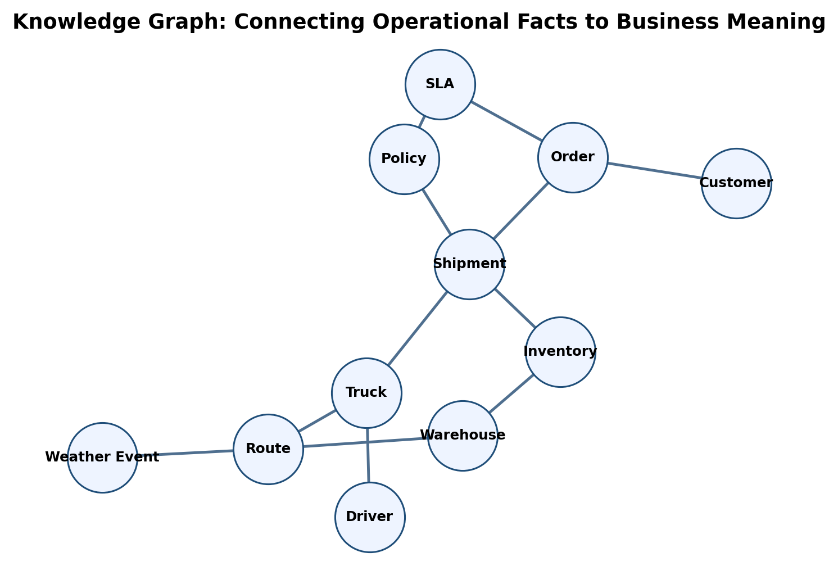
Figure 4. Example logistics knowledge graph for Agentic AI reasoning.
A practical enterprise knowledge graph should include several types of nodes: core business entities, operational assets, spatial entities, events, policies, risk controls, digital twin objects, and AI decision records. The graph should not be treated as a separate academic artifact. It should be integrated with data catalogs, semantic models, API platforms, identity systems, workflow systems, and AI retrieval layers.
Knowledge graph architecture for Agentic AI should address entity resolution, graph schema design, governance, incremental updates, event integration, spatial relationships, vector search integration, and explainability. The most valuable graph is not the largest graph. It is the graph that makes business-critical decisions explainable and actionable.
Graph Component | Purpose | Example
Entity nodes | Represent business objects. | Customer, Order, Truck, Warehouse, Feeder, Transformer.
Relationship edges | Represent dependencies and meaning. | Customer has SLA, Truck carries Shipment, Warehouse stocks Product.
Event nodes | Represent operational change. | Highway Closure, Sensor Alert, Load Spike, Identity Risk Event.
Policy nodes | Represent constraints and rules. | Approval Limit, Compliance Control, Route Restriction, Safety Rule.
Decision records | Represent AI actions and evidence. | Reroute Decision, Customer Notification, Load Balancing Action.

11. AI Agent Orchestration Patterns
AI agents should not be designed as unrestricted autonomous actors. They should be designed as governed participants in enterprise workflows. The orchestration layer defines how agents collaborate, access tools, escalate decisions, and record evidence.
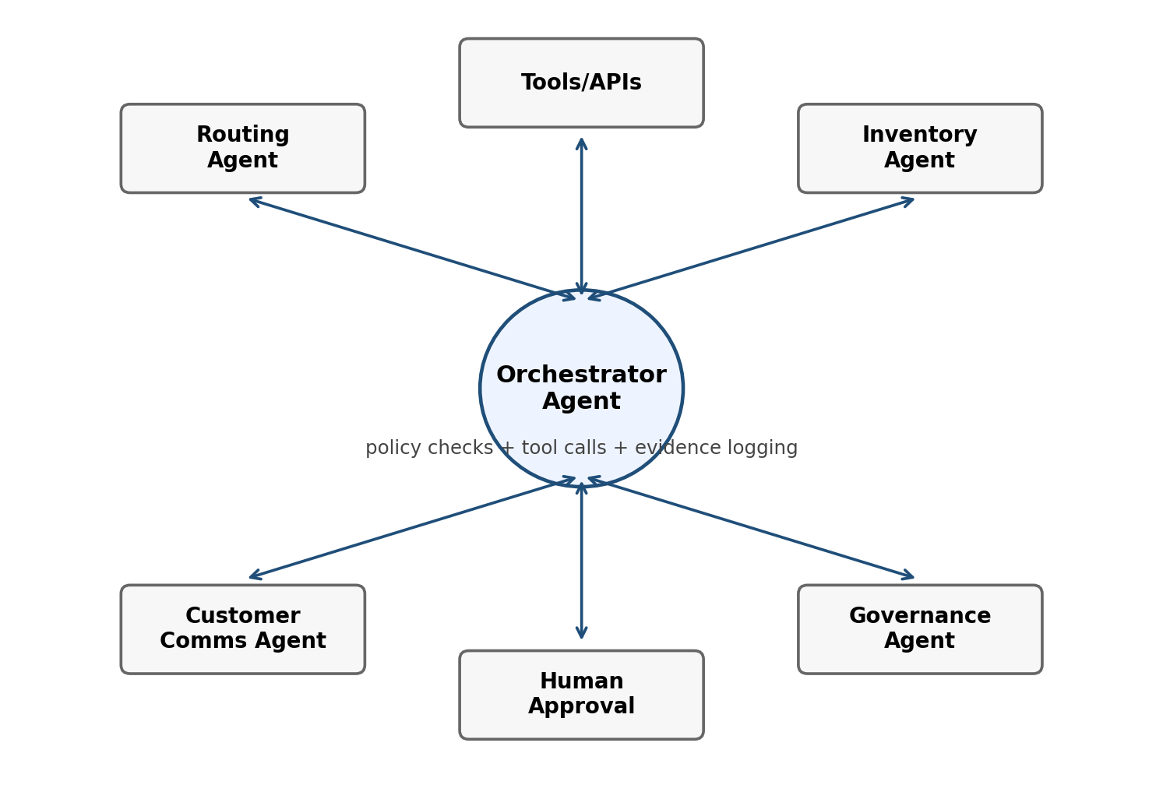
Figure 5. AI Agent orchestration pattern with governance and human-in-the-loop controls.
Pattern | Description | Best Fit
Coordinator Agent | A central agent decomposes the task and delegates to specialist agents. | Operational workflows that require routing across multiple systems.
Specialist Agents | Each agent has a narrow responsibility such as routing, inventory, communications, or policy checks. | Complex workflows where domain-specific logic matters.
Planner-Executor | A planning agent creates steps and an executor invokes tools under controls. | Tasks requiring traceability and approval gates.
Human-in-the-Loop | Humans approve high-risk, high-cost, regulated, or irreversible actions. | Financial, legal, safety, customer-impacting, or regulated decisions.
Governance Agent | A policy-aware agent checks authorization, constraints, and evidence before execution. | Any workflow involving autonomous or semi-autonomous action.

The orchestration layer should be designed around decision rights. For every agentic workflow, architects should define what the agent can observe, what it can recommend, what it can execute automatically, what it can execute only with approval, and what it is prohibited from doing. This decision-rights model is central to responsible autonomy.

12. Adoption Maturity Model
Enterprises should not attempt to jump directly from dashboards to full autonomy. A maturity model helps organizations adopt the framework gradually. The V.E.N.K.A.T maturity model defines six levels that correspond to the framework layers and the increasing ability of AI systems to act responsibly.
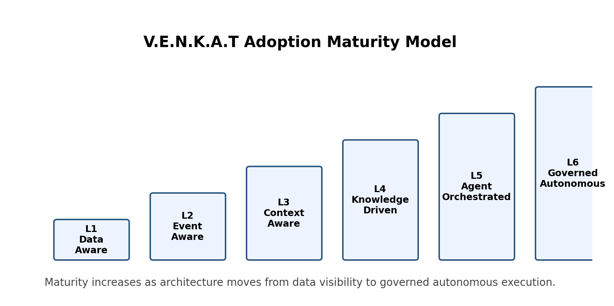
Figure 6. V.E.N.K.A.T adoption maturity model.
Level | Name | Characteristics | Readiness Question
1 | Data Aware | Core data sources are cataloged and basic data quality is measured. | Can we identify and trust the data sources feeding AI?
2 | Event Aware | Critical business events are captured and routed in near real time. | Can AI observe the business as it changes?
3 | Context Aware | Spatial, operational, and environmental context is integrated. | Does AI understand where and under what constraints the event occurred?
4 | Knowledge Driven | Relationships and dependencies are modeled in graphs or semantic layers. | Can AI reason across business relationships and impact?
5 | Agent Orchestrated | Agents coordinate workflows, APIs, and tools with controlled autonomy. | Can AI convert reasoning into coordinated execution?
6 | Governed Autonomous | Actions are auditable, explainable, policy-bound, and continuously improved. | Can AI act responsibly at enterprise scale?

13. Governance and Trust Model
Governance in the V.E.N.K.A.T Framework is not a separate compliance checklist. It is an architectural capability that must be embedded into data, events, spatial services, knowledge graphs, agent orchestration, and business actions. The model aligns with the general intent of NIST AI RMF and ISO/IEC 42001: organizations need repeatable ways to manage AI risks, improve trustworthiness, and govern AI systems across their lifecycle.
Governance Control | Architectural Implementation | Evidence Produced
Data governance | Catalog, lineage, quality rules, data contracts, access policies. | Source evidence, confidence score, lineage trace.
Policy enforcement | Policy engine, approval thresholds, role-based tool access, prohibited action list. | Policy decision record.
Human oversight | Approval workflow based on risk, cost, reversibility, and customer impact. | Approval logs and escalation history.
Explainability | Decision trace showing data, context, graph relationships, model output, and tool calls. | Decision explanation package.
Auditability | Immutable log of prompts, inputs, outputs, tool invocations, approvals, and outcomes. | Audit trail and compliance report.
Monitoring | Outcome monitoring, drift detection, exception tracking, incident reporting. | Feedback metrics and corrective actions.

Responsible autonomy requires evidence. Every material AI-driven action should produce an evidence package: the triggering event, data confidence, spatial context, graph reasoning, model or agent output, policy checks, approval status, tool calls, action taken, and result. This evidence package is what allows the enterprise to audit, improve, and defend autonomous operations.

14. Implementation Roadmap
The framework can be adopted incrementally. A practical roadmap should begin with a focused business use case rather than an enterprise-wide transformation. The use case should have measurable business value, available data, clear operational pain, and manageable governance boundaries.
Phase | Objective | Key Deliverables
Phase 1: Assess | Evaluate current architecture against the six layers. | Readiness scorecard, gap analysis, priority use cases.
Phase 2: Verify | Create trusted data foundation for selected use case. | Data contracts, quality rules, lineage, source inventory.
Phase 3: Event Enable | Convert critical business changes into governed event streams. | Event taxonomy, schemas, streaming pipeline, replay strategy.
Phase 4: Contextualize | Add spatial and operational context. | GIS integration, route/asset/location model, digital twin links.
Phase 5: Connect Knowledge | Model key entities and dependencies. | Knowledge graph schema, entity resolution, policy relationships.
Phase 6: Orchestrate | Deploy agents and workflows with tool access. | Agent design, tool registry, approval workflows, test harness.
Phase 7: Govern and Scale | Operationalize responsible autonomy. | Audit logs, monitoring, KPI dashboard, governance board, roadmap.

A successful implementation should produce not only a working AI agent but also reusable architecture assets: event definitions, graph schemas, governance controls, integration patterns, operational runbooks, testing datasets, failure scenarios, and a maturity score. These assets allow the framework to be repeated across business domains.

15. Versioned Framework Roadmap
Version 1.0 defines the core framework, reference architecture, maturity model, and representative use cases. Future versions can expand the framework into industry-specific blueprints, detailed implementation accelerators, assessment templates, and certification-style readiness scoring.
Version | Target | Planned Scope
1.0 | June 2026 | Initial public release: framework layers, reference architecture, comparison analysis, use cases, technology mapping, maturity model.
1.1 | Planned | Expanded reference architectures for logistics, manufacturing, energy, IAM, geospatial intelligence, and digital twins.
1.2 | Planned | Maturity assessment toolkit, scorecards, templates, and implementation patterns.
2.0 | Planned | Autonomous Enterprise Operating Model with governance patterns, controls library, and industry-specific extensions.

16. Why the Framework Is Relevant and Significant
The V.E.N.K.A.T Framework is significant because it addresses a timely and practical gap. Enterprises are moving from AI experimentation to AI-enabled execution. However, most organizations are still using architecture patterns created for dashboards, reporting, and human-centered workflows. This creates risk when AI agents are asked to take action.
The framework is relevant for four reasons. First, it provides a clear architecture model that connects data, events, spatial intelligence, knowledge graphs, orchestration, and governance. Second, it introduces Native Spatial Intelligence as a first-class layer, which is frequently overlooked despite the fact that many enterprise operations are location-dependent. Third, it reframes Agentic AI as an architecture problem rather than only a model or application problem. Fourth, it complements established frameworks rather than replacing them, making it easier for enterprise architects to adopt.
For CIOs, CTOs, Chief Data Officers, enterprise architects, AI leaders, and data engineering teams, the framework provides a practical way to ask: Are we architecturally ready for AI that can act?

17. References and Source Notes
- [1] The Open Group. TOGAF Standard. https://www.opengroup.org/togaf
- [2] DAMA International. DAMA-DMBOK: Data Management Body of Knowledge. https://www.dama.org/cpages/body-of-knowledge
- [3] Dehghani, Z. Data Mesh Principles and Logical Architecture. Martin Fowler. https://martinfowler.com/articles/data-mesh-principles.html
- [4] Apache Kafka. Introduction to Event Streaming and Apache Kafka. https://kafka.apache.org/intro/
- [5] Apache Sedona. Apache Sedona Documentation. https://sedona.apache.org/latest/
- [6] Databricks. What is a Data Lakehouse? https://docs.databricks.com/aws/en/lakehouse/
- [7] Databricks. Medallion Lakehouse Architecture. https://docs.databricks.com/aws/en/lakehouse/medallion
- [8] Databricks. Structured Streaming Concepts. https://docs.databricks.com/aws/en/structured-streaming/concepts
- [9] Neo4j. Knowledge Graph Concepts and Graph Database Resources. https://neo4j.com/knowledge-graph/
- [10] Heist, N., Hertling, S., Ringler, D., Paulheim, H. Knowledge Graphs on the Web: An Overview. arXiv:2003.00719.
- [11] NIST. Artificial Intelligence Risk Management Framework. https://www.nist.gov/itl/ai-risk-management-framework
- [12] ISO. ISO/IEC 42001:2023 Artificial Intelligence Management System. https://www.iso.org/standard/42001
- [13] Snowflake Documentation. Snowflake Data Cloud, Cortex AI, Snowpipe Streaming, Governance, and Geospatial Capabilities. https://docs.snowflake.com/
- [14] LangChain / LangGraph Documentation. Agent and workflow orchestration concepts. https://langchain-ai.github.io/langgraph/
- [15] Microsoft Semantic Kernel Documentation. Agent and plugin orchestration concepts. https://learn.microsoft.com/semantic-kernel/
- [16] Venkat Framework. V.E.N.K.A.T Framework official website. https://venkatframework.com
- [17] GitHub Repository. V.E.N.K.A.T Framework for Agentic AI. https://github.com/vkondepati/venkat-framework-agentic-ai

18. Author Biography
Venkata (Venkat) Kondepati is a technology executive, enterprise architect, and data engineering leader with more than 25 years of experience delivering large-scale digital transformation initiatives across cloud platforms, enterprise data systems, GIS, digital twins, identity platforms, and artificial intelligence solutions.
His experience spans enterprise architecture, cloud transformation, data engineering, geospatial intelligence, identity and access management, digital twin solutions, AI-enabled platforms, and leadership of distributed engineering teams. The V.E.N.K.A.T Framework represents the convergence of these disciplines into a unified architecture model for the Agentic AI era.
The framework reflects Venkat's view that the next generation of enterprise AI will be defined not only by models, but by the architecture that allows AI to observe, understand, reason, act, and learn responsibly at scale.

19. Change Log
Version | Date | Description
1.0 | June 2026 | Initial public release of the V.E.N.K.A.T Framework whitepaper.
1.1 | Planned | Expanded reference architectures and implementation templates.
1.2 | Planned | Assessment toolkit, adoption checklist, and maturity scoring template.
2.0 | Planned | Autonomous Enterprise Operating Model and industry-specific extensions.

Appendix A: V.E.N.K.A.T Readiness Scorecard
The following scorecard can be used during workshops. Each category can be scored from 1 to 5, where 1 indicates ad hoc capability and 5 indicates mature, governed, reusable capability.
Layer | Assessment Criteria | Score (1-5)
Verified Data | Quality rules, data contracts, lineage, source ownership, observability.
Event-Driven | Event taxonomy, real-time streaming, replay, schema governance, latency SLAs.
Spatial Intelligence | Geospatial data model, GIS integration, route/proximity analysis, digital twin context.
Knowledge Graphs | Entity resolution, relationship model, graph governance, policy and dependency mapping.
AI Orchestration | Agent design, tool access, workflow integration, approval patterns, test harness.
Trust & Governance | Policy enforcement, audit trails, explainability, risk controls, monitoring, human oversight.

