Modification Screens

As per your requirement we have modified all models to predict all possible types of attacks showing below

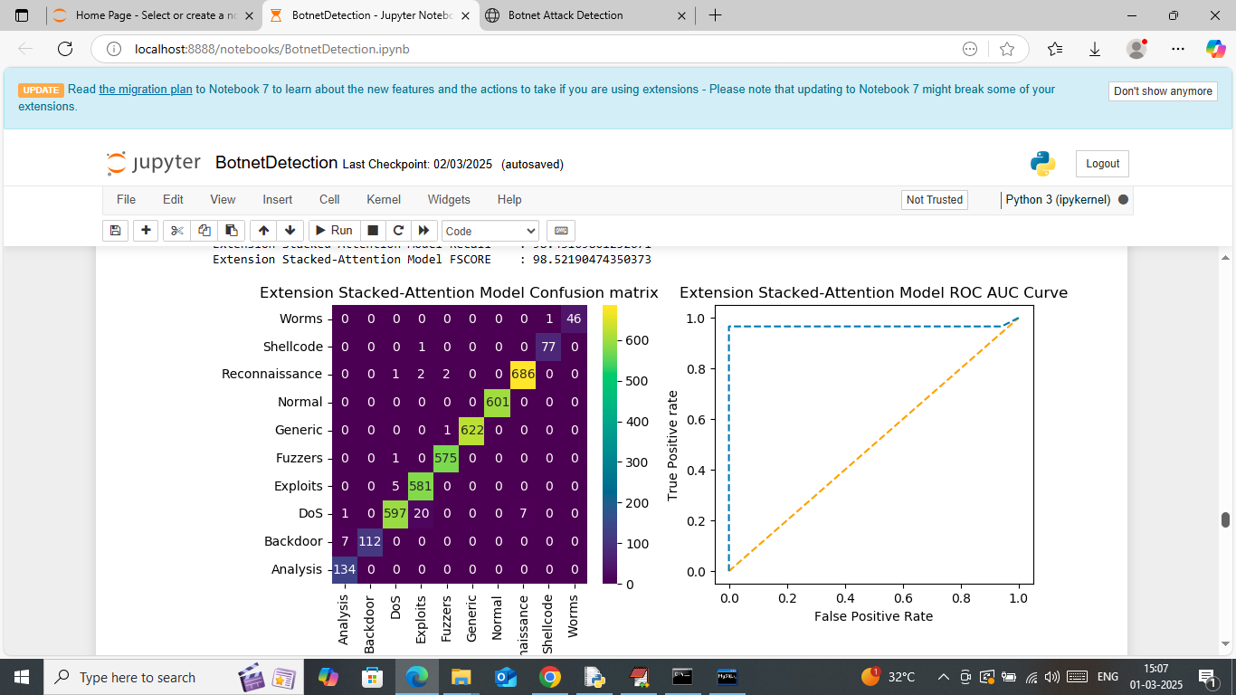

In above screen in confusion matrix classification graph can see classification of all attacks where x-axis represents ‘Predicted Attack’ and y-axis represents ‘True attacks’ and then all different color boxes in diagonal represents correct prediction count and remaining blue boxes represents incorrect prediction count which are very few

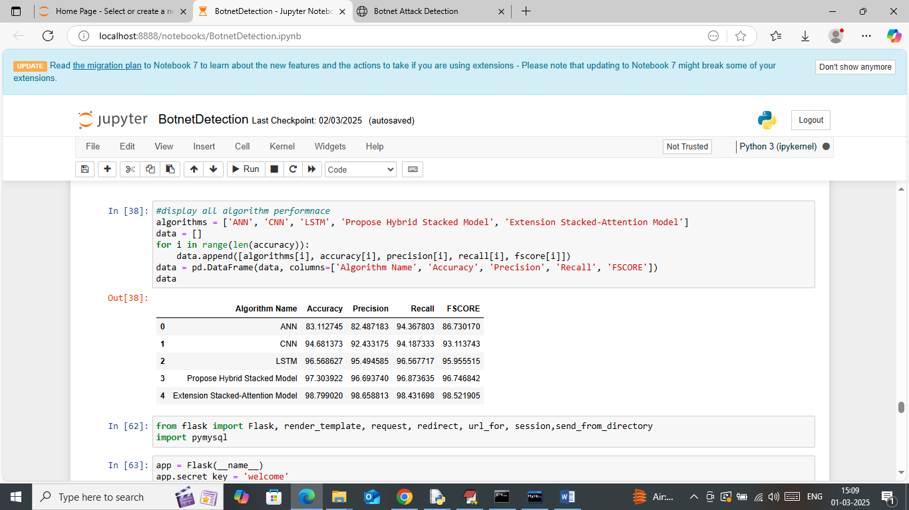

In above screen in table format can see performance of all algorithms and below is the web output

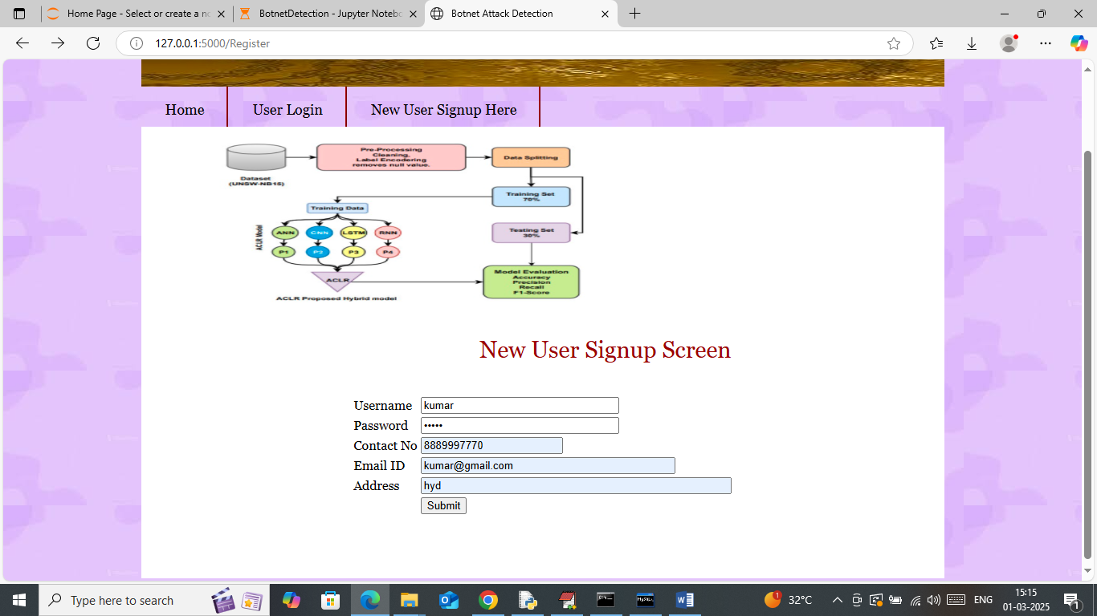

In above screen user is entering sign up details and then press button to get below page

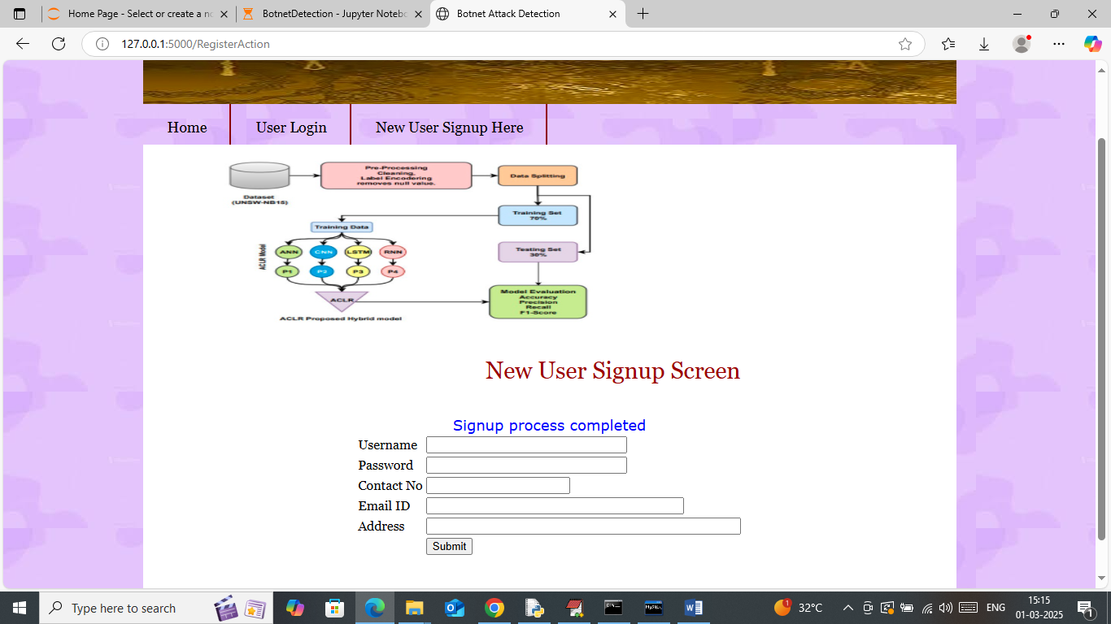

In above screen user sign up completed and now click on ‘User Login’ link to get below page

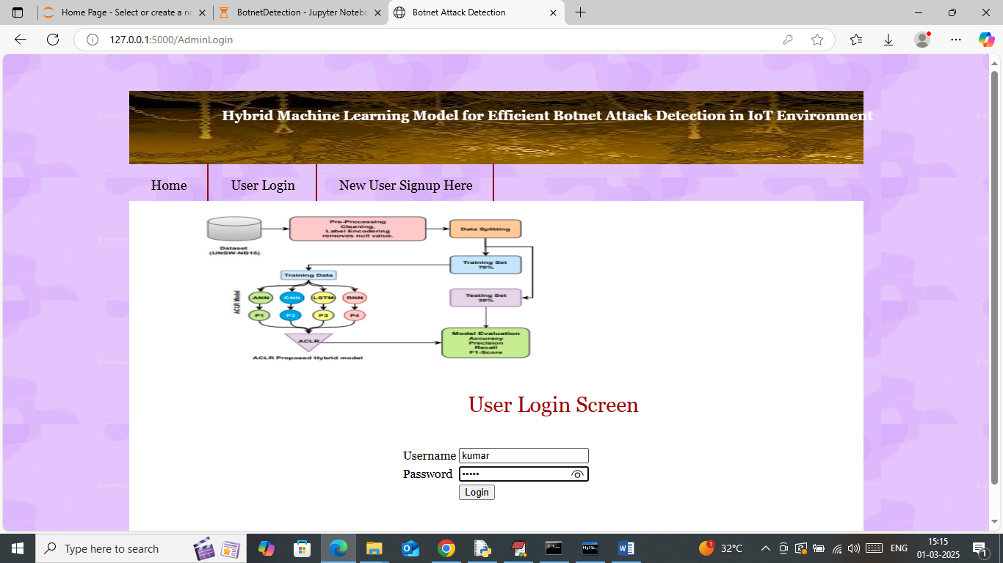

In above screen user is entering login details and then press button to get below page

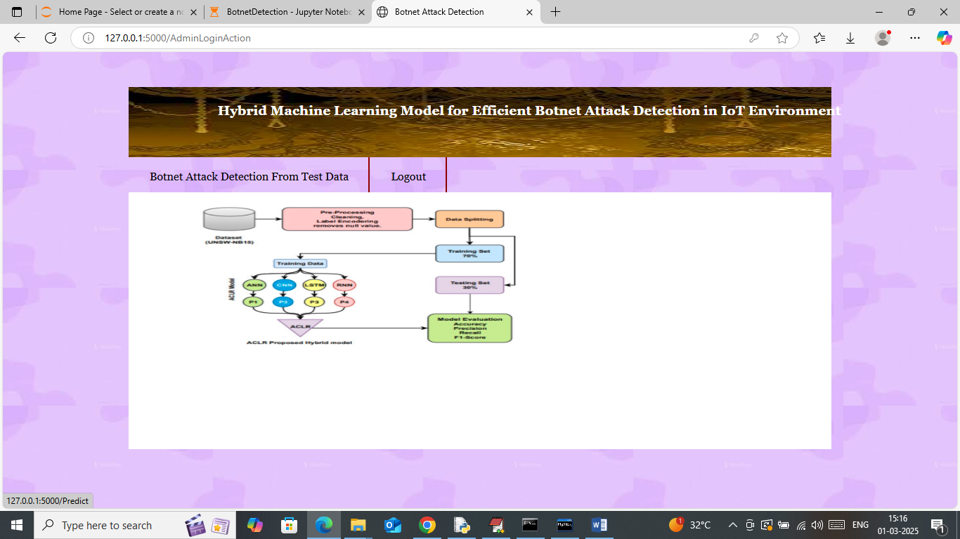

In above screen click on ‘Botnet Attack Detection’ link to get below page

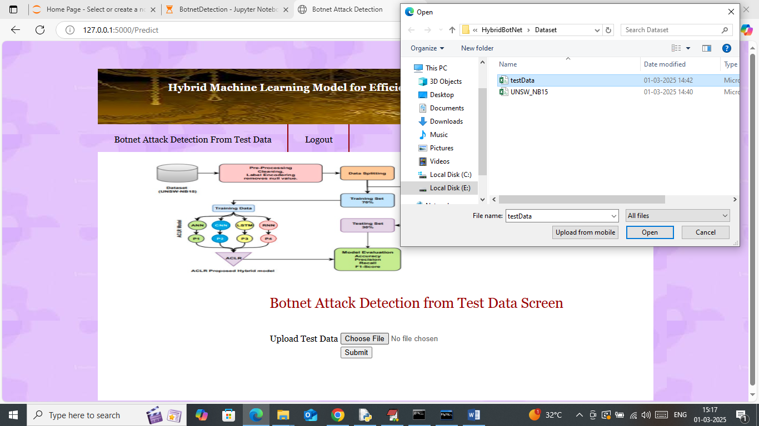

In above screen selecting and uploading test data file and then press button to get below page

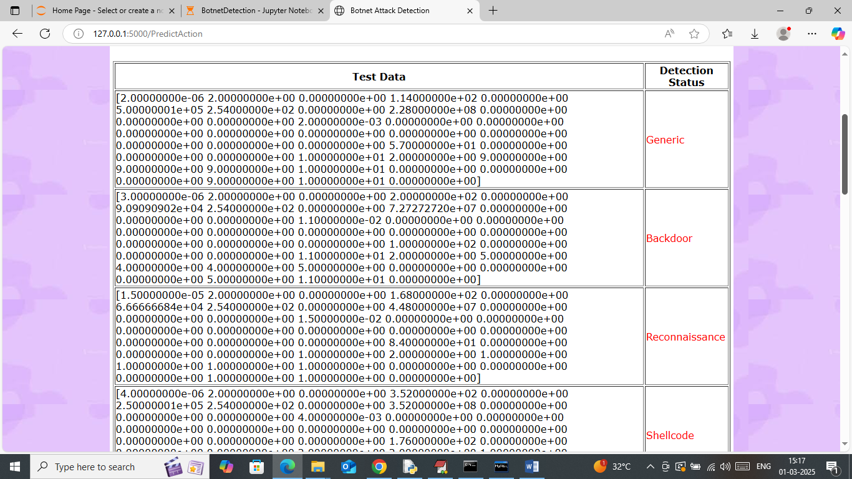

In above screen first column contains TEST data and second column contains predicted attack type

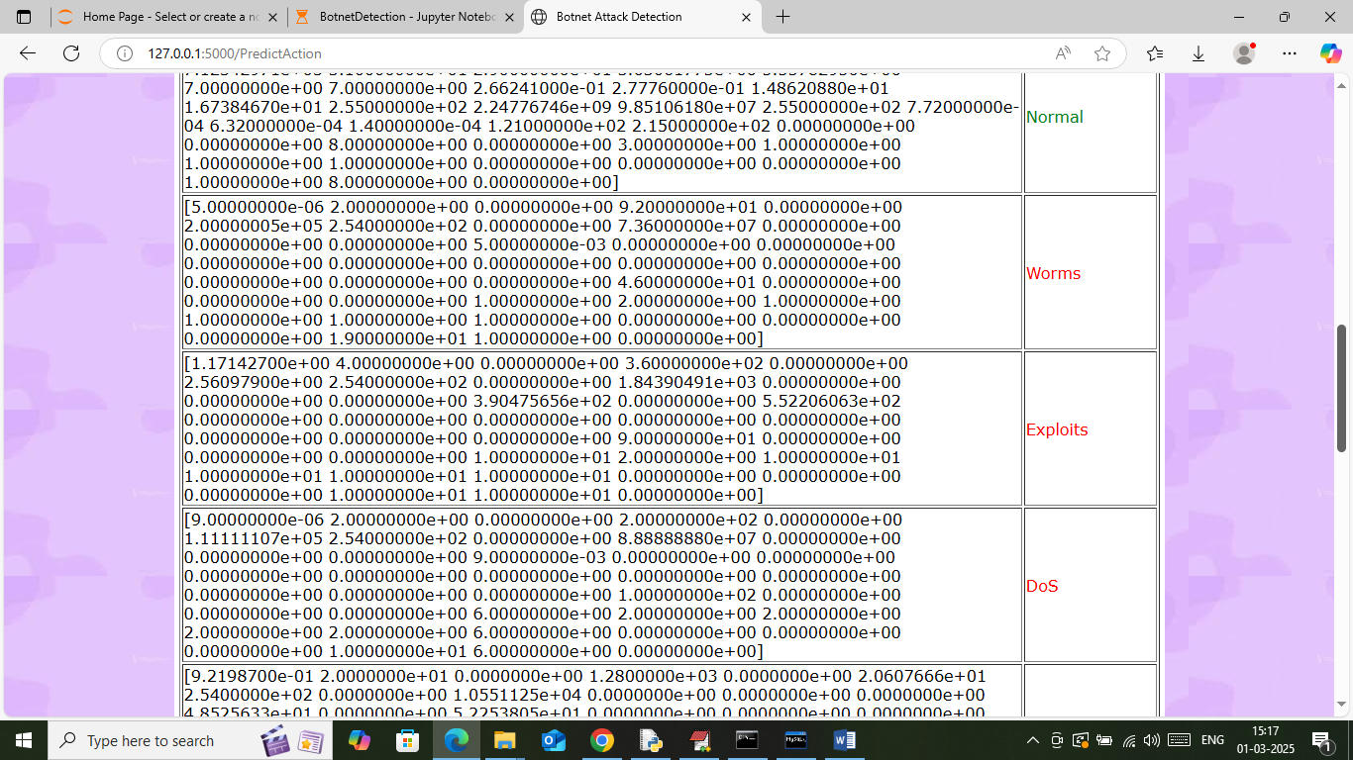

In above screens can see all types of predicted attack