COVID-19 Project

Definition: Recently we have seen that COVID-19 or Corona virus has affected so many lives in the world. It has been started in Wuhan city of China in 2019 and now has spread in all over the world. There are so many symptoms of this virus which affect the people and caused so many deaths in the world.

Problem Definition: By considering various factors like different country, states, people affected, recovered, deaths I have used different machine learning algorithms to predict the deaths due to covid-19.

For the above problem I have done some process step-by-step in the following way:
- Importing data
- Data wrangling
- Data analysis
- Data Pre-processing
- Importing Machine Learning Algorithms
- Model saving
- Conclusion

We will see all above steps in detail below-
- Importing Data: First to get our data like from ‘csv file’, ‘excel file’ or any other file we have to import pandas library.

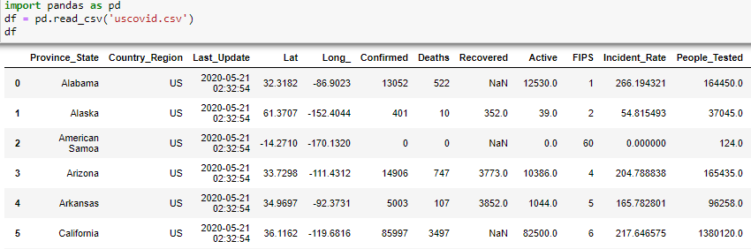

In this way we can read our data using read_csv.

- Data Wrangling: Our dataset is not always in proper format. Sometimes there maybe some missing values, sometimes there must be out of the box values. Our data is always a raw data so for that we have to do some wrangling process like.
- Check if there are any null values are present in the dataset or not.

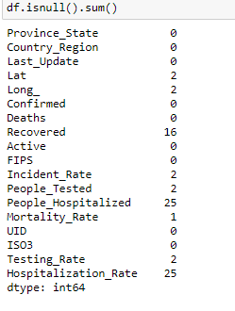

So there are so many null values present in some columns. So we have fill that values using fillna method. For filling the NaN values we can take mean or average for that particular column. If more than 50% of values are missing then in that case it is better to remove that rows.

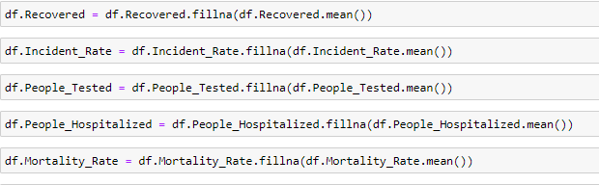

- Check the datatype of each column.

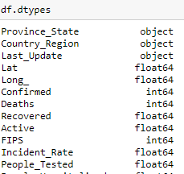

- Check the summary of our dataset using

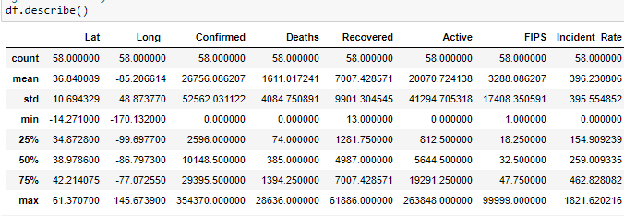

From above image we can say that all values for each column is different. For confirmed column max value is 354370 and 75% value is 29395 so in this case we can say that some outliers are present in this column.
- Data Analysis: In this step we have to do the analysis of each column using univariate method. And analysis of each column with target variable using bivariate method. So for this I have used Count method to check the number of unique values present in that particular column and also some visualization libraries to understand our data more clearly.

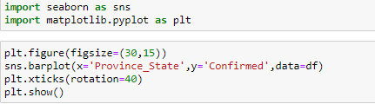

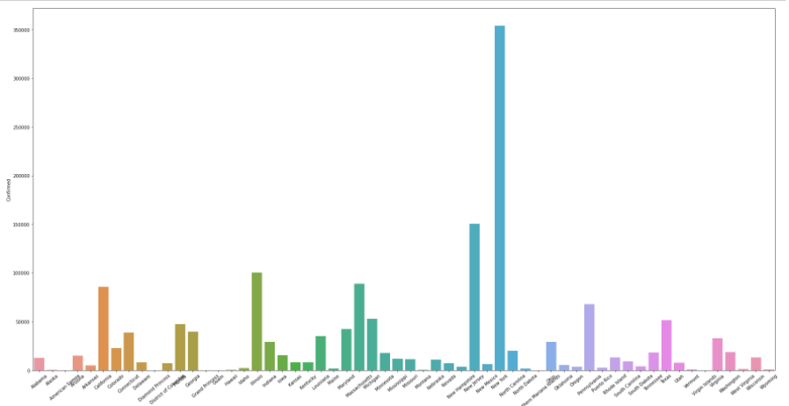

Seaborn and Matplotlib are two visualization libraries that I used to visualize graphically my data. The same method I have used for remaining variables.

This is the bivariate method because I have taken two variable one is target variable (target) and other variable as sex. In this way we have to visualize all variables with our target variable.

Now we have to find the correlation between all variables.

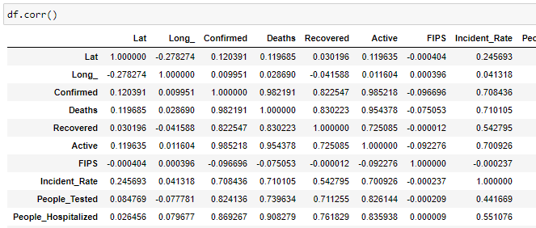

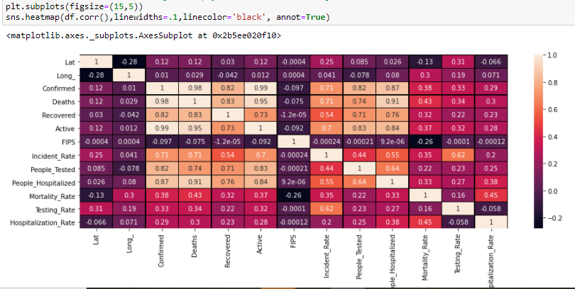

This above method is used to check the correlation between all columns. Heatmap method gives the graphical visualization from which we can easily understand the correlation. So from above diagram we can say that-

From above we can say that there are columns Confirmed and Deaths which has good positive correlation with other columns. So we can use any one of them as our target variable.

Checking Outliers: Our data is a raw data so we have to check whether any value is out of the box or not.

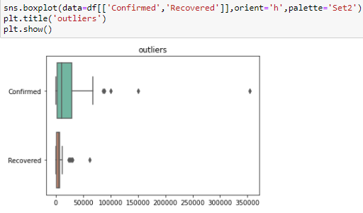

From above diagram we can say that there are some outliers present in both columns. So in the same way we have to check the outliers for all columns.

Skewness: Checking the skewness in our data is important for predictions. So we have check the skewness.

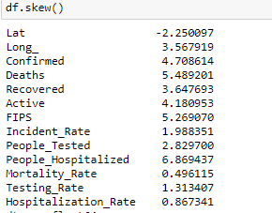

From above diagram we can say that some variables have positive skewness and some has very negative skewness. So we have to remove skewness and and outliers using following method.

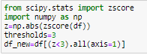

Zscore is used to normalize our dataset.

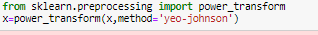

Yeo-Johnson method is used to remove the skewness from our data.

- Data Pre-Processing: Now we have to do the standard scaling of our data which means we have to make our data in particular level, so that it will be easy for the predictions.

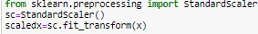

Splitting the data: We have to split our data for training and testing. So from this we can train some data and do the testing on remaining data.

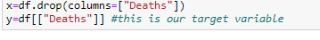

First we split our data in x and y variable. In x we have all input columns except out target variable and in y we have our target variable.

- Importing Machine Learning Algorithms: In this project I have used 3 machine learning algorithms with different parameters. Then I have checked which algorithm gives the best accuracy for saving the model.

In this I have used Linear Regression, Adaboostregressor, SGDRegressor.

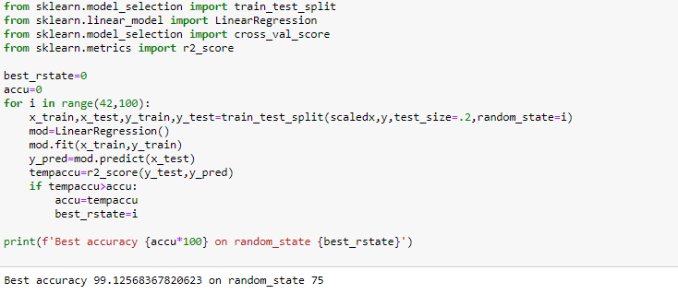

We have to do the same steps for other algorithms like Adaboostregressor, SGDRegressor. But in this case I have got good accuracy using Linear regression. So I have this algorithm for saving the model. So we can say that our model has performed better with accuracy 99.12%.

- Conclusion: From above we concluded that Linear Regression is better performed for this dataset with accuracy >95%.
- Model Saving: Now we have to save our best model using following method.

