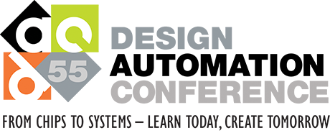

2018 Design Automation Conference, San Francisco, CA

**Student’s Pocket Guide**

Welcome to DAC! Below are a few quick suggestions to get the most out of your trip to DAC. this is a dynamic document. If you have suggestions contact Patrick or Laleh

Travel / getting around

Mark Twain allegedly wrote: ‘*the coldest winter I ever spent was a summer in San Francisco*’ (this is an [urban legend](http://www.snopes.com/quotes/twain.asp)). While Silicon Valley is mildly warm, SF can be much chillier. It's no big issue, just don’t forget to pack a sweater. Rain is unlikely during the summer months.

You will likely arrive at San Francisco International Airport. The lines for customs/immigration at could be long. Just take it easy and plan for some extra time. Don’t take fruits or meats, and you will be fine. SFO airport has a [BART](http://www.bart.gov/) (subway) connection to downtown San Francisco

If your accomodation is close to the convention center you can do most on foot. Public transport in SF is decent. Avoid the shady area west of Union Square (Tenderloin), the rest is pretty safe. You will notice many homeless people on the streets.

DAC is in [Moscone West](https://goo.gl/maps/t62d2PMrSPR2), which is right downtown. Most major attractions can be reached on foot.

What not to miss at DAC?

There are hundreds of presentations, and at many times 7-8 things going on at the same time. Use the [guide](https://www.dac.com/events) or the iOs/Android app to plan your day. Below is a selection:

* Best paper candidates. There are well over 100 paper presentations to check out. The candidates for the best paper award are a good start if you need to make a selection. We will ask you to share your impression of a paper of your choice.
* 5 [Keynotes](https://dac.com/content/keynote-visionary-and-sky-talk-presentations) . Especially check out the monday one on IoT, and the Tuesday one on AI.
* [Sky talks](https://dac.com/content/keynote-visionary-and-sky-talk-presentations) are in-depth keynotes by senior luminaries of the industry. Don’t miss the one on Tuesday Morning on Biologically Inspired design. I plan to see them all…
* [Panels](https://dac.com/events/panels) and [pavilion panels](https://dac.com/events/pavilion_panels) address a controversy with experts giving strong opinions.
* [Designer track](https://dac.com/events/designer_track) and IP track show the real designers describing their experiences.

Also, stroll around the trade show floor to check out the companies. Sit in on demos and score some ‘freebies’.

Who is Who in EDA? People watching

26000 people work in EDA, many of which come to DAC each year. Here is a crash course on people you will likely see at DAC:

**Journalists**

They report and blog about EDA, any typically they are connected to the tool user (designer) community. Some are independent consultants, most work for the major EDA companies.

* [John Cooley](http://greeleysghost.brian-fuller.com/wp-content/uploads/2009/07/beauty-and-the-beast.jpg) is the master loudmouth gossip journalist of EDA. Check out [www.deepchip.com](http://www.deepchip.com) which is likely the most read web page in EDA. Annually he makes a [‘must-see’ list](http://deepchip.com/gadfly/gad053014.html) for DAC.
* [Karen Bartleson](http://blogs.synopsys.com/thestandardsgame/) is a main public face for Synopsys. She produces many [youtube videos with interviews](https://www.youtube.com/watch?v=gAx6GQbI7_I)
* [Peggy Aycinena](http://www.aycinena.com/) takes a human-interest approach to blogging on the EDA community.
* Several bloggers are tied to [EDACafe.com](http://www.edacafe.com/)

**CEOs, movers and shakers**

The EDA industry is one of the larger employers in Silicon Valley.

* Cadence (~8000 people) : [Lip-Bu Tan](http://www.cadence.com/cadence/executive_team/pages/bio_ltan.aspx) (CEO, also major VC [investor](http://www.wiig.com/team/lip-bu_tan.aspx) in GoPro),  Anirudh Devgan.
* Synopsys (~12000 people): [Aart de Geus (CEO), Chi-Foon Chan (CEO), Antun Domic, Joachim Kunkel](https://www.synopsys.com/company/management-team.html). Aart co-founded the company and has led it since the beginning in 1987.
* Siemens (formerly: Mentor Graphics) (~5000 people): [Wally Rhines](http://www.forbes.com/profile/walden-rhines/) (CEO), Greg Hinckley. Mentor is the oldest major EDA company..
* [Jim Hogan](http://www10.edacafe.com/blogs/ed-lee/tag/jim-hogan/) major investor in EDA companies.
* [Joe Costello](http://en.wikipedia.org/wiki/Joseph_Costello_(software_executive)), Flamboyant ex-CEO of Cadence, currently involved with EDA startups.
* ARM: [Simon Segars](http://ir.arm.com/phoenix.zhtml?c=197211&p=irol-govBio&ID=148869) (CEO)

**Academia**

Many professors have been in the field for a long time and are a fixture at DAC. A small subset in not particular order: Bob Brayton (UCB), Giovanni deMicheli (Lausanne), Jason Cong (UCLA), Andrew Kahng (UCSD), Sangiovanni-Vincentelli (UCB), many more.

**DAC committee**

These are the volunteers that run DAC and the professional support staff from MPA. Check out [this page](https://dac.com/committees/executive) to see a few of them.

Party!

There are some legendary parties at DAC organized by DAC sponsors. With not too much effort it should be possible to score (free) tickets for the famous [Denali party](https://www.cadence.com/content/cadence-www/global/en_US/home/dac/dac-2018/denali-party.html)

On the show floor your should be able to find more parties.

Scoring (free) food at DAC

Check out the DAC organized networking events with food and drinks:

* Sunday Welcome reception (5:30-7:00pm)
* Monday Networking reception (5:00pm-6:00pm)
* Tuesday networking reception (6:00pm-7:00pm)
* Tuesday SIGDA Ph.D Forum / A. Richard Newton Fellowship Student Program (7:00-8:30pm)
* Wednesday networking reception (6:00pm-7:00pm)

Check out the major EDA companies that have misc. breakfast and lunch events:

* [Cadence](http://www.cadence.com/dac2015/pages/exhibits.aspx)
* [Synopsys](http://www.synopsys.com/apps/dac2015/)
* [Mentor Graphics](http://www.mentor.com/events/design-automation-conference/)

Other food for sale in the convention center is generally very much overpriced. Since DAC is right in the center of of the city, there are many places to eat and to sample the ‘local cuisine’.

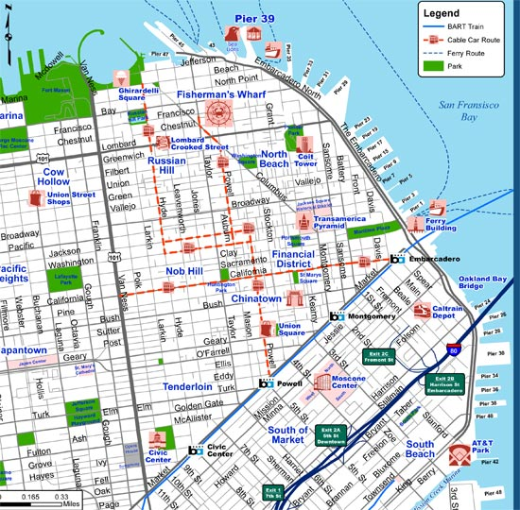

Checking out San Francisco

We’re at the Moscone Center. The city center in toward the north of Moscone Center (the convention center).  A short guide on what's in walking distance:

* Union square is the shopping hub, just a 2 blocks walk from Moscone center. Levi’s flagship store, Apple store, Abercrombie and other fashion stalwarts are all close.
* North of that is Chinatown, with loads of bazaars and shops. Unfortunately, gentrification is slowly pushing out the small stores.
* The [SFMOMA](https://www.sfmoma.org/) is next to Moscone. Worth a visit as it is better and larger than the one in New York.
* Financial districts are always boring, but the embarcadero and historic [ferry building](https://goo.gl/maps/ibpr8yjNiRN2) are landmarks to soak up San Francisco business life.
* Fisherman’s wharf and Pier 39 are tourist traps with loads of restaurants. Still nice to visit with a view over the bay and Golden Gate bridge. You can take the famous cable tram (but there can be a queue).
* [Alcatraz](http://www.nps.gov/alca/index.htm) is pretty cool, the boat trip is a great way to see the city and the bay.
* [Baker Beach](https://goo.gl/maps/MvsdbCyxrvF2) is the best spot on the Pacific Ocean with a nice view on the Golden Gate bridge. The water is too cold to swim.