Problem Solving Technique Questions
- Authenticate a User in a login form.
- List factors of all numbers from 1 to 100.
- Find all the Prime no’s from 1 to 100
- Towers of Hanoi
- Move one disk at a time
- No disk can sit on a smaller disk
- Get all disks from pole 1 to pole 3
- Date Problems
- Yesterday was Tuesday. What is 2 days before 4 days after tomorrow?
- Tomorrow is Sunday. What is 2 days after 3 days before yesterday?
- Yesterday was Saturday. What is 4 days before 7 days after 2 days before today?
- Today is Monday. What is 3 days after 2 days before 6 days after 5 days after tomorrow?
- Write the steps for withdrawing money from an ATM as an algorithm. Be as specific as possible.
- Write the steps for booking a railway ticket from IRCTC as an algorithm.
- Write a program that will accept as input from the user, an answer to the following question: Is it raining? If it is raining, tell the user to get an umbrella. Based on the temperature, either tell the user to bring a heavy jacket (colder than 32 degrees), light jacket (between 32 and 50 degrees), or no jacket at all.
- Draw a flowchart for the following
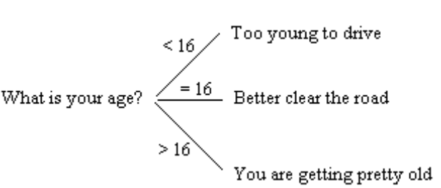
- Write a program that tells the user what type of movie they can attend based on their age, if they are with their parents, and their amount of money.
Under 13: G
Under 13 w/ parent: G, PG
13 and Over and Under 16 G, PG
Under 16 w/ parent G, PG, R
16 and Over G, PG, R
Matinee: $7.50
Evening: $10.50
- Write a program that will take as input the user’s bank account balance and the type and level of account they have. Based on this information and the below rate table, determine the interest rate they are receiving.
Type of account | Level | Minimum Balance | Interest Rate
Personal | Standard | $0 | 1.20%
Personal | Gold | $1,000 | 1.90%
Personal | Gold | $5,000 | 2.30%
Business | Standard | $1,500 | 1.70%
Business | Platinum | $10,000 | 2.50%
- Write a small program that will display the numbers 1 - 10.
- Solve the equation 2x² + x + 5 for all numbers between 5 and 10 for x.
- Create a program to provide an output like the following:
1
1 2
1 2 3
1 2 3 4
1 2 3 4 5
1 2 3 4 5 6
1 2 3 4 5 6 7
1 2 3 4 5 6 7 8
1 2 3 4 5 6 7 8 9
- Create a program to provide an output like the following:
…………1
………..21
………321
……..4321
……54321
…..654321
…7654321
..87654321
987654321
- Create a program to provide an output like the following:
…………1
………..212
………32123
……..4321234
……543212345
…..65432123456
…7654321234567
..876543212345678
98765432123456789
- Write a program for Generate Random Number in a given range of numbers
- How to encrypt a value (a password or a PIN).

