**Innovation in Teaching and Learning**

**Subject: Applied Physics Course Code: BSC102**

**Semester: I Div (Branch): E, F (CSE(DS)), G (IT) and I (EXTC)**

**Faculty: Dr. Vivek Singh Dates: November 11-15 & 18-22, 2024**

**Activity:** Flipped Classroom

**Objective:** To prioritize active learning in classroom

**Activity Description**: The flipped classroom is an innovative teaching and learning method where the traditional teaching strategy is reversed, leveraging technology to enhance learning. Video lectures on topics such as *Interference in Thin Films*, *Gradient, Divergence, Curl*, and *Heisenberg's Uncertainty Principle* were shared with students prior to the class. Students were instructed to watch the videos and come prepared. During laboratory sessions, students worked on numerical problems related to these topics. At the end of each session, solutions and the underlying physics concepts were discussed collaboratively, fostering a deeper understanding.

**Resources Used:** Video lectures

* [**https://www.youtube.com/watch?v=FDkSeCzDAUY**](https://www.youtube.com/watch?v=FDkSeCzDAUY)
* [**https://www.youtube.com/watch?v=dt9pLWusnxU**](https://www.youtube.com/watch?v=dt9pLWusnxU)

**Proof of Activity:**

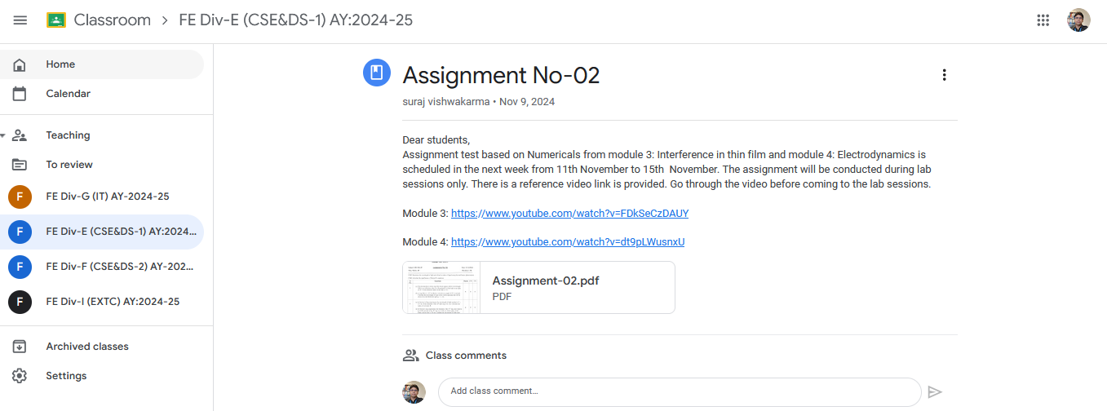

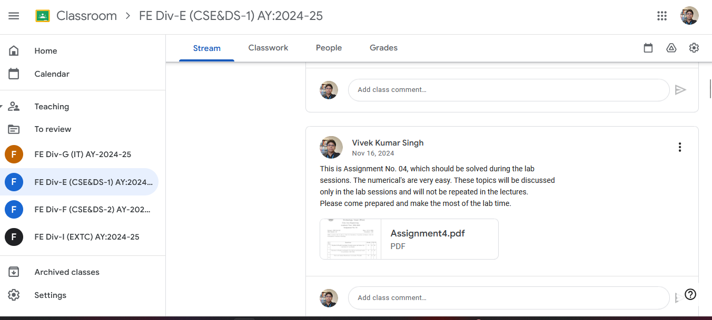

Screenshot of the announcement on Google Classroom for the session

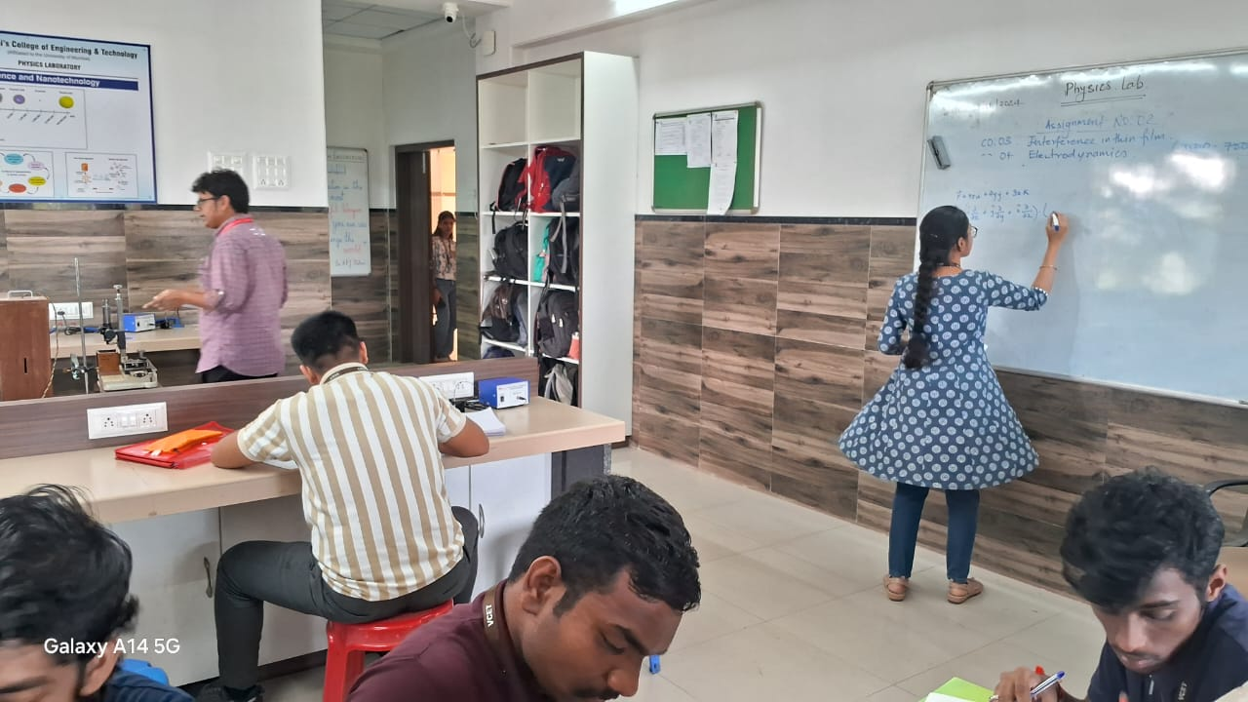

*Photographs of students solving problems on the board and participating in discussions*

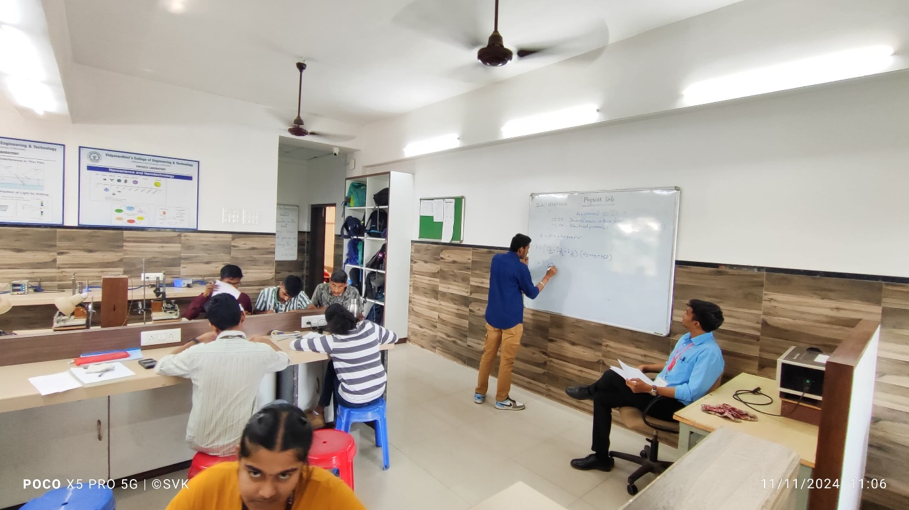

*Photographs of students solving problems on the board and participating in discussions*

**Outcomes:** This method enhanced students' problem-solving skills and their grasp of theoretical concepts. It encouraged collaborative learning and active participation, leading to increased interaction in the classroom. Flipped learning thrives on three main pillars:

1. **Flexible Environment**
2. **Learning Culture**
3. **Intentional Content**

**Signature of Faculty**

**(Dr. Vivek Singh)**